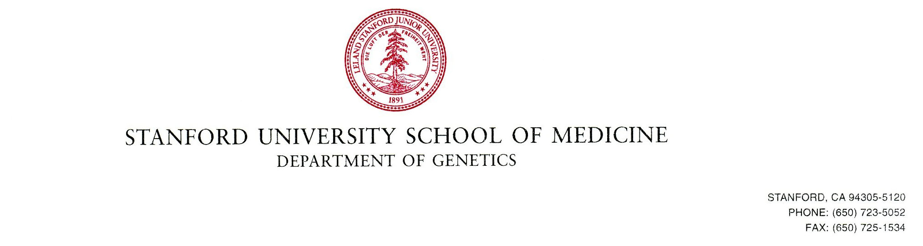
William J. Greenleaf Ph.D.
Associate Professor
Department of Genetics
Stanford University School of Medicine
Stanford, CA, 94305
Beckman Center Room B257A
phone: 650-725-3672
email: wjg@stanford.edu

August 19, 2021

Dear Editors:
Please find enclosed our manuscript titled “The chromatin organization of a chlorarachniophyte nucleomorph genome”, which we would like to submit for publication to Genome Biology.
Nucleomoprhs are one of nature’s unique evolutionary experiments in which the basic workings of a eukaryotic nucleus have been reshaped in major ways. They are the remnants of secondary endosymbiotic events between two eukaryote cells wherein the endosymbiont has retained its eukaryotic nucleus. This has happened at least twice independently, in the unrelated chlorarachniophyte and cryptophyte lineages, yet nucleomorph genome evolution has converged on a remarkably similar genomic architecture, characterized by the most extreme compression and miniatuarization among all known eukaryotic genomes. Previous studies examining nucleomorph genome sequences have suggested that nucleomorph chromatin exhibits a number of highly derived features (e.g. extremely divergent histone protein sequences lacking nearly all key ``histone code’’ residues, lack of RNA Polymerase II CTD tails, and others), but no direct experimental studies of it have been carried out before.
In this work, we provide the first maps of open chromatin, active transcription, and three-dimensional genome organization for the nucleomorph genome of the chlorarachniophyte Bigelowiella natans. We find that this nucleomorph genome exists in a highly accessible state, akin to that of ribosomal DNA in some other eukaryotes, and that it is highly transcribed over its entire length, with few signs of polymerase pausing at transcription start sites (TSSs). However, surprisingly, most nucleomorph TSSs show very strong nucleosome positioning, indicating the existence of mechanisms for specifying and establishing precisely defined chromatin states at promoters. Chromosome conformation (Hi-C) maps reveal the folding of nucleomorph chromosomes, and also unexpectedly show high interaction frequencies between genomic compartments of distinct topological origin (the host-derived mitochondrion and the nucleomorph genome).

Our work opens the first window into the structure and workings of the fascinating and evolutionarily unique nucleomorph genomes, and we thus believe that our manuscript will be of interest to readers of Genome Biology.
Sincerely,
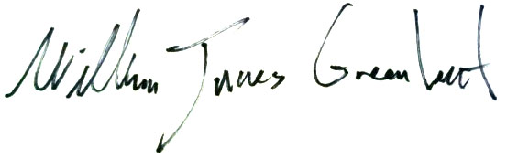
Associate Professor
Department of Genetics and, by courtesy, Applied Physics
Stanford University School of Medicine

