Transcription-dependent DNA supercoils determine the 3D organization of dinoflagellate genomes
Georgi K. Marinov^{1,,*,#}, Alexandro E. Trevino^{3,7,*}, Tingting Xiang^{2,8,*}, John R. Pringle¹, Anshul Kundaje^{1,6}, Arthur R. Grossman², and William J. Greenleaf^{1,3,4,5,#}
- Department of Genetics, Stanford University, Stanford, California 94305, USA
- Carnegie Institution for Science, Department of Plant Biology, Stanford, California 94305, USA
- Center for Personal Dynamic Regulomes, Stanford University, Stanford, California 94305, USA
- Department of Applied Physics, Stanford University, Stanford, California 94305, USA
5
Chan Zuckerberg Biohub, San Francisco, California, USA
- Department of Computer Science, Stanford University, Stanford, California 94305, USA
- Department of Bioengineering, Stanford University, Stanford, California 94305, USA
- Department of Biological Sciences, University of North Carolina at Charlotte, Charlotte, NC 28223, USA
* These authors contributed equally to this work
#
Corresponding author

Abstract
Dinoflagellate chromosomes represent a unique evolutionary experiment, as they exist in a permanently condensed, liquid crystalline state, are not packaged by histones, and genes are organized into polycistronic arrays, with little transcriptional regulation. We analyze the 3D genome of Breviolum minutum, and find large topological domains without chromatin loops, demarcated by convergent gene array boundaries (“dinoTADs). Transcriptional inhibition degrades dinoTADs, implicating transcription-induced supercoiling as the primary topological force in di-

noflagellates.
Investigations into the 3D organization of genomes have identified multiple mechanisms underlying genome folding². Two main forces are thought to drive it – associations between similar chromatin states determine formation of compartments, a mechanism probably present in most eukaryotes, while constraints on cohesin-mediated loop extrusion, imposed in vertebrates by CTCF, generate topologically associating domains (TADs).
Three-dimensional genome architecture has functional consequences for gene regulation, organismal development, replication, mutational processes, and others, but how functional activity itself impacts genome organization is still poorly understood. There has also been little exploration of 3D organization across eukaryotes, even though major deviations from conventional eukaryotic norms are known to exist, presenting natural experiments that may reveal deeper underlying organizational principles masked in other lineages.
Dinoflagellates are the most radical such departure. They are a diverse, widespread clade playing major roles in aquatic ecosystems, for example, as symbioints of corals, providing the metabolic basis for reef ecosystems. Dinoflagellates possess numerous highly divergent molecular features⁴, including, uniquely among eukaryotes, the loss of nucleosomal packaging of chromatin. Histones are extremely conserved across eukaryotes, were present in their current form already in the Last Eukaryotic Common Ancestor⁵, and they and their posttranslational modifications are pivotal to all biochemical processes involving chromatin.
Dinoflagellates are the sole known exception. Their chromosomes exist in a liquid crystalline state, are permanently condensed throughout the cell cycle, and, although highly divergent histone genes are retained in their genomes⁶, a combination of virus-derived nucleoproteins and bacterial-derived histone-like proteins have taken over as main packaging components⁷. Dinoflagellate genomes are often huge (up to ≥100 Gbp), genes are organized into polycistronic gene arrays, individual mRNAs are generated through trans-splicing, and transcriptional regulation is largely absent. These fascinating features simultaneously pose intriguing questions regarding the adaptation of transcriptional and regulatory mechanisms to the absence of nucleosomes, and provide a unique opportunity to explore the biophysical forces underlying genomic organization in the context of a large eukaryotic genome in which nucleosomes are absent.
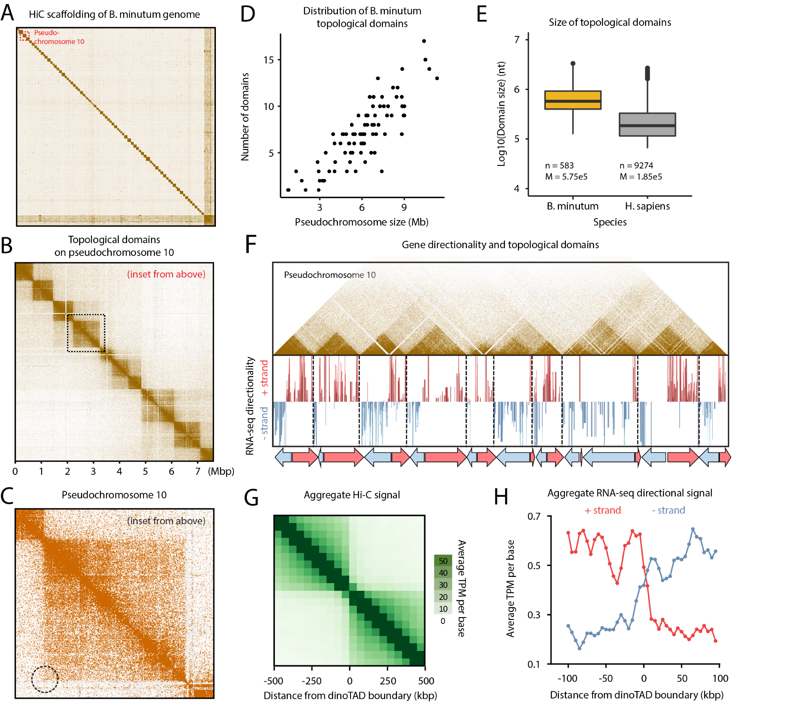
Figure 1: B. minutum genome is physically partitioned into dinoTADs defined by polycistronic gene arrays. (A) Hi-C scaffolding of the B. minutum draft genome assembly. (B) Inset from (A). KR-normalized 5-kb resolution Hi-C map for pseudochromosome 10. (C) Inset from (B). Hi-C loops and stripes are not observed in dinoTADs. (D) Scales of chromosome size with dinoTAD number. (E) Comparison of human and B. minutum topological domain sizes. (F) Hi-C map for pseudochromosome 10 together with forward- and reverse-strand transcript levels and gene arrays.
(G) Average Hi-C contacts across dinoTAD boundaries. (H) Average forward- and reverse-strand RNA-seq levels across
dinoTAD boundaries.
We address these questions by studying the 3D genome of the coral symbiont Breviolum minutum. We generated multiple Hi-C libraries, including one for cells grown at elevated temperature, obtained ∼150–220 million Hi-C contacts for each (Supplementary Table 1), pooled reads and used them to generate a chromosome-level scaffolding of the previously fragmented B. minutum assembly⁸. We identified 91 major pseudochromosomes (≥ 500 kbp), encompassing ∼94% of the total sequence (Fig. 1A-B; Supplementary Fig. 1A), the longest being ∼11 Mbp in size, with a median length of 6.7 Mbp (Supplementary Fig. 1A). At 1-Mbp resolution, they exhibit a bipartite (occasionally tripartite) structure (Supplementary Fig. 2).
High-resolution maps revealed strong topological domains, ≤200–≥2 Mbp in size (Fig. 1B-E; Supplementary Fig. 3–12). In mammals, TAD boundaries are demarcated by CTCF sites blocking loop extrusion, reflected by chromatin loops and “stripes”. We find no loop or stripe features in B. minutum (Fig. 1C), suggesting a different mechanism for the formation of dinoflagellate TADs, which we term “dinoTADs”. DinoTAD number correlates with chromosome size (Fig. 1D), and they are considerably larger than mammalian TADs (Fig. 1E).
We then compared Hi-C maps to available annotation features. Remarkably, we find that each dinoTAD corresponds to a pair of divergent gene arrays (Fig. 1F), and dinoTAD boundaries coincide with convergence between gene arrays (Fig. 1G-H).
The correspondence between gene arrays and dinoTADs suggests a role for transcription-dependent DNA supercoiling in the formation of the latter. Transcription inducing self-interacting domains has been previously demonstrated in bacteria¹², and similar mechanisms have been proposed to explain some topological features in fission yeast¹³. The torque generated by polymerases causes positive/negative supercoiling in front of/behind the transcription bubble; the resulting torsional stress either alters the twist of the double helix or induces superhelical writhe, which in turn can be accommodated through the formation of plectonemes, nucleosome remodeling, or other alterations in DNA structure¹⁴. Plectoneme formation over gene arrays is an intuitive explanation for dinoTADs, although other topological constraints might also be involved.
This model makes a clear prediction – inhibition of transcription should result in dinoTADs decompaction. We first compared Hi-C maps for cells grown at 34◦C versus 27◦C, as heat stress could result in general transcription reduction¹⁵. While we did not observe dinoTADs disappearance, we did find mild decompaction at 34◦C (Supplementary Fig. 18–20).
We then carried out transcription inhibition experiments using α-amanitin and triptolide (Fig. 2A-B). Triptolide quickly blocks transcription initiation by targeting the TFIIH XPB subunit, while α-amanitin directly inhibits RNA Polymerase II, but is slow acting¹⁶. Transcription inhibition conditions for B. minutum are not well established; it is also possible that triptolide does not strongly inhibit transcription due to the divergence of dinoflagellate transcription initiation factors⁸. We therefore assayed multiple time points and doses for each inhibitor (Fig. 2B). We also found that even high α-amanitin doses do not detectably affect photosynthetic efficiency or cell viability relative to controls (Fig. 2C), excluding cell death as a confounder in our analysis.
Strikingly, α-amanitin treatment resulted in a dosedependent, progressive, near-complete dinoTAD decompaction (Fig. 2D,F; Supplementary Fig. 21–24). Triptolide treatment did not eliminate topological structures to the same extent, but nevertheless caused “blurring” of dinoTADs boundaries (Fig. 2E-F; Supplementary Figures 25–28). These effects were observed in both technical and biological replicates (Supplementary Fig. 21–24).
These observations support transcription-induced supercoiling as the primary force driving dinoTAD formation. Examination of dinoflagellate gene repertoires also suggests that they contend with elevated torsional stress, revealing a striking and dinoflagellate-specific expansion of topoisomerase II- and topoisomerase III-like genes (Fig. 1D; Supplementary Fig. 17; Supplementary Table 2), i.e. the genes necessary for relieving torsional stress¹⁷.
Comparison with self-interacting domains in bacteria or S. pombe shows much stronger topological insulation for dinoTADs (Supplementary Fig. 14) and 15)). Remarkably, no TAD domains are observed in kinetoplastids, the other lineage with long gene arrays and no transcriptional regulation (Supplementary Fig. 16).
These differences are readily explained by the unusual dinoflagellate properties. First, neither bacteria nor yeast possess comparably long gene arrays and transcription there is highly nonuniform; less transcription-induced torsional stress is therefore expected. Nucleosome loss is the second, and most salient difference. Single mammalian genes as long as dinoTADs are quite common, yet supercoiling is not apparent in mammalian Hi-C maps, nor is it seen in kinetoplastids (which have conventional chromatin). We therefore hypothesize that plectonemes form in dinoflagellates due to the lack of nucleosomes. In other eukaryotes, interactions between nucleosomes prevent formation of writhe-based structures, requiring more of torsion to be accommodated by changes in twist (Fig. 2H).
Numerous open questions remain. How exactly are boundaries between dinoTADs formed mechanistically? Specific boundary elements of markedly different chromatin state could exist; alternatively, they might form purely through torsion-related mechanisms. What exactly role histone genes play is also not clear. Answers to these questions, together with dissecting the specific roles of topoisomerases, will help fully elucidate the interplay between packaging proteins, torsional stress and genome folding in dinoflagellates.
We also identify transcription-induced torsional stress as a key direction of future studies in eukaryotes generally. The strength of dinoTADs underlines its potency as a topological force. The precise manner by which torsion is accommodated as twist and writhe, as well as its consequences for regulatory protein occupancy, transcriptional activity and other chromatin processes are exciting questions remaining to be unraveled.

Author contributions
G.K.M. performed Hi-C experiments. G.K.M and A.E.T. analyzed the data. A.E.T. and T.X. designed and carried out transcription inhibition experiments and cell viability experiments. T.X. carried out S. minutum culture and heat stress treatment. W.J.G., A.R.G.. A.K. and J.R.P. supervised the study. G.K.M., A.E.T. and T.X. interpreted data and wrote manuscript with input from all authors.

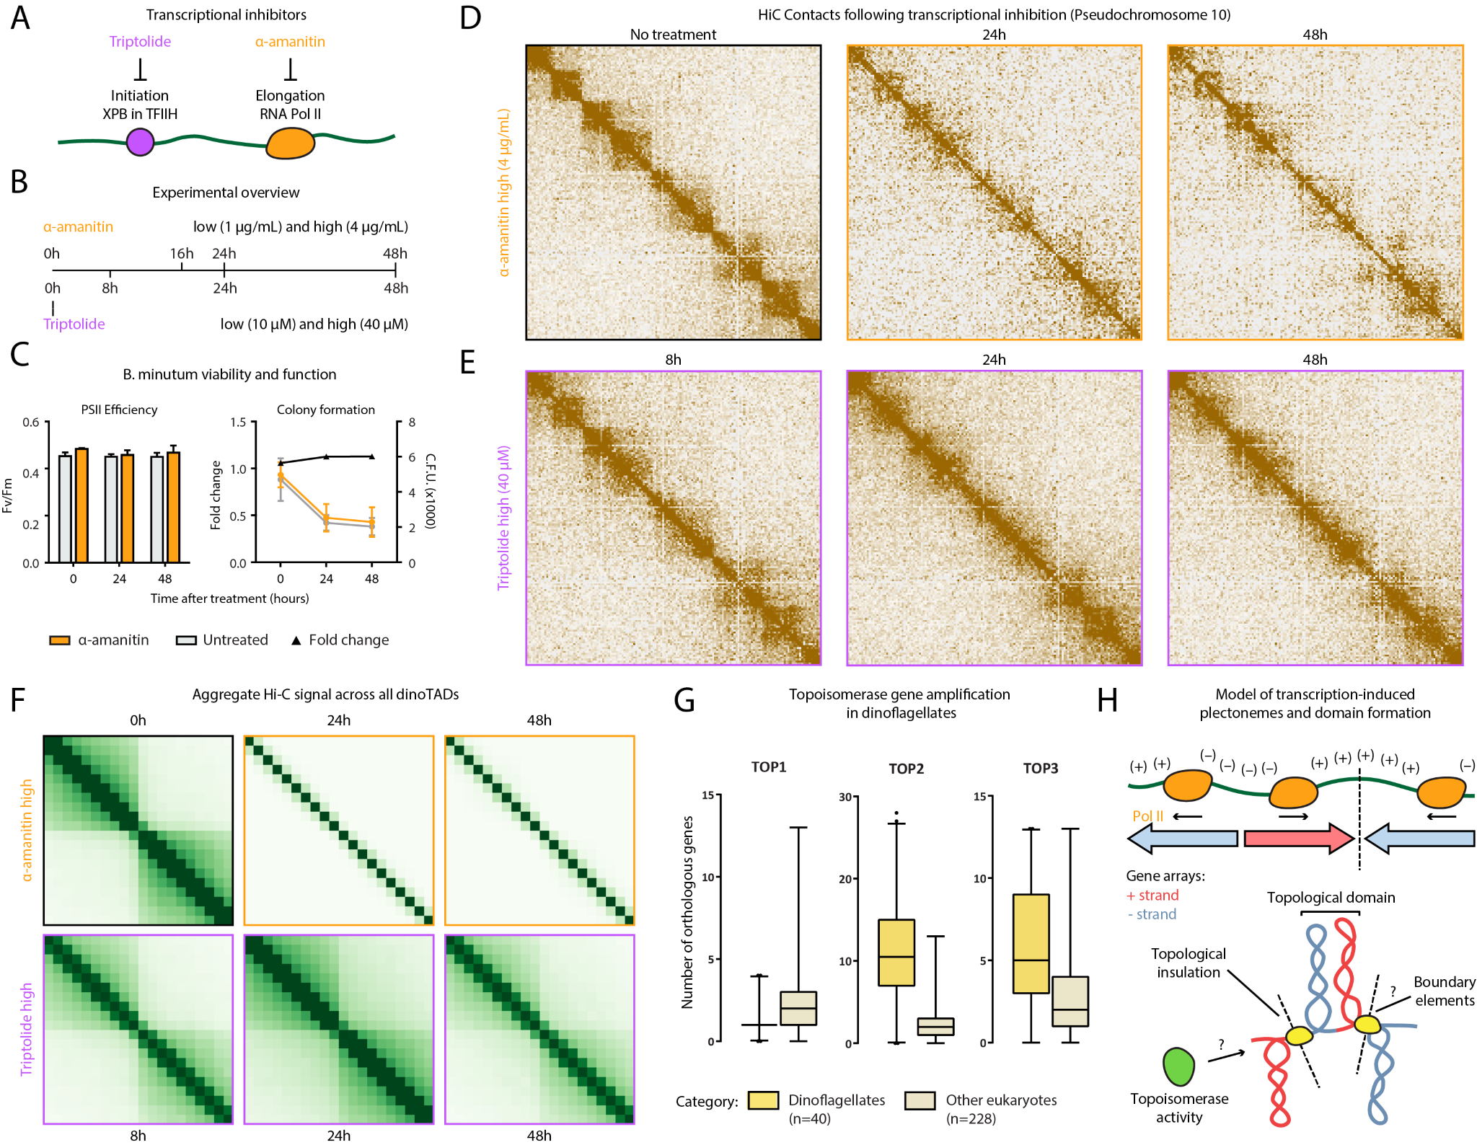
Figure 2: Decompaction of dinoTADs upon transcriptional inhibition and the transcription-induced supercoiling model for their formation. Shown is pseudochromosome 10. (A-B) Outline of transcription inhibition time course experiments. (C) Comparison of cell function, measured by PSII photosythetic efficiency, and cell viability, measured by colony formation (right), between α-amanitin-treated and untreated cells. (D) KR-normalized Hi-C maps (50-kb resolution) show marked loss of dinoTADs after α-amanitin treatment. (E) Hi-C maps show reduction of insulation at dinoTAD boundaries after triptolide treatment. (F) Metaplots of Hi-C signal around domain boundaries (50-kb resolution). (G) Amplification of TOP2 and TOP3 topoisomerases in dinoflagellates (based on MMETSP¹⁰ transcriptome assemblies). (H) Transcription-induced supercoiling as driver of dinoflagellate chromatin folding. Transcribing polymerases introduce negative/positive DNA supercoiling behind/ahead of the transcription machinery. Interactions within supercoiled domains could explain the physical association of divergently-oriented arrays. Topological insulation could be driven by supercoiling-related effects, or by specific boundary elements. The exact role of the expanded repertoire of topoisomerases is also currently unclear.
Fac | ulty | Scholar | Grant, | and | the | Hu | man | Fron | tiers | Sci | ence

Acknowledgments
Pro | gram | grant | RGY006S | (to
This |  | work |  | was |  |  | sup | ported |  |  |  |  | by | NIH |  |  |  | grants |  |  | (P50HG007735,
RO1 |  |  | HG008140, |  |  |  |  |  |  | U19AI057266 |  |  |  |  |  |  |  |  | and |  |  | UM1HG009442
to |  | W.J.G., |  |  |  | 1UM1HG009436 |  |  |  |  |  |  |  |  |  | to |  |  | W.J.G. |  |  |  |  |  | and |  |  |  | A.K.,
1DP2OD022870 |  |  |  |  |  |  | -01 |  | and |  |  | 1U01HG009431 |  |  |  |  |  |  |  | to |  | A.K.), |  |  |  | the |  |  | Rita
Allen |  | Foun |  |  | da | tion |  |  | (to |  |  | W.J.G.), |  |  |  |  | the |  | Bax |  | ter |  |  |  | Foun |  |  | da |  | tion
W.J.G). W.J.G is a Chan Zuckerberg Biohub investigator and acknowledges grants 2017-174468 and 2018-182817 from the Chan Zuckerberg Initiative. Fellowship support provided by the Stanford School of Medicine Dean’s Fellowship (G.K.M.), the Siebel Scholars, the Enhancing Diversity in Graduate Education

Program and the Weiland Family Fellowship (A.E.T.). This work is also supported by NSF-IOS EDGE Award 1645164 and Carnegie Venture grant 10907 (to T.X. and G.K.M.).
The authors would like to thank Zohar Shipony, Erez Lieberman Aiden, Philip Cleves, and members of the Greenleaf, Kundaje, Pringle and Grossman labs for helpful discussion and suggestions regarding this work.

