Transcription-dependent DNA supercoils determine the 3D organization of dinoflagellate genomes
Georgi K. Marinov^{1,,*,#}, Alexandro E. Trevino^{3,7,*}, Tingting Xiang^{2,8,*}, John R. Pringle¹, Anshul Kundaje^{1,6}, Arthur R. Grossman², and William J. Greenleaf^{1,3,4,5,#}
- Department of Genetics, Stanford University, Stanford, California 94305, USA
- Carnegie Institution for Science, Department of Plant Biology, Stanford, California 94305, USA
- Center for Personal Dynamic Regulomes, Stanford University, Stanford, California 94305, USA
- Department of Applied Physics, Stanford University, Stanford, California 94305, USA
5
Chan Zuckerberg Biohub, San Francisco, California, USA
- Department of Computer Science, Stanford University, Stanford, California 94305, USA
- Department of Bioengineering, Stanford University, Stanford, California 94305, USA
- Department of Biological Sciences, University of North Carolina at Charlotte, Charlotte, NC 28223, USA
* These authors contributed equally to this work
#
Corresponding author

Abstract
Unlike most eukaryotes, dinoflagellate chromosomes exist in a permanently condensed, liquid crystalline state and are primarily packaged by proteins of viral and bacterial origin, rather than by nucleosomal histones. Genes are organized into polycistronic arrays, and gene regulation is thought to be largely post-transcriptional. How dinoflagellate chromosomes are physically organized has long remained a mystery. Here, we analyze the 3D genome structure of Breviolum minutum, a coral symbiont dinoflagellate. We find that the genome partitions into topologically associating domains of 100-2000 kilobases, not associated with chromatin loops. Domain boundaries instead correspond to transitions between convergent gene arrays. Importantly, transcriptional inhibition degrades these domains. This study points to transcription-induced supercoiling as a fundamental force shaping the physical genome.

The three dimensional organization of genomes and its functional consequences have attracted much attention in recent years, especially in mammalian systems. These studies have by now identified multiple physical mechanisms underlying genome folding (2). Two main topological forces are currently thought to drive 3D organization. Associations between similar chromatin states drive the formation of compartments, and this mechanism is probably present in most eukaryotes (2). Better known (and more prominent in mammalian genomes) are the constraints on cohesinmediated loop extrusion (4), imposed by pairs of boundary elements specified by occupancy sites of the CTCF insulation factor. They drive the formation of topologically associating loop extrusion domains (TADs), approximately 100-1000 kbp in size (4).
Three-dimensional genome architecture has been proposed to have multiple important functional consequences for gene regulation (5, 6), organismal development (7), replication (8), mutational processes (9), and others. However, how functional activity in turn impacts genome organization is still poorly understood, and little is known how these biophysical properties vary across eukaryotes.
Dinoflagellates are a diverse, widespread lineage of eukaryotes that play major roles in aquatic ecosystems. As an example, the association of dinoflagellates in the Symbiodiniaceae clade (10) with reef-building coral species provides the metabolic basis for vital and highly biologically diverse reef ecosystems.
Dinoflagellates are also a unique lineage possessing numerous highly divergent molecular features relative to other eukaryotic organisms (11). Nucleosomal packaging of chromatin evolved in archaea and developed into its present form, shared across all eukaryotes, prior to the time of the Last Eukaryotic Common Ancestor (LECA) (12). All living eukaryotes ancestrally possess four core nucleosomal histones (H2A, H2B, H3 and H4), each featuring long unstructured N-terminal tails. These tails, as well as a few residues in the histone fold domain, are subject to ex-

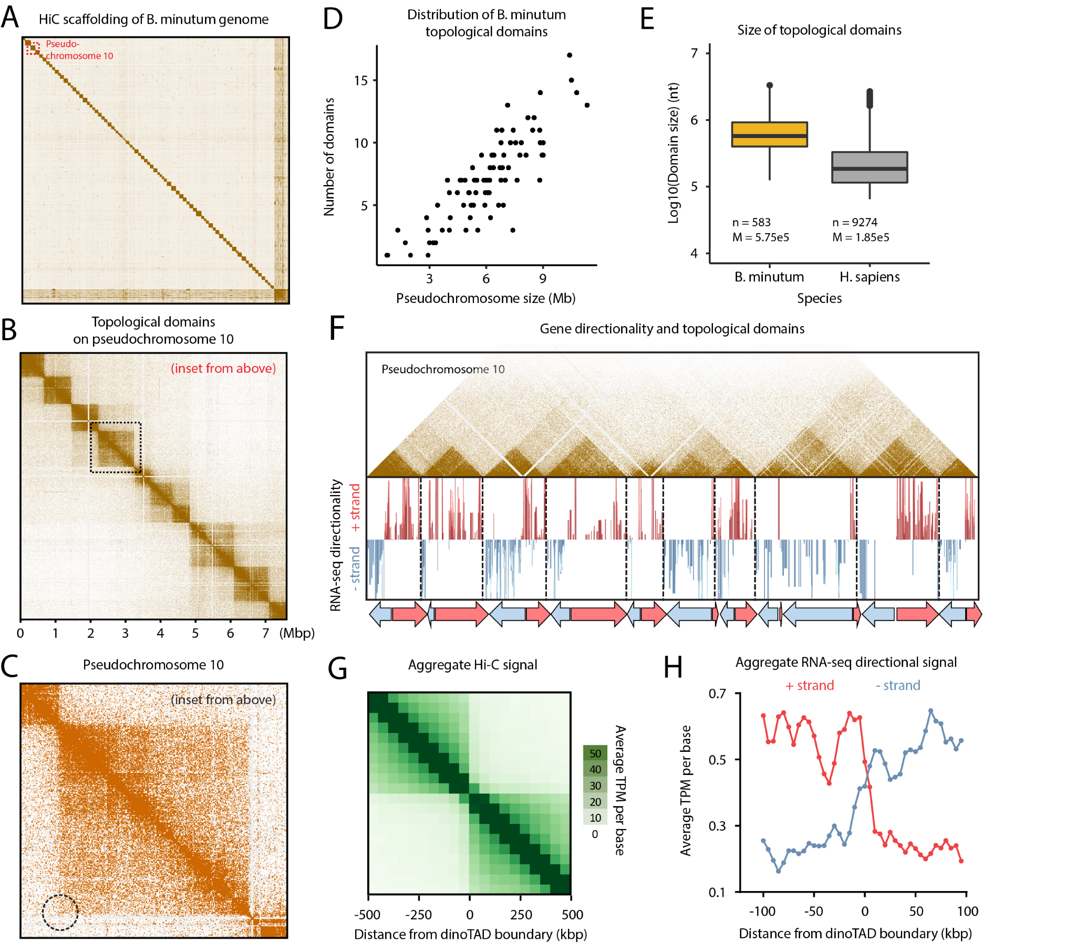
Figure 1: B. minutum genome is physically partitioned into topological domains defined by polycistronic gene arrays. (A-C) Organization of dinoflagellate chromosomes. (A) Hi-C scaffolding of the B. minutum draft genome assembly identifies 91 major pseudochromosomes ≥500kb in size. (B) Inset from (A). KR-normalized (1) 5-kb resolution Hi-C map for pseudochromosome 10. Pseudochromosomes are physically partitioned into strong topological domains (“dinoTADs”). (C) Focus on a single topological domain, inset from (D). The usual signs of loop extrusion domains (presence of loops and stripes in Hi-C maps) are not observed in dinoTADs. (D) The number of dinoTADs per chromosome scales with chromosome size. (E) Comparison of H. sapiens (grey) and B. minutum (yellow) topological domain sizes. (F-H) Boundaries of dinoTADs are primarily associated with transitions between convergent polycistronic gene arrays. (F) Shown is the Hi-C map for pseudochromosome 10 together with transcript levels on the forward and the reverse strands. (G) Average Hi-C contacts across dinoTAD boundaries. (H) Average forward- and reverse-strand RNA-seq contacts across dinoTAD boundaries.
tensive posttranslational modifications, serving as recruit- cesses involving chromatin. The code’s fundamental imporment platforms for effector domain-containing proteins thus tance is strongly underscored by the fact that key histone forming the basis of the so called “histone code”(13) and code residues are almost invariant across eukaryotes (14). playing important roles in essentially all biochemical pro- Dinoflagellates are a striking exception. Their chromo-

somes exist in a liquid crystalline state, are permanently condensed throughout the cell cycle, and are characterized by a very low DNA to protein ratio of 1:10 (compared to the usual 1:1 (15)). This is because, even though histone genes (although highly divergent) are retained in dinoflagellate genomes (16), a combination of virusderived dinoflagellate-specific nucleoproteins (DVNPs) and bacterial-derived histone-like proteins (HLPs) have taken over as the main DNA packaging components (17, 18).
The functional organization of dinoflagellate genomes is also unusual, though not without some parallels (19), as genes are organized into polycistronic gene arrays transcribed as a single unit, with individual mRNAs generated through trans-splicing; it is generally thought that transcriptional regulation is largely absent. In addition, despite being relatively small unicellular organisms, their genomes are often very large in size (up to two orders of magnitude larger than mammalian genomes).
These fascinating features of dinoflagellate nuclei simultaneously present numerous intriguing questions regarding the adaptation of the conventional eukaryotic gene regulation mechanisms to the general absence of nucleosomal chromatin, and also provide an opportunity to explore the biophysical forces underlying genomic organization in the context of such an exceptional natural experiment.
Here, we chart the 3D genome organization of the coral symbiont Breviolum minutum (previously Symbiodinium minutum), and uncover a novel mechanism for its formation.
We first generated three genome-wide chromosome conformation capture (Hi-C) libraries for the B. minutum SSB01 strain using a slight modification of the standard in situ Hi-C protocol (4), including one under elevated temperature conditions. We obtained between ∼150 and 220 million distinct Hi-C contacts from each library (Supplementary Table 1). We pooled reads from all samples and processed them against the existing, highly fragmented B. minutum assembly (20), then used the resulting Hi-C maps to generate a chromosome-level assembly scaffolding using established methods (21) (see Supplementary Methods for details). The resulting assembly consists of 91 major pseudochromosomes ≥ 500 kbp in size, encompassing ∼94% of the total sequence, with 85 of them ≥1 Mbp (Figure 1A, B and Supplementary Figure 1 A). The longest major pseudochromosomes are ∼11 Mbp in size, with a median length of 6.7 Mbp (Supplementary Figure 1A). At 1-Mbp resolution, they exhibit a bipartite (on a few occasions tripartite) structure, with two major interacting domains (Supplementary Figure 2).
This assembly likely underestimates the total genome size, as the original set of contigs clearly contains a number of collapsed repeats, a common feature of Hi-C-based genome assemblies (Figure 1A, lower right). We note that our assembly disagrees with published reports, which suggest ∼20 chromosomes based on microscopy images (20). Nonetheless, Hi-C analysis strongly suggests the physical separation of a larger number of pseudochromosomes in the nucleus, as does the recent chromosome-level assembly of F. kawagutii (another Symbiodiniaceae species) (22). We expect truly complete assemblies that leverage a combination of long-read and Hi-C sequencing methods to become available in the near future.
High-resolution (5 kbp) maps revealed the existence of strong topological domains ranging in length from ≤ 200 kbp to ≥2 Mbp (Figure 1B-E, Supplementary Figures 3– 12). In mammals, where TADs are best documented (4), TAD boundaries are demarcated by opposite-orientation pairs of CTCF sites blocking the process of loop extrusion by cohesin rings (2). Constraints on loop extrusion are reflected in high-resolution Hi-C maps by the presence of loops at TAD boundaries and “stripes” on the edges of TAD blocks (6). However, we observed no loop or stripe features in B. minutum (Figure 1C), suggesting that dinoflagellate TADs are formed by a different mechanism. We term these domains “dinoTADs” to distinguish them from the loop extrusion-related domains in vertebrates. The number of dinoTADs appears to be a function of the chromosome size (Figure 1D), while comparison with mammalian TADs reveals dinoTADs to be considerably larger (Figure 1E).
In order to understand the formation of dinoTADs, we compared Hi-C maps to available annotation features for B. minutum, in particular transcriptomic data (Supplementary Methods). Remarkably, we found that each dinoTAD corresponds to a pair of divergent gene arrays (Figure 1F), while boundaries between dinoTADs coincide with regions of convergence between gene arrays (Figure 1G-H).
Numerous models for dinoflagellate chromosome organization have been suggested since the 1960s, primarily based on electron microscopy. These include proposals that chromosomes are organized as “toroidal chromonemas” (24), “stacks of discs” (25), “cored pineapples” (26), or around “central core fibers” (27). Most of these models imply specific topological constraints maintaining the proposed shapes.
The Hi-C patterns we observe instead strongly suggest a role for dynamic transcription-dependent DNA supercoiling in dinoTAD formation. Studies of 3D genome organization in bacteria have suggested that transcription can cause the formation of self-interacting domains (28), and similar mechanisms have been proposed as an explanation for topological features observed in the yeast Schizosaccharomyces pombe (29). Transcription can affect topological features due to its effects on DNA supercoiling (30) – the torque generated by RNA polymerase causes positive supercoiling in front of the transcription bubble and negative supercoiling behind it. Formation of plectonemes, nucleosome remodeling, or alteration in DNA structure are among the possible consequences (31). Transcription-driven plectoneme formation coinciding with long dinoflagellate gene arrays is an intuitive explanation for the compact dinoTADs we observe, although it is also possible that other topological constraints are responsible.

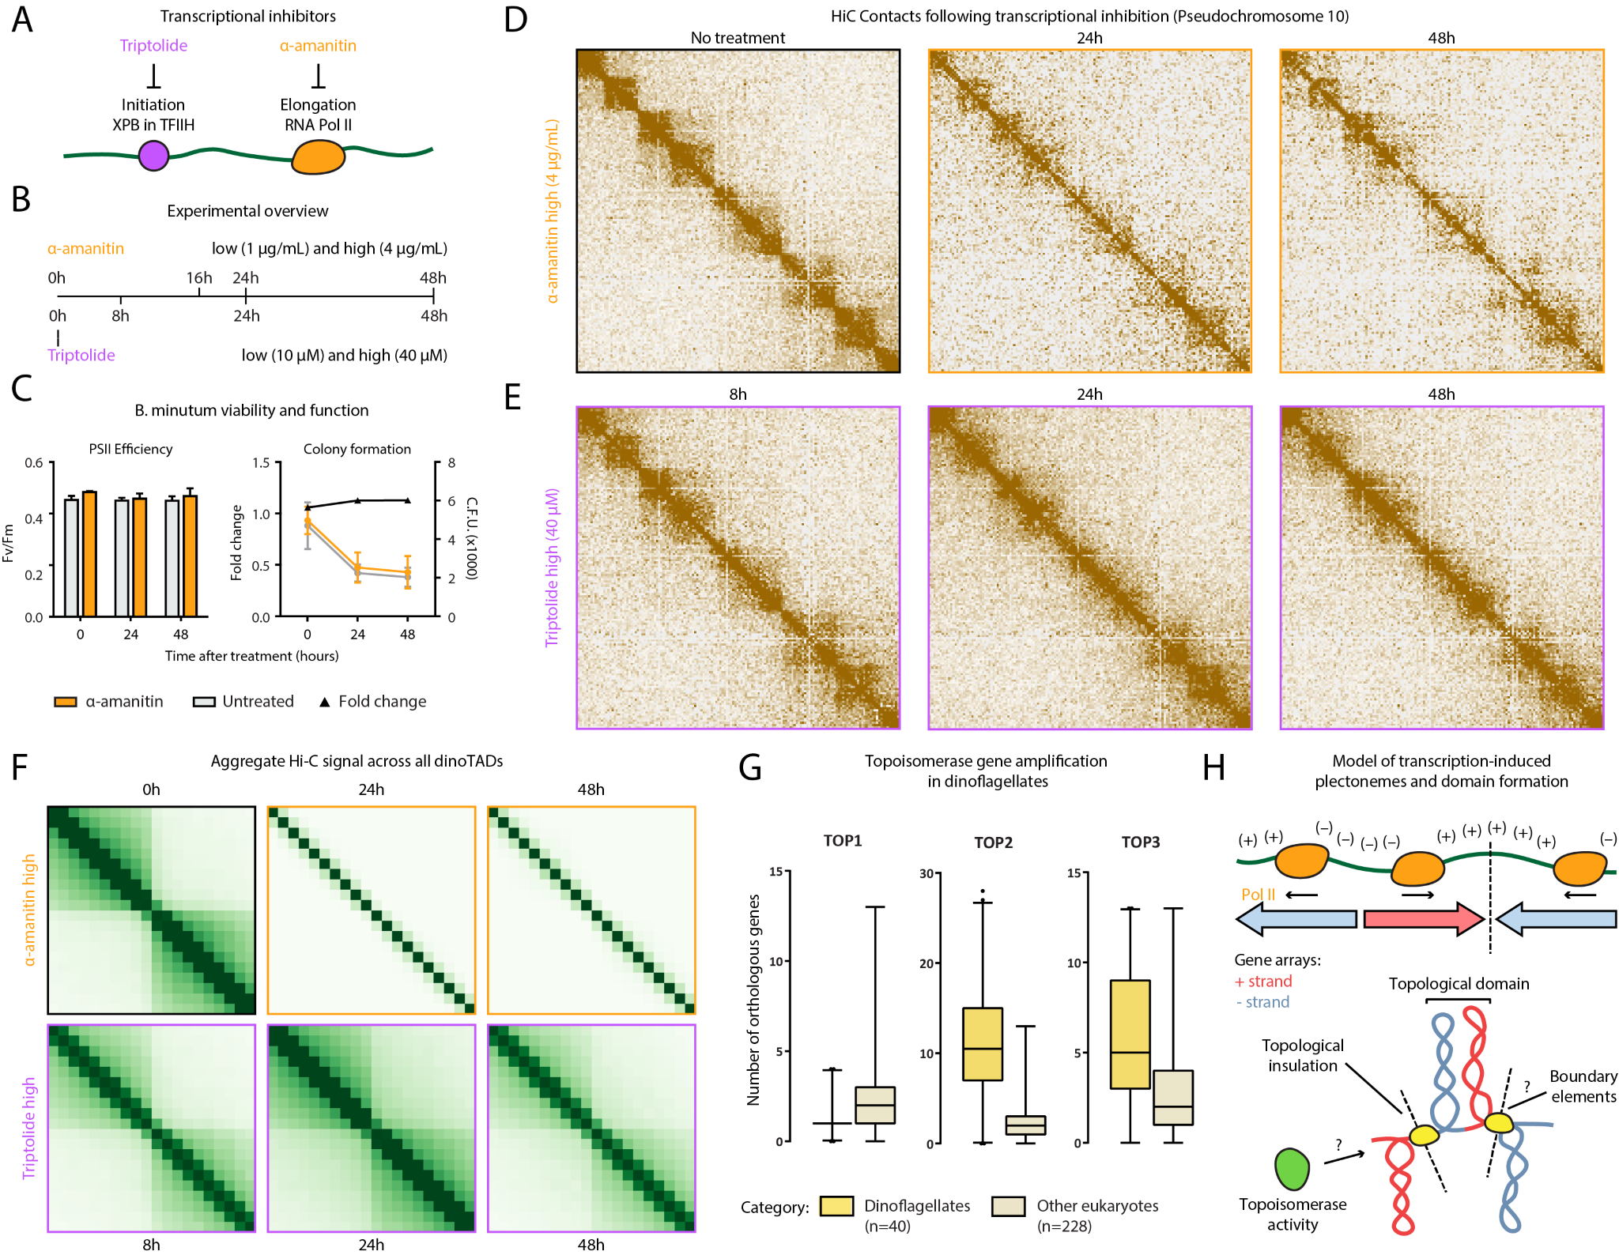
Figure 2: Decompaction of dinoTADs upon transcriptional inhibition supports the transcription-induced supercoiling model for their formation. Shown is pseudochromosome 10 as in Figure 1. (A) Outline of transcription inhibition experiments carried out using α-amanitin (orange) and triptolide (purple). (B) Time course and dosages of transcriptional inhibition. (C) Comparison of cell function, measured by PSII photosythetic efficiency test (left), and cell viability, measured by a colony counting assay (right), between α-amanitin-treated and untreated samples over time. (D) KR-normalized Hi-C maps (50-kb resolution) at 0 hours, 24 hours and 48 hours (high dose) after α-amanitin treatment show marked loss of dinoTADs. (E) KR-normalized Hi-C maps (50-kb resolution) at 8 hours, 24 hours and 48 hours (high dose) after triptolide treatment show reduction of insulation at dinoTAD boundaries. (F) Metaplots of Hi-C signal around domain boundaries (50-kb resolution; see Supplementary Methods for details). (G) Amplification of TOP2 and TOP3 topoisomerase homolog genes in dinoflagellates compated to other unicellular eukaryotes. Transcriptome assemblies from the MMETSP (23) were used (See Supplementary Methods for details). (H) Transcription-induced supercoiling as the main topological force driving the physical organization of dinoflagellate chromosomes. Transcribing RNA Polymerase molecules introduce negative and positive DNA supercoling behind and ahead of the transcription machinery, respectively, and the interactions of negatively supercoiled domains could explain the physical association of divergently-oriented gene arrays. Topological insulation could be driven by supercoiling-related effects, or by unknown boundary elements. Also unknown at present is the role of the expanded repertoire of topoisomerases.

The transcription-induced supercoiling model makes a clear prediction that can distinguish these possibilities – inhibition of transcription should lead to the decompaction of dinoTADs.
We first compared Hi-C maps for B. minutum cells grown at 27◦C and at 34◦C, as exposure to heat stress could result in general reduction in transcription activity (32). Indeed, while we do not observe disappearance of dinoTADs in the 34◦C sample, we do observe mild dinoTAD decompaction and an increase in interactions across dinoTAD boundaries (Supplementary Figures 18–20).
To directly test the transcription-induced supercoiling model, we carried out transcription inhibition experiments using α-amanitin and triptolide (Figure 2A-B). Triptolide prevents transcription initiation by targeting the XPB subunit of the TFIIH complex, and is fast acting (within hours). In contract, α-amanitin directly inhibits RNA Polymerase II, and usually takes ≥12 hours to act due to its slow uptake by cells (33). We note that well-established transcription inhibition conditions for B. minutum are lacking, and it is quite possible that inhibitor uptake is more difficult than in mammalian cells. It is also possible that triptolide does not strongly inhibit transcription due to the divergence of dinoflagellate transcription machinery components. We therefore carried out two sets of experiments, one using a “normal” dose for each inhibitor (the one usually used for mammalian cells) and a “high” dose (4× higher), harvesting cells at 0, 8, 24 and 48 hours for triptolide and at 0, 16, 24 and 48 hours for α-amanitin.
Of note, we found that even a high concentration of 4 µg/mL α-amanitin did not cause detectable decreases in photosynthetic efficiency or cell viability relative to untreated controls (Figure 2C), thus excluding increased cell death as a confounding factor in our analysis.
Strikingly, treatment with α-amanitin resulted in a progressive, near-complete disappearance of dinoTADs over 48 hours (Figure 2D and F; Supplementary Figures 21–24); the effects of a lower-dose treatment were more modest. Triptolide treatment did not trigger a disappearance of all topological structures, but nevertheless induced “blurring” of boundaries between dinoTADs (Figure 2E-F; Supplementary Figures 25–28); this milder effect, as mentioned above, is possibly the result of XPB protein divergence (20). The effects of transcriptional inhibition were observed in both technical and biological replicates (Supplementary Figures 21–24), and on aggregate across all dinoTADs (Figure 2F).
Taken together, these observations support transcription-driven supercoiling as the primary mechanism being the formation of dinoTADs. Examination of dinoflagellate gene repertoires corroborates the hypothesis that their genomes contend with elevated torsional stress. We surveyed available transcriptome assemblies for dinoflagellates and a wide sampling of other unicellular eukaryotes (23) and uncovered a striking expansion of topoisomerase II- and topoisomerase III-like genes (but not topoisomerase
I-like genes) within dinoflagellates (Figure 1D; Supplementary Figure 17; Supplementary Table 2); topoisomerases are necessary for relieving transcription-induced torsional stress (34).
We also note that topological insulation within dinoTADs is much stronger than self-interacting domains observed in bacteria or S. pombe (Supplementary Figures 14) and 15)), and that no such domains are observed in HiC datasets for kinetoplastids, the other well-known lineage of eukaryotes with highly prominent unidirectional polycistronic gene arrays and loss of transcription-level gene regulation (Supplementary Figures 16).
These differences are readily explained as the result of the unusual properties of dinoflagellates and underscore their importance as a unique natural experiment for understanding fundamental topological forces driving genome folding.
Neither bacteria nor S. pombe possess unidirectional gene arrays of length comparable to that of dinoflagellates; accordingly, the amount of torsional stress that can accumulate along their genomes is reduced. In addition, transcription activity in those lineages is strongly non-uniform along the length of the genome, unlike the situation in dinoflagellates.
The general absence of nucleosomes is the second, and perhaps more important key variable. In mammals, where genes as long as dinoTADs are quite common (due to the presence of extremely long introns), transcriptiondependent DNA supercoiling is nevertheless not directly apparent as a topological force in Hi-C maps, nor is it seen in kinetoplastids, which lack transcriptional regulation and have long gene arrays, but have otherwise mostly conventional nucleosomal chromatin. However, as discussed above, the main topological force in most eukaryotes appears to be the interactions between similar chromatin states, while in metazoans loop extrusion domains are also observed (2). But these interactions are not present in dinoflagellates as their genomes are not packaged by nucleosomes. The model emerging is therefore one in which transcription-induced plectonemes are free to form in dinoflagellate genomes but not in other eukaryotes, where nucleosomal chromatin prevents that, and they can also be quite large due to the long length of dinoflagellate gene arrays (Figure 2H).
In summary, we have presented the first map of the physical organization of a dinoflagellate genome using modern molecular tools and have found unexpected links to the functional organization of the genome. The folding of the dinoflagellate genome in 3D space appears to be primarily dependent on transcription, and more specifically, transcription-dependent DNA supercoiling. This model is supported by the co-association of topological domains with pairs of divergent unidirectional gene arrays, the large expansion of topoisomerase genes in dinoflagellate genomes, and, most importantly, the disappearance of dinoTADs upon general inhibition of transcription. As the only known eukaryotes that do not use histones to package DNA, dinoflagellates represent a unique evolutionary experiment that reveals aspects of genome biology that are otherwise masked by nucleosomal chromatin and insulation. This natural experiment also highlights the potential magnitude of transcription-induced supercoiling as a general organizing force for genomes given that transcription-induced torsional stress is present in all organisms.
Nevertheless, numerous unanswered questions remain. It is not known what roles histone genes play in dinoflagellate genome biology. Although clearly not extensively used, they are expressed by all known dinoflagellates (16). ChIPseq experiments using specifically raised antibodies against the divergent B. minutum histones will be necessary to study their roles. It is also possible that as-yet unidentified boundary elements of markedly different chromatin state exist at the boundaries of gene arrays. The specific actions and genomic localization of topoisomerases, which are highly copy-number amplified in dinoflagellates, will also be critical for modeling and interpreting our results. Detailed mechanistic investigation of these and other topics in dinoflagellates will require the development of robust methods for their genetic manipulation, which remains a notoriously difficult problem. On the other hand, the question of what exactly the interplay between nucleosomes, topoisomerases, torsional stress and genome folding in other eukaryotes is now emerges prominently. Since our Hi-C protocols report the population average across millions of cells, another open question is how local folding states are distributed at the single-cell level, or across the cell cycle, and how these states relate to transcription. Single-cell genomic and superresolution microscopy techniques are needed to resolve these questions. Finally, when exactly in evolution did this unique physical arrangement appear? As Hi-C is becoming a standard tool in the genome assembly toolkit, we expect its application to early branching dinoflagellate lineages and their nearest relatives (such as the perkinsids) to reveal the answers in the not too distant future.

Author contributions
G.K.M. performed Hi-C experiments. G.K.M and A.E.T. analyzed the data. A.E.T. and T.X. carried out transcription inhibition experiments and cell viability experiments. T.X. carried out S. minutum culture and heat stress treatment. W.J.G., A.R.G.. A.K. and J.R.P. supervised the study. G.K.M., A.E.T. and T.X. interpreted data and wrote manuscript with input from all authors.

Acknowledgments
This |  |  | work |  | was |  |  | sup |  | ported |  |  |  |  | by |  | NIH |  |  |  | grants |  |  | (P50HG007735,
RO1 |  |  |  | HG008140, |  |  |  |  |  |  |  | U19AI057266 |  |  |  |  |  |  |  |  |  | and |  |  | UM1HG009442
to |  |  | W.J.G., |  |  |  | 1UM1HG009436 |  |  |  |  |  |  |  |  |  |  |  | to |  |  | W.J.G. |  |  |  |  |  | and |  |  |  | A.K.,
1DP2OD022870 |  |  |  |  |  |  |  | -01 |  |  | and |  |  | 1U01HG009431 |  |  |  |  |  |  |  |  | to |  | A.K.), |  |  |  | the |  |  | Rita
Allen |  |  | Foun |  |  | da | tion |  |  |  | (to |  |  | W.J.G.), |  |  |  |  | t | he |  | Bax |  | ter |  |  |  | Foun |  |  | da |  | tion
Fac |  | ulty |  | Scholar |  |  |  |  | Grant, |  |  |  |  | and |  | the |  |  | Hu |  | man |  | Fron |  |  |  | tiers |  |  | Sci |  | ence
Pro | gram | grant | RGY006S | (to
W.J.G). W.J.G is a Chan
Zuckerberg Biohub investigator and acknowledges grants
2017-174468 and 2018-182817 from the Chan Zuckerberg Initiative. Fellowship support provided by the Stanford School of Medicine Dean’s Fellowship (G.K.M.), the Siebel Scholars, the Enhancing Diversity in Graduate Education Program and the Weiland Family Fellowship (A.E.T.). This work is also supported by NSF-IOS EDGE Award 1645164 and Carnegie Venture grant 10907 (to T.X. and G.K.M.).
The authors would like to thank Zohar Shipony, Erez
Lieber | man
Aiden, Philip Cleves, and members of the Greenleaf, Kundaje, Pringle and Grossman labs for helpful discussion and suggestions regarding this work.

References
- Knight P, Ruiz D. 2013. A fast algorithm for matrix balancing. IMA J Num Anal 33(3):1029–1047.
- Szabo Q, Bantignies F, Cavalli G. 2019. Principles of genome folding into topologically associating domains. Sci Adv 5(4):eaaw1668.
- Fidel Ramirez, Vivek Bhardwaj, Jose Villaveces, Laura Arrigoni, Bjoern A Gruening,Kin Chung Lam, Bianca Habermann, Asifa Akhtar, Thomas Manke. “High-resolution TADs reveal DNA sequences underlying genome organization in flies”. Nature Communications, Volume 9, Article number: 189 (2018).
- Rao SSP, Huang SC, Glenn St Hilaire B, Engreitz JM, Perez EM, Kieffer-Kwon KR, Sanborn AL, Johnstone SE, Bascom GD, Bochkov ID, Huang X, Shamim MS, Shin J, Turner D, Ye Z, Omer AD, Robinson JT, Schlick T, Bernstein BE, Casellas R, Lander ES, Aiden EL. 2017. Cohesin Loss Eliminates All Loop Domains. Cell 171(2):305–320.e24.
- Narendra V, Rocha PP, An D, Raviram R, Skok JA, Mazzoni EO, Reinberg D. 2015. CTCF establishes discrete functional chromatin domains at the Hox clusters during differentiation. Science 347(6225):1017– 1021.
- Vian L, Pekowska A, Rao SSP, Kieffer–Kwon KR, Jung S, Baranello L, Huang SC, El Khattabi L, Dose M, Pruett N, Sanborn AL, Canela A, Maman Y, Oksanen A, Resch W, Li X, Lee B, Kovalchuk AL, Tang Z, Nelson S, Di Pierro M, Cheng RR, Machol I, St Hilaire BG, Durand NC, Shamim MS, Stamenova EK, Onuchic JN, Ruan Y, Nussenzweig A, Levens D, Aiden EL, Casellas R. 2018. The Energetics and Physiological Impact of Cohesin Extrusion. Cell 173(5):1165– 1178.e20.
- Lupi´an˜ez DG, Kraft K, Heinrich V, Krawitz P, Brancati F, Klopocki E, Horn D, Kayserili H, Opitz JM, Laxova R, Santos-Simarro F, Gilbert-Dussardier B, Wittler L, Borschiwer M, Haas SA, Osterwalder M, Franke M, Timmermann B, Hecht J, Spielmann M, Visel A, Mundlos S. 2015. Disruptions of topological chromatin domains cause pathogenic rewiring of geneenhancer interactions. Cell 161(5):1012–1025.
- Pope BD, Ryba T, Dileep V, Yue F, Wu W, Denas O, Vera DL, Wang Y, Hansen RS, Canfield TK, Thurman RE, Cheng Y, Gu¨lsoy G, Dennis JH, Snyder MP, Stamatoyannopoulos JA, Taylor J, Hardison RC, Kahveci T, Ren B, Gilbert DM. 2014. Topologically associating domains are stable units of replicationtiming regulation. Nature 515(7527):402–405.
- Canela A, Maman Y, Jung S, Wong N, Callen E, Day A, Kieffer-Kwon KR, Pekowska A, Zhang H, Rao SSP, Huang SC, Mckinnon PJ, Aplan PD, Pommier Y, Aiden EL, Casellas R, Nussenzweig A. 2017. Genome Organization Drives Chromosome Fragility. Cell 170(3):507–521.e18.
- LaJeunesse TC, Parkinson JE, Gabrielson PW, Jeong HJ, Reimer JD, Voolstra CR, Santos SR. 2018. Systematic Revision of Symbiodiniaceae Highlights the Antiquity and Diversity of Coral Endosymbionts. Curr Biol 28(16):2570–2580.e6.
- Hackett JD, Anderson DM, Erdner DL, Bhattacharya D. 2004. Dinoflagellates: a remarkable evolutionary experiment. Am J Bot 91:1523–1534.
- Talbert PB, Meers MP, Henikoff S. 2019. Old cogs, new tricks: the evolution of gene expression in a chromatin context. Nat Rev Genet 20(5):283–297.
- Jenuwein T, Allis CD. 2001. Translating the histone code. Science 293(5532):1074–1080.
- Postberg J, Forcob S, Chang WJ, Lipps HJ. 2010. The evolutionary history of histone H3 suggests a deep eukaryotic root of chromatin modifying mechanisms. BMC Evol Biol 10:259.
- Herzog M, Soyer MO. 1981. Distinctive features of dinoflagellate chromatin. Absence of nucleosomes in a primitive species Prorocentrum micans E. Eur J Cell Biol 23(2):295–302.
- Marinov GK, Lynch M. 2015. Diversity and Divergence of Dinoflagellate Histone Proteins. G3 (Bethesda) 6(2):397–422.
- Gornik SG, Ford KL, Mulhern TD, Bacic A, McFadden GI, Waller RF. 2012. Loss of nucleosomal DNA condensation coincides with appearance of a novel nuclear protein in dinoflagellates. Curr Biol 22(24):2303–2312.
- Janouˇskovec J, Gavelis GS, Burki F, Dinh D, Bachvaroff TR, Gornik SG, Bright KJ, Imanian B, Strom SL, Delwiche CF, Waller RF, Fensome RA, Leander BS, Rohwer FL, Saldarriaga JF. 2017. Major transitions in dinoflagellate evolution unveiled by phylotranscriptomics. Proc Natl Acad Sci U S A 114(2):E171– E180.
- Lukes J, Leander BS, Keeling PJ. 2009. Cascades of convergent evolution: the corresponding evolutionary histories of euglenozoans and dinoflagellates. Proc Natl Acad Sci U S A 106 Suppl 1:9963–9970
- Shoguchi E, Shinzato C, Kawashima T, Gyoja F, Mungpakdee S, Koyanagi R, Takeuchi T, Hisata K,
Tanaka M, Fujiwara M, Hamada M, Seidi A, Fu-
jie M, Usami T, Goto H, Yamasaki S, Arakaki N, Suzuki Y, Sugano S, Toyoda A, Kuroki Y, Fujiyama A, Medina M, Coffroth MA, Bhattacharya D, Satoh N. 2013. Draft assembly of the Symbiodinium minutum nuclear genome reveals dinoflagellate gene structure. Curr Biol 23(15):1399–1408.
- Dudchenko O, Batra SS, Omer AD, Nyquist SK, Hoeger M, Durand NC, Shamim MS, Machol I, Lander ES, Aiden AP, Aiden EL. 2017. De novo assembly of the Aedes aegypti genome using Hi-C yields chromosome-length scaffolds. Science 356(6333):92– 95.
- Li T, Yu L, Song B, Song Y, Li L, Lin X, Lin S. 2020. Genome Improvement and Core Gene Set Refinement of Fugacium kawagutii. Microorganisms 8(1). pii: E102.
- Keeling PJ, Burki F, Wilcox HM, Allam B, Allen
EE, Amaral-Zettler LA, Armbrust EV, Archibald JM, Bharti AK, Bell CJ, Beszteri B, Bidle KD, Cameron CT, Campbell L, Caron DA, Cattolico RA, Collier JL, Coyne K, Davy SK, Deschamps P, Dyhrman ST,
Edvardsen B, Gates RD, Gobler CJ, Greenwood SJ, Guida SM, Jacobi JL, Jakobsen KS, James ER, Jenkins B, John U, Johnson MD, Juhl AR, Kamp A, Katz LA, Kiene R, Kudryavtsev A, Leander BS, Lin S, Lovejoy C, Lynn D, Marchetti A, McManus G, Nedelcu AM, Menden-Deuer S, Miceli C, Mock T, Montresor M, Moran MA, Murray S, Nadathur G, Nagai S, Ngam PB, Palenik B, Pawlowski J, Petroni G, Piganeau G, Posewitz MC, Rengefors K, Romano G, Rumpho ME, Rynearson T, Schilling KB, Schroeder DC, Simpson AG, Slamovits CH, Smith DR, Smith GJ, Smith SR, Sosik HM, Stief P, Theriot E, Twary
SN, Umale PE, Vaulot D, Wawrik B, Wheeler GL, Wilson WH, Xu Y, Zingone A, Worden AZ. 2014. The Marine Microbial Eukaryote Transcriptome Sequencing Project (MMETSP): illuminating the functional diversity of eukaryotic life in the oceans through transcriptome sequencing. PLoS Biol 12(6):e1001889.
- Oakley BR. Dodge JD. 1979. Evidence for a doublehelically coiled toroidal chromonema in the dinoflagellate chromosome. Chromosoma 70:277–291.
- Livolant F, Bouligand, Y. 1978. New observations on the twisted arrangement of dinoflagellate chromosomes. Chromosoma 68:21–44.
- Levi-Setti R, Gavrilov KL, Rizzo PJ. 2008. Divalent cation distribution in dinoflagellate chromosomes imaged by high-resolution ion probe mass spectrometry. Eur J Cell Biol 87(12):963–976.
- Spector DL, Triemer RE. 1981. Chromosome structure and mitosis in the dinoflagellates: an ultrastructural approach to an evolutionary problem. Biosystems 14(3–4):289–298.
- Le TB, Imakaev MV, Mirny LA, Laub MT. 2013.
High-resolution mapping of the spatial organization of a bacterial chromosome. Science 342(6159):731–734.
- Benedetti F, Racko D, Dorier J, Burnier Y, Stasiak A. 2017. Transcription-induced supercoiling explains formation of self-interacting chromatin domains in S.
pombe. Nucleic Acids Res 45(17):9850–9859.
- Wu HY, Shyy SH, Wang JC, Liu LF. 1988. Transcription generates positively and negatively supercoiled domains in the template. Cell 53(3):433–440.
- Teves SS, Henikoff S. 2014. DNA torsion as a feedback mediator of transcription and chromatin dynamics. Nucleus 5(3):211–218.
- Levin RA, Beltran VH, Hill R, Kjelleberg S, McDougald D, Steinberg PD, van Oppen MJ. 2016. Sex, Scavengers, and Chaperones: Transcriptome Secrets of Divergent Symbiodinium Thermal Tolerances. Mol Biol Evol 33(9):2201–2215.
- Bensaude O. 2011. Inhibiting eukaryotic transcription: Which compound to choose? How to evaluate its activity? Transcription 2(3):103–108.
- Pommier Y, Sun Y, Huang SN, Nitiss JL. 2016. Roles of eukaryotic topoisomerases in transcription, replication and genomic stability. Nat Rev Mol Cell Biol 17(11):703–721.
- Xiang T, Hambleton EA, DeNofrio JC, Pringle JR, Grossman AR. 2013. Isolation of clonal axenic strains of the symbiotic dinoflagellate Symbiodinium and their growth and host specificity. J Phycol 49(3):447–458.
- Xiang T, Nelson W, Rodriguez J, Tolleter D, Grossman AR. 2015. Symbiodinium transcriptome and global responses of cells to immediate changes in light intensity when grown under autotrophic or mixotrophic conditions. Plant J 82(1):67–80.
- Mumbach MR, Rubin AJ, Flynn RA, Dai C, Khavari PA, Greenleaf WJ, Chang HY. 2016. HiChIP: efficient and sensitive analysis of protein-directed genome architecture. Nat Methods 13(11):919–922.
- Durand NC, Shamim MS, Machol I, Rao SS, Huntley MH, Lander ES, Aiden EL. 2016. Juicer Provides a One-Click System for Analyzing Loop-Resolution HiC Experiments. Cell Syst 3(1):95–98.
- Dobin A, Davis CA, Schlesinger F, Drenkow J, Zaleski C, Jha S, Batut P, Chaisson M, Gingeras TR. 2013. STAR: ultrafast universal RNA-seq aligner. Bioinformatics 29(1):15–21.
- Pertea M, Pertea GM, Antonescu CM, Chang TC, Mendell JT, Salzberg SL. 2015. StringTie enables improved reconstruction of a transcriptome from RNAseq reads. Nat Biotechnol 33(3):290-295.
- Eddy SR. 2011. Accelerated Profile HMM Searches. PLoS Comput Biol 7(10):e1002195.
- Finn RD, Bateman A, Clements J, Coggill P, Eberhardt RY, Eddy SR, Heger A, Hetherington K, Holm L, Mistry J, Sonnhammer EL, Tate J, Punta M. 2014. Pfam: the protein families database. Nucleic Acids Res 42(Database issue):D222–230.

Supplementary Materials

Supplementary Methods

Except where otherwise stated, computational analyses were carried out using custom-written Python scripts.

B. minutum cell culture
The clonal axenic Symbiodinium/Breviolum minutum strain SSB01 was used in all experiments. Stock cultures were grown as previously described(35, 36) in Daigo’s IMK medium for marine microalgae (Wako Pure Chemicals) supplemented with casein hydrolysate (IMK+Cas) at 27◦C at a light intensity of 10 µmol photons m² s¹ from Philips ALTO II 25-W bulbs on a 12-h-light:12-h-dark cycle. The medium was prepared in artificial seawater (ASW).

Transcription inhibition experiments
For α-amanitin treatment, Breviolum minutum cells at a density of ∼1 ×10⁶ cells/mL were treated with α-amanitin (Sigma-Aldrich, Cat # A2263) at concentrations of 1 µg/mL (“normal” dose) and 4 µg/mL (”high”) dose.
Samples were harvested at 0, 24, and 48 hours after treatment.
For triptolide treatment, Breviolum minutum cells at a density of ∼1 ×10⁶ cells/mL were treated with triptolide (Sigma-Aldrich, Cat # T3652) at concentrations of 10 µM (“normal” dose) and 40 µM (”high”) dose.
Samples were harvested fat 0, 8, 24 and 48 hours after treatment.

Cell viability measurements
Photosynthetic activity
Maximum quantum yields of photosystem II, Fv/Fm = (Fm−F0)/Fm was used to indicate photosynthetic function. S. minutum cultures (approximately 10⁶ cells/mL) were collected and dark adapted for 5 min, and Fv/Fm was determined using a Dual Pam-100 fluorometer (Heinz Walz).
Colony formation assay
Fresh SSB01 cells were sampled at 0, 24 and 48 hours after the treatment of transcription inhibitor α-amanitin. For each condition, cell suspensions were diluted 1:5 and 1:10 before plating 1 µL of each dilution on marine broth (BD) agar plates. Plates were incubated at 27◦C at a light intensity of 10 µmol photons m² s¹. Cell numbers on each plate were counted after three weeks.

Hi-C experiments
The in situ Hi-C procedure used to map 3D genomic interactions in Symbiodinium was adapted from previous studies(4, 37) as follows:
Symbiodinium minutum SSBO1 cells were first crosslinked using 37% formaldehyde (Sigma) at a final concentration of 1% for 15 minutes at room temperature. Formaldehyde was then quenched using 2.5 M Glycine at a final concentration of 0.25 M. Cells were subsequently centrifuged at 2,000 g for 5 minutes, washed once in 1× PBS, and stored at -80◦C.
Cell lysis was initiated by incubation with 250 µL of cold Hi-C Lysis Buffer (10 mM Tris-HCl pH 8.0, 10 mM NaCl, 0.2% Igepal CA630) on ice for 15 minutes, followed by centrifugation at 2,500 g for 5 minutes, a wash with 500 µL of cold Hi-C Lysis Buffer, and centrifugation at 2,500 g for 5 minutes. The pellet was the resuspended in 50 µL of 0.5% SDS and incubated at 62◦C for 10 minutes. SDS was quenched by adding 145 µL of H₂O and 25 µL of 10% Triton X-100 and incubating at 37◦C for 15 minutes.
Restriction digestion was carried out by adding 25 µL of 10× NEBuffer 2 and 100 U of the MboI restriction enzyme (NEB, R0147) and incubating for ≥2 hours at 37◦C in a Thermomixer at 900 rpm. The reaction was then incubated at 62◦C for 20 minutes in order to inactivate the restriction enzyme.
Fragment ends were filled in by adding 37.5 µL of 0.4 mM biotin-14-dATP (ThermoFisher Scientific, # 19524016), 1.5 µL each of 10 mM dCTP, dGTP and dTTP, and 8
µL of 5U/µL DNA Polymerase I Large (Klenow) Fragment (NEB M0210). The reaction was the incubated at 37◦C in a Thermomixer at 900 rpm for 45 minutes.
Fragment end ligation was carried out by adding 663 µL
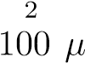
H O, 120 µL 10× NEB T4 DNA ligase buffer (NEB B0202),
L of 10% Triton X-100, 12 µL of 10 mg/mL Bovine Serum Albumin (100× BSA, NEB), 5 µL of 400 U/µL T4 DNA Ligase (NEB M0202), and incubating at room temperature for ≥4 hours with rotation.
Nuclei were then pelleted by centrifugation at 3,500 g for 5 minutes; the pellet was resuspended in 200 µL ChIP Elution Buffer (1% SDS, 0.1 M NaHCO₃), Proteinase K was added, and incubated at 65◦C overnight to reverse crosslinks.
After addition of 600 µL 1×TE buffer, DNA was sonicated using a Qsonica S-4000 with a 1/16” tip for 3 minutes, with 10 second pulses at intensity 3.5, and 20 seconds rest between pulses. DNA was then purified using the MinElute PCR Purificaiton Kit (Qiagen #28006), with elution in a total volume of 300 µL 1× EB buffer.
For streptavidin pulldown of biotin-labeled DNA, 150
µL of 10 mg/mL Dynabeads MyOne Streptavidin T1 beads (Life Technologies, 65602) were separated on a magnetic stand, then washed with 400 µL of 1× TWB (Tween Washing Buffer; 5 mM Tris-HCl pH 7.5; 0.5 mM EDTA; 1 M NaCl; 0.05% Tween 20). The beads were resuspended in 300 µL of 2× Binding Buffer (10 mM Tris-HCl pH 7.5, 1 mM EDTA; 2 M NaCl), the sonicated DNA was added, and the beads were incubated for ≥15 minutes at room temperature on a rotator. After separation on a magnetic stand, the beads were washed with 600 µL of 1× TWB, and heated at 55◦C in a Thermomixer with shaking for 2 minutes. After removal of the supernatant on a magnetic stand, the TWB wash and 55◦C incubation were repeated.
Final libraries were prepared on beads using the NEBNext Ultra II DNA Library Prep Kit (NEB, #E7645) as follows. End repair was carried out by resuspending beads in 50 µL 1× EB buffer, and adding 3 µL NEB Ultra End Repair Enzyme and 7 µL NEB Ultra End Repair Enzyme, followed by incubation at 20◦C for 30 minutes and then at 65◦C for 30 minutes.
Adapters were ligated to DNA fragments by adding 30 µL Blunt Ligation mix, 1 µL Ligation Enhancer and 2.5 µL NEB Adapter, incubating at 20◦C for 20 minutes, adding 3 µL USER enzyme, and incubating at 37◦C for 15 minutes.
Beads were then separated on a magnetic stand, and washed with 600 µL TWB for 2 minutes at 55◦C, 1000 rpm in a Thermomixer. After separation on a magnetic stand, beads were washed in 100 µL 0.1 × TE buffer, then resuspended in 16 µL 0.1 × TE buffer, and heated at 98◦C for 10 minutes.
For PCR, 5 µL of each of the i5 and i7 NEB Next sequencing adapters were added together with 25 µL 2× NEB Ultra PCR Mater Mix. PCR was carried out with a 98◦C incubation for 30 seconds and 12 cycles of 98◦C for 10 seconds, 65◦C for 30 seconds, and 72◦C for 1 minute, followed by incubation at 72◦C for 5 minutes.
Beads were separated on a magnetic stand, and the supernatant was cleaned up using 1× AMPure XP beads.
Libraries were sequenced in a paired-end format on a Illumina NextSeq instrument using NextSeq 500/550 high output kits (either 2×75 or 2×36 cycles).

Hi-C data processing and assembly scaffolding
As an initial step, Hi-C sequencing reads from all libraries were trimmed of adapter sequences, pooled together, and processed against the previously published B. minutum assembly (20) using the Juicer pipeline (38) for analyzing HiC datasets (version 1.8.9 of Juicer Tools).
The resulting Hi-C matrices were then used as input to the 3D DNA pipeline (21) for automated scaffolding with the following parameters: --editor-coarse-resolution 5000 --editor-coarse-region 5000 --polisher-input-size
100000--polisher-coarse-resolution1000
--polisher-coarse-region300000
--splitter-input-size100000 --splitter-coarse-resolution5000
--splitter-coarse-region 300000 --sort-output --build-gapped-map-r 10-i 5000.
Manual correction of obvious assembly and scaffolding errors was then carried out using Juicebox (38).
After finalizing the scaffolding, Hi-C reads were reprocessed against the new assembly using the Juicer pipeline. This was done individually for each library as well as together for the pooled set of reads.
Data was extracted from the final read matrices using the Juicer suite of tools for Hi-C data analysis.

Identification of Hi-C domains
Hi-C matrices were first converted to cool format using HiCExplorer (3) ”hicConvertFormat” with parameters
--inputFormat hic --outputFormat h5 and default resolutions. Subsequent HiCExplorer commands were carried out at 10 kb, 25 kb, and 50 kb resolutions with similar results. Matrices were normalized using ”hicNormalize” with parameter --normalize smallest, and corrected using ”hicCorrectMatrix correct” with parameters
--correctionMethodKR. Hi-C domains were computationally identified using the ”hicFindTADs” from HiCExplorer with parameter --correctForMultipleTestingfdr.

RNA-seq datasets
Approximately 5×10⁷ cells were collected by centrifugation at 100 g for 5 minutes at room temperature. Total RNA was extracted and libraries were constructed for RNA-Seq using the TruSeq RNA Library Prep Kit V2 (Illumina, San Diego, CA, USA) according to the manufacturer protocol. All of the raw sequencing reads are available at Sequence Read Archive (SRA) with accession number SRX7258938.

RNA-seq data analysis
RNA-seq reads were aligned against the corresponding assemblies using the STAR aligner (39) (version 2.5.3a) with the following settings: --limitSjdbInsertNsj
10000000 --outFilterMultimapNmax 50 \verb– outFilterMismatchNmax— 999
--outFilterMismatchNoverReadLmax0.04
--alignIntronMin 10 --alignIntronMax 1000000
--alignMatesGapMax 1000000 --alignSJoverhangMin 8 --alignSJDBoverhangMin 1 --sjdbScore 1
--twopassModeBasic--twopass1readsN-1. As available RNA-seq datasets for B. minutum are not strand-specific, the strand orientation of the transcriptome was visualized as follows. Aligned reads were first de novo assembled into transcripts and quantified at the transcript level using Stringtie (40) (version 1.3.3.b); the orientation of splice junctions serves as a reliable guide for the directionality of these transcripts. Open reading frames (ORFs) were identified for each transcript, and transcripts with ORFs shorter than 60 amino acids were filtered out of the transcript set. Strand-specific genomic tracks were then generated by assigning to each basepair covered by at least one exon in that set the sum of the TPM (Transcript Per Million transcripts) values of all transcripts it is included in.

External Hi-C datasets
Hi-C data for Trypanosoma brucei was obtained from GEO accession GSE118764.
Hi-C data for Schizosaccharomyces pombe was obtained from GEO accession GSE57316.
Hi-C data for Caulobacter vibrioides CB15 was obtained from GEO accession GSE45966.

Sequence Analysis
Topoisomerase and other replication-related proteins were identified in annotated MMETSP transcriptome assemblies using HMMER3.0 (41) and the Pfam 27.0 protein domain database (42) as previously described (16).

Supplementary Tables
Supplementary Table 1: Summary of Hi-C datasets used in this study
Hi-C library | Number raw  read pairs | Estimated library com-  plexity | Number Hi-C  contacts
L142-SSBO1-HIC | 534,609,924 | 920,112,029 | 220,908,462
L533-SSBO1 27C Hi-C | 556,089,015 | 1,513,268,498 | 151,618,419
L534-SSBO1 34C Hi-C | 531,461,453 | 2,971,291,849 | 165,231,965
L1240-SSBO1-α amanitin-0h-Hi-C | 111,333,226 | 233,525,989 | 34,384,671
L1241-SSB01-α amanitin-16h-Hi-C-rep1 | 60,696,609 | 317,650,525 | 24,238,281
L1242-SSB01-α amanitin-16h-Hi-C-rep2 | 67,376,168 | 227,736,960 | 25,551,603
L1243-SSB01-α amanitin-24h-Hi-C-rep1 | 81,532,584 | 235,898,386 | 29,748,439
L1244-SSB01-α amanitin-24h-Hi-C-rep2 | 106,381,220 | 110,607,925 | 28,845,306
L1245-SSB01-α amanitin-48h-Hi-C-rep1 | 90,180,763 | 155,046,434 | 27,045,343
L1246-SSB01-α amanitin-48h-Hi-C-rep2 | 78,982,528 | 152,703,652 | 22,153,117
L1247-SSB01-α amanitin high-48h-Hi-C | 110,015,013 | 157,350,902 | 28,138,017
L1332-SSB01-α amanitin-0h-Hi-C-technical rep | 117,543,007 | 182,213,300 | 34,089,285
L1333-SSB01-α amanitin-48h-Hi-C-rep1-technical rep | 117,821,773 | 82,740,021 | 23,654,760
L1334-SSB01-α amanitin high-48h-Hi-C-technical rep | 95,662,202 | 164,149,035 | 23,944,231
L1336-SSB01-α amanitin high-24h-Hi-C-second time course | 58,747,402 | 103,174,104 | 15,663,160
L1337-SSB01-α amanitin high-48h-Hi-C-second time course | 83,691,617 | 62,658,394 | 14,523,464
L1344-SSB01-α amanitin/triptolide 0h NT-Hi-C | 79,383,186 | 208,157,102 | 23,592,335
L1346-SSB01-triptolide 8h normal dose-Hi-C | 81,731,190 | 193,514,340 | 22,700,096
L1347-SSB01-triptolide 8h high dose-Hi-C | 112,753,865 | 187,235,670 | 28,552,855
L1348-SSB01-Triptolide 24h NT-Hi-C | 52,148,987 | 166,057,825 | 15,674,551
L1349-SSB01-triptolide 24h normal dose-Hi-C | 132,715,807 | 206,778,720 | 36,745,591
L1350-SSB01-triptolide 24h high dose-Hi-C | 98,429,444 | 265,027,975 | 32,121,298
L1351-SSB01-Triptolide 48h NT-Hi-C | 96,846,551 | 240,797,245 | 28,296,251
L1352-SSB01-triptolide 48h normal dose-Hi-C | 85,347,611 | 255,500,603 | 25,051,605
L1353-SSB01-triptolide 48h high dose-Hi-C | 99,978,207 | 215,504,692 | 26,572,806

Supplementary Table 2: Inventory of topoisomerases and some other proteins involved in DNA replication in dinoflagellates and other eukaryotes as annotated by transcriptome assemblies in the MMETSP databses
clade species |  |  |  |  |  | TOP1TOP2TOP3MCM PCNA RPA1 RPA2 RPA3 RFC1
Amoebozoa Stereomyxa ramosa Chinc5 |  | 1 | 2 | 2 | 6 | 2 | 3 | 0 | 2 | 1
Amoebozoa Vexillifera sp. DIVA3 564 2 |  | 1 | 2 | 2 | 7 | 1 | 2 | 0 | 0 | 1
Apicomplexa Lankesteria abbottii Grappler Inlet BC |  | 1 | 1 | 0 | 12 | 5 | 1 | 0 | 0 | 1
Bicosoecid Bicosoecid sp ms1 |  | 1 | 0 | 0 | 3 | 1 | 1 | 1 | 1 | 0
Bicosoecid Cafeteria roenbergensis E4 10 |  | 1 | 0 | 2 | 6 | 1 | 0 | 0 | 1 | 0
Bicosoecid Cafeteria sp. Caron Lab Isolate |  | 1 | 1 | 4 | 15 | 1 | 1 | 0 | 1 | 1
Bolidophyte Bolidomonas pacifica CCMP 1866 |  | 2 | 5 | 7 | 8 | 1 | 1 | 0 | 0 | 1
Chlorarachniophyte Bigelowiella natans CCMP1258.1 |  | 1 | 1 | 9 | 3 | 1 | 4 | 1 | 0 | 0
Chlorarachniophyte Bigelowiella natans CCMP1259 |  | 1 | 1 | 6 | 7 | 1 | 4 | 1 | 0 | 1
Chlorarachniophyte Bigelowiella natans CCMP 2755 |  | 0 | 0 | 4 | 5 | 1 | 4 | 1 | 0 | 1
Chlorarachniophyte Bigelowiella natans CCMP623 |  | 1 | 3 | 7 | 9 | 1 | 2 | 1 | 0 | 1
Chlorarachniophyte Chlorarachnion reptans CCCM449 |  | 2 | 4 | 8 | 11 | 2 | 3 | 1 | 0 | 1
Chlorarachniophyte Lotharella amoebiformis CCMP2058 |  | 2 | 6 | 5 | 10 | 1 | 4 | 1 | 0 | 1
Chlorarachniophyte Lotharella globosa CCCM811 |  | 1 | 2 | 1 | 0 | 1 | 1 | 1 | 1 | 1
Chlorarachniophyte Lotharella oceanica CCMP622 |  | 1 | 0 | 0 | 1 | 1 | 2 | 1 | 1 | 1
Chlorarachniophyte Norrisiella sphaerica BC52 |  | 1 | 0 | 3 | 0 | 1 | 2 | 1 | 1 | 0
Chlorarachniophyte Partenskyella glossopodia RCC365 |  | 1 | 2 | 1 | 7 | 1 | 3 | 1 | 2 | 1
Chlorophyte | Bathycoccus prasinos CCMP1898 | 1 | 2 | 3 | 9 | 1 | 2 | 0 | 0 | 0
Chlorophyte | Bathycoccus prasinos RCC716 | 1 | 2 | 3 | 7 | 1 | 3 | 0 | 0 | 1
Chlorophyte | Chlamydomonas cf sp CCMP681 | 1 | 0 | 0 | 5 | 2 | 1 | 0 | 0 | 1
Chlorophyte | Crustomastix stigmata CCMP3273 | 1 | 2 | 4 | 10 | 1 | 1 | 1 | 0 | 1
Chlorophyte | Cyanoptyche gloeocystis SAG4.97 | 1 | 0 | 0 | 4 | 1 | 1 | 1 | 0 | 0
Chlorophyte | Dolichomastix tenuilepis CCMP3274 | 1 | 1 | 3 | 1 | 2 | 1 | 0 | 1 | 1
Chlorophyte | Dunaliella tertiolecta CCMP1320 | 1 | 2 | 3 | 10 | 1 | 2 | 0 | 1 | 1
Chlorophyte | Mantoniella antarctica SL 175 | 1 | 8 | 4 | 13 | 1 | 2 | 2 | 1 | 1
Chlorophyte | Mantoniella sp CCMP1436 | 1 | 2 | 1 | 2 | 1 | 1 | 1 | 1 | 1
Chlorophyte | Micromonas sp CCMP2099 | 1 | 2 | 2 | 9 | 1 | 2 | 0 | 1 | 1
Chlorophyte | Micromonas sp NEPCC29 | 1 | 2 | 3 | 7 | 1 | 2 | 0 | 1 | 1
Chlorophyte | Micromonas sp RCC472 | 1 | 2 | 2 | 7 | 1 | 2 | 1 | 0 | 1
Chlorophyte | Nephroselmis pyriformis CCMP717 | 1 | 4 | 8 | 10 | 1 | 2 | 0 | 1 | 1
Chlorophyte | Picochlorum oklahomensis CCMP2329 | 1 | 2 | 2 | 6 | 2 | 2 | 1 | 0 | 1
Chlorophyte | Picochlorum sp. RCC944 | 1 | 1 | 2 | 6 | 1 | 2 | 0 | 2 | 1
Chlorophyte | Picocystis salinarum CCMP1897 | 1 | 2 | 1 | 8 | 2 | 2 | 1 | 2 | 1
Chlorophyte | Polytomella parva SAG 63 3 | 1 | 5 | 3 | 18 | 2 | 3 | 0 | 0 | 1
Chlorophyte | Prasinoderma coloniale CCMP1413 | 1 | 2 | 0 | 2 | 1 | 1 | 0 | 0 | 0
Chlorophyte | Prasinoderma singularis RCC927 | 1 | 1 | 1 | 7 | 1 | 1 | 0 | 1 | 1
Chlorophyte | Pterosperma sp. CCMP1384 | 1 | 0 | 0 | 3 | 1 | 1 | 1 | 1 | 1
Chlorophyte | Pycnococcus provasolii RCC2336 | 1 | 1 | 0 | 9 | 1 | 1 | 0 | 0 | 1
Chlorophyte | Pycnococcus provasolii RCC931 | 1 | 0 | 0 | 7 | 1 | 1 | 0 | 0 | 1
Chlorophyte | Pyramimonas parkeae CCMP726 | 1 | 0 | 4 | 7 | 1 | 2 | 1 | 1 | 1
Chlorophyte | Stichococcus sp RCC1054 | 1 | 1 | 1 | 8 | 1 | 1 | 0 | 0 | 1
Chlorophyte | Tetraselmis chuii PLY429 | 2 | 0 | 0 | 0 | 0 | 2 | 0 | 1 | 2
Chlorophyte | Tetraselmis striata LANL1001 | 1 | 4 | 4 | 11 | 1 | 2 | 0 | 1 | 1
Choanoflagellata | Acanthoeca like sp 10tr | 1 | 3 | 4 | 10 | 1 | 1 | 0 | 1 | 1
Chromerida | Chromera velia CCMP2878 | 1 | 1 | 3 | 10 | 2 | 2 | 0 | 0 | 1
Chromerida | Vitrella brassicaformis CCMP3346 | 1 | 1 | 2 | 9 | 2 | 1 | 0 | 0 | 1
Chrysophyte | Chromulina nebulosa UTEXLB2642 | 1 | 1 | 1 | 2 | 1 | 1 | 0 | 0 | 1
Chrysophyte | Dinobryon sp UTEXLB2267 | 1 | 3 | 0 | 8 | 1 | 1 | 0 | 0 | 1
Chrysophyte | Mallomonas Sp CCMP3275 | 1 | 2 | 1 | 9 | 1 | 1 | 0 | 1 | 1
Chrysophyte | Ochromonas sp CCMP1393 | 1 | 2 | 2 | 7 | 1 | 1 | 0 | 0 | 1
Chrysophyte | Paraphysomonas bandaiensis Caron Lab Isolate | 1 | 2 | 3 | 9 | 2 | 1 | 1 | 1 | 1
Chrysophyte | Paraphysomonas imperforata PA2 | 0 | 1 | 3 | 6 | 1 | 1 | 1 | 1 | 1
Chrysophyte | Pelagococcus subviridis CCMP1429 | 1 | 1 | 2 | 11 | 1 | 0 | 0 | 0 | 1
Chrysophyte | Spumella elongata CCAP 955 1 | 1 | 1 | 3 | 10 | 4 | 3 | 0 | 1 | 1
Ciliate | Aristerostoma sp. ATCC 50986 | 2 | 1 | 1 | 0 | 2 | 1 | 0 | 0 | 2
Ciliate | Blepharisma japonicum Stock R1072 | 0 | 0 | 0 | 7 | 4 | 1 | 0 | 0 | 0
Ciliate | Climacostomum virens Stock W 24 | 1 | 2 | 2 | 9 | 3 | 1 | 0 | 0 | 3

clade | species |  |  |  |  | TOP1TOP2TOP3MCM PCNA RPA1 RPA2 RPA3 RFC1
Ciliate | Condylostoma magnum COL2 | 0 | 0 | 0 | 2 | 0 | 0 | 0 | 0 | 0
Ciliate | Euplotes focardii TN1 | 1 | 0 | 0 | 5 | 2 | 1 | 0 | 2 | 0
Ciliate | Euplotes harpa FSP1.4 | 2 | 0 | 5 | 3 | 1 | 0 | 0 | 1 | 0
Ciliate | Fabrea salina Unknown | 1 | 1 | 3 | 7 | 2 | 3 | 0 | 0 | 2
Ciliate | Favella taraikaensis FeNarragansettBay | 0 | 1 | 2 | 7 | 3 | 0 | 0 | 0 | 0
Ciliate | Litonotus pictus P1 | 1 | 1 | 2 | 0 | 0 | 0 | 0 | 0 | 0
Ciliate | Mesodinium pulex SPMC105 | 2 | 13 | 2 | 16 | 9 | 4 | 0 | 0 | 6
Ciliate | Myrionecta rubra CCMP2563 | 0 | 1 | 4 | 11 | 1 | 1 | 0 | 1 | 0
Ciliate | Platyophrya macrostoma WH | 4 | 4 | 4 | 23 | 4 | 6 | 0 | 0 | 3
Ciliate | Protocruzia adherens Boccale | 3 | 1 | 0 | 9 | 3 | 3 | 0 | 0 | 1
Ciliate | Pseudokeronopsis sp. OXSARD2 | 1 | 1 | 1 | 6 | 1 | 0 | 0 | 1 | 1
Ciliate | Strombidinopsis acuminatum SPMC142 | 2 | 6 | 0 | 32 | 10 | 5 | 0 | 0 | 0
Ciliate | Strombidinopsis sp. SopsisLIS2011 | 1 | 0 | 0 | 8 | 3 | 2 | 0 | 0 | 0
Ciliate | Strombidium inclinatum S3 | 1 | 1 | 2 | 8 | 1 | 1 | 0 | 0 | 1
Ciliate | Strombidium rassoulzadegani ras09 | 1 | 0 | 1 | 6 | 1 | 1 | 0 | 1 | 0
Ciliate | Tiarina fusus LIS | 1 | 7 | 3 | 16 | 3 | 4 | 2 | 1 | 1
Cryptophyte | Chroomonas mesostigmatica cf CCMP1168 | 1 | 5 | 4 | 8 | 1 | 2 | 2 | 0 | 1
Cryptophyte | Cryptomonas curvata CCAP979 52 | 2 | 0 | 2 | 0 | 1 | 1 | 0 | 1 | 0
Cryptophyte | Cryptomonas paramecium CCAP977 2a | 3 | 2 | 2 | 5 | 1 | 1 | 0 | 0 | 1
Cryptophyte | Geminigera cryophila CCMP2564 | 2 | 1 | 5 | 11 | 1 | 2 | 0 | 1 | 2
Cryptophyte | Geminigera sp. Caron Lab Isolate | 1 | 3 | 5 | 18 | 1 | 5 | 0 | 1 | 1
Cryptophyte | Goniomonas pacifica CCMP1869 | 8 | 4 | 4 | 12 | 1 | 5 | 1 | 3 | 7
Cryptophyte | Guillardia theta CCMP 2712 | 1 | 0 | 2 | 3 | 1 | 1 | 0 | 1 | 0
Cryptophyte | Hemiselmis andersenii CCMP644 | 1 | 2 | 5 | 12 | 1 | 2 | 0 | 1 | 1
Cryptophyte | Hemiselmis rufescens PCC563 | 1 | 0 | 3 | 7 | 1 | 1 | 1 | 1 | 1
Cryptophyte | Hemiselmis tepida CCMP443 | 3 | 2 | 0 | 3 | 1 | 1 | 1 | 1 | 1
Cryptophyte | Hemiselmis viresens PCC157 | 1 | 0 | 0 | 7 | 1 | 1 | 0 | 1 | 0
Cryptophyte | Palpitomonas bilix NIES 2562 | 0 | 1 | 2 | 13 | 4 | 3 | 0 | 1 | 3
Cryptophyte | Proteomonas sulcata CCMP704 | 0 | 1 | 0 | 3 | 1 | 1 | 0 | 0 | 1
Cryptophyte | Rhodomonas lens RHODO | 2 | 3 | 2 | 2 | 2 | 2 | 0 | 1 | 0
Cryptophyte | Rhodomonas sp. CCMP768 | 1 | 0 | 1 | 0 | 1 | 1 | 0 | 0 | 0
Diatome | Amphiprora sp. | 1 | 4 | 3 | 9 | 1 | 1 | 0 | 0 | 1
Diatome | Amphora coffeaeformis CCMP127 | 1 | 1 | 0 | 4 | 1 | 1 | 0 | 0 | 0
Diatome | Asterionellopsis glacialis CCMP134 | 1 | 7 | 1 | 10 | 1 | 1 | 0 | 0 | 1
Diatome | Astrosyne radiata 13vi08 1A | 1 | 8 | 3 | 6 | 3 | 2 | 0 | 0 | 1
Diatome | Attheya septentrionalis CCMP2084 | 1 | 2 | 0 | 9 | 1 | 1 | 0 | 0 | 1
Diatome | Aulacoseira subarctica CCAP 1002 5 | 1 | 2 | 3 | 8 | 2 | 1 | 0 | 0 | 1
Diatome | Chaetoceros affinis CCMP159 | 1 | 3 | 1 | 8 | 1 | 1 | 0 | 0 | 1
Diatome | Chaetoceros curvisetus | 1 | 4 | 4 | 6 | 1 | 3 | 0 | 0 | 1
Diatome | Chaetoceros debilis MM31A 1 | 1 | 3 | 1 | 12 | 1 | 1 | 0 | 0 | 1
Diatome | Chaetoceros neogracile CCMP1317 | 1 | 9 | 3 | 10 | 1 | 1 | 0 | 1 | 1
Diatome | Coscinodiscus wailesii CCMP2513 | 1 | 3 | 6 | 10 | 1 | 1 | 0 | 1 | 1
Diatome | Craspedostauros australis CCMP3328 | 1 | 0 | 0 | 4 | 0 | 1 | 0 | 0 | 0
Diatome | Cyclophora tenuis ECT3854 | 1 | 1 | 0 | 3 | 1 | 1 | 0 | 0 | 0
Diatome | Cyclotella meneghiniana CCMP 338 | 1 | 4 | 3 | 8 | 1 | 1 | 0 | 0 | 1
Diatome | Cylindrotheca closterium KMMCC:B 181 | 3 | 7 | 3 | 14 | 1 | 2 | 0 | 0 | 1
Diatome | Dactyliosolen fragilissimus Unknown | 1 | 3 | 3 | 8 | 1 | 1 | 0 | 1 | 1
Diatome | Ditylum brightwellii GSO103 | 1 | 4 | 3 | 11 | 1 | 1 | 0 | 1 | 1
Diatome | Ditylum brightwellii GSO104 | 1 | 4 | 5 | 10 | 1 | 1 | 0 | 1 | 1
Diatome | Ditylum brightwellii GSO105 | 1 | 2 | 3 | 11 | 2 | 1 | 0 | 1 | 1
Diatome | Entomoneis sp. CCMP2396 | 0 | 1 | 0 | 0 | 1 | 1 | 0 | 0 | 0
Diatome | Eucampia antarctica CCMP1452 | 1 | 3 | 0 | 5 | 1 | 1 | 1 | 1 | 1
Diatome | Extubocellulus spinifer CCMP396 | 1 | 4 | 10 | 13 | 2 | 5 | 3 | 1 | 2
Diatome | Fragilariopsis kerguelensis L2 C3 | 1 | 3 | 3 | 11 | 1 | 1 | 2 | 0 | 1
Diatome | Fragilariopsis kerguelensis L26 C5 | 1 | 3 | 5 | 22 | 1 | 1 | 3 | 0 | 1
Diatome | Grammatophora oceanica CCMP 410 | 1 | 1 | 3 | 5 | 1 | 1 | 0 | 0 | 1
Diatome | Helicotheca tamensis CCMP826 | 0 | 1 | 0 | 1 | 1 | 1 | 0 | 1 | 0
Diatome | Leptocylindrus danicus var. apora B651 | 3 | 5 | 3 | 0 | 3 | 2 | 0 | 1 | 1
Diatome | Leptocylindrus danicus var. danicus B650 | 3 | 11 | 3 | 19 | 1 | 1 | 0 | 1 | 2

clade | species |  |  |  |  | TOP1TOP2TOP3MCM PCNA RPA1 RPA2 RPA3 RFC1
Diatome | Licmophora paradoxa CCMP2313 | 1 | 1 | 3 | 7 | 1 | 2 | 0 | 0 | 1
Diatome | Minutocellus polymorphus CCMP3303 | 0 | 0 | 0 | 3 | 1 | 1 | 1 | 1 | 0
Diatome | Minutocellus polymorphus NH13 | 2 | 8 | 7 | 21 | 1 | 0 | 1 | 0 | 3
Diatome | Minutocellus polymorphus RCC2270 | 1 | 2 | 1 | 7 | 1 | 1 | 1 | 1 | 1
Diatome | Nitzschia punctata CCMP561 | 1 | 2 | 2 | 9 | 1 | 1 | 1 | 1 | 1
Diatome | Odontella aurita isolate 1302 5 | 1 | 3 | 7 | 11 | 2 | 2 | 1 | 1 | 1
Diatome | Odontella sinensis Grunow 1884 | 1 | 3 | 0 | 2 | 1 | 1 | 1 | 1 | 1
Diatome | Proboscia alata PI D3 | 1 | 7 | 2 | 21 | 1 | 1 | 2 | 0 | 1
Diatome | Pseudo-nitzschia australis 10249 10 AB | 1 | 3 | 4 | 8 | 1 | 1 | 1 | 0 | 1
Diatome | Pseudo-nitzschia fradulenta WWA7 | 2 | 11 | 6 | 24 | 4 | 5 | 0 | 0 | 3
Diatome | Rhizosolenia setigera CCMP 1694 | 1 | 7 | 4 | 18 | 1 | 2 | 0 | 0 | 2
Diatome | Skeletonema dohrnii SkelB | 1 | 2 | 0 | 14 | 1 | 1 | 2 | 1 | 1
Diatome | Skeletonema marinoi SkelA | 1 | 1 | 2 | 7 | 1 | 1 | 2 | 0 | 1
Diatome | Skeletonema menzelii CCMP793 | 1 | 4 | 4 | 8 | 1 | 1 | 2 | 0 | 1
Diatome | Stauroneis constricta CCMP1120 | 1 | 0 | 1 | 1 | 1 | 1 | 1 | 0 | 0
Diatome | Staurosira complex sp. CCMP2646 | 1 | 3 | 4 | 8 | 1 | 1 | 0 | 1 | 1
Diatome | Stephanopyxis turris CCMP 815 | 2 | 0 | 1 | 7 | 3 | 2 | 0 | 1 | 1
Diatome | Striatella unipunctata CCMP2910 | 4 | 2 | 1 | 6 | 3 | 0 | 1 | 0 | 2
Diatome | Synedropsis recta cf CCMP1620 | 1 | 2 | 0 | 1 | 1 | 1 | 1 | 1 | 0
Diatome | Thalassionema frauenfeldii CCMP 1798 | 1 | 5 | 7 | 15 | 1 | 3 | 1 | 1 | 2
Diatome | Thalassionema nitzschioides L26 B | 1 | 3 | 4 | 8 | 1 | 1 | 1 | 1 | 1
Diatome | Thalassiosira antarctica CCMP982 | 1 | 4 | 2 | 12 | 1 | 1 | 3 | 1 | 1
Diatome | Thalassiosira gravida GMp14c1 | 1 | 1 | 3 | 13 | 1 | 1 | 2 | 1 | 1
Diatome | Thalassiosira miniscula CCMP1093 | 1 | 13 | 6 | 10 | 1 | 1 | 2 | 1 | 1
Diatome | Thalassiosira oceanica CCMP1005 | 1 | 10 | 1 | 10 | 1 | 1 | 0 | 0 | 1
Diatome | Thalassiosira rotula CCMP3096 | 1 | 5 | 3 | 11 | 1 | 1 | 2 | 1 | 1
Diatome | Thalassiosira rotula GSO102 | 1 | 3 | 2 | 11 | 1 | 1 | 1 | 1 | 1
Diatome | Thalassiosira weissflogii CCMP1010 | 1 | 4 | 1 | 9 | 1 | 0 | 1 | 0 | 1
Diatome | Thalassiosira weissflogii CCMP1336 | 1 | 4 | 1 | 8 | 1 | 0 | 1 | 0 | 1
Diatome | Thalassiothrix antarctica L6 D1 | 1 | 2 | 4 | 6 | 1 | 1 | 0 | 1 | 1
Diatome | Triceratium dubium CCMP147 | 0 | 1 | 1 | 1 | 1 | 0 | 1 | 1 | 0
Dinoflagellata | Alexandrium temarense CCMP1771 | 3 | 18 | 12 | 45 | 18 | 10 | 3 | 4 | 2
Dinoflagellata | Amphidinium carterae CCMP1314 | 2 | 5 | 5 | 8 | 2 | 4 | 0 | 0 | 3
Dinoflagellata | Azadinium spinosum 3D9 | 1 | 12 | 13 | 35 | 11 | 6 | 0 | 0 | 3
Dinoflagellata | Brandtodinium nutriculum RCC3387 | 1 | 13 | 9 | 30 | 21 | 4 | 0 | 0 | 3
Dinoflagellata | Ceratium fusus PA161109 | 1 | 15 | 10 | 18 | 12 | 9 | 1 | 1 | 3
Dinoflagellata | Crypthecodinium cohnii Seligo | 1 | 6 | 5 | 15 | 2 | 4 | 0 | 0 | 3
Dinoflagellata | Dinophysis acuminata DAEP01 | 4 | 15 | 9 | 29 | 13 | 8 | 0 | 0 | 2
Dinoflagellata | Durinskia baltica CSIRO CS 38 | 2 | 12 | 9 | 18 | 9 | 8 | 0 | 0 | 4
Dinoflagellata | Gambierdiscus australes CAWD 149 | 1 | 5 | 0 | 9 | 14 | 6 | 0 | 0 | 2
Dinoflagellata | Glenodinium foliaceum CCAP1116 3 | 2 | 9 | 3 | 23 | 7 | 6 | 0 | 1 | 4
Dinoflagellata | Gonyaulax spinifera CCMP409 | 1 | 2 | 0 | 10 | 10 | 8 | 1 | 1 | 1
Dinoflagellata | Heterocapsa rotundata SCCAP K 0483 | 2 | 19 | 4 | 12 | 6 | 4 | 0 | 0 | 6
Dinoflagellata | Heterocapsa triquestra CCMP 448 | 1 | 8 | 5 | 13 | 5 | 4 | 0 | 0 | 3
Dinoflagellata | Karenia brevis CCMP2229 | 1 | 14 | 8 | 10 | 8 | 7 | 0 | 1 | 4
Dinoflagellata | Karenia brevis SP1 | 1 | 14 | 13 | 16 | 6 | 8 | 0 | 1 | 4
Dinoflagellata | Karenia brevis SP3 | 1 | 12 | 9 | 13 | 8 | 10 | 0 | 1 | 4
Dinoflagellata | Karenia brevis Wilson | 1 | 14 | 7 | 14 | 9 | 8 | 0 | 2 | 5
Dinoflagellata | Karlodinium micrum CCMP2283 | 2 | 9 | 7 | 46 | 13 | 31 | 2 | 0 | 5
Dinoflagellata | Kryptoperidinium foliaceum CCMP1326 | 4 | 14 | 11 | 64 | 16 | 10 | 1 | 0 | 7
Dinoflagellata | Lingulodinium polyedra CCMP1738 | 1 | 17 | 8 | 19 | 11 | 11 | 1 | 0 | 3
Dinoflagellata | Noctiluca scintillans Unknown | 1 | 7 | 3 | 9 | 1 | 6 | 0 | 1 | 1
Dinoflagellata | Oxyrrhis marina | 1 | 2 | 5 | 9 | 7 | 3 | 0 | 1 | 2
Dinoflagellata | Oxyrrhis marina CCMP1795 | 0 | 0 | 0 | 0 | 3 | 0 | 0 | 0 | 0
Dinoflagellata | Oxyrrhis marina LB1974 | 1 | 2 | 4 | 10 | 4 | 2 | 0 | 0 | 2
Dinoflagellata | Pelagodinium beii RCC1491 | 1 | 8 | 2 | 12 | 11 | 4 | 0 | 0 | 4
Dinoflagellata | Peridinium aciculiferum PAER 2 | 1 | 7 | 5 | 11 | 6 | 5 | 0 | 0 | 3
Dinoflagellata | Polarella glacialis CCMP 1383 | 1 | 28 | 5 | 23 | 5 | 5 | 0 | 0 | 8
Dinoflagellata | Prorocentrum minimum CCMP1329 | 1 | 15 | 6 | 29 | 13 | 6 | 0 | 0 | 3

clade | species |  |  |  |  | TOP1TOP2TOP3MCM PCNA RPA1 RPA2 RPA3 RFC1
Dinoflagellata | Prorocentrum minimum CCMP2233 | 1 | 14 | 4 | 29 | 12 | 5 | 0 | 0 | 3
Dinoflagellata | Protoceratium reticulatum CCCM 535 CCMP  1889 | 2 | 20 | 9 | 18 | 11 | 10 | 0 | 0 | 2
Dinoflagellata | Pyrodinium bahamense pbaha01 | 1 | 21 | 8 | 29 | 19 | 11 | 0 | 0 | 3
Dinoflagellata | Scrippsiella hangoei like SHHI 4 | 1 | 8 | 6 | 22 | 6 | 16 | 0 | 2 | 2
Dinoflagellata | Scrippsiella hangoei SHTV5 | 1 | 8 | 11 | 14 | 3 | 5 | 0 | 0 | 2
Dinoflagellata | Scrippsiella trochoidea CCMP3099 | 1 | 27 | 10 | 38 | 12 | 8 | 1 | 1 | 3
Dinoflagellata | Symbiodinium kawagutii CCMP2468 | 0 | 0 | 0 | 0 | 2 | 0 | 0 | 0 | 0
Dinoflagellata | Symbiodinium sp. C1 | 1 | 9 | 4 | 9 | 6 | 4 | 0 | 0 | 3
Dinoflagellata | Symbiodinium sp. C15 | 1 | 7 | 2 | 12 | 3 | 4 | 1 | 0 | 3
Dinoflagellata | Symbiodinium sp. CCMP2430 | 1 | 7 | 2 | 10 | 7 | 4 | 0 | 0 | 3
Dinoflagellata | Symbiodinium sp. Mp | 1 | 7 | 3 | 13 | 6 | 3 | 0 | 0 | 3
Dinoflagellata | Togula jolla CCCM 725 | 1 | 17 | 3 | 21 | 3 | 6 | 0 | 0 | 4
Discosea | Mayorella sp. BSH 02190019 | 1 | 3 | 2 | 5 | 1 | 1 | 0 | 1 | 1
Discosea | Neoparamoeba aestuarina SoJaBio B1 5 56 2 | 3 | 3 | 3 | 12 | 3 | 3 | 0 | 1 | 1
Discosea | Paramoeba atlantica 621 1 CCAP 1560 9 | 1 | 3 | 2 | 8 | 3 | 2 | 0 | 1 | 1
Discosea | Pessonella sp. PRA 29 | 1 | 1 | 3 | 0 | 1 | 5 | 0 | 2 | 3
Discosea | Stygamoeba regulata BSH 02190019 | 3 | 8 | 2 | 7 | 2 | 4 | 0 | 0 | 2
Discosea | Trichosphaerium sp. Am I 7 wt | 2 | 0 | 0 | 1 | 2 | 3 | 0 | 0 | 2
Eugelnophyta | Eutreptiella gymnastica like CCMP1594 | 1 | 1 | 1 | 5 | 2 | 1 | 0 | 1 | 1
Foraminifera | Ammonia sp. Unknown | 1 | 1 | 3 | 9 | 5 | 2 | 0 | 1 | 1
Foraminifera | Elphidium margaritaceum Unknown | 1 | 1 | 2 | 8 | 3 | 1 | 1 | 0 | 1
Foraminifera | Rosalina sp. Unknown | 1 | 0 | 0 | 9 | 5 | 0 | 2 | 0 | 1
Foraminifera | Sorites sp. Unknown | 3 | 3 | 0 | 27 | 12 | 3 | 0 | 0 | 2
Fungi | Debaryomyces hansenii J26 | 1 | 0 | 0 | 4 | 0 | 0 | 0 | 0 | 1
Glaucophyte | Gloeochaete witrockiana SAG46 84 | 2 | 2 | 3 | 9 | 2 | 2 | 1 | 1 | 1
Haptophyte | Calcidiscus leptoporus RCC1130 | 1 | 3 | 0 | 7 | 1 | 1 | 1 | 0 | 1
Haptophyte | Chrysochromulina brevifilum UTEX LB 985 | 1 | 2 | 1 | 4 | 1 | 3 | 0 | 1 | 0
Haptophyte | Chrysochromulina ericina CCMP281 | 2 | 1 | 0 | 10 | 1 | 3 | 1 | 1 | 2
Haptophyte | Chrysochromulina polylepis CCMP1757 | 1 | 3 | 5 | 9 | 1 | 2 | 1 | 1 | 1
Haptophyte | Chrysoculter rhomboideus RCC1486 | 1 | 0 | 0 | 9 | 1 | 0 | 0 | 1 | 0
Haptophyte | Coccolithus pelagicus ssp braarudi PLY182g | 1 | 3 | 0 | 7 | 1 | 2 | 1 | 1 | 0
Haptophyte | Emiliania huxleyi 374 | 1 | 2 | 1 | 9 | 1 | 1 | 0 | 0 | 0
Haptophyte | Emiliania huxleyi 379 | 1 | 1 | 1 | 0 | 0 | 2 | 0 | 0 | 0
Haptophyte | Emiliania huxleyi CCMP370 | 1 | 3 | 5 | 9 | 0 | 2 | 1 | 1 | 1
Haptophyte | Emiliania huxleyi PLYM219 | 1 | 3 | 4 | 10 | 0 | 2 | 1 | 1 | 1
Haptophyte | Exanthemachrysis gayraliae RCC1523 | 1 | 2 | 0 | 1 | 1 | 1 | 0 | 1 | 1
Haptophyte | Gephyrocapsa oceanica RCC1303 | 1 | 3 | 5 | 11 | 1 | 1 | 0 | 0 | 1
Haptophyte | Imantonia sp. RCC918 | 3 | 1 | 1 | 4 | 2 | 1 | 1 | 1 | 0
Haptophyte | Isochrysis galbana CCMP1323 | 2 | 5 | 6 | 13 | 2 | 3 | 1 | 0 | 2
Haptophyte | Isochrysis sp. CCMP1244 | 1 | 2 | 5 | 11 | 1 | 1 | 0 | 1 | 1
Haptophyte | Isochrysis sp. CCMP1324 | 1 | 2 | 0 | 12 | 1 | 2 | 1 | 0 | 1
Haptophyte | Pavlova sp. CCMP459 | 1 | 2 | 1 | 6 | 2 | 1 | 2 | 1 | 1
Haptophyte | Phaeocystis antarctica Caron Lab Isolate | 3 | 7 | 2 | 12 | 1 | 3 | 2 | 0 | 2
Haptophyte | Phaeocystis sp. CCMP2710 | 1 | 0 | 1 | 2 | 1 | 1 | 1 | 1 | 1
Haptophyte | Pleurochrysis carterae CCMP645 | 3 | 2 | 1 | 7 | 1 | 2 | 1 | 1 | 1
Haptophyte | Prymnesium parvum Texoma1 | 1 | 6 | 4 | 1 | 1 | 2 | 1 | 1 | 1
Haptophyte | Scyphosphaera apsteinii RCC1455 | 1 | 3 | 1 | 7 | 1 | 2 | 1 | 0 | 1
Heterolobosea | Percolomonas cosmopolitus AE 1 ATCC 50343 | 1 | 4 | 2 | 9 | 2 | 2 | 0 | 0 | 1
Heterolobosea | Percolomonas cosmopolitus WS | 1 | 3 | 1 | 12 | 1 | 2 | 0 | 0 | 3
Khakista | Corethron pennatum L29A3 | 2 | 5 | 5 | 16 | 1 | 1 | 1 | 0 | 1
Khakista | Detonula confervacea CCMP 353 | 1 | 3 | 2 | 9 | 1 | 1 | 2 | 1 | 1
Kinetoplastida | Neobodo designis CCAP 1951 1 | 1 | 1 | 4 | 8 | 1 | 1 | 0 | 0 | 1
Labyrinthulida | Aplanochytrium sp. PBS07 | 1 | 2 | 1 | 3 | 1 | 1 | 1 | 2 | 1
Labyrinthulida | Aplanochytrium stocchinoi GSBS06 | 1 | 2 | 0 | 7 | 1 | 1 | 1 | 1 | 1
Pelagophyte | Aureococcus anophagefferens CCMP1850 | 6 | 2 | 3 | 45 | 1 | 2 | 0 | 0 | 1
Pelagophyte | Aureoumbra lagunensis CCMP1510 | 1 | 2 | 2 | 9 | 1 | 2 | 1 | 0 | 1
Pelagophyte | Chrysocystis fragilis CCMP3189 | 2 | 0 | 2 | 6 | 1 | 1 | 1 | 0 | 1
Pelagophyte | Chrysoreinhardia sp. CCMP2950 | 1 | 2 | 1 | 5 | 0 | 1 | 0 | 0 | 1

clade | species |  |  |  |  | TOP1TOP2TOP3MCM PCNA RPA1 RPA2 RPA3 RFC1
Pelagophyte | Chrysoreinhardia sp. CCMP3193 | 1 | 3 | 2 | 10 | 1 | 2 | 1 | 0 | 1
Pelagophyte | Pelagomonas calceolata CCMP1756 | 1 | 2 | 1 | 9 | 1 | 1 | 2 | 0 | 1
Pelagophyte | Sarcinochrysis sp. CCMP770 | 0 | 0 | 0 | 2 | 1 | 1 | 1 | 1 | 0
Perkinsid | Perkinsus chesapeaki ATCC PRA 65 | 2 | 0 | 0 | 0 | 0 | 0 | 0 | 0 | 0
Perkinsid | Perkinsus marinus ATCC50439 | 1 | 0 | 0 | 1 | 2 | 0 | 0 | 0 | 0
Pinguiophyte | Phaeomonas parva CCMP2877 | 1 | 3 | 1 | 5 | 3 | 1 | 0 | 1 | 0
Pinguiophyte | Pinguiococcus pyrenoidosus CCMP2078 | 1 | 2 | 3 | 0 | 1 | 1 | 0 | 1 | 0
Raphidophyte | Chattonella subsalsa CCMP2191 | 1 | 3 | 0 | 5 | 1 | 1 | 1 | 0 | 1
Raphidophyte | Fibrocapsa japonica CCMP1661 | 0 | 1 | 1 | 5 | 1 | 1 | 0 | 1 | 0
Raphidophyte | Heterosigma akashiwo CCMP2393 | 1 | 4 | 2 | 11 | 2 | 1 | 0 | 1 | 1
Raphidophyte | Heterosigma akashiwo CCMP3107 | 1 | 7 | 2 | 0 | 1 | 1 | 0 | 0 | 0
Raphidophyte | Heterosigma akashiwo CCMP452 | 0 | 1 | 0 | 4 | 1 | 1 | 0 | 0 | 0
Raphidophyte | Heterosigma akashiwo NB | 1 | 6 | 1 | 8 | 1 | 1 | 0 | 1 | 1
Rhodophyte | Compsopogon coeruleus SAG 36.94 | 1 | 3 | 2 | 11 | 1 | 1 | 0 | 0 | 1
Rhodophyte | Erythrolobus australicus CCMP3124 | 1 | 2 | 3 | 0 | 1 | 1 | 0 | 1 | 1
Rhodophyte | Erythrolobus madagascarensis CCMP3276 | 1 | 1 | 1 | 3 | 1 | 2 | 0 | 1 | 0
Rhodophyte | Madagascaria erythrocladiodes CCMP3234 | 3 | 4 | 5 | 12 | 1 | 2 | 0 | 1 | 2
Rhodophyte | Porphyridium aerugineum SAG 1380 2 | 2 | 1 | 2 | 5 | 1 | 2 | 1 | 0 | 1
Rhodophyte | Rhodella maculata CCMP736 | 1 | 3 | 3 | 12 | 1 | 1 | 0 | 0 | 1
Rhodophyte | Rhodosorus marinus CCMP 769 | 1 | 8 | 6 | 17 | 0 | 3 | 0 | 0 | 2
Rhodophyte | Timspurckia oligopyrenoides CCMP3278 | 1 | 2 | 4 | 6 | 1 | 2 | 1 | 1 | 1
Silicoflagellates | Dictyocha speculum CCMP1381 | 1 | 4 | 2 | 9 | 1 | 2 | 1 | 1 | 1
Silicoflagellates | Pseudopedinella elastica CCMP716 | 1 | 5 | 6 | 9 | 1 | 1 | 1 | 1 | 1
Silicoflagellates | Pteridomonas danica PT | 1 | 1 | 1 | 2 | 1 | 1 | 1 | 1 | 0
Silicoflagellates | Rhizochromulina marina cf CCMP1243 | 1 | 5 | 2 | 8 | 2 | 2 | 1 | 1 | 1
Synchromophyceae Synchroma pusillum CCMP3072 |  | 1 | 0 | 1 | 3 | 3 | 1 | 0 | 1 | 1
Syndinian Amoebophrya sp. Ameob2 |  | 2 | 8 | 1 | 13 | 0 | 1 | 0 | 0 | 0
Thraustochytrid Aurantiochytrium limacinum ATCCMYA1381 |  | 1 | 3 | 2 | 9 | 1 | 1 | 0 | 1 | 1
Thraustochytrid Schizochytrium aggregatum ATCC28209 |  | 1 | 1 | 1 | 4 | 1 | 1 | 0 | 0 | 1
Thraustochytrid Thraustochytrium sp. LLF1b |  | 1 | 2 | 1 | 9 | 1 | 1 | 0 | 1 | 1
Tubulinid Filamoeba nolandi NC AS 23 1 |  | 2 | 4 | 1 | 13 | 0 | 3 | 1 | 0 | 1
Tubulinid Sexangularia sp. ATCC50979 |  | 0 | 6 | 7 | 14 | 2 | 2 | 1 | 0 | 3
Vanellinid Vannella robusta DIVA3 518 3 11 1 6 |  | 1 | 2 | 3 | 6 | 1 | 2 | 1 | 1 | 1
Vanellinid Vannella sp. DIVA3 517 6 12 |  | 6 | 6 | 9 | 13 | 1 | 1 | 0 | 1 | 1
Xantophyte Vaucheria litorea CCMP2940 1 2 0 6 1 1 0 1 1

Supplementary Figures
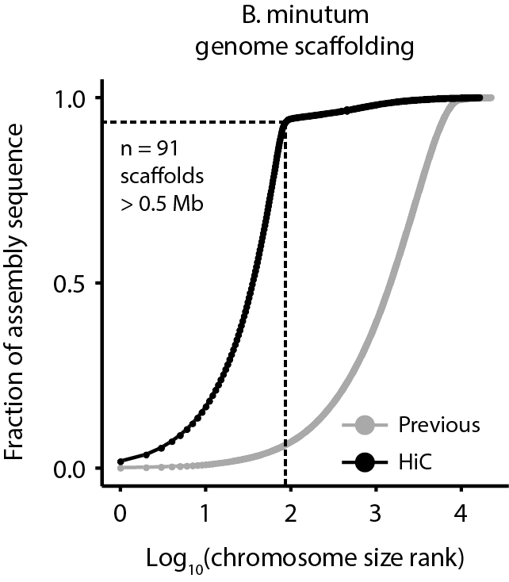
Supplementary Figure 1: Cumulative distribution of scaffolds and pseudochromosome sizes before and after Hi-C scaffolding of the draft Breviolum/Symbiodinium minutum assembly (20). 3D DNA(21) scaffolding of the assembly results in 91 major pseudochromosomes ≥500kb encompassing ∼94% of the assembled sequence.
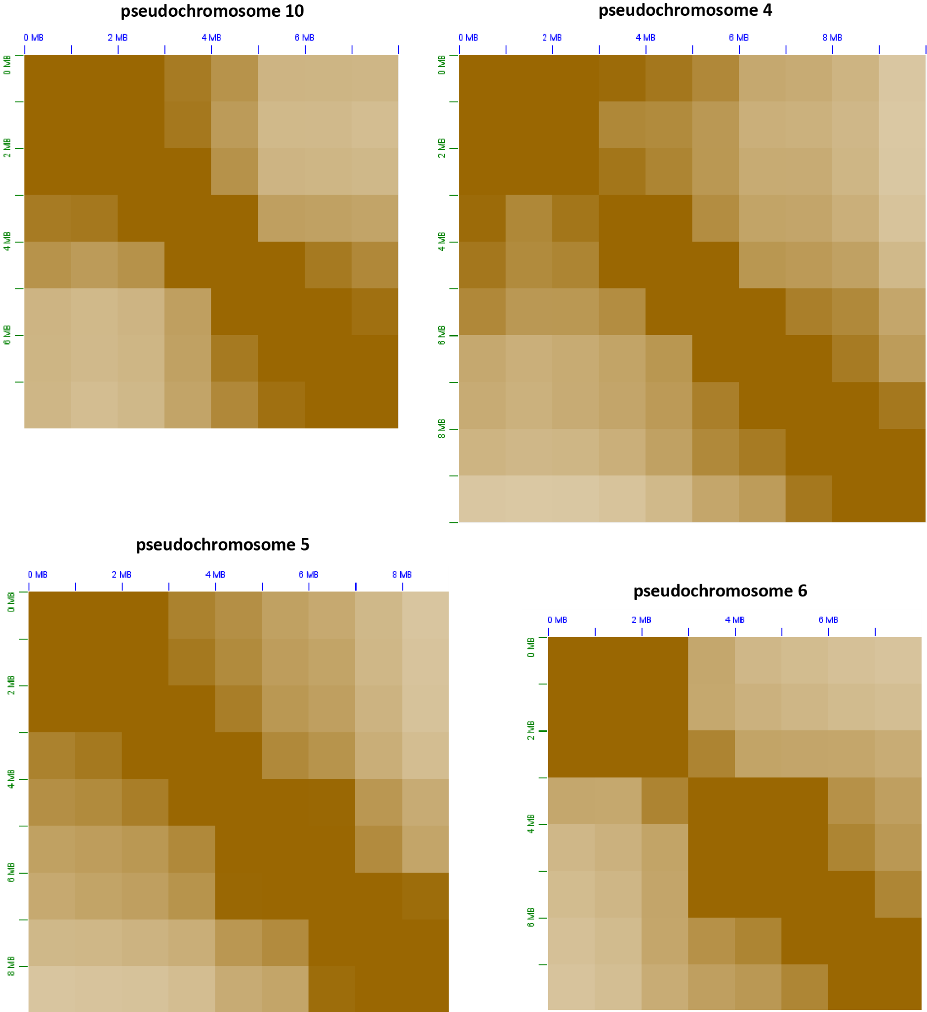
Supplementary Figure 2: Broad-level bipartite to tripartite topological structure of dinoflagellate. Shown are 1Mbp-resolution KR-normalized(1) Hi-C matrices for four of the B. minutum pseudochromosomes.
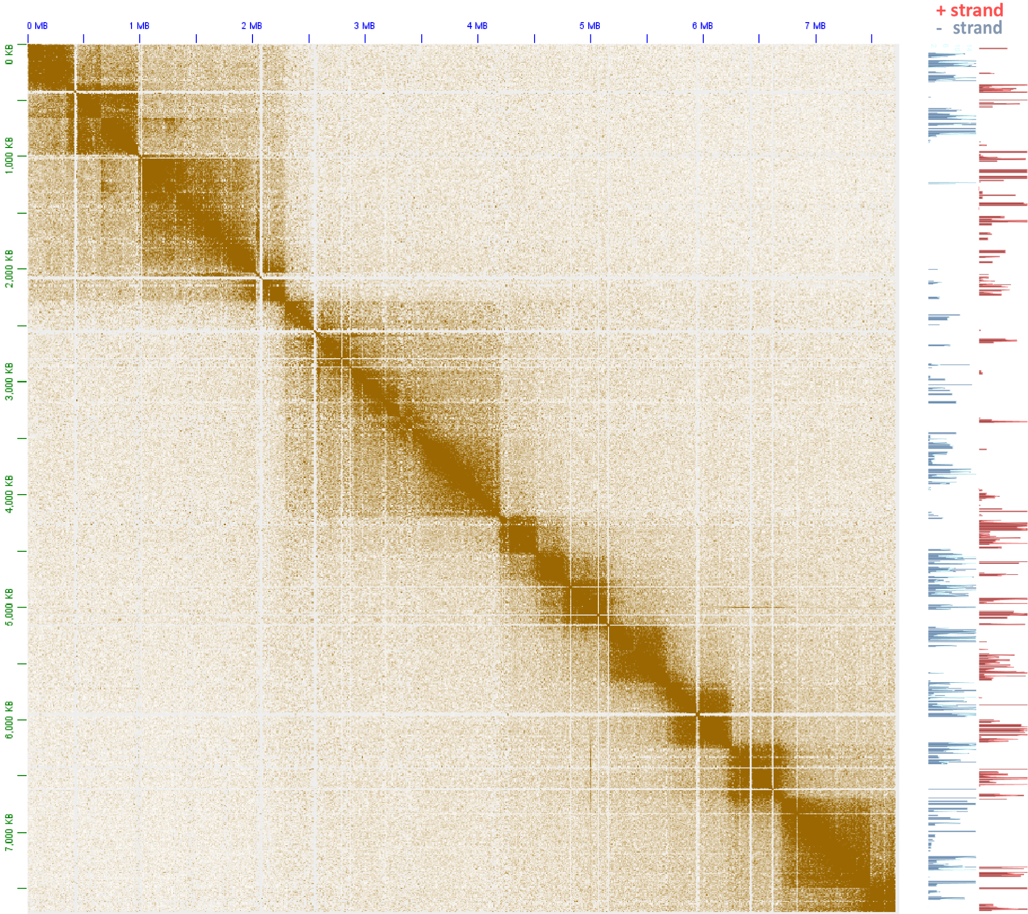
Supplementary Figure 3: The topological domain organization of dinoflagellate chromosomes is related to polycistronic gene array orientation. Shown is the 5kb-resolution KR-normalized Hi-C map together with strandspecific RNA expression levels for pseudochromosome 17.
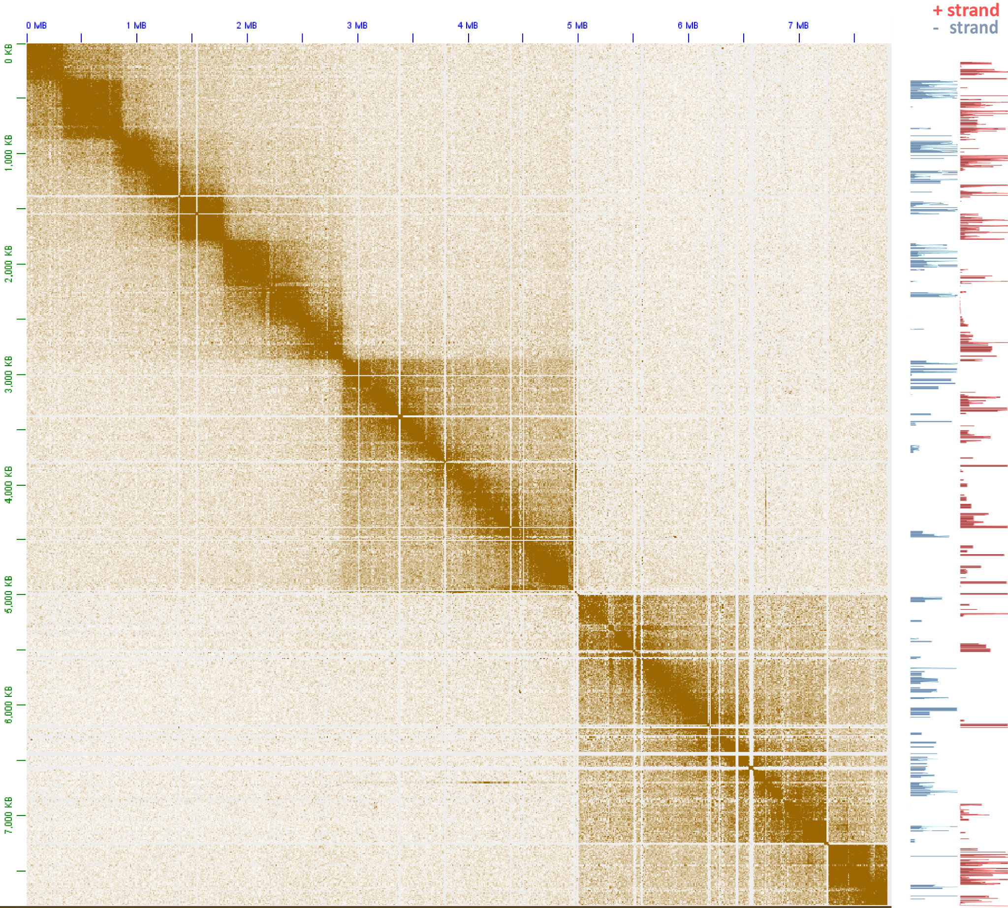
Supplementary Figure 4: The topological domain organization of dinoflagellate chromosomes is related to polycistronic gene array orientation. Shown is the 5kb-resolution KR-normalized Hi-C map together with strandspecific RNA expression levels for pseudochromosome 18.
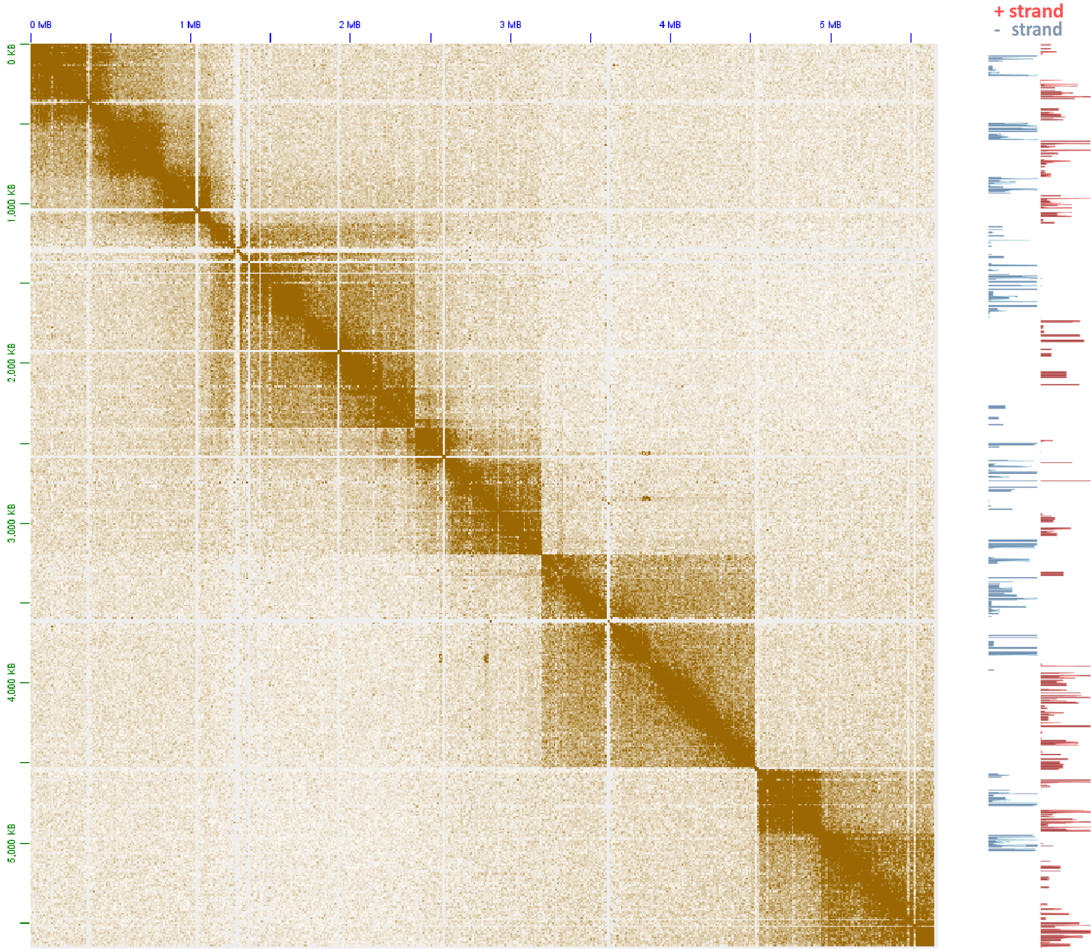
Supplementary Figure 5: The topological domain organization of dinoflagellate chromosomes is related to polycistronic gene array orientation. Shown is the 5kb-resolution KR-normalized Hi-C map together with strandspecific RNA expression levels for pseudochromosome 21.
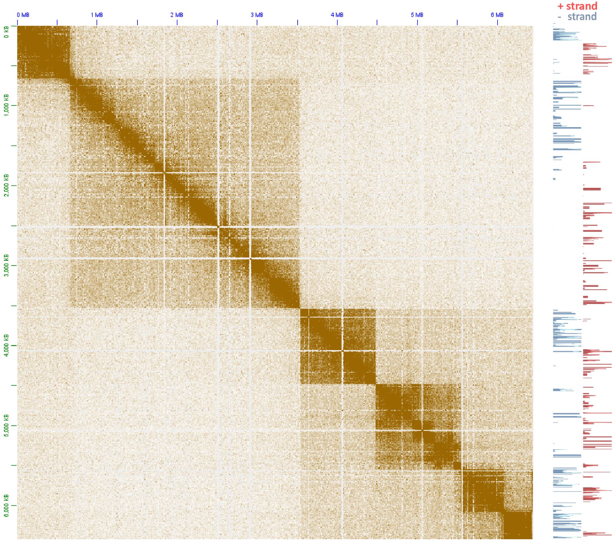
Supplementary Figure 6: The topological domain organization of dinoflagellate chromosomes is related to polycistronic gene array orientation. Shown is the 5kb-resolution KR-normalized Hi-C map together with strandspecific RNA expression levels for pseudochromosome 26.
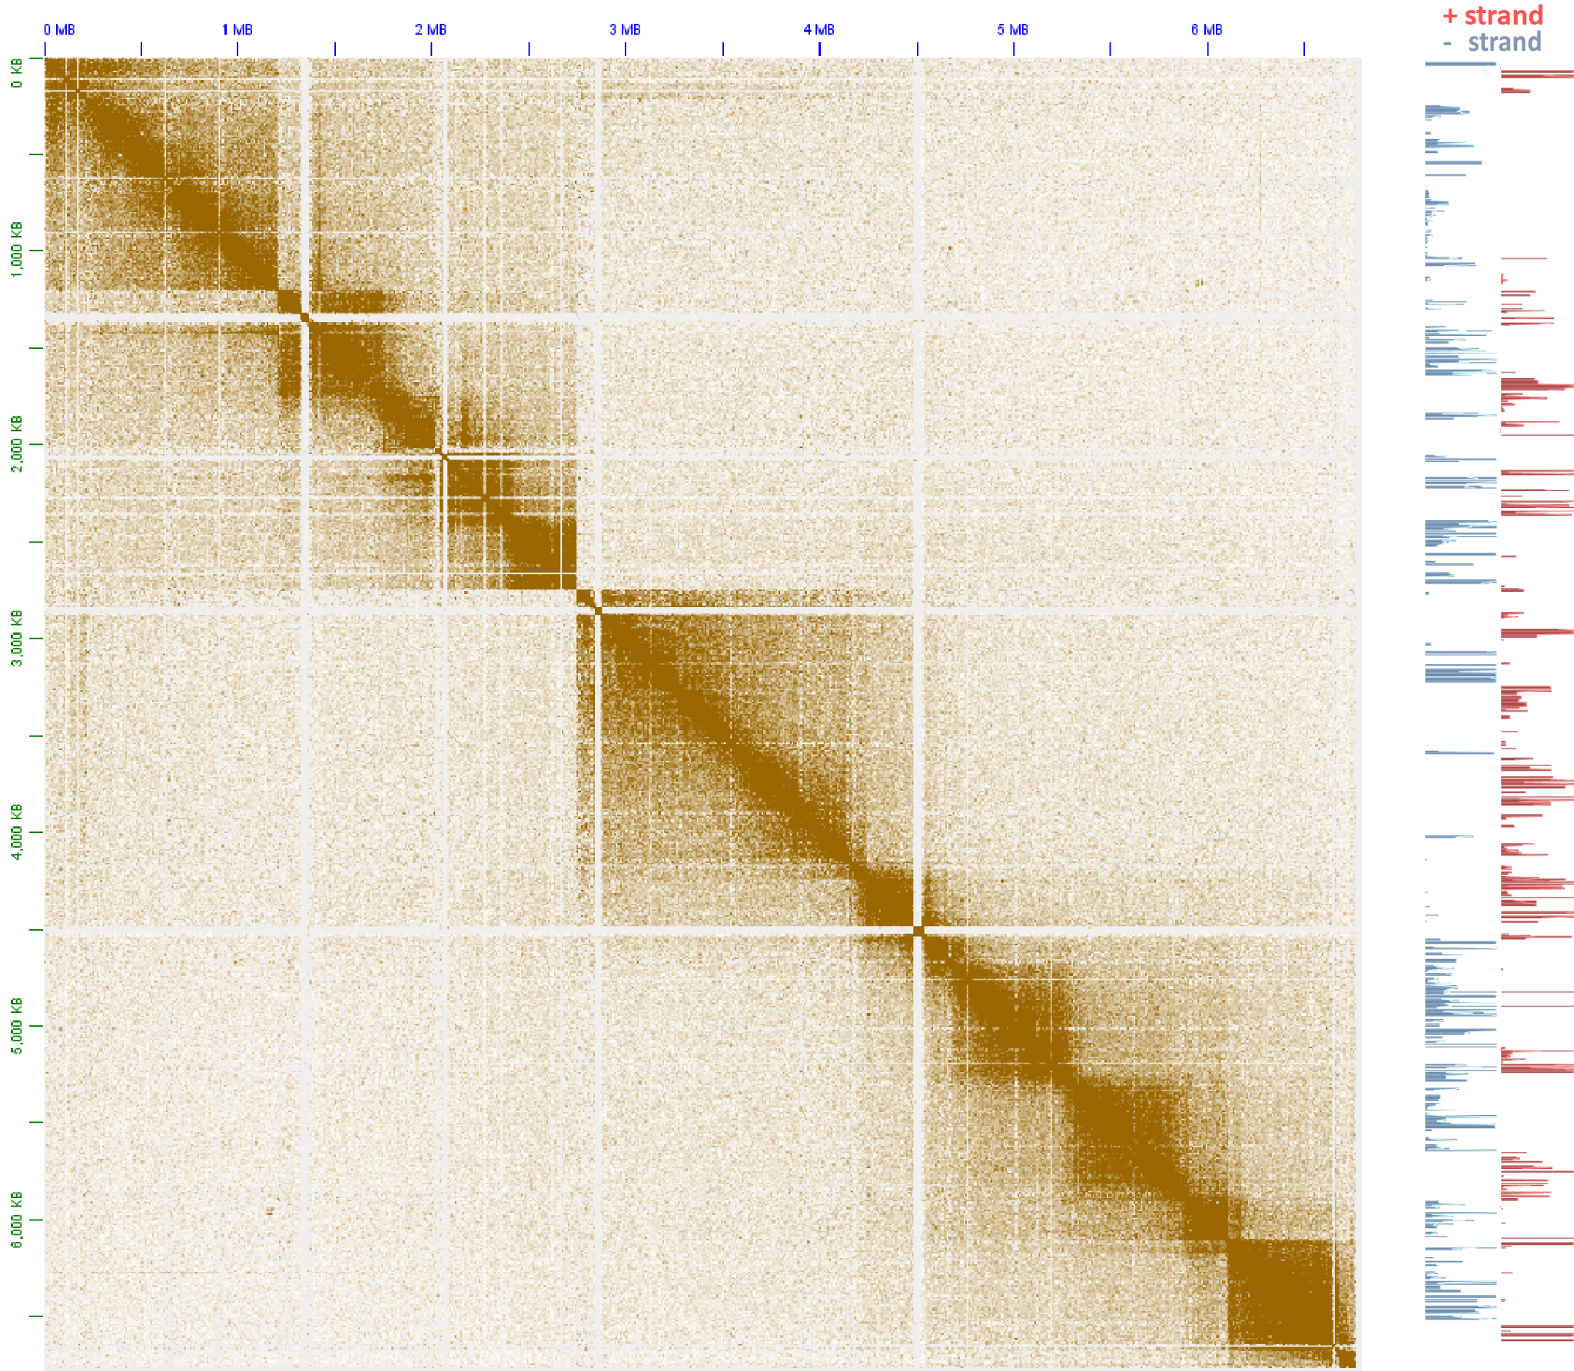
Supplementary Figure 7: The topological domain organization of dinoflagellate chromosomes is related to polycistronic gene array orientation. Shown is the 5kb-resolution KR-normalized Hi-C map together with strandspecific RNA expression levels for pseudochromosome 32.
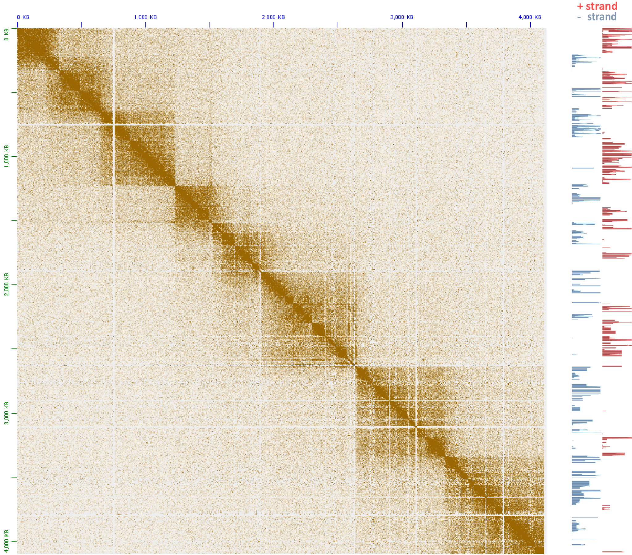
Supplementary Figure 8: The topological domain organization of dinoflagellate chromosomes is related to polycistronic gene array orientation. Shown is the 5kb-resolution KR-normalized Hi-C map together with strandspecific RNA expression levels for pseudochromosome 36.
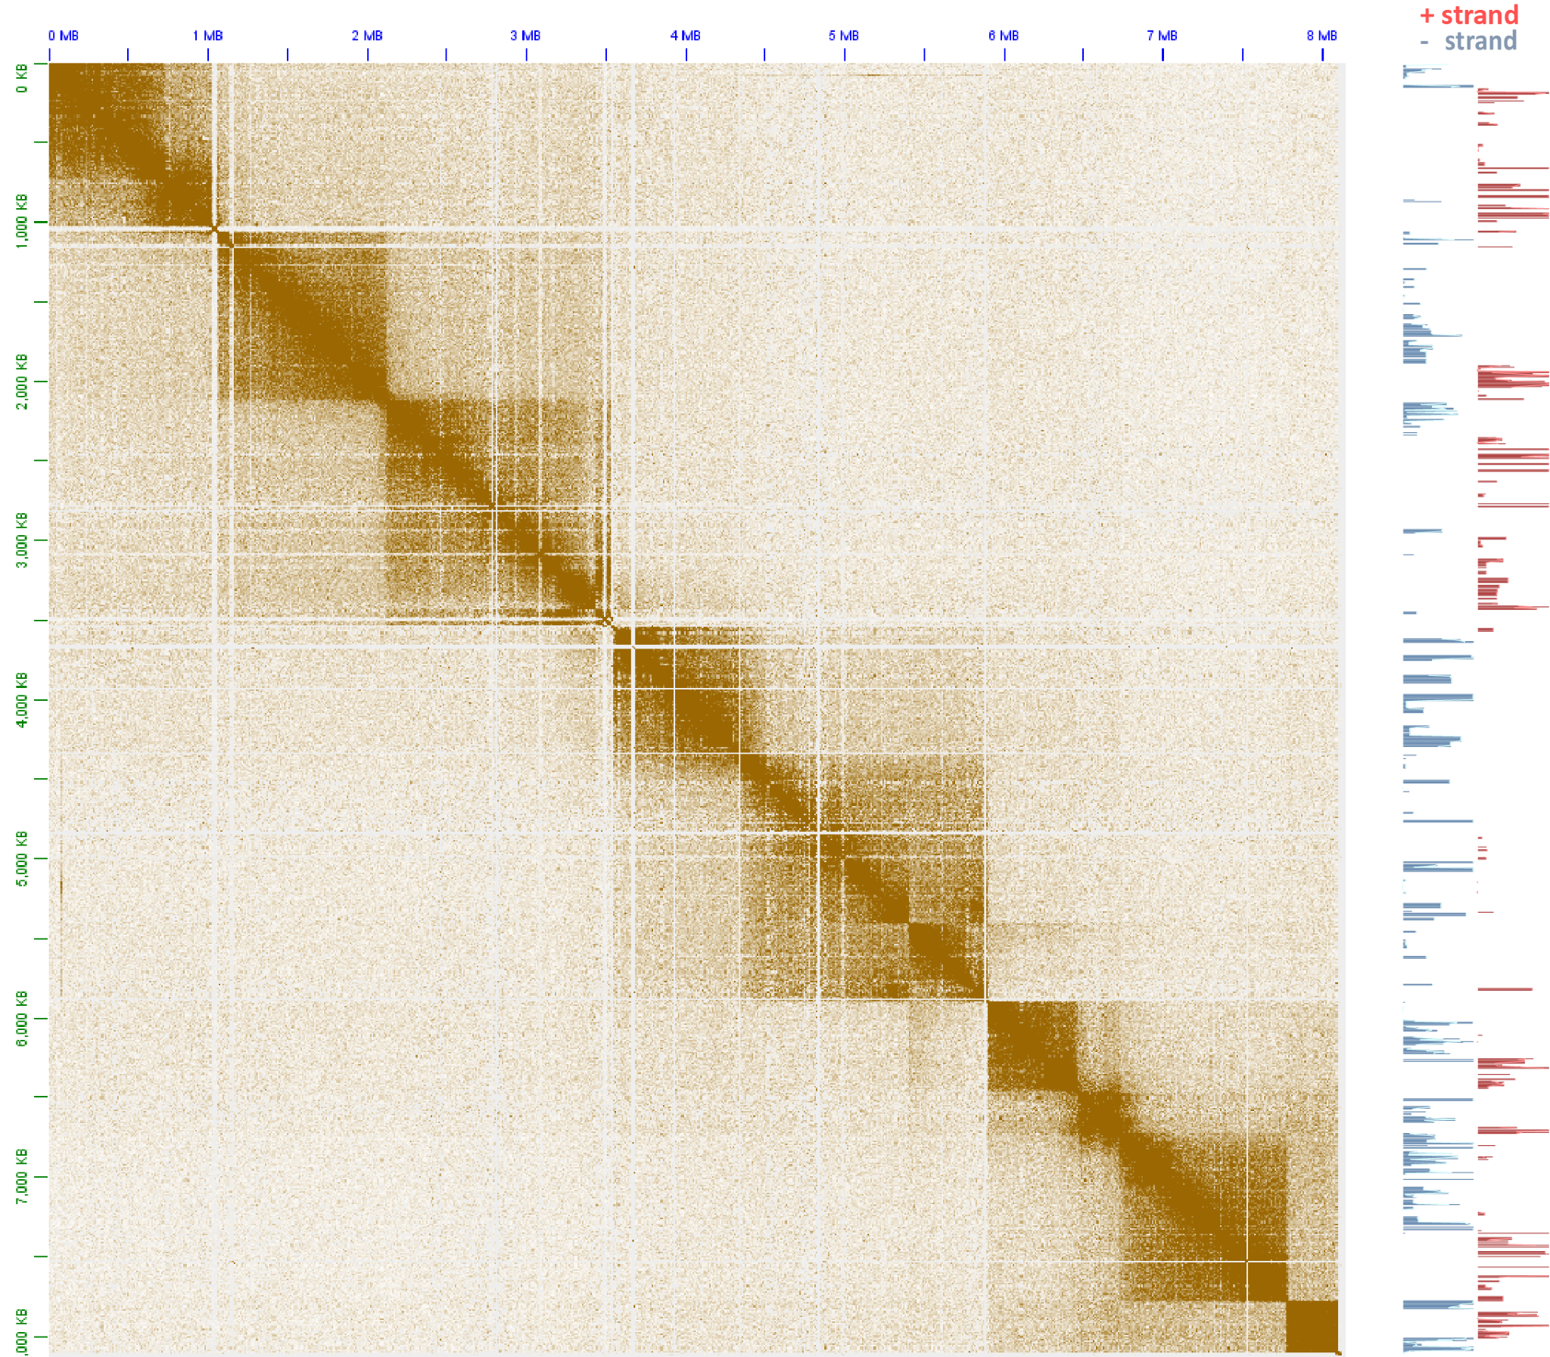
Supplementary Figure 9: The topological domain organization of dinoflagellate chromosomes is related to polycistronic gene array orientation. Shown is the 5kb-resolution KR-normalized Hi-C map together with strandspecific RNA expression levels for pseudochromosome 71.
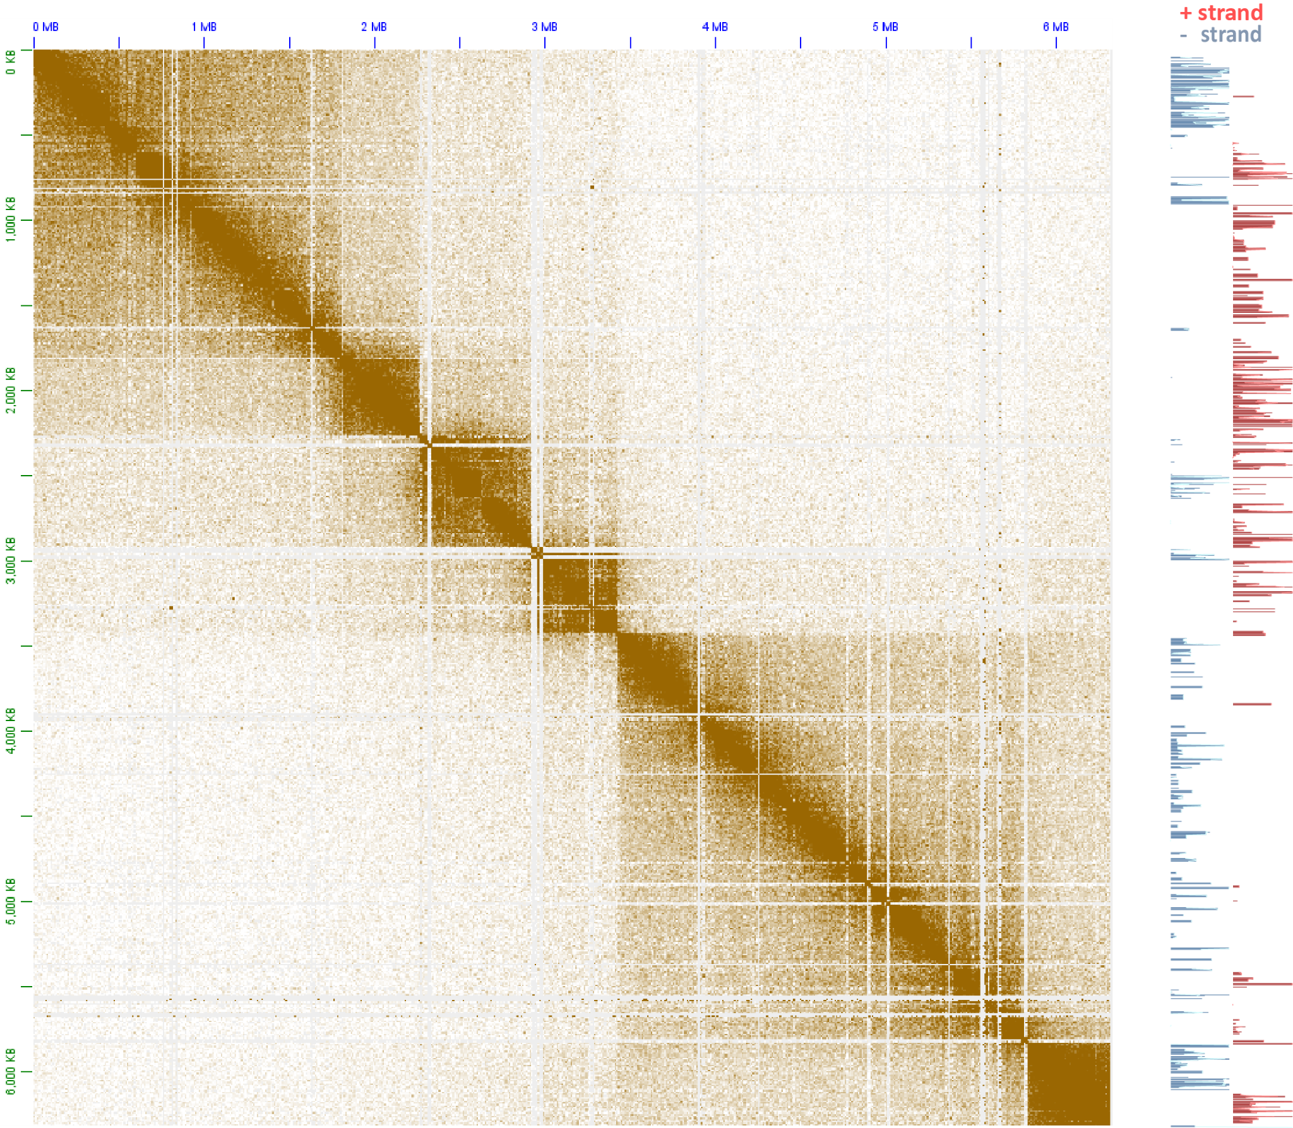
Supplementary Figure 10: The topological domain organization of dinoflagellate chromosomes is related to polycistronic gene array orientation. Shown is the 5kb-resolution KR-normalized Hi-C map together with strandspecific RNA expression levels for pseudochromosome 77.
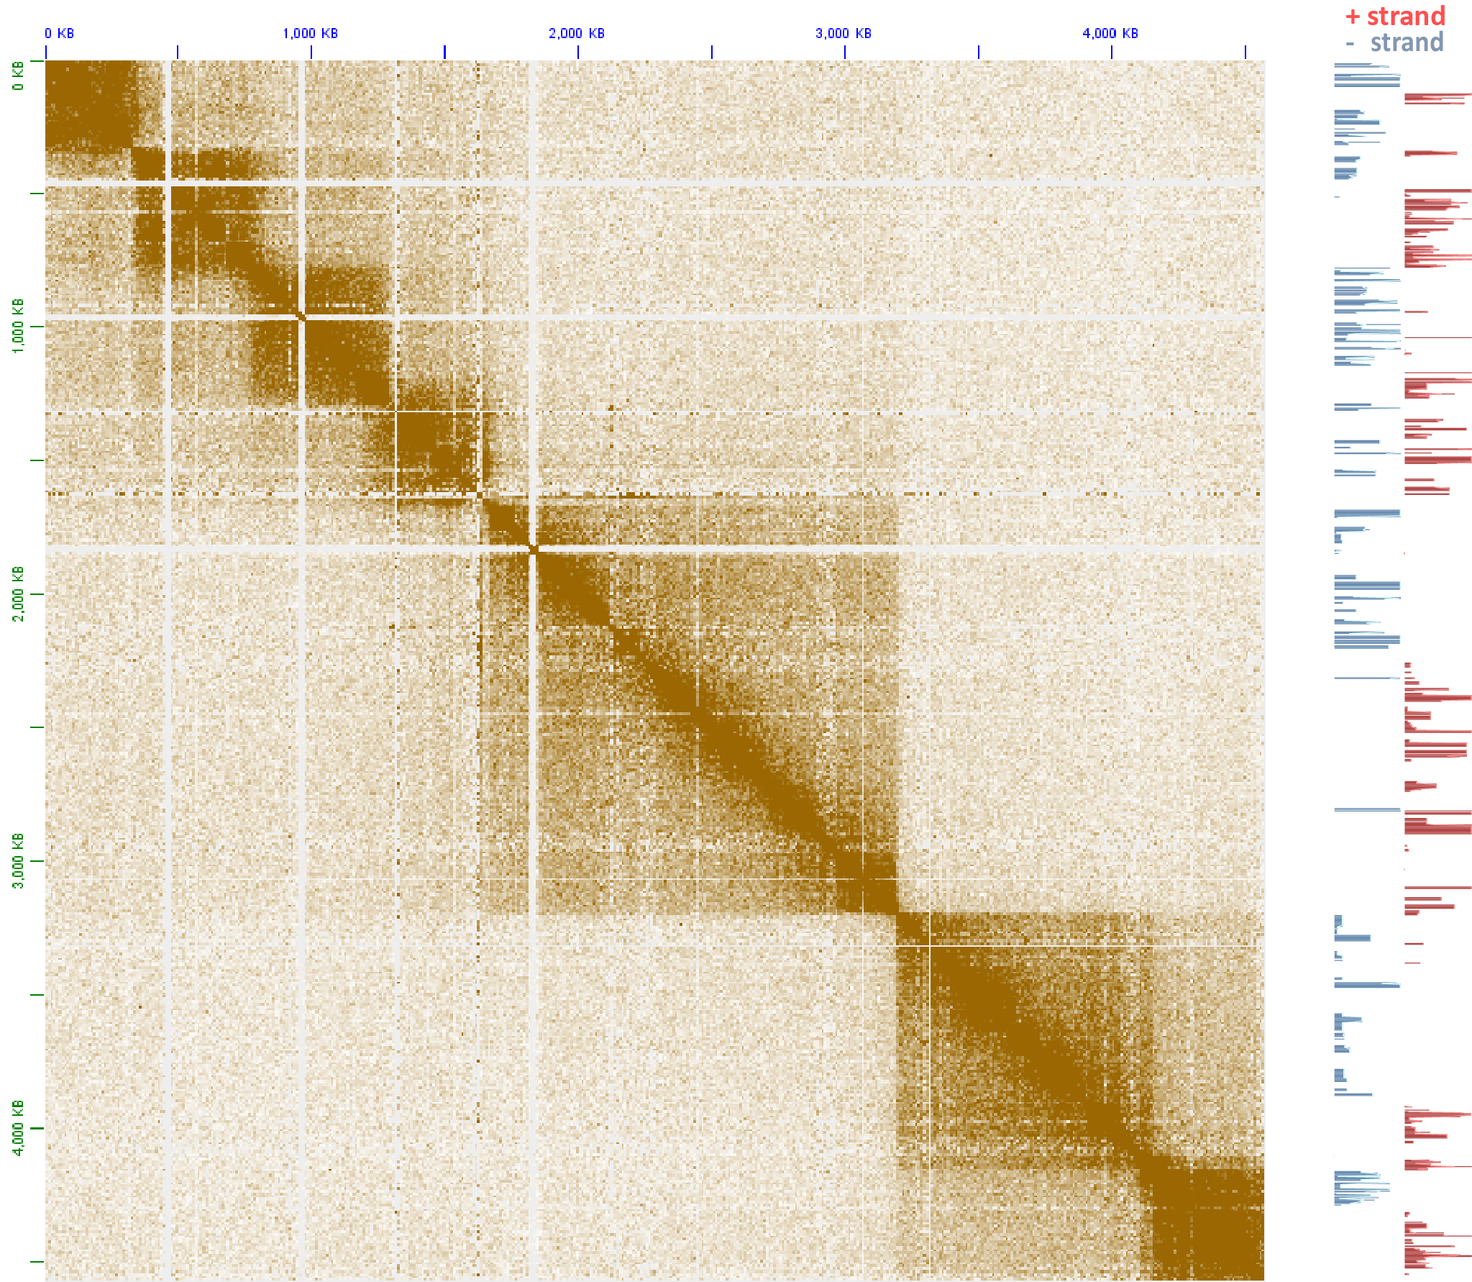
Supplementary Figure 11: The topological domain organization of dinoflagellate chromosomes is related to polycistronic gene array orientation. Shown is the 5kb-resolution KR-normalized Hi-C map together with strandspecific RNA expression levels for pseudochromosome 78.
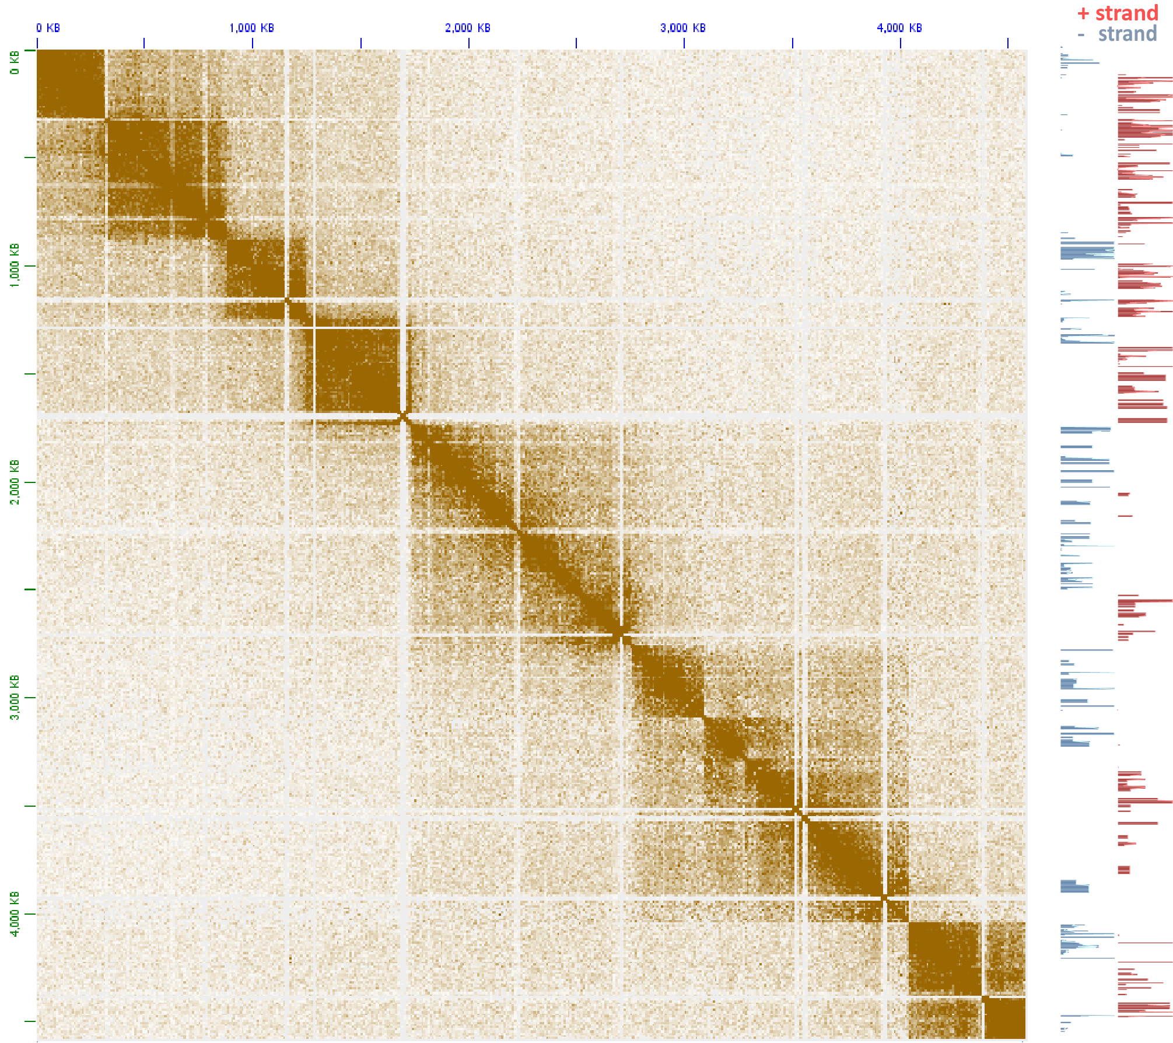
Supplementary Figure 12: The topological domain organization of dinoflagellate chromosomes is related to polycistronic gene array orientation. Shown is the 5kb-resolution KR-normalized Hi-C map together with strandspecific RNA expression levels for pseudochromosome 88.
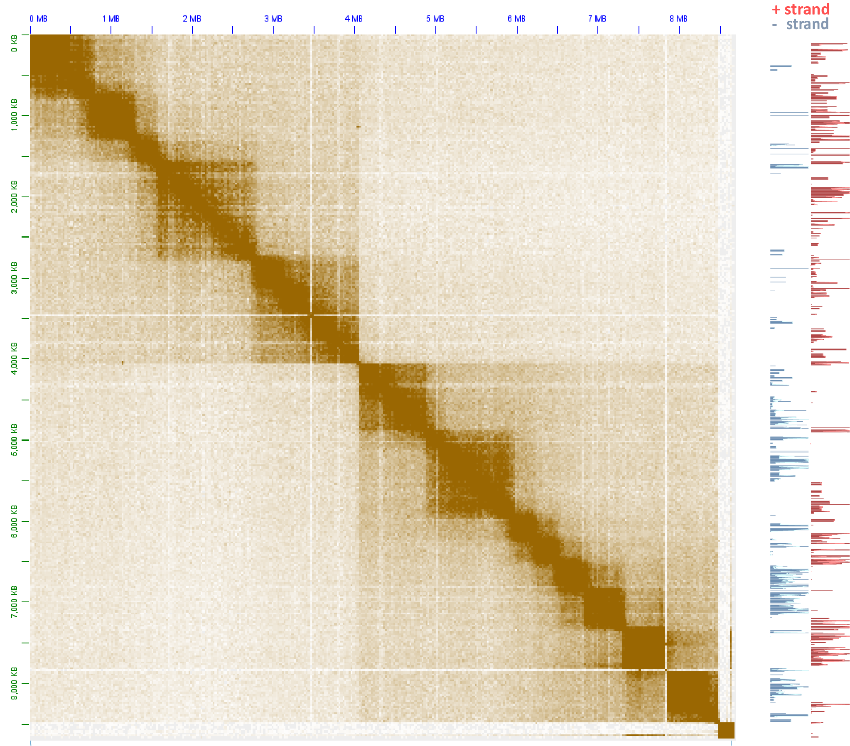
Supplementary Figure 13: The topological domain organization of dinoflagellate chromosomes is related to polycistronic gene array orientation. Shown is the 5kb-resolution KR-normalized Hi-C map together with strandspecific RNA expression levels for pseudochromosome 89.
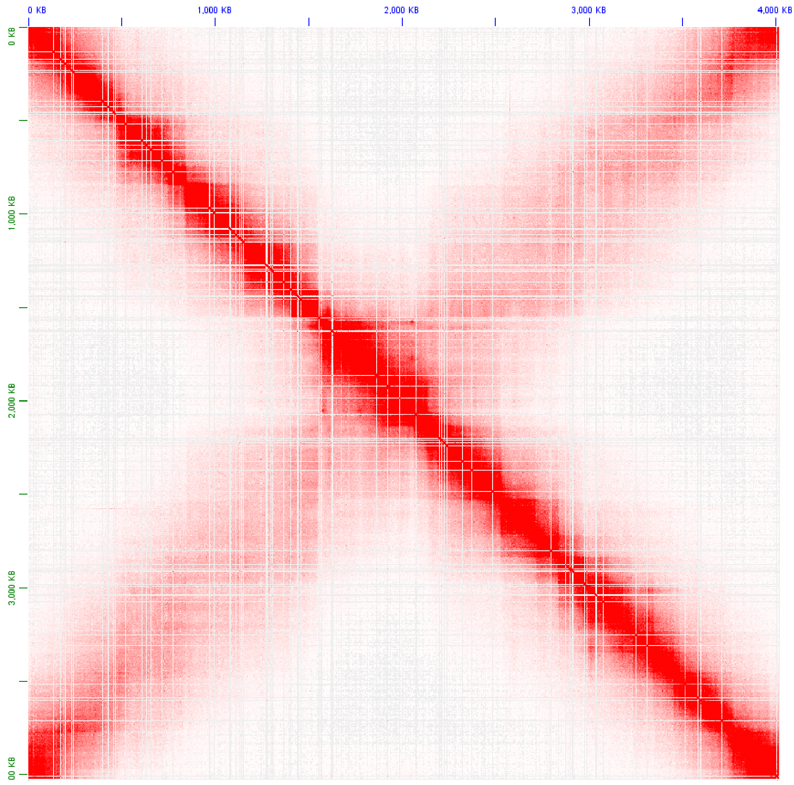
Supplementary Figure 14: Topological structure of the Caulobacter crescentus CB15 genome. Shown is the KR-normalized 5-kb resolution maps for the whole Caulobacter chromosome (GEO accession GSM1120448).
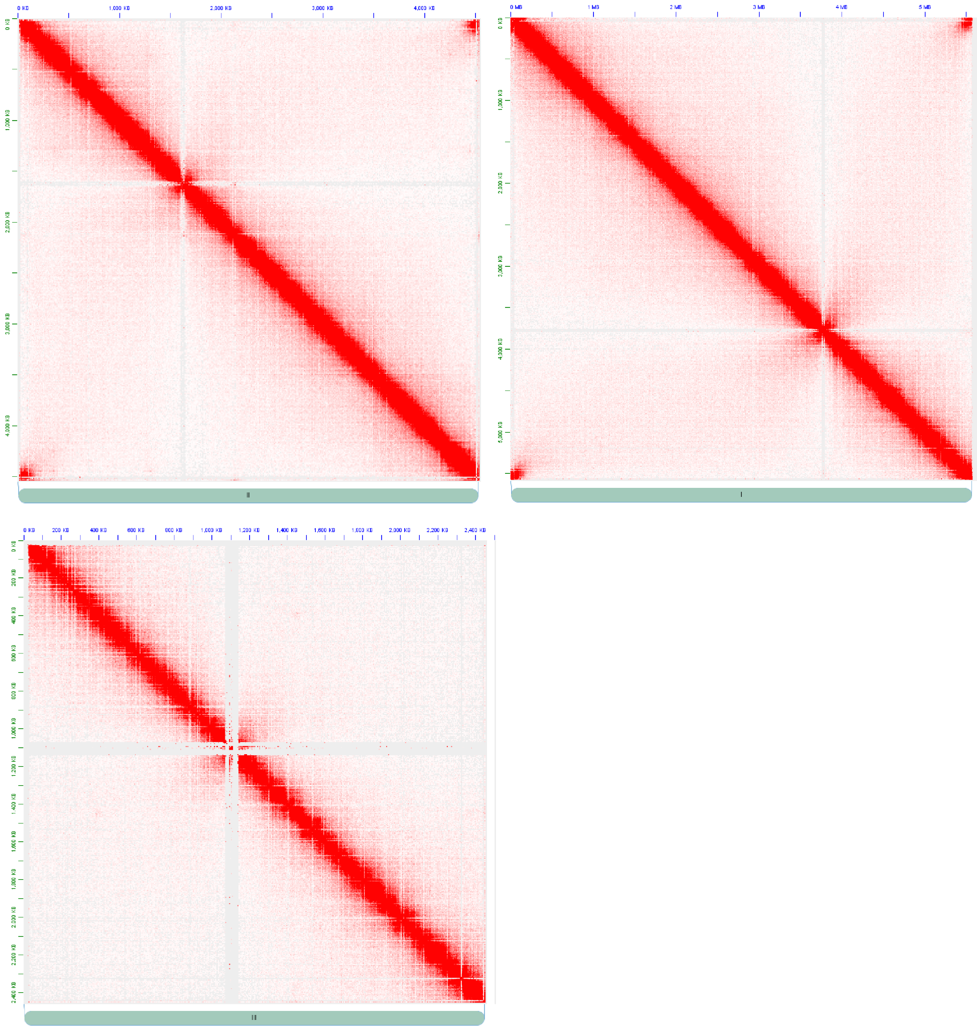
Supplementary Figure 15: Topological structure of the Schizosaccharomyces pombe genome. Shown are the KR-normalized 5-kb resolution maps for all three S. pombe chromosome (GEO accession GSM1379427).
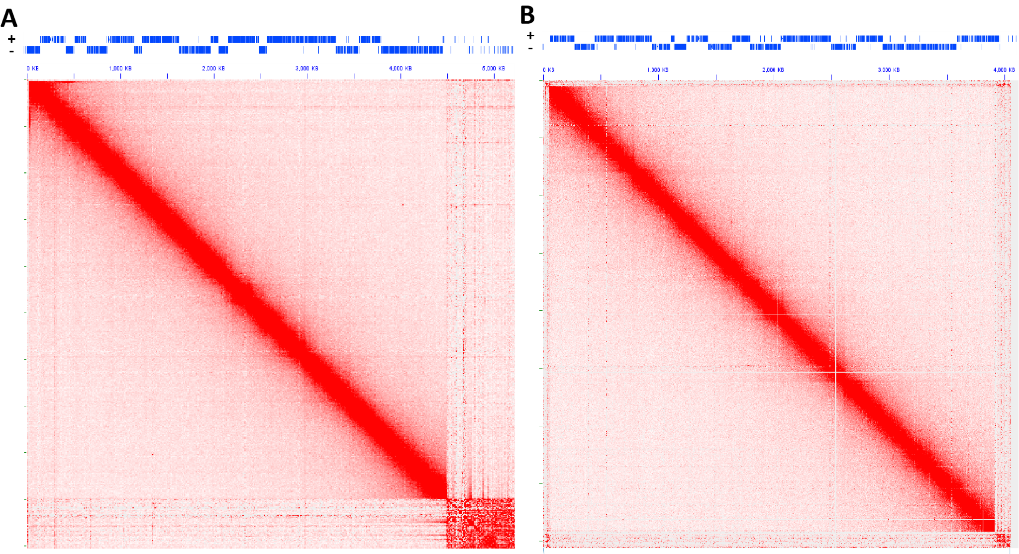
Supplementary Figure 16: No topological domains associated with gene arrays are observed in the kinetoplastid Trypanosoma brucei. Shown are KR-normalized 10-kb resolution maps for chr11 (A) and chr10 (B) for GEO accession GSM3346690.
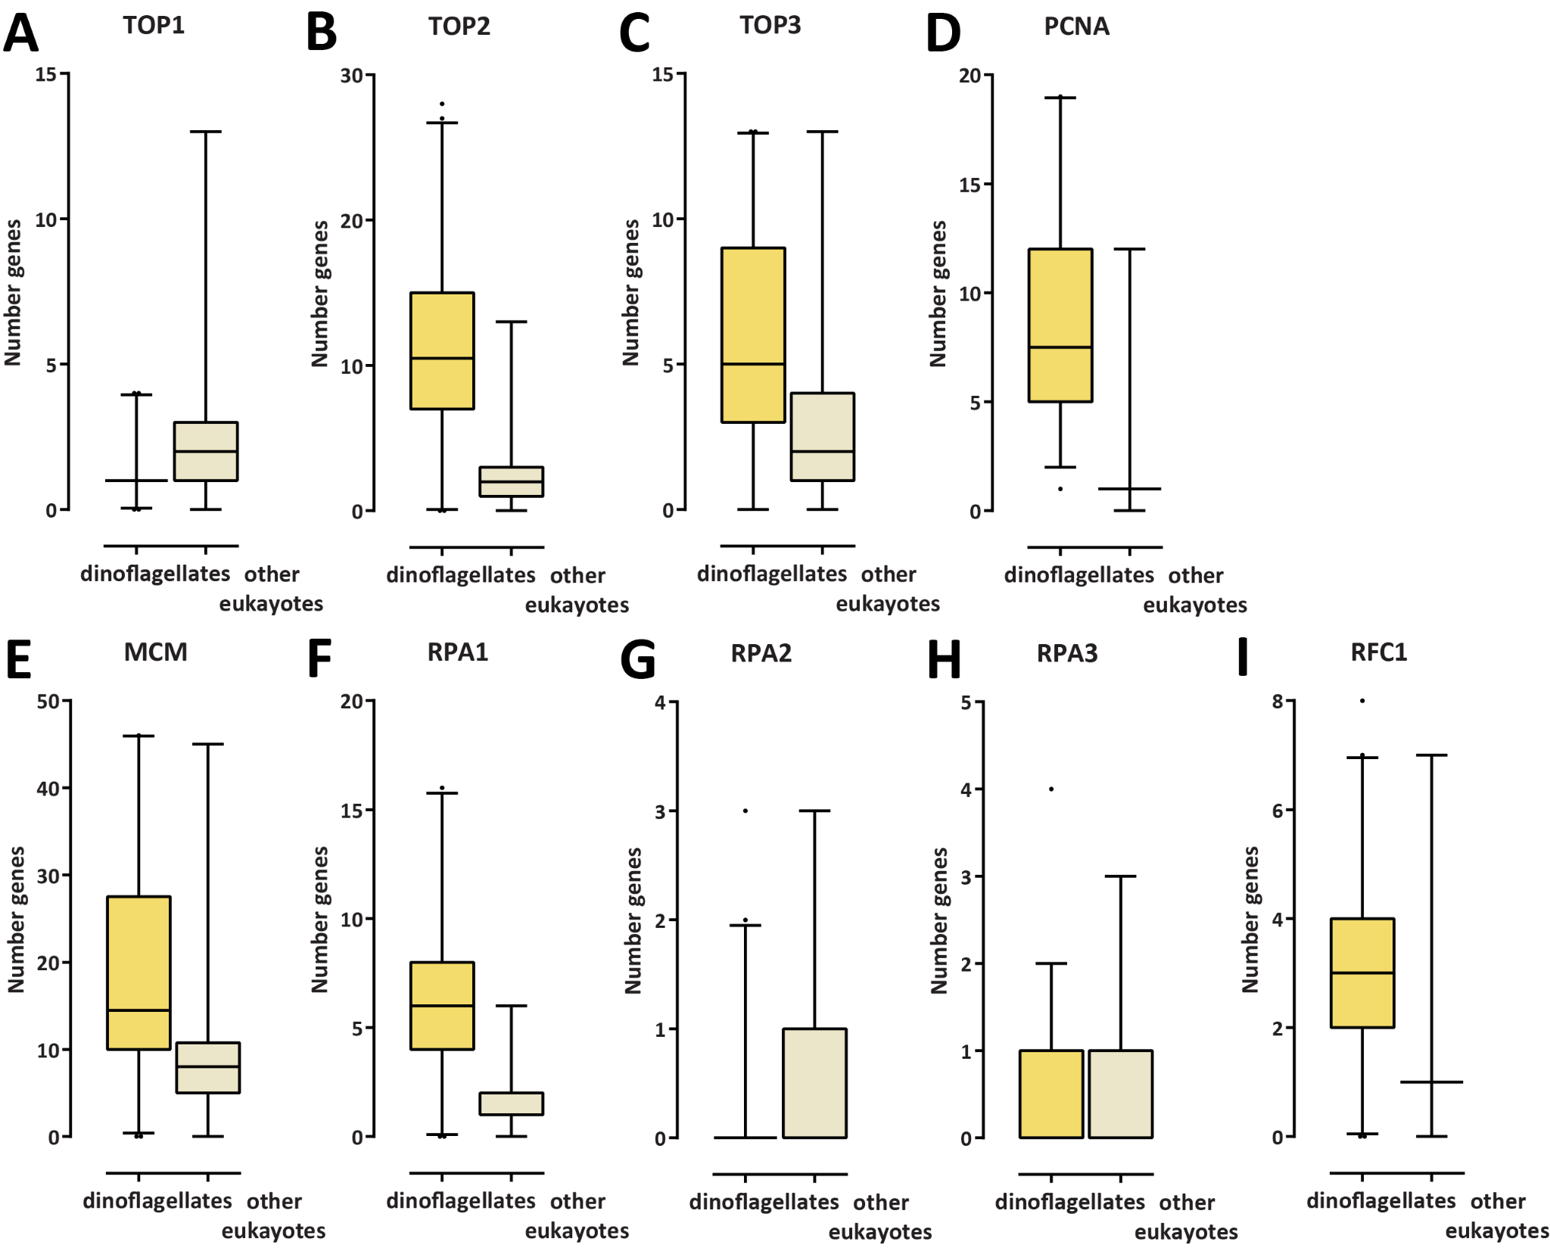
Supplementary Figure 17: Expansion of the Type II and II topoisomerase gene repertoire as well as of certain other replication-related proteins in dinoflagellates. Shown are the number of genes annotated in MMETSP transcriptome assemblies of dinoflagellates and other eukaryotes. (A) Number of Type I topoisomerase genes; (B) Number of Type II topoisomerase genes; (C) Number of Type III topoisomerase genes; (D) Number of PCNA genes; (E) Number of MCM genes; (F) Number of RPA1 genes; (G) Number of RPA2 genes; (H) Number of RPA3 genes; (I) Number of RFC1 genes.
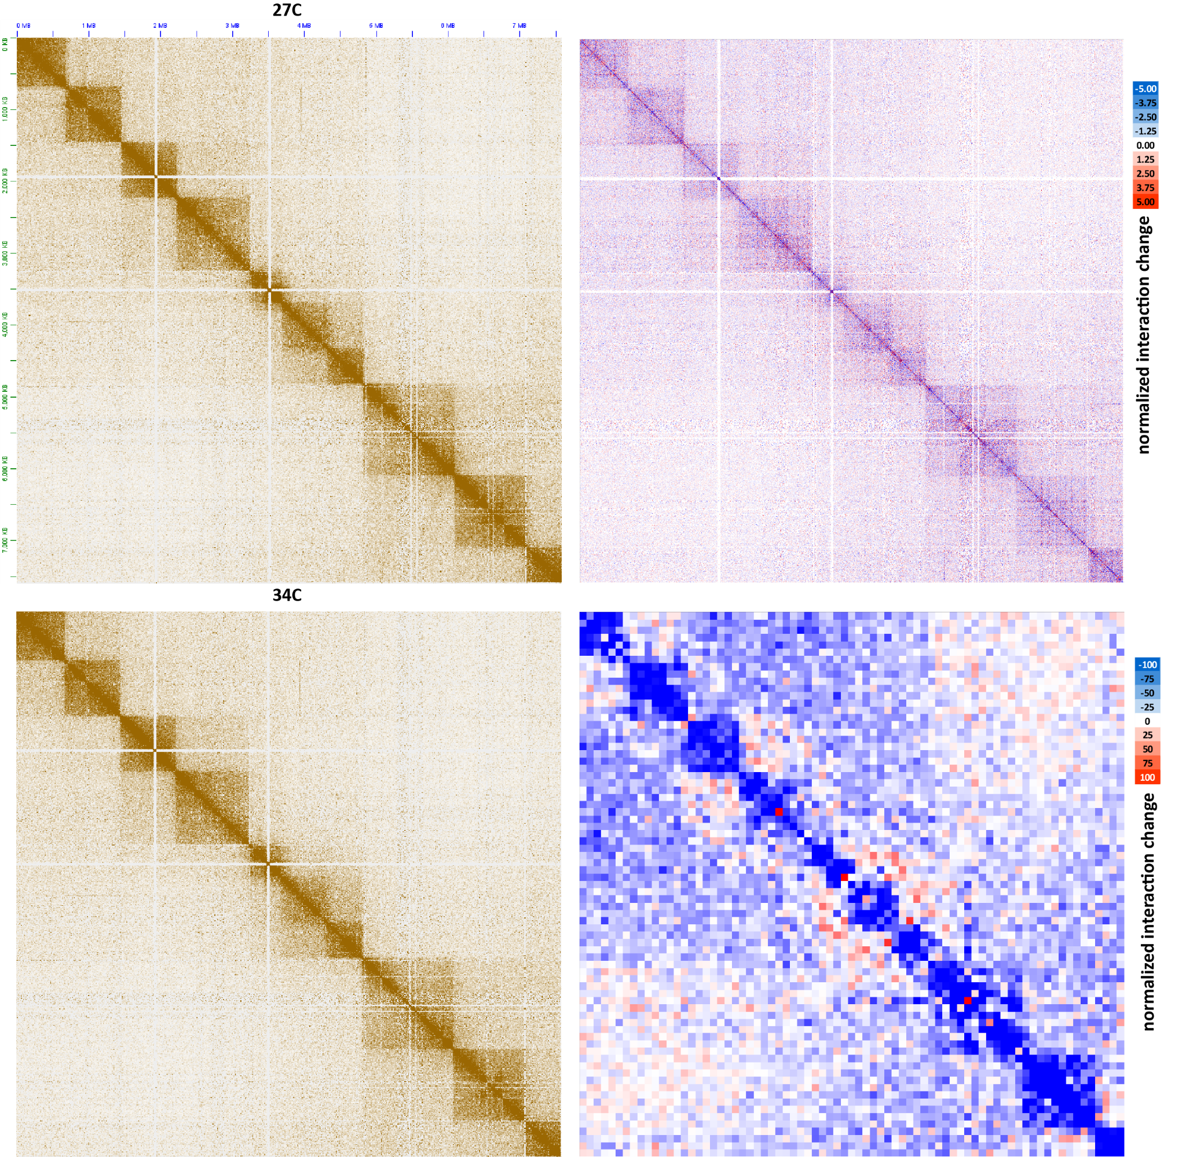
Supplementary Figure 18: Moderate decompaction of dinoTADs upon exposure to elevated temperatures. Shown is pseudochromosome 10 (KR-normalized) and the difference between the KR-normalized Hi-C maps generated from B. minutum grown at 34◦C and at 27◦C at 100-kb resolution (lower right) and 5-kb resolution (upper right).
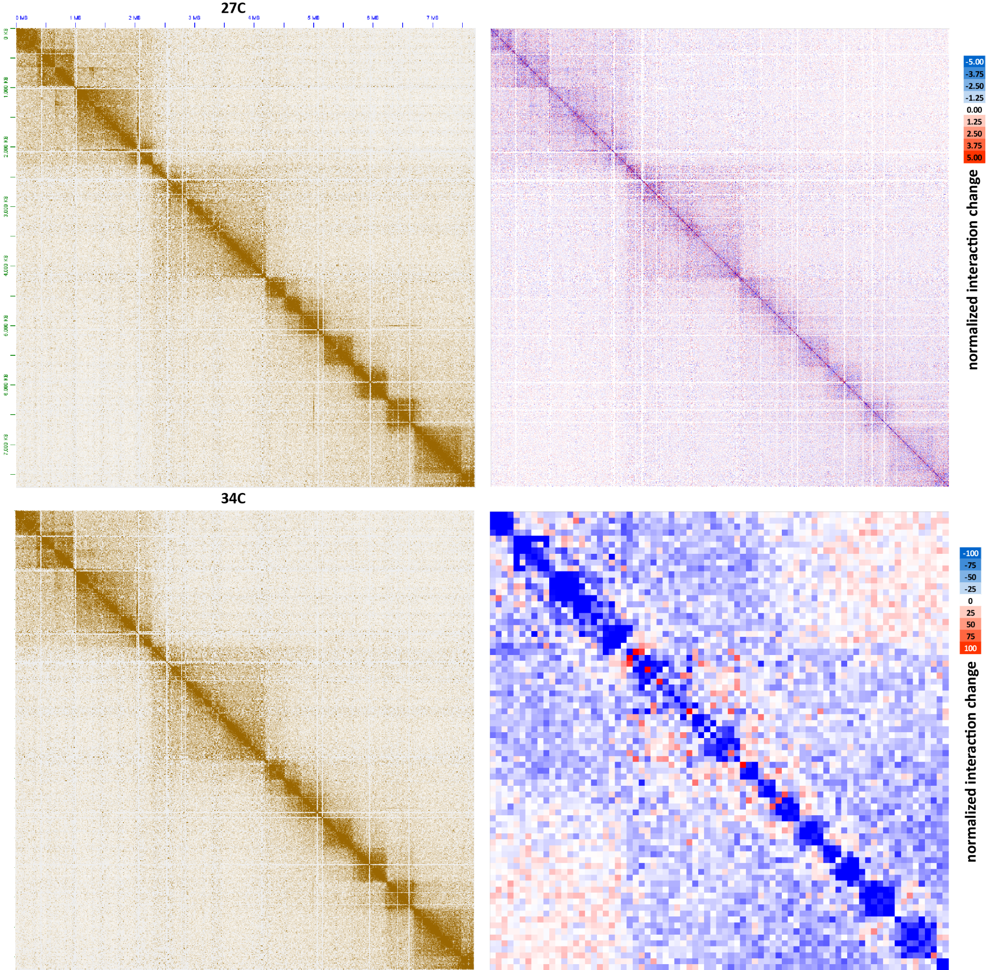
Supplementary Figure 19: Moderate decompaction of dinoTADs upon exposure to elevated temperatures. Shown is pseudochromosome 17 (KR-normalized) and the difference between the KR-normalized Hi-C maps generated from B. minutum grown at 34◦C and at 27◦C at 100-kb resolution (lower right) and 5-kb resolution (upper right).
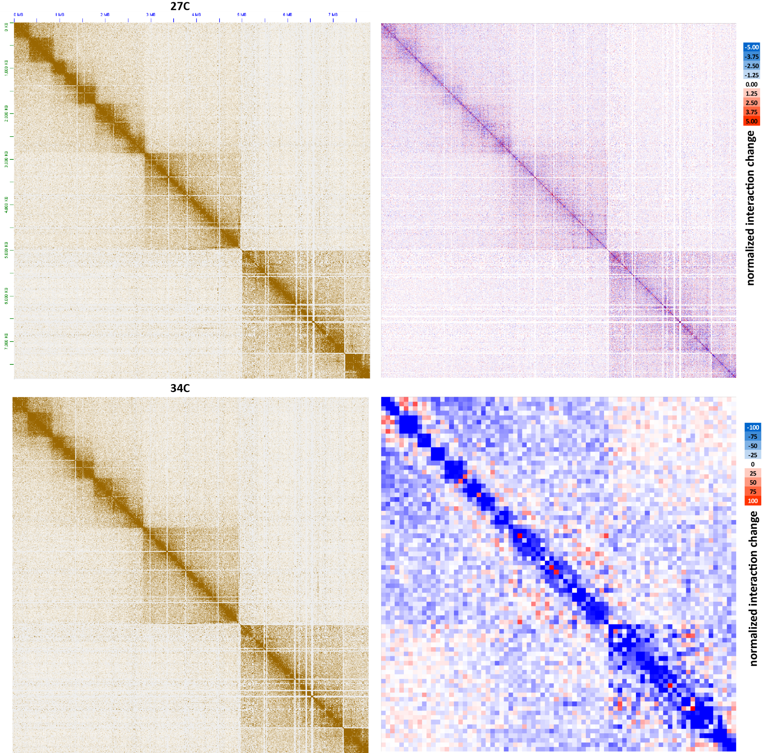
Supplementary Figure 20: Moderate decompaction of dinoTADs upon exposure to elevated temperatures. Shown is pseudochromosome 18 (KR-normalized) and the difference between the KR-normalized Hi-C maps generated from B. minutum grown at 34◦C and at 27◦C at 100-kb resolution (lower right) and 5-kb resolution (upper right).
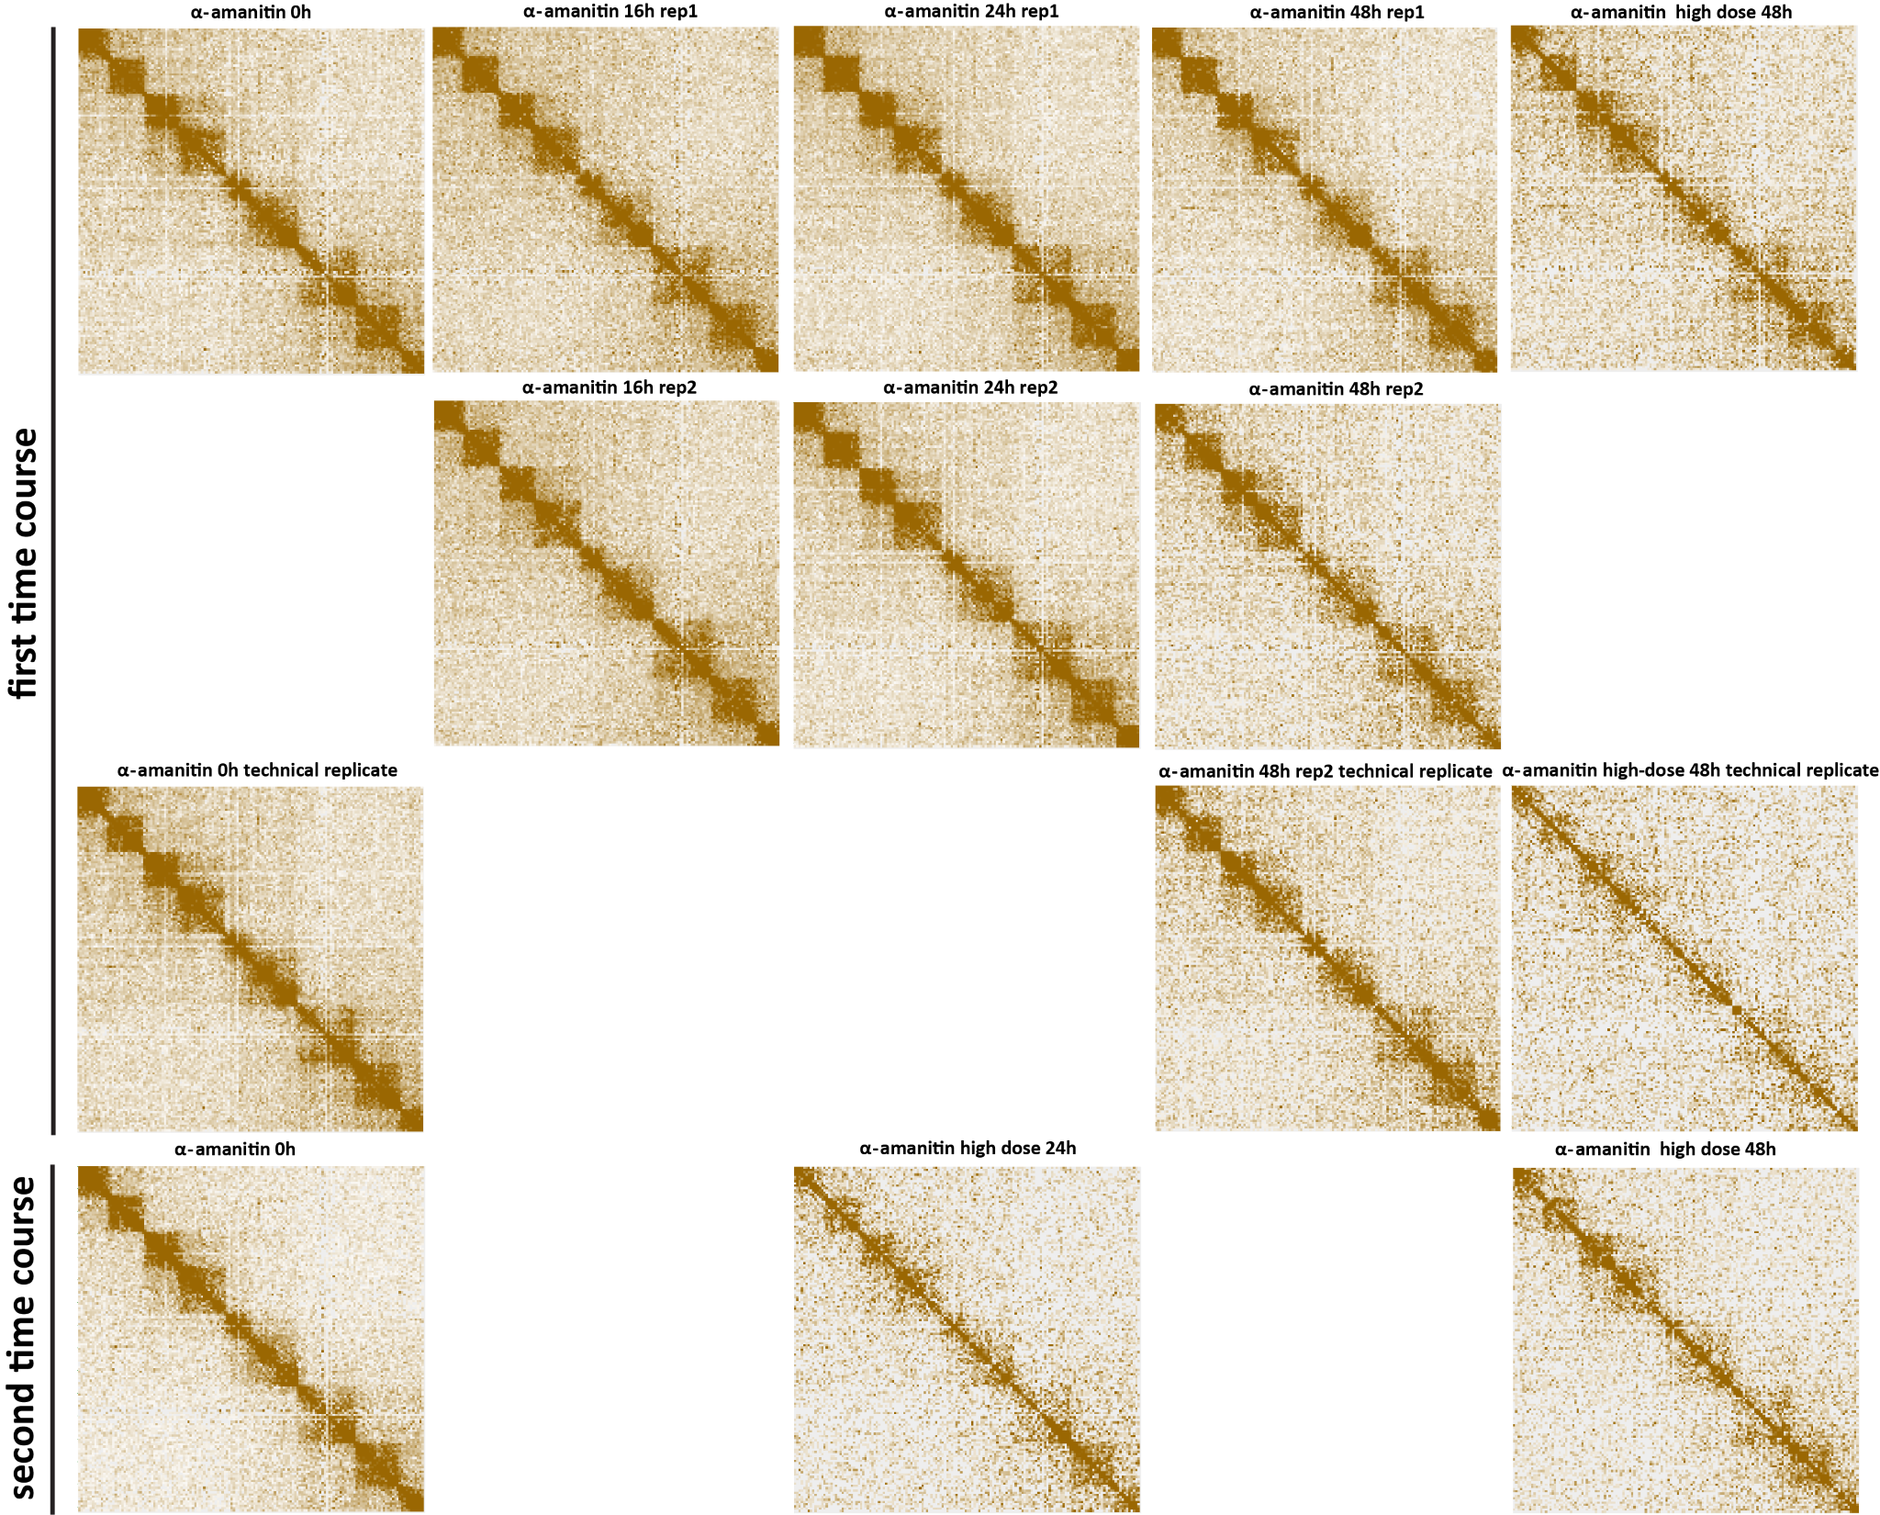
Supplementary Figure 21: Decompaction of dinoTADs upon transcriptional inhibition using α-amanitin. Shown is pseudochromosome 10. Two time courses were carried out following the outline presented in Figure 2B.
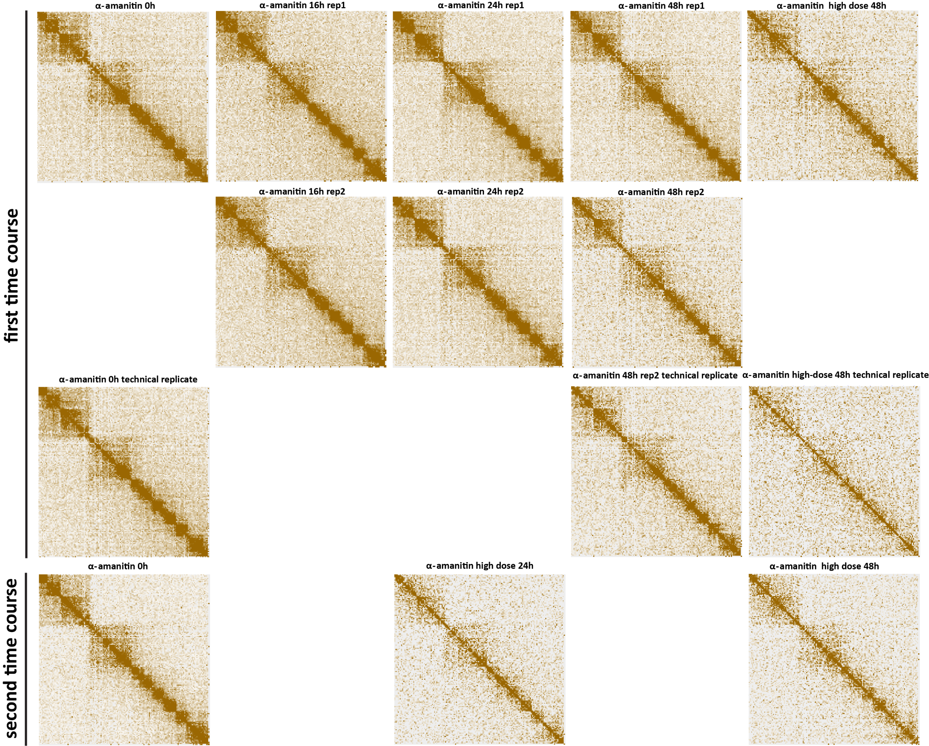
Supplementary Figure 22: Decompaction of dinoTADs upon transcriptional inhibition using α-amanitin. Shown is pseudochromosome 17. Two time courses were carried out following the outline presented in Figure 2B.
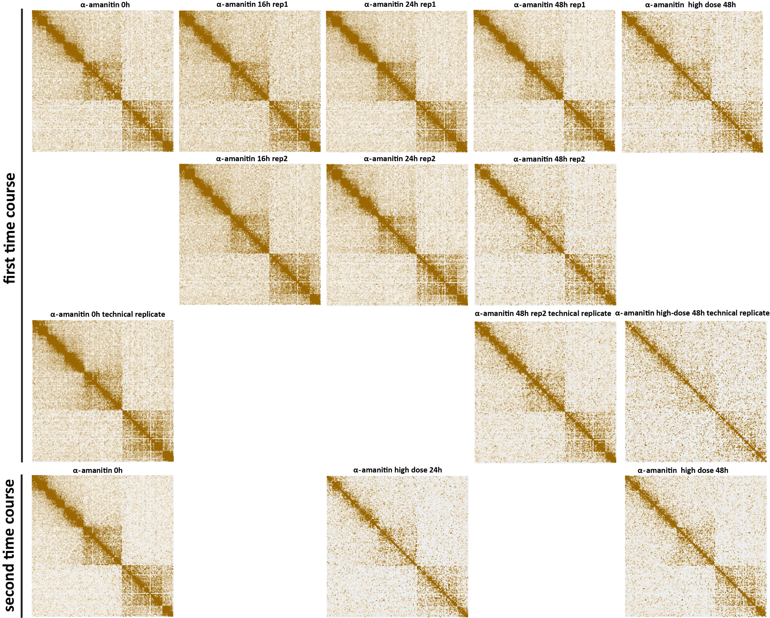
Supplementary Figure 23: Decompaction of dinoTADs upon transcriptional inhibition using α-amanitin. Shown is pseudochromosome 18. Two time courses were carried out following the outline presented in Figure 2B.
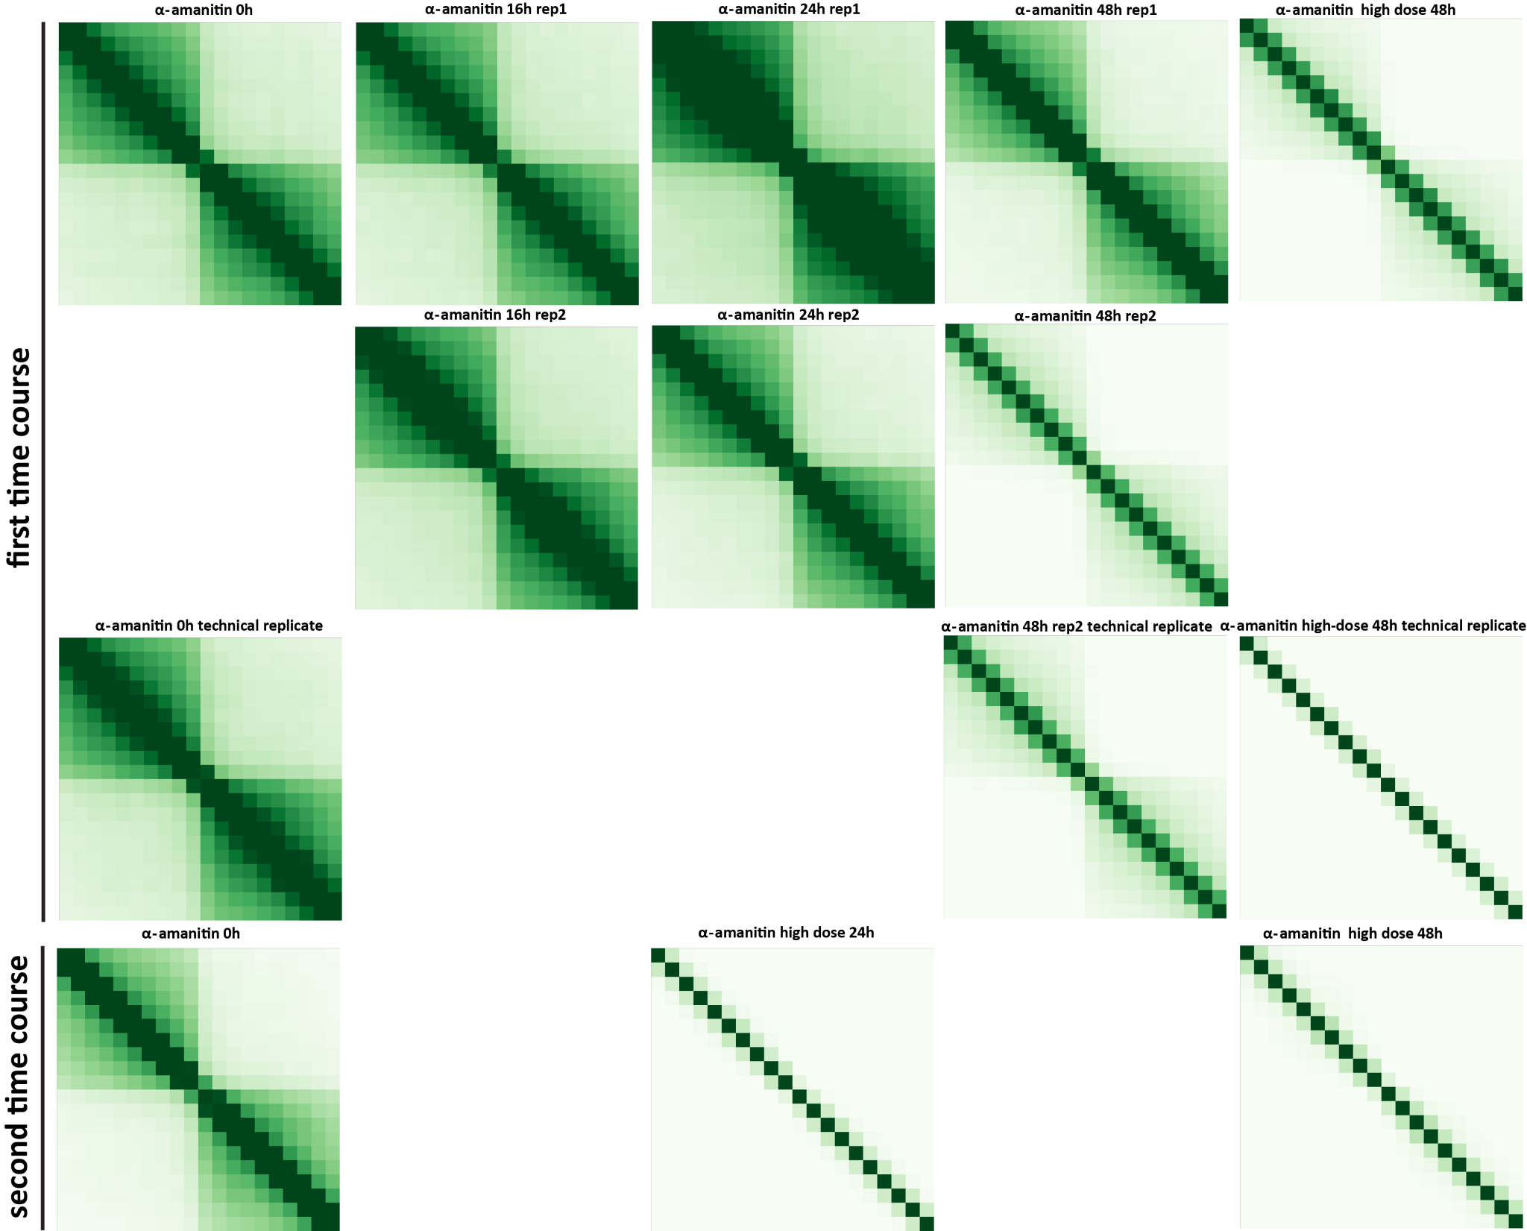
Supplementary Figure 24: Decompaction of dinoTADs upon transcriptional inhibition using α-amanitin. Shown are 50-kb resolution metaplots centered on dinoTAD domain boundaries. Two time courses were carried out following the outline presented in Figure 2B.
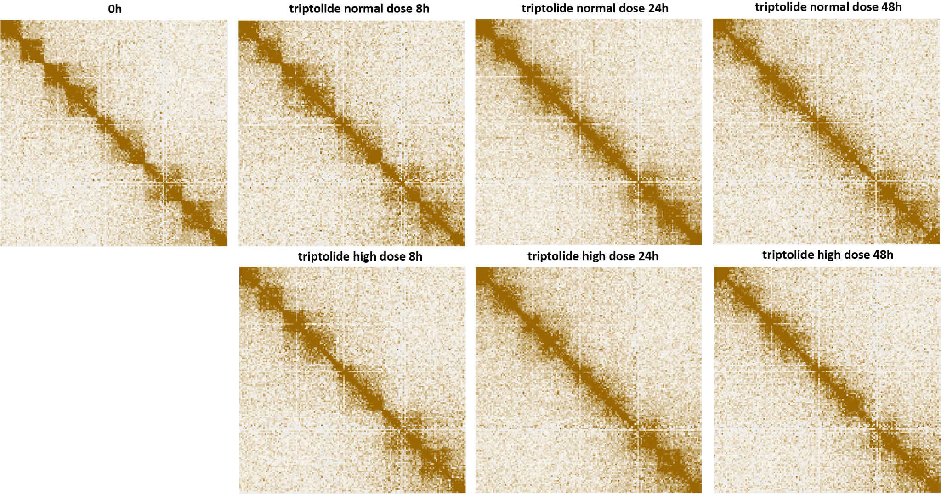
Supplementary Figure 25: Blurring of dinoTAD boundaries upon transcriptional inhibition using triptolide. Shown is pseudochromosome 10. The triptolide time course was carried out following the outline presented in Figure 2B.
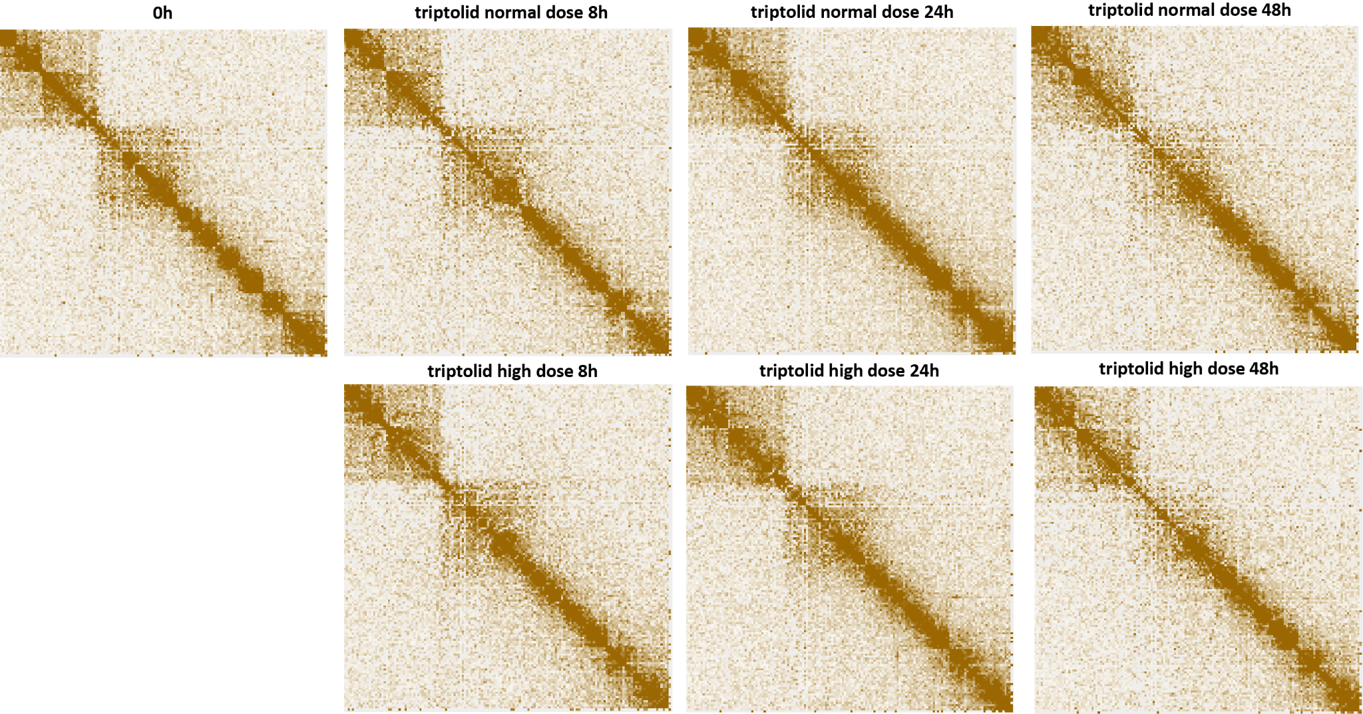
Supplementary Figure 26: Blurring of dinoTAD boundaries upon transcriptional inhibition using triptolide. Shown is pseudochromosome 17. The triptolide time course was carried out following the outline presented in Figure 2B.
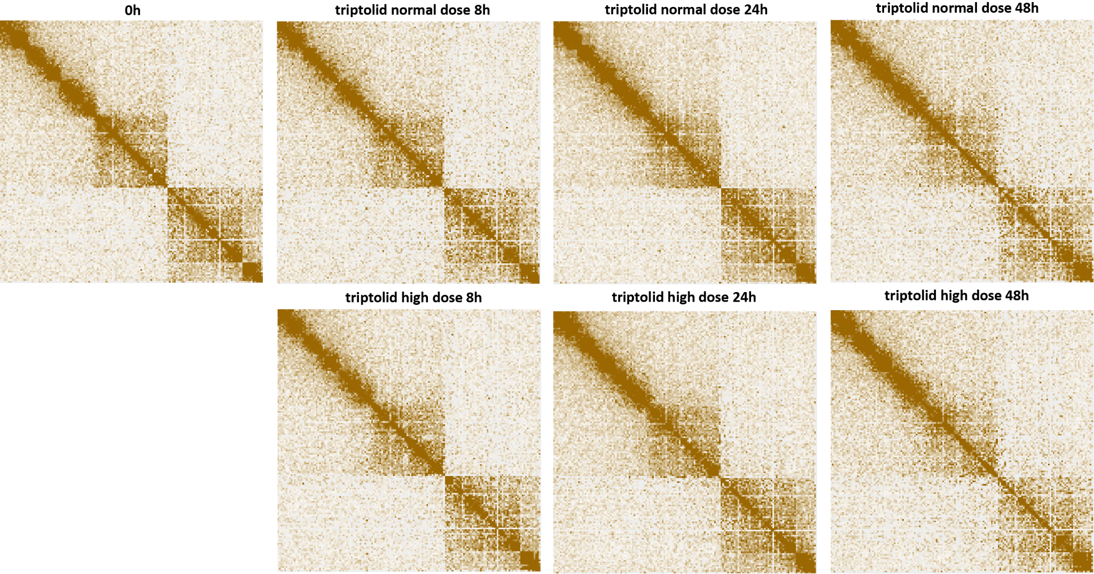
Supplementary Figure 27: Blurring of dinoTAD boundaries upon transcriptional inhibition using triptolide. Shown is pseudochromosome 18. The triptolide time course was carried out following the outline presented in Figure 2B.
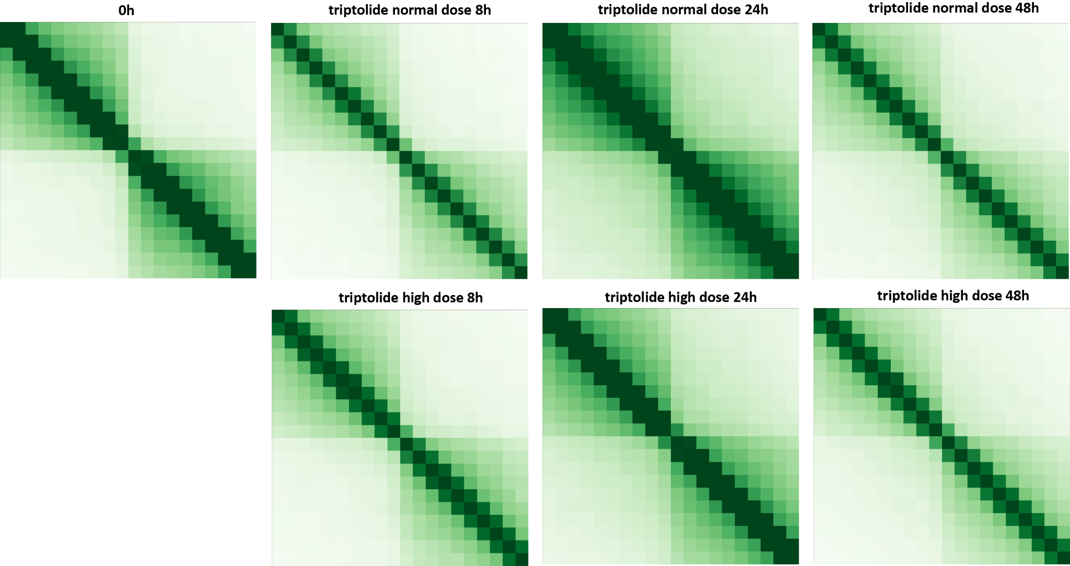
Supplementary Figure 28: Blurring of dinoTAD boundaries upon transcriptional inhibition using triptolide. Shown are 50-kb resolution metaplots centered on dinoTAD domain boundaries. The triptolide time course was carried out following the outline presented in Figure 2B.

