Transcription-dependent domain-scale 3D genome organization in dinoflagellates
Georgi K. Marinov^{1,*,#}, Alexandro E. Trevino^{3,7,*}, Tingting Xiang^{2,8,*}, Anshul Kundaje^{1,6}, Arthur R. Grossman², and William J. Greenleaf^{1,3,4,5,#}
- Department of Genetics, Stanford University, Stanford, California 94305, USA
- Carnegie Institution for Science, Department of Plant Biology, Stanford, California 94305, USA
- Center for Personal Dynamic Regulomes, Stanford University, Stanford, California 94305, USA
- Department of Applied Physics, Stanford University, Stanford, California 94305, USA
5
Chan Zuckerberg Biohub, San Francisco, California, USA
- Department of Computer Science, Stanford University, Stanford, California 94305, USA
- Department of Bioengineering, Stanford University, Stanford, California 94305, USA
- Department of Biological Sciences, University of North Carolina at Charlotte, Charlotte, NC 28223, USA
* These authors contributed equally to this work
#
Corresponding author

Abstract
tan
Dinoflagellate chromosomes represent a unique evolutionary experiment, as they exist in a permanently condensed, liquid crystalline state, are not packaged by histones, and contain genes organized into dem gene arrays, with minimal transcriptional regulation. We analyze the 3D genome of Breviolum minutum, and find large topological domains without chromatin loops, demarcated by convergent gene array boundaries (“dinoTADs). Transcriptional inhibition degrades dinoTADs, implicating transcription-induced supercoiling as the primary topological force in di-

noflagellates.
The three-dimensional (3D) genome architecture of cells has functional consequences for gene regulation, organismal development, replication, and mutational processes. Mechanisms known to drive genome folding in eukaryotes include constraints on cohesin-mediated loop extrusion – imposed by CTCF in vertebrates – that generate topologically associating domains (TADs), and self-associations between similar chromatin states that form compartments¹. However, the extent to which genome function itself may influence genome folding, for example through transcriptional activity, is poorly understood. There has also been little exploration of 3D organization across eukaryotes, even though major deviations from conventional norms are known to exist, presenting natural experiments that may reveal deeper underlying organizational principles masked in other lineages.
Dinoflagellates are the most radical such departure. They are a diverse, widespread clade playing major roles in aquatic ecosystems, for example, as symbioints of corals, providing the metabolic basis for reef ecosystems. Dinoflagellates possess numerous highly divergent molecular features², including, uniquely among eukaryotes, the loss of nucleosomal packaging of chromatin. Histones are extremely conserved across eukaryotes, were present in their current form already in the Last Eukaryotic Common Ancestor³, and they and their posttranslational modifications are pivotal to all biochemical processes involving chromatin.
tan
Dinoflagellates are the sole known exception. Their chromosomes exist in a liquid crystalline state, are permanently condensed throughout the cell cycle, and, although highly divergent histone genes are retained in their genomes⁴, a combination of virus-derived nucleoproteins and bacterial-derived histone-like proteins have taken over as main packaging components⁵. Dinoflagellate genomes are often huge (up to ≥100 Gbp), genes are organized into dem gene arrays, individual mRNAs are generated through trans-splicing, and transcriptional regulation is largely absent. These fascinating features simultaneously pose intriguing questions regarding the adaptation of transcriptional and regulatory mechanisms to the absence of nucleosomes, and provide a unique opportunity to explore the biophysical forces underlying genomic organization in the context of a large eukaryotic genome nearly devoid of nucleosomes.
ap | plied | chro
mo | some | con | for | ma | tion | cap | ture | us | ing | Hi-
To explore these questions, we performedC on the coral sym-
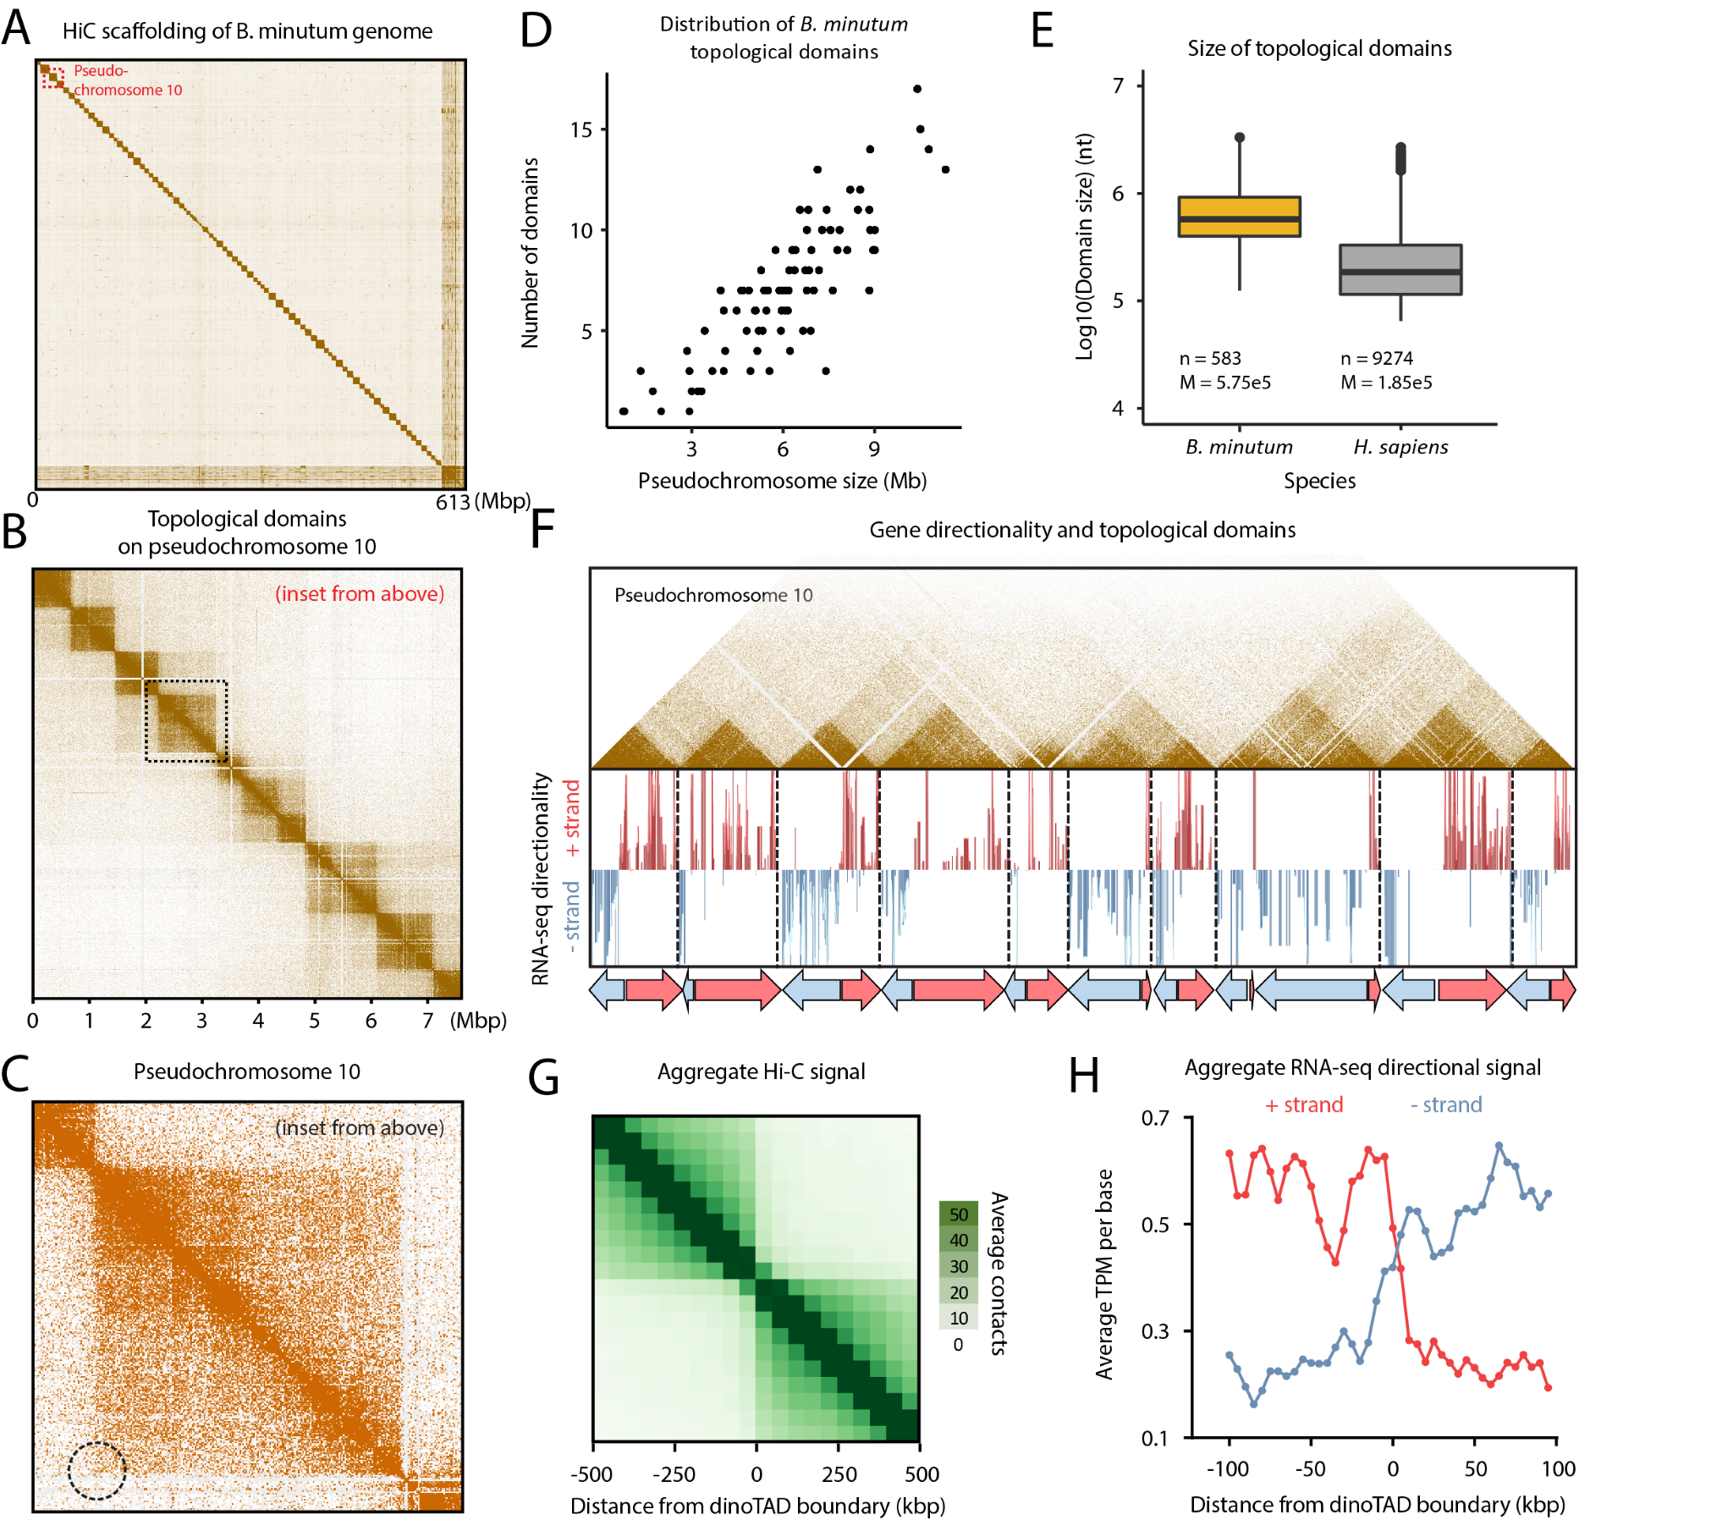
tan
(dot | ted | cir | cle
Figure 1: B. minutum genome is physically partitioned into dinoTADs defined by dem gene arrays. (A) Hi-C scaffolding of the B. minutum draft genome assembly. (B) Inset from (A). KR-normalized 5-kb resolution Hi-C map for pseudochromosome 10. (C) Inset from (B). Hi-C loops and stripes are not observed in dinoTADs notes where a loop would be). (D) Scales of chromosome size with dinoTAD number. (E) Comparison of human and B. minutum topological domain sizes. (F) Hi-C map (5-kb resolution) for pseudochromosome 10 together with forward- and reverse-strand transcript levels and gene arrays. (G) Average Hi-C contacts across dinoTAD boundaries. (H) Average forward- and reverse-strand RNA-seq levels across dinoTAD boundaries.
biont Breviolum minutum. We generated multiple libraries under standard growth conditions and for cells grown at elevated temperature, obtaining ∼150–220 million Hi-C contacts for each (Supplementary Table 1). We pooled these libraries to generate a chromosome-level scaffolding of the previously fragmented B. minutum assembly⁶. We identified 91 major pseudochromosomes (≥ 500 kbp), encompassing ∼94% of the total sequence (Fig. 1A-B; Supplementary Fig. 1A), the longest being ∼11 Mbp in size, with a median length of 6.7 Mbp (Supplementary Fig. 1A). At 1-Mbp resolution, they exhibit a bipartite (occasionally tripartite) structure (Supplementary Fig. 2).
(of | note, | omit | ting | the
High-resolution maps revealed very strong topological domains, ≤200–≥2 Mbp in size (Fig. 1B-E; Supplementary Fig. 3–12). In mammals, TAD boundaries are demarcated by CTCF sites blocking loop extrusion, reflected in Hi-C maps by chromatin loops and “stripes”. We observe no loop or stripe features in B. minutum (Fig. 1C), suggesting a different mechanism for the formation of dinoflagellate TADs, which we term “dinoTADs”
de | nat | u | ra | tion | step | in | the | Hi- | C | pro | to | col, | which | should | bet
-
ter | pre |  | serve |  | pro |  | tein | -pro | tein | con |  | tacts |  | strongly |  |  | ac |  | cen |  | tu | ated
dino |  | TADs, |  | but |  | still |  | did | not | re | veal |  | signs |  | of | loops |  | or |  | loop |  |  | ex
-
tru | sion | do | mains; | Sup | ple | men | tary
Fig. 14). DinoTAD num-
ber correlates with chromosome size (Fig. 1D), and they are considerably larger than mammalian TADs (Fig. 1E).
We next compared Hi-C maps to available annotation features. Remarkably, we found that each dinoTAD corresponds to a pair of divergent gene arrays (Fig. 1F), and dinoTAD boundaries coincide with convergence between gene arrays (Fig. 1G-H).
Nu | mer | ous | mod | els | for | di | noflagel | late | chro | mo | some | or | ga
-
ni | za | tion |  | have |  |  | been |  |  | sug | gested | since | the |  | 1960s, |  | pri |  | mar |  | ily
based |  |  | on |  | elec | tron |  | mi | croscopy. |  |  | These | in | clude |  | pro | pos | als |  | that
chro | mo | somes | are | or | ga | nized | as | “toroidal | chromone | mas”
8,
“stacks | of | discs” | 9, | “cored | pineap | ples” | 10, | or | around | “cen | tral
core | fibers” | 11. | Most | of | these | mod | els | im | ply | spe | cific | topo | log
-
cal | con | straints | main | tain | ing | the | pro | posed | shapes | and | are
i not directly reconcilable with our Hi-C observations.
We | also | note | that
Instead, the correspondence between dinoTADs and gene arrays suggested a role for transcription in their formation. Although TADs form independently of transcription in metazoan cells, transcription-induced self-interacting domains have been previously demonstrated in bacteria¹², and similar mechanisms have been proposed to explain some topological features in fission yeast¹³. a-
 | hand |  | ful | of | mod |  | els |  | of |  | di |  | noflag |  | el | late |  |  | chro | mo | some | struc
 |  | have |  | sug |  | gested |  |  | the |  |  | pres |  | ence |  | of |  | coil/plectoneme- |  |  |  |  | like
ture
fea | tures | 14,15, | but | with | out | re | lat | ing | them | to | gene | ar | rays | and
tran | scrip
tion. This model makes a clear prediction – inhibition of transcription should result in dinoTADs decompaction.
To test this relationship, we first compared Hi-C maps for cells grown at 34◦C versus 27◦C, as heat stress could result in general transcription reduction¹⁶. We observed mild decompaction of dinoTADs at 34◦C, though domains remained intact (Supplementary Fig. 19–21).
While | di | noflag
We next carried out chemical transcription inhibition experiments. Since transcription inhibition conditions for B. minutum are not well established, we chose two inhibitors – triptolide and α-amanitin – with distinct mechanisms of action, and assayed multiple time points and doses (Fig. 2A-B). Amanitin directly inhibits RNA Polymerase II and is slow acting, while triptolide quickly blocks initiation by targeting the TFIIH XPB subunit¹⁷. el-
late |  | RNA | poly | merase |  | II | has |  | been |  | re |  | ported |  | to | be |  | sensi | tive
to | α | -aman | itin | it is | pos | sible |  | that |  | the |  | sensi |  | tiv | ity | is | some |  | what
par | tial | 18; | in | ad | di | tion, | the | B. | min | u | tum | XPB | ho | molog
is
highly | di | ver | gent | 6, | thus | a | mod | er | ate | in | hi | bi | tion | effect | is | not
un | ex | pected. |  |  | We |  | there |  |  | fore |  | car | ried |  | out | sev |  | eral |  | ex |  | per |  | iments
to | di | rectly |  | es |  | timate |  |  | the |  | ex | tent |  | of | tran | scrip |  |  | tion |  | in |  | hi | bi | tion.
How |  | ever, | we |  | were |  |  | not |  | able |  | to | per |  | form | di | rect |  |  | metabolic |  |  |  |  |  | la
-
bel | ing | fol | low | ing | ap | proaches | such | as | SLAM- | seq | 19 | as | it | ap
-
pears | that | Sym | bio | dini | aceae | cells | are | im | per | me | able | to | nu
-
cleotide | and | nu | cle | o | side | analogs | such | as | 4SU | and | 4TU. | We
were, |  |  | how | ever, |  | able |  | to |  | qual | ita | tively |  | as | sess |  | in | hi | bi | tion |  | us |  | ing
the |  | proxy |  | of | nascent |  |  |  | RNA |  | as | mea | sured |  |  | by | the |  | pro |  | por |  | tion
of | un |  | spliced |  | reads |  | in |  | PolyA+ |  |  | RNA |  | -seq |  | datasets |  |  |  | (Sup |  |  | ple
-
men | tary | Fig. | 30); | we | ob | serve | more | than | 50% | re | duc | tion | in
un | spliced |  |  | reads |  |  | in | both |  | α- | aman |  |  | itin- |  | and |  |  | trip |  | tolide |  |  | -cells |  | af
ter | 48 |  | hours |  | sug |  | gest |  | ing | that |  | tran |  |  | scrip |  |  | tion |  | has |  | in | deed |  | been
in | hib | ited. |  | We |  | also |  | did |  | not |  | ob | serve |  |  |  | large- |  |  | scale |  | changes |  |  |  | in
-
the | lev | els | of | in | di | vid | ual | tran | scripts | (Sup | ple | men | tary | Fig.
31). Finally, even at high doses, α-amanitin treatment did not detectably affect photosynthetic efficiency or cell viability relative to controls (Fig. 2C), excluding cell death as a confounding factor.
pen | dent, | pro | gres | sive | dino | TAD | de | com
We | also | ob | served | clear | dose- | de | pen | dent
Strikingly, α-amanitin treatment resulted in a dose-depaction (Fig. 2D,F; Supplementary Fig. 22–25). These effects were observed in both technical and biological replicates (Supplementary Fig. 22–25).
blur | ring |  | of | dino |  | TAD |  | bound |  | aries | af | ter | trip |  | tolide | treat |  | ment,
though |  | broad |  |  | dino |  | TAD- |  | like | struc | tures |  | re | mained |  | visi | ble |  | to | a
greater extent than in α-amanitin-treated cells (Fig. 2E-F; Supplementary Fig. 26–29).
These experiments support a transcription-induced supercoiling model for dinoTAD formation. Torque generated by active polymerases produces positive/negative supercoiling ahead of/behind the transcription bubble. This can alter the twist of the double helix or induce superhelical writhe, which in turn can be accommodated through nucleosome remodeling, local alterations in DNA secondary structure, or formation of writhed structures such as plectonemes²⁰.
Although other topological constraints might also be involved, supercoiling-induced plectoneme formation over gene arrays is an intuitive mechanistic explanation for the presence of dinoTADs. An examination of dinoflagellate gene repertoires also corroborates this model, revealing a striking, dinoflagellate-specific expansion of topoisomerase II- and topoisomerase III-like genes (Fig. 1D; Supplementary Fig. 18; Supplementary Table 2), further suggestive of contending with increased levels of writhed forms of helical twist.
Comparison with self-interacting domains in bacteria or S. pombe shows much stronger topological insulation for dinoTADs (Supplementary Fig. 15) and 16)). Remarkably, no TAD domains are observed in kinetoplastids, the other lineage with long gene arrays and no transcriptional regulation (Supplementary Fig. 17).
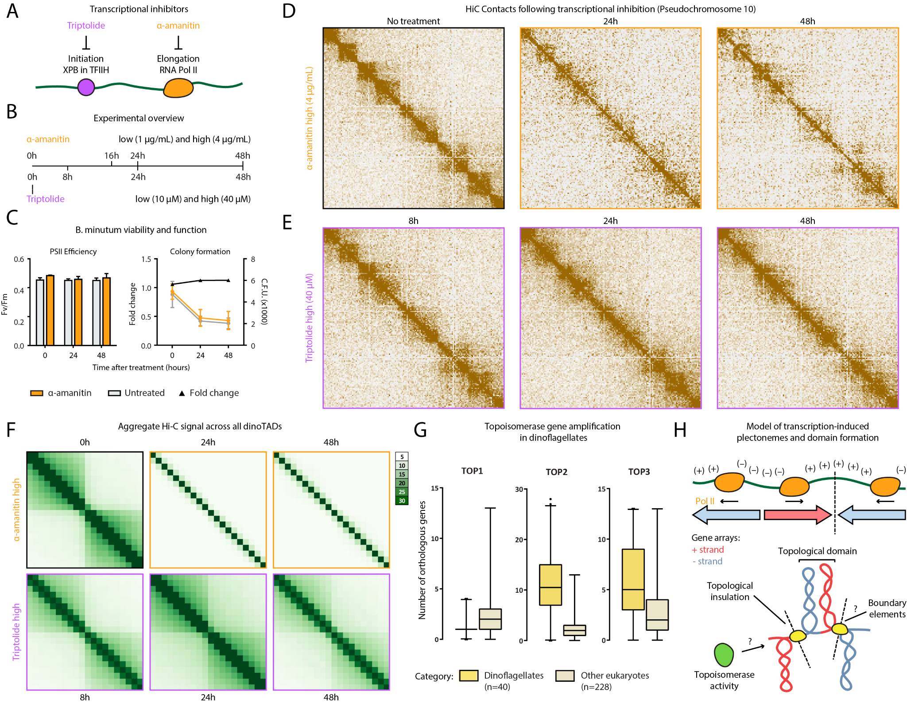
Figure 2: Decompaction of dinoTADs upon application of transcriptional inhibitors and the transcriptioninduced supercoiling model for their formation. Shown is pseudochromosome 10. (A-B) Outline of transcription inhibition time course experiments. (C) Comparison of cell function, measured by PSII photosythetic efficiency, and cell viability, measured by colony formation (right), between α-amanitin-treated and untreated cells. (D) KR-normalized Hi-C maps (50-kb resolution) show marked loss of dinoTADs after α-amanitin treatment. (E) Hi-C maps show reduction of insulation at dinoTAD boundaries after triptolide treatment. (F) Metaplots of Hi-C signal around domain boundaries (50-kb resolution). (G) Amplification of TOP2 and TOP3 topoisomerases in dinoflagellates (based on MMETSP⁷ transcriptome assemblies). (H) Transcription-induced supercoiling as driver of dinoflagellate chromatin folding. Transcribing polymerases introduce negative/positive DNA supercoiling behind/ahead of the transcription machinery. Interactions within supercoiled domains could explain the physical association of divergently-oriented arrays. Topological insulation could be driven by supercoiling-related effects, or by specific boundary elements.
These differences can be rationalized by the unusual dinoflagellate properties. First, neither bacteria nor yeast possess comparably long gene arrays and transcription in those species is highly nonuniform; less transcriptioninduced torsional stress is therefore expected. Nucleosome loss is the second, and most salient difference. Single mammalian genes as long as dinoTADs are quite common, yet supercoiling is not apparent in mammalian Hi-C maps, nor is it seen in kinetoplastids, which have gene arrays but also have conventional chromatin. We therefore hypothesize that plectonemic structures form due to transcriptioninduced supercoiling in the nucleosome-depleted genomes of dinoflagellates, while in other eukaryotes, a combination of the wrapping of DNA around nucleosomes, interactions between nucleosomes, and accumulation of DNA twist, prevent their formation (Fig. 2H).
These results generate a number of open questions. How exactly are boundaries between dinoTADs formed mechanistically? Specific boundary elements of markedly different chromatin state could exist; alternatively, these boundaries may self-organize purely through torsion-related mechanisms. The roles that dinoflagellates’ divergent histone genes play is also not clear. Finally, the relationship between Hi-C features and the “toroidal chromonemas”⁸ observed by electron microscopy remains unknown. Answers to these questions, together with the dissection of specific roles different topoisomerase classes, will help fully elucidate the interplay between packaging proteins, transcription-induced torsional stress, and genome folding in dinoflagellates.
These observations also identify transcription-induced torsional stress as a key direction of future studies in eukaryotes generally. The strength of dinoTADs underlines the potency of this fundamental biological process for generating topological structure. The precise manner by which torsion is accommodated as twist and writhe, as well as its consequences for regulatory protein occupancy, transcriptional activity, and other chromatin processes, such as the behavior of ATP-dependent chromatin remodelers, are exciting questions remaining to be unraveled.

Author contributions
G.K.M. performed Hi-C experiments. G.K.M and A.E.T. analyzed the data. A.E.T. and T.X. designed and carried out transcription inhibition experiments and cell viability experiments. T.X. carried out S. minutum culture and heat stress treatment. W.J.G., A.R.G.. A.K. and J.R.P. supervised the study. G.K.M., A.E.T. and T.X. interpreted data and wrote manuscript with input from all authors.

Acknowledgments
This work was supported by NIH grants (P50HG007735, RO1 HG008140, U19AI057266 and UM1HG009442 to W.J.G., 1UM1HG009436 to W.J.G. and A.K., 1DP2OD022870-01 and 1U01HG009431 to A.K.), the Rita Allen Foundation (to W.J.G.), the Baxter Foundation Faculty Scholar Grant, and the Human Frontiers Science Program grant RGY006S (to W.J.G). W.J.G is a Chan Zuckerberg Biohub investigator and acknowledges grants 2017-174468 and 2018-182817 from the Chan Zuckerberg Initiative. Fellowship support provided by the Stanford School of Medicine Dean’s Fellowship (G.K.M.), the Siebel Scholars, the Enhancing Diversity in Graduate Education Program and the Weiland Family Fellowship (A.E.T.). This work is also supported by NSF-IOS EDGE Award 1645164 and Carnegie Venture grant 10907 (to T.X. and G.K.M.).
The authors would like to thank Zohar Shipony, Erez Lieberman Aiden, Olga Dudchenko, John R. Pringle, Philip Cleves, and members of the Greenleaf, Kundaje, Pringle and Grossman labs for helpful discussion and suggestions regarding this work.

References
- Szabo Q, Bantignies F, Cavalli G. 2019. Principles of genome folding into topologically associating domains. Sci Adv 5(4):eaaw1668.
- Hackett JD, Anderson DM, Erdner DL, Bhattacharya D. 2004. Dinoflagellates: a remarkable evolutionary experiment. Am J Bot 91:1523–1534.
- Postberg J, Forcob S, Chang WJ, Lipps HJ. 2010. The evolutionary history of histone H3 suggests a deep eukaryotic root of chromatin modifying mechanisms. BMC Evol Biol 10:259.
- Marinov GK, Lynch M. 2015. Diversity and Divergence of Dinoflagellate Histone Proteins. G3 (Bethesda) 6(2):397–422.
- Janouˇskovec J, Gavelis GS, Burki F, Dinh D, Bachvaroff TR, Gornik SG, Bright KJ, Imanian B, Strom SL, Delwiche CF, Waller RF, Fensome RA, Leander BS, Rohwer FL, Saldarriaga JF. 2017. Major transitions in dinoflagellate evolution unveiled by phylotranscriptomics. Proc Natl Acad Sci U S A 114(2):E171– E180.
- Shoguchi E, Shinzato C, Kawashima T, Gyoja F, Mungpakdee S, Koyanagi R, Takeuchi T, Hisata K, Tanaka M, Fujiwara M, Hamada M, Seidi A, Fujie M, Usami T, Goto H, Yamasaki S, Arakaki N, Suzuki Y, Sugano S, Toyoda A, Kuroki Y, Fujiyama A, Medina M, Coffroth MA, Bhattacharya D, Satoh N. 2013. Draft assembly of the Symbiodinium minutum nuclear genome reveals dinoflagellate gene structure. Curr Biol 23(15):1399–1408.
- Keeling PJ, Burki F, Wilcox HM, Allam B, Allen EE, Amaral-Zettler LA, Armbrust EV, Archibald JM, Bharti AK, Bell CJ, Beszteri B, Bidle KD, Cameron CT, Campbell L, Caron DA, Cattolico RA, Collier JL, Coyne K, Davy SK, Deschamps P, Dyhrman ST,
Edvardsen B, Gates RD, Gobler CJ, Greenwood SJ, Guida SM, Jacobi JL, Jakobsen KS, James ER, Jenkins B, John U, Johnson MD, Juhl AR, Kamp A, Katz LA, Kiene R, Kudryavtsev A, Leander BS, Lin S, Lovejoy C, Lynn D, Marchetti A, McManus G, Nedelcu AM, Menden-Deuer S, Miceli C, Mock T, Montresor M, Moran MA, Murray S, Nadathur G, Nagai S, Ngam PB, Palenik B, Pawlowski J, Petroni G, Piganeau G, Posewitz MC, Rengefors K, Romano G, Rumpho ME, Rynearson T, Schilling KB, Schroeder DC, Simpson AG, Slamovits CH, Smith DR, Smith GJ, Smith SR, Sosik HM, Stief P, Theriot E, Twary
SN, Umale PE, Vaulot D, Wawrik B, Wheeler GL, Wilson WH, Xu Y, Zingone A, Worden AZ. 2014. The Marine Microbial Eukaryote Transcriptome Sequencing Project (MMETSP): illuminating the functional diversity of eukaryotic life in the oceans through transcriptome sequencing. PLoS Biol 12(6):e1001889.
- Oakley BR. Dodge JD. 1979. Evidence for a doublehelically coiled toroidal chromonema in the dinoflagellate chromosome. Chromosoma 70:277–291.
- Livolant F, Bouligand, Y. 1978. New observations on the twisted arrangement of dinoflagellate chromosomes. Chromosoma 68:21–44.
- Levi-Setti R, Gavrilov KL, Rizzo PJ. 2008. Divalent cation distribution in dinoflagellate chromosomes imaged by high-resolution ion probe mass spectrometry. Eur J Cell Biol 87(12):963–976.
- Spector DL, Triemer RE. 1981. Chromosome structure and mitosis in the dinoflagellates: an ultrastructural approach to an evolutionary problem. Biosystems 14(3–4):289–298.
- Le TB, Imakaev MV, Mirny LA, Laub MT. 2013.
High-resolution mapping of the spatial organization of a bacterial chromosome. Science 342(6159):731–734.
- Benedetti F, Racko D, Dorier J, Burnier Y, Stasiak A. 2017. Transcription-induced supercoiling explains formation of self-interacting chromatin domains in S.
pombe. Nucleic Acids Res 45(17):9850–9859.
- Livolant F, Bouligand Y. 1980. Double helical arrangement of spread dinoflagellate chromosomes. Chromosoma 80:97–118.
- Wong JTY. 2019. Architectural Organization of Dinoflagellate Liquid Crystalline Chromosomes. Microorganisms 7(2):27.
- Levin RA, Beltran VH, Hill R, Kjelleberg S, McDougald D, Steinberg PD, van Oppen MJ. 2016. Sex, Scavengers, and Chaperones: Transcriptome Secrets of Divergent Symbiodinium Thermal Tolerances. Mol Biol Evol 33(9):2201–2215.
- Bensaude O. 2011. Inhibiting eukaryotic transcription: Which compound to choose? How to evaluate its activity? Transcription 2(3):103–108.
- Rizzo PJ. 1979. RNA synthesis in isolated nuclei of the dinoflagellate Crypthecodinium cohnii. J Protozool 26(2):290–294.
- Herzog VA, Reichholf B, Neumann T, Rescheneder P, Bhat P, Burkard TR, Wlotzka W, von Haeseler A, Zuber J, Ameres SL. 2017. Thiol-linked alkylation of RNA to assess expression dynamics. Nat Methods 14(12):1198–1204.
- Teves SS, Henikoff S. 2014. DNA torsion as a feedback mediator of transcription and chromatin dynamics. Nucleus 5(3):211–218.
- Xiang T, Hambleton EA, DeNofrio JC, Pringle JR, Grossman AR. 2013. Isolation of clonal axenic strains of the symbiotic dinoflagellate Symbiodinium and their growth and host specificity. J Phycol 49(3):447–458.
- Xiang T, Nelson W, Rodriguez J, Tolleter D, Grossman AR. 2015. Symbiodinium transcriptome and global responses of cells to immediate changes in light intensity when grown under autotrophic or mixotrophic conditions. Plant J 82(1):67–80.
- Rao SS, Huntley MH, Durand NC, Stamenova EK,
Bochkov ID, Robinson JT, Sanborn AL, Machol I, Omer AD, Lander ES, Aiden EL. 2014. A 3D map of the human genome at kilobase resolution reveals principles of chromatin looping. Cell 159(7):1665–1680.
- Durand NC, Shamim MS, Machol I, Rao SS, Huntley MH, Lander ES, Aiden EL. 2016. Juicer Provides a One-Click System for Analyzing Loop-Resolution HiC Experiments. Cell Syst 3(1):95–98.
- Dudchenko O, Batra SS, Omer AD, Nyquist SK, Hoeger M, Durand NC, Shamim MS, Machol I, Lander ES, Aiden AP, Aiden EL. 2017. De novo assembly of the Aedes aegypti genome using Hi-C yields chromosome-length scaffolds. Science 356(6333):92– 95.
- Ram´ırez F, Bhardwaj V, Arrigoni L, Lam KC, Gru¨ning BA, Villaveces J, Habermann B, Akhtar A, Manke T. 2018. High-resolution TADs reveal DNA sequences underlying genome organization in flies. Nat Commun 9(1):189.
- Dobin A, Davis CA, Schlesinger F, Drenkow J, Zaleski C, Jha S, Batut P, Chaisson M, Gingeras TR. 2013. STAR: ultrafast universal RNA-seq aligner. Bioinformatics 29(1):15–21.
- Langmead B, Trapnell C, Pop M, Salzberg SL. 2009. Ultrafast and memory-efficient alignment of short DNA sequences to the human genome. Genome Biol
10(3):R25.
- Roberts A, Pachter L. 2013. Streaming fragment assignment for real-time analysis of sequencing experiments. Nat Methods 10(1):71-73.
- Love MI, Huber W, Anders S. 2014. Moderated estimation of fold change and dispersion for RNA-seq data with DESeq2. Genome Biol 15(12):550.
- Pertea M, Pertea GM, Antonescu CM, Chang TC, Mendell JT, Salzberg SL. 2015. StringTie enables improved reconstruction of a transcriptome from RNAseq reads. Nat Biotechnol 33(3):290-295.
- Eddy SR. 2011. Accelerated Profile HMM Searches. PLoS Comput Biol 7(10):e1002195.
- Finn RD, Bateman A, Clements J, Coggill P, Eberhardt RY, Eddy SR, Heger A, Hetherington K, Holm L, Mistry J, Sonnhammer EL, Tate J, Punta M. 2014. Pfam: the protein families database. Nucleic Acids Res 42(Database issue):D222–230.
- Knight P, Ruiz D. 2013. A fast algorithm for matrix balancing. IMA J Num Anal 33(3):1029–1047.
- Hou Y, Ji N, Zhang H, Shi X, Han H, Lin S. 2019. Genome size-dependent pcna gene copy number in dinoflagellates and molecular evidence of retroposition as a major evolutionary mechanism. J Phycol
55(1):37–46.

Supplementary Materials

Supplementary Methods

Except where otherwise stated, computational analyses were carried out using custom-written Python scripts.

B. minutum cell culture
The clonal axenic Breviolum minutum strain SSB01 was used in all experiments. Stock cultures were grown as previously described^{21,22} in Daigo’s IMK medium for marine microalgae (Wako Pure Chemicals) supplemented with casein hydrolysate (IMK+Cas) at 27◦C at a light intensity of 10 µmol photons m² s¹ from Philips ALTO II 25-W bulbs on a 12-h-light:12-h-dark cycle. The medium was prepared in artificial seawater (ASW).

Transcription inhibition experiments
For α-amanitin treatment, Breviolum minutum cells at a density of ∼1 ×10⁶ cells/mL were treated with α-amanitin (Sigma-Aldrich, Cat # A2263) at concentrations of 1 µg/mL (“normal” dose) and 4 µg/mL (”high”) dose.
Samples were harvested at 0, 24, and 48 hours after treatment.
For triptolide treatment, Breviolum minutum cells at a density of ∼1 ×10⁶ cells/mL were treated with triptolide (Sigma-Aldrich, Cat # T3652) at concentrations of 10 µM (“normal” dose) and 40 µM (”high”) dose.
Samples were harvested at 0, 8, 24 and 48 hours after treatment.

Cell viability measurements
Photosynthetic activity
Maximum quantum yields of photosystem II, Fv/Fm = (Fm−F0)/Fm was used to indicate photosynthetic function. S. minutum cultures (approximately 10⁶ cells/mL) were collected and dark adapted for 5 min, and Fv/Fm was determined using a Dual Pam-100 fluorometer (Heinz Walz).
Colony formation assay
Fresh SSB01 cells were sampled at 0, 24 and 48 hours after the treatment of transcription inhibitor α-amanitin. For each condition, cell suspensions were diluted 1:5 and 1:10 before plating 1 µL of each dilution on marine broth (BD) agar plates. Plates were incubated at 27◦C at a light intensity of 10 µmol photons m² s¹. Cell numbers on each plate were counted after three weeks.

Hi-C experiments
The in situ Hi-C procedure used to map 3D genomic interactions in B. minutum was adapted from previous studies²³ as follows:
B. minutum SSBO1 cells were first crosslinked using 37% formaldehyde (Sigma) at a final concentration of 1% for 15 minutes at room temperature. Formaldehyde was then quenched using 2.5 M Glycine at a final concentration of 0.25 M. Cells were subsequently centrifuged at 2,000 g for 5 minutes, washed once in 1× PBS, and stored at -80◦C.
(ex
Cell lysis was initiated by incubation with 250 µL of cold Hi-C Lysis Buffer (10 mM Tris-HCl pH 8.0, 10 mM NaCl, 0.2% Igepal CA630) on ice for 15 minutes, followed by centrifugation at 2,500 g for 5 minutes, a wash with 500 µL of cold Hi-C Lysis Buffer, and centrifugation at 2,500 g for 5 minutes. The pellet was the resuspended in 50 µL of 0.5% SDS and incubated at 62◦C for 10 minutes-
cept | for | the | “no- | de | nat | u | ra | tion | sam | ple, | for | which | the | pel | let
was | re | sus | pended | in | 50 | µL | H₂
O). SDS was quenched by
adding 145 µL of H₂O and 25 µL of 10% Triton X-100 and incubating at 37◦C for 15 minutes.
Restriction digestion was carried out by adding 25 µL of 10× NEBuffer 2 and 100 U of the MboI restriction enzyme (NEB, R0147) and incubating for ≥2 hours at 37◦C in a Thermomixer at 900 rpm. The reaction was then incubated at 62◦C for 20 minutes in order to inactivate the restriction enzyme.
Fragment ends were filled in by adding 37.5 µL of 0.4 mM biotin-14-dATP (ThermoFisher Scientific, # 19524016), 1.5 µL each of 10 mM dCTP, dGTP and dTTP, and 8
µL of 5U/µL DNA Polymerase I Large (Klenow) Fragment (NEB M0210). The reaction was the incubated at 37◦C in a Thermomixer at 900 rpm for 45 minutes.
Fragment end ligation was carried out by adding 663 µL H₂O, 120 µL 10× NEB T4 DNA ligase buffer (NEB B0202), 100 µL of 10% Triton X-100, 12 µL of 10 mg/mL Bovine Serum Albumin (100× BSA, NEB), 5 µL of 400 U/µL T4 DNA Ligase (NEB M0202), and incubating at room temperature for ≥4 hours with rotation.
Nuclei were then pelleted by centrifugation at 3,500 g for 5 minutes; the pellet was resuspended in 200 µL ChIP Elution Buffer (1% SDS, 0.1 M NaHCO₃), Proteinase K was added, and incubated at 65◦C overnight to reverse crosslinks.
After addition of 600 µL 1×TE buffer, DNA was sonicated using a Qsonica S-4000 with a 1/16” tip for 3 minutes, with 10 second pulses at intensity 3.5, and 20 seconds rest between pulses. DNA was then purified using the MinElute PCR Purificaiton Kit (Qiagen #28006), with elution in a total volume of 300 µL 1× EB buffer.
For streptavidin pulldown of biotin-labeled DNA, 150
µL of 10 mg/mL Dynabeads MyOne Streptavidin T1 beads (Life Technologies, 65602) were separated on a magnetic stand, then washed with 400 µL of 1× TWB (Tween Washing Buffer; 5 mM Tris-HCl pH 7.5; 0.5 mM EDTA; 1 M NaCl; 0.05% Tween 20). The beads were resuspended in 300 µL of 2× Binding Buffer (10 mM Tris-HCl pH 7.5, 1 mM EDTA; 2 M NaCl), the sonicated DNA was added, and the beads were incubated for ≥15 minutes at room temperature on a rotator. After separation on a magnetic stand, the beads were washed with 600 µL of 1× TWB, and heated at 55◦C in a Thermomixer with shaking for 2 minutes. After removal of the supernatant on a magnetic stand, the TWB wash and 55◦C incubation were repeated.
Final libraries were prepared on beads using the NEBNext Ultra II DNA Library Prep Kit (NEB, #E7645) as follows. End repair was carried out by resuspending beads in 50 µL 1× EB buffer, and adding 3 µL NEB Ultra End Repair Enzyme and 7 µL NEB Ultra End Repair Enzyme, followed by incubation at 20◦C for 30 minutes and then at 65◦C for 30 minutes.
Adapters were ligated to DNA fragments by adding 30 µL Blunt Ligation mix, 1 µL Ligation Enhancer and 2.5 µL NEB Adapter, incubating at 20◦C for 20 minutes, adding 3 µL USER enzyme, and incubating at 37◦C for 15 minutes.
Beads were then separated on a magnetic stand, and washed with 600 µL TWB for 2 minutes at 55◦C, 1000 rpm in a Thermomixer. After separation on a magnetic stand, beads were washed in 100 µL 0.1 × TE buffer, then resuspended in 16 µL 0.1 × TE buffer, and heated at 98◦C for 10 minutes.
For PCR, 5 µL of each of the i5 and i7 NEB Next sequencing adapters were added together with 25 µL 2× NEB Ultra PCR Mater Mix. PCR was carried out with a 98◦C incubation for 30 seconds and 12 cycles of 98◦C for 10 seconds, 65◦C for 30 seconds, and 72◦C for 1 minute, followed by incubation at 72◦C for 5 minutes.
Beads were separated on a magnetic stand, and the supernatant was cleaned up using 1× AMPure XP beads.
Libraries were sequenced in a paired-end format on a Illumina NextSeq instrument using NextSeq 500/550 high output kits (either 2×75 or 2×36 cycles).

Hi-C data processing and assembly scaffolding
As an initial step, Hi-C sequencing reads from all libraries were trimmed of adapter sequences, pooled together, and processed against the previously published B. minutum assembly⁶ using the Juicer pipeline²⁴ for analyzing Hi-C datasets (version 1.8.9 of Juicer Tools).
The resulting Hi-C matrices were then used as input to the 3D DNA pipeline²⁵ for automated scaffolding with the following parameters: --editor-coarse-resolution5000 --editor-coarse-region 5000 --polisher-input-size
100000--polisher-coarse-resolution1000
--polisher-coarse-region300000
--splitter-input-size100000 --splitter-coarse-resolution5000
--splitter-coarse-region 300000 --sort-output --build-gapped-map-r 10-i 5000.
Manual correction of obvious assembly and scaffolding errors was then carried out using Juicebox²⁴.
After finalizing the scaffolding, Hi-C reads were reprocessed against the new assembly using the Juicer pipeline. This was done individually for each library as well as together for the pooled set of reads.
Data was extracted from the final read matrices using the Juicer suite of tools for Hi-C data analysis.

Identification of Hi-C domains
Hi-C matrices were first converted to cool format using HiCExplorer²⁶ “hicConvertFormat” with parameters
--inputFormathic--outputFormath5 and default resolutions. Subsequent HiCExplorer commands were carried out at 10 kb, 25 kb, and 50 kb resolutions with similar results. Matrices were normalized using “hicNormalize” with parameter --normalize smallest, and corrected using ‘‘hicCorrectMatrix correct” with parameters --correctionMethodKR. Hi-C domains were computationally identified using the “hicFindTADs” from HiCExplorer with parameter --correctForMultipleTestingfdr.
RNA- | seq | ex | peri | ments
Total RNA was isolated following previously described protocols²².
RNA-seq libraries were generated after selection of polyadenylated RNA using the Nebnext Poly(A) mRNA Magnetic Isolation Module (NEB E7490) and using the NEBNext Ultra II Directional RNA Library Prep (NEB
E7765), following manufacturer’s instructions.

RNA-seq data analysis
For the analysis of unspliced transcripts, RNA-seq reads were aligned against the original B. minitum assembly and annotation using the STAR aligner²⁷ (version 2.5.3a) with the following settings: --limitSjdbInsertNsj
10000000 --outFilterMultimapNmax 50 \verb– outFilterMismatchNmax— 999
--outFilterMismatchNoverReadLmax0.04
--alignIntronMin 10 --alignIntronMax 1000000
--alignMatesGapMax 1000000 --alignSJoverhangMin 8 --alignSJDBoverhangMin 1 --sjdbScore 1
--twopassMode Basic --twopass1readsN -1. The fraction of intronic reads was estimated from the resulting BAM files.
For the purpose of differential expression analysis, reads were aligned against un transcriptome space using Bowtie²⁸ (version 1.0.1) with the following settings: -e 200 -a and quantified using eXpress²⁹ (version 1.5.1). The resulting effective counts were used as input to DESeq2³⁰ for differential expression analysis. An adjusted p-value threshold of 0.05 was used to derive lists of significantly differential genes.

External RNA-seq datasets
Approximately 5×10⁷ cells were collected by centrifugation at 100 g for 5 minutes at room temperature. Total RNA was extracted and libraries were constructed for RNA-Seq using the TruSeq RNA Library Prep Kit V2 (Illumina, San Diego, CA, USA) according to the manufacturer protocol. All of the raw sequencing reads are available at Sequence Read Archive (SRA) with accession number SRX7258938.

External RNA-seq data analysis
RNA-seq reads were aligned against the corresponding assemblies using the STAR aligner²⁷ (version 2.5.3a) with the following settings: --limitSjdbInsertNsj
10000000 --outFilterMultimapNmax 50 \verb– outFilterMismatchNmax— 999
--outFilterMismatchNoverReadLmax0.04
--alignIntronMin 10 --alignIntronMax 1000000
--alignMatesGapMax 1000000 --alignSJoverhangMin 8 --alignSJDBoverhangMin 1 --sjdbScore 1
--twopassModeBasic--twopass1readsN-1. As available RNA-seq datasets for B. minutum are not strand-specific, the strand orientation of the transcriptome was visualized as follows. Aligned reads were first de novo assembled into transcripts and quantified at the transcript level using Stringtie³¹ (version 1.3.3.b); the orientation of splice junctions serves as a reliable guide for the directionality of these transcripts. Open reading frames (ORFs) were identified for each transcript, and transcripts with ORFs shorter than 60 amino acids were filtered out of the transcript set. Strand-specific genomic tracks were then generated by assigning to each basepair covered by at least one exon in that set the sum of the TPM (Transcript Per Million transcripts) values of all transcripts it is included in.

External Hi-C datasets
Hi-C data for Trypanosoma brucei was obtained from GEO accession GSE118764.
Hi-C data for Schizosaccharomyces pombe was obtained from GEO accession GSE57316.
Hi-C data for Caulobacter vibrioides CB15 was obtained from GEO accession GSE45966.

Sequence Analysis
Topoisomerase and other replication-related proteins were identified in annotated MMETSP transcriptome assemblies using HMMER3.0³² and the Pfam 27.0 protein domain database³³ as previously described⁴.

Supplementary Tables
Hi-C library | Number raw  read pairs | Estimated library com-  plexity | Number Hi-C  contacts
L142-SSBO1-HIC | 534,609,924 | 920,112,029 | 220,908,462
L533-SSBO1 27C Hi-C | 556,089,015 | 1,513,268,498 | 151,618,419
L534-SSBO1 34C Hi-C | 531,461,453 | 2,971,291,849 | 165,231,965
L1240-SSBO1-α amanitin-0h-Hi-C | 111,333,226 | 233,525,989 | 34,384,671
L1241-SSB01-α amanitin-16h-Hi-C-rep1 | 60,696,609 | 317,650,525 | 24,238,281
L1242-SSB01-α amanitin-16h-Hi-C-rep2 | 67,376,168 | 227,736,960 | 25,551,603
L1243-SSB01-α amanitin-24h-Hi-C-rep1 | 81,532,584 | 235,898,386 | 29,748,439
L1244-SSB01-α amanitin-24h-Hi-C-rep2 | 106,381,220 | 110,607,925 | 28,845,306
L1245-SSB01-α amanitin-48h-Hi-C-rep1 | 90,180,763 | 155,046,434 | 27,045,343
L1246-SSB01-α amanitin-48h-Hi-C-rep2 | 78,982,528 | 152,703,652 | 22,153,117
L1247-SSB01-α amanitin high-48h-Hi-C | 110,015,013 | 157,350,902 | 28,138,017
L1332-SSB01-α amanitin-0h-Hi-C-technical rep | 117,543,007 | 182,213,300 | 34,089,285
L1333-SSB01-α amanitin-48h-Hi-C-rep1-technical rep | 117,821,773 | 82,740,021 | 23,654,760
L1334-SSB01-α amanitin high-48h-Hi-C-technical rep | 95,662,202 | 164,149,035 | 23,944,231
L1336-SSB01-α amanitin high-24h-Hi-C-second time course | 58,747,402 | 103,174,104 | 15,663,160
L1337-SSB01-α amanitin high-48h-Hi-C-second time course | 83,691,617 | 62,658,394 | 14,523,464
L1344-SSB01-α amanitin/triptolide 0h NT-Hi-C | 79,383,186 | 208,157,102 | 23,592,335
L1346-SSB01-triptolide 8h normal dose-Hi-C | 81,731,190 | 193,514,340 | 22,700,096
L1347-SSB01-triptolide 8h high dose-Hi-C | 112,753,865 | 187,235,670 | 28,552,855
L1348-SSB01-Triptolide 24h NT-Hi-C | 52,148,987 | 166,057,825 | 15,674,551
L1349-SSB01-triptolide 24h normal dose-Hi-C | 132,715,807 | 206,778,720 | 36,745,591
L1350-SSB01-triptolide 24h high dose-Hi-C | 98,429,444 | 265,027,975 | 32,121,298
L1351-SSB01-Triptolide 48h NT-Hi-C | 96,846,551 | 240,797,245 | 28,296,251
L1352-SSB01-triptolide 48h normal dose-Hi-C | 85,347,611 | 255,500,603 | 25,051,605
L1353-SSB01-triptolide 48h high dose-Hi-C | 99,978,207 | 215,504,692 | 26,572,806
L1859-SSB01-no denaturation Hi-C | 66,901,271 | 82,102,436 | 20,405,394
L1860-SSB01-NT third time course 0h Hi-C-rep1 | 63,376,846 | 295,146,381 | 23,998,854
L1861-SSB01-NT third time course 48h Hi-C-rep1 | 50,110,006 | 438,263,324 | 20,240,831
L1862-SSB01-α-amanitin third time course 48h Hi-C-rep1 | 34,285,113 | 511,366,949 | 13,933,089
L1863-SSB01-Triptolide third time course 48h Hi-C-rep1 | 51,692,203 | 514,314,180 | 20,258,253
L1864-SSB01-NT third time course 96h washout Hi-C-rep1 | 69,331,722 | 258,102,133 | 26,471,641
L1865-SSB01-α-amanitin third time course 96h washout Hi-C-rep1 | 45,055,806 | 422,472,015 | 18,126,550
L1866-SSB01-Triptolide third time course 96h washout Hi-C-rep1 | 54,731,637 | 510,122,857 | 22,146,724
Supplementary Table 1: Summary of Hi-C datasets used in this study

Supplementary Table 2: Inventory of topoisomerases and some other proteins involved in DNA replication in dinoflagellates and other eukaryotes as annotated by transcriptome assemblies in the MMETSP databses
clade species |  |  |  |  |  | TOP1TOP2TOP3MCM PCNA RPA1 RPA2 RPA3 RFC1
Amoebozoa Stereomyxa ramosa Chinc5 |  | 1 | 2 | 2 | 6 | 2 | 3 | 0 | 2 | 1
Amoebozoa Vexillifera sp. DIVA3 564 2 |  | 1 | 2 | 2 | 7 | 1 | 2 | 0 | 0 | 1
Apicomplexa Lankesteria abbottii Grappler Inlet BC |  | 1 | 1 | 0 | 12 | 5 | 1 | 0 | 0 | 1
Bicosoecid Bicosoecid sp ms1 |  | 1 | 0 | 0 | 3 | 1 | 1 | 1 | 1 | 0
Bicosoecid Cafeteria roenbergensis E4 10 |  | 1 | 0 | 2 | 6 | 1 | 0 | 0 | 1 | 0
Bicosoecid Cafeteria sp. Caron Lab Isolate |  | 1 | 1 | 4 | 15 | 1 | 1 | 0 | 1 | 1
Bolidophyte Bolidomonas pacifica CCMP 1866 |  | 2 | 5 | 7 | 8 | 1 | 1 | 0 | 0 | 1
Chlorarachniophyte Bigelowiella natans CCMP1258.1 |  | 1 | 1 | 9 | 3 | 1 | 4 | 1 | 0 | 0
Chlorarachniophyte Bigelowiella natans CCMP1259 |  | 1 | 1 | 6 | 7 | 1 | 4 | 1 | 0 | 1
Chlorarachniophyte Bigelowiella natans CCMP 2755 |  | 0 | 0 | 4 | 5 | 1 | 4 | 1 | 0 | 1
Chlorarachniophyte Bigelowiella natans CCMP623 |  | 1 | 3 | 7 | 9 | 1 | 2 | 1 | 0 | 1
Chlorarachniophyte Chlorarachnion reptans CCCM449 |  | 2 | 4 | 8 | 11 | 2 | 3 | 1 | 0 | 1
Chlorarachniophyte Lotharella amoebiformis CCMP2058 |  | 2 | 6 | 5 | 10 | 1 | 4 | 1 | 0 | 1
Chlorarachniophyte Lotharella globosa CCCM811 |  | 1 | 2 | 1 | 0 | 1 | 1 | 1 | 1 | 1
Chlorarachniophyte Lotharella oceanica CCMP622 |  | 1 | 0 | 0 | 1 | 1 | 2 | 1 | 1 | 1
Chlorarachniophyte Norrisiella sphaerica BC52 |  | 1 | 0 | 3 | 0 | 1 | 2 | 1 | 1 | 0
Chlorarachniophyte Partenskyella glossopodia RCC365 |  | 1 | 2 | 1 | 7 | 1 | 3 | 1 | 2 | 1
Chlorophyte | Bathycoccus prasinos CCMP1898 | 1 | 2 | 3 | 9 | 1 | 2 | 0 | 0 | 0
Chlorophyte | Bathycoccus prasinos RCC716 | 1 | 2 | 3 | 7 | 1 | 3 | 0 | 0 | 1
Chlorophyte | Chlamydomonas cf sp CCMP681 | 1 | 0 | 0 | 5 | 2 | 1 | 0 | 0 | 1
Chlorophyte | Crustomastix stigmata CCMP3273 | 1 | 2 | 4 | 10 | 1 | 1 | 1 | 0 | 1
Chlorophyte | Cyanoptyche gloeocystis SAG4.97 | 1 | 0 | 0 | 4 | 1 | 1 | 1 | 0 | 0
Chlorophyte | Dolichomastix tenuilepis CCMP3274 | 1 | 1 | 3 | 1 | 2 | 1 | 0 | 1 | 1
Chlorophyte | Dunaliella tertiolecta CCMP1320 | 1 | 2 | 3 | 10 | 1 | 2 | 0 | 1 | 1
Chlorophyte | Mantoniella antarctica SL 175 | 1 | 8 | 4 | 13 | 1 | 2 | 2 | 1 | 1
Chlorophyte | Mantoniella sp CCMP1436 | 1 | 2 | 1 | 2 | 1 | 1 | 1 | 1 | 1
Chlorophyte | Micromonas sp CCMP2099 | 1 | 2 | 2 | 9 | 1 | 2 | 0 | 1 | 1
Chlorophyte | Micromonas sp NEPCC29 | 1 | 2 | 3 | 7 | 1 | 2 | 0 | 1 | 1
Chlorophyte | Micromonas sp RCC472 | 1 | 2 | 2 | 7 | 1 | 2 | 1 | 0 | 1
Chlorophyte | Nephroselmis pyriformis CCMP717 | 1 | 4 | 8 | 10 | 1 | 2 | 0 | 1 | 1
Chlorophyte | Picochlorum oklahomensis CCMP2329 | 1 | 2 | 2 | 6 | 2 | 2 | 1 | 0 | 1
Chlorophyte | Picochlorum sp. RCC944 | 1 | 1 | 2 | 6 | 1 | 2 | 0 | 2 | 1
Chlorophyte | Picocystis salinarum CCMP1897 | 1 | 2 | 1 | 8 | 2 | 2 | 1 | 2 | 1
Chlorophyte | Polytomella parva SAG 63 3 | 1 | 5 | 3 | 18 | 2 | 3 | 0 | 0 | 1
Chlorophyte | Prasinoderma coloniale CCMP1413 | 1 | 2 | 0 | 2 | 1 | 1 | 0 | 0 | 0
Chlorophyte | Prasinoderma singularis RCC927 | 1 | 1 | 1 | 7 | 1 | 1 | 0 | 1 | 1
Chlorophyte | Pterosperma sp. CCMP1384 | 1 | 0 | 0 | 3 | 1 | 1 | 1 | 1 | 1
Chlorophyte | Pycnococcus provasolii RCC2336 | 1 | 1 | 0 | 9 | 1 | 1 | 0 | 0 | 1
Chlorophyte | Pycnococcus provasolii RCC931 | 1 | 0 | 0 | 7 | 1 | 1 | 0 | 0 | 1
Chlorophyte | Pyramimonas parkeae CCMP726 | 1 | 0 | 4 | 7 | 1 | 2 | 1 | 1 | 1
Chlorophyte | Stichococcus sp RCC1054 | 1 | 1 | 1 | 8 | 1 | 1 | 0 | 0 | 1
Chlorophyte | Tetraselmis chuii PLY429 | 2 | 0 | 0 | 0 | 0 | 2 | 0 | 1 | 2
Chlorophyte | Tetraselmis striata LANL1001 | 1 | 4 | 4 | 11 | 1 | 2 | 0 | 1 | 1
Choanoflagellata | Acanthoeca like sp 10tr | 1 | 3 | 4 | 10 | 1 | 1 | 0 | 1 | 1
Chromerida | Chromera velia CCMP2878 | 1 | 1 | 3 | 10 | 2 | 2 | 0 | 0 | 1
Chromerida | Vitrella brassicaformis CCMP3346 | 1 | 1 | 2 | 9 | 2 | 1 | 0 | 0 | 1
Chrysophyte | Chromulina nebulosa UTEXLB2642 | 1 | 1 | 1 | 2 | 1 | 1 | 0 | 0 | 1
Chrysophyte | Dinobryon sp UTEXLB2267 | 1 | 3 | 0 | 8 | 1 | 1 | 0 | 0 | 1
Chrysophyte | Mallomonas Sp CCMP3275 | 1 | 2 | 1 | 9 | 1 | 1 | 0 | 1 | 1
Chrysophyte | Ochromonas sp CCMP1393 | 1 | 2 | 2 | 7 | 1 | 1 | 0 | 0 | 1
Chrysophyte | Paraphysomonas bandaiensis Caron Lab Isolate | 1 | 2 | 3 | 9 | 2 | 1 | 1 | 1 | 1
Chrysophyte | Paraphysomonas imperforata PA2 | 0 | 1 | 3 | 6 | 1 | 1 | 1 | 1 | 1
Chrysophyte | Pelagococcus subviridis CCMP1429 | 1 | 1 | 2 | 11 | 1 | 0 | 0 | 0 | 1
Chrysophyte | Spumella elongata CCAP 955 1 | 1 | 1 | 3 | 10 | 4 | 3 | 0 | 1 | 1
Ciliate | Aristerostoma sp. ATCC 50986 | 2 | 1 | 1 | 0 | 2 | 1 | 0 | 0 | 2
Ciliate | Blepharisma japonicum Stock R1072 | 0 | 0 | 0 | 7 | 4 | 1 | 0 | 0 | 0
Continued on next page

clade | species |  |  |  |  | TOP1TOP2TOP3MCM PCNA RPA1 RPA2 RPA3 RFC1
Ciliate | Climacostomum virens Stock W 24 | 1 | 2 | 2 | 9 | 3 | 1 | 0 | 0 | 3
Ciliate | Condylostoma magnum COL2 | 0 | 0 | 0 | 2 | 0 | 0 | 0 | 0 | 0
Ciliate | Euplotes focardii TN1 | 1 | 0 | 0 | 5 | 2 | 1 | 0 | 2 | 0
Ciliate | Euplotes harpa FSP1.4 | 2 | 0 | 5 | 3 | 1 | 0 | 0 | 1 | 0
Ciliate | Fabrea salina Unknown | 1 | 1 | 3 | 7 | 2 | 3 | 0 | 0 | 2
Ciliate | Favella taraikaensis FeNarragansettBay | 0 | 1 | 2 | 7 | 3 | 0 | 0 | 0 | 0
Ciliate | Litonotus pictus P1 | 1 | 1 | 2 | 0 | 0 | 0 | 0 | 0 | 0
Ciliate | Mesodinium pulex SPMC105 | 2 | 13 | 2 | 16 | 9 | 4 | 0 | 0 | 6
Ciliate | Myrionecta rubra CCMP2563 | 0 | 1 | 4 | 11 | 1 | 1 | 0 | 1 | 0
Ciliate | Platyophrya macrostoma WH | 4 | 4 | 4 | 23 | 4 | 6 | 0 | 0 | 3
Ciliate | Protocruzia adherens Boccale | 3 | 1 | 0 | 9 | 3 | 3 | 0 | 0 | 1
Ciliate | Pseudokeronopsis sp. OXSARD2 | 1 | 1 | 1 | 6 | 1 | 0 | 0 | 1 | 1
Ciliate | Strombidinopsis acuminatum SPMC142 | 2 | 6 | 0 | 32 | 10 | 5 | 0 | 0 | 0
Ciliate | Strombidinopsis sp. SopsisLIS2011 | 1 | 0 | 0 | 8 | 3 | 2 | 0 | 0 | 0
Ciliate | Strombidium inclinatum S3 | 1 | 1 | 2 | 8 | 1 | 1 | 0 | 0 | 1
Ciliate | Strombidium rassoulzadegani ras09 | 1 | 0 | 1 | 6 | 1 | 1 | 0 | 1 | 0
Ciliate | Tiarina fusus LIS | 1 | 7 | 3 | 16 | 3 | 4 | 2 | 1 | 1
Cryptophyte | Chroomonas mesostigmatica cf CCMP1168 | 1 | 5 | 4 | 8 | 1 | 2 | 2 | 0 | 1
Cryptophyte | Cryptomonas curvata CCAP979 52 | 2 | 0 | 2 | 0 | 1 | 1 | 0 | 1 | 0
Cryptophyte | Cryptomonas paramecium CCAP977 2a | 3 | 2 | 2 | 5 | 1 | 1 | 0 | 0 | 1
Cryptophyte | Geminigera cryophila CCMP2564 | 2 | 1 | 5 | 11 | 1 | 2 | 0 | 1 | 2
Cryptophyte | Geminigera sp. Caron Lab Isolate | 1 | 3 | 5 | 18 | 1 | 5 | 0 | 1 | 1
Cryptophyte | Goniomonas pacifica CCMP1869 | 8 | 4 | 4 | 12 | 1 | 5 | 1 | 3 | 7
Cryptophyte | Guillardia theta CCMP 2712 | 1 | 0 | 2 | 3 | 1 | 1 | 0 | 1 | 0
Cryptophyte | Hemiselmis andersenii CCMP644 | 1 | 2 | 5 | 12 | 1 | 2 | 0 | 1 | 1
Cryptophyte | Hemiselmis rufescens PCC563 | 1 | 0 | 3 | 7 | 1 | 1 | 1 | 1 | 1
Cryptophyte | Hemiselmis tepida CCMP443 | 3 | 2 | 0 | 3 | 1 | 1 | 1 | 1 | 1
Cryptophyte | Hemiselmis viresens PCC157 | 1 | 0 | 0 | 7 | 1 | 1 | 0 | 1 | 0
Cryptophyte | Palpitomonas bilix NIES 2562 | 0 | 1 | 2 | 13 | 4 | 3 | 0 | 1 | 3
Cryptophyte | Proteomonas sulcata CCMP704 | 0 | 1 | 0 | 3 | 1 | 1 | 0 | 0 | 1
Cryptophyte | Rhodomonas lens RHODO | 2 | 3 | 2 | 2 | 2 | 2 | 0 | 1 | 0
Cryptophyte | Rhodomonas sp. CCMP768 | 1 | 0 | 1 | 0 | 1 | 1 | 0 | 0 | 0
Diatome | Amphiprora sp. | 1 | 4 | 3 | 9 | 1 | 1 | 0 | 0 | 1
Diatome | Amphora coffeaeformis CCMP127 | 1 | 1 | 0 | 4 | 1 | 1 | 0 | 0 | 0
Diatome | Asterionellopsis glacialis CCMP134 | 1 | 7 | 1 | 10 | 1 | 1 | 0 | 0 | 1
Diatome | Astrosyne radiata 13vi08 1A | 1 | 8 | 3 | 6 | 3 | 2 | 0 | 0 | 1
Diatome | Attheya septentrionalis CCMP2084 | 1 | 2 | 0 | 9 | 1 | 1 | 0 | 0 | 1
Diatome | Aulacoseira subarctica CCAP 1002 5 | 1 | 2 | 3 | 8 | 2 | 1 | 0 | 0 | 1
Diatome | Chaetoceros affinis CCMP159 | 1 | 3 | 1 | 8 | 1 | 1 | 0 | 0 | 1
Diatome | Chaetoceros curvisetus | 1 | 4 | 4 | 6 | 1 | 3 | 0 | 0 | 1
Diatome | Chaetoceros debilis MM31A 1 | 1 | 3 | 1 | 12 | 1 | 1 | 0 | 0 | 1
Diatome | Chaetoceros neogracile CCMP1317 | 1 | 9 | 3 | 10 | 1 | 1 | 0 | 1 | 1
Diatome | Coscinodiscus wailesii CCMP2513 | 1 | 3 | 6 | 10 | 1 | 1 | 0 | 1 | 1
Diatome | Craspedostauros australis CCMP3328 | 1 | 0 | 0 | 4 | 0 | 1 | 0 | 0 | 0
Diatome | Cyclophora tenuis ECT3854 | 1 | 1 | 0 | 3 | 1 | 1 | 0 | 0 | 0
Diatome | Cyclotella meneghiniana CCMP 338 | 1 | 4 | 3 | 8 | 1 | 1 | 0 | 0 | 1
Diatome | Cylindrotheca closterium KMMCC:B 181 | 3 | 7 | 3 | 14 | 1 | 2 | 0 | 0 | 1
Diatome | Dactyliosolen fragilissimus Unknown | 1 | 3 | 3 | 8 | 1 | 1 | 0 | 1 | 1
Diatome | Ditylum brightwellii GSO103 | 1 | 4 | 3 | 11 | 1 | 1 | 0 | 1 | 1
Diatome | Ditylum brightwellii GSO104 | 1 | 4 | 5 | 10 | 1 | 1 | 0 | 1 | 1
Diatome | Ditylum brightwellii GSO105 | 1 | 2 | 3 | 11 | 2 | 1 | 0 | 1 | 1
Diatome | Entomoneis sp. CCMP2396 | 0 | 1 | 0 | 0 | 1 | 1 | 0 | 0 | 0
Diatome | Eucampia antarctica CCMP1452 | 1 | 3 | 0 | 5 | 1 | 1 | 1 | 1 | 1
Diatome | Extubocellulus spinifer CCMP396 | 1 | 4 | 10 | 13 | 2 | 5 | 3 | 1 | 2
Diatome | Fragilariopsis kerguelensis L2 C3 | 1 | 3 | 3 | 11 | 1 | 1 | 2 | 0 | 1
Diatome | Fragilariopsis kerguelensis L26 C5 | 1 | 3 | 5 | 22 | 1 | 1 | 3 | 0 | 1
Diatome | Grammatophora oceanica CCMP 410 | 1 | 1 | 3 | 5 | 1 | 1 | 0 | 0 | 1
Diatome | Helicotheca tamensis CCMP826 | 0 | 1 | 0 | 1 | 1 | 1 | 0 | 1 | 0
Diatome | Leptocylindrus danicus var. apora B651 | 3 | 5 | 3 | 0 | 3 | 2 | 0 | 1 | 1

clade | species |  |  |  |  | TOP1TOP2TOP3MCM PCNA RPA1 RPA2 RPA3 RFC1
Diatome | Leptocylindrus danicus var. danicus B650 | 3 | 11 | 3 | 19 | 1 | 1 | 0 | 1 | 2
Diatome | Licmophora paradoxa CCMP2313 | 1 | 1 | 3 | 7 | 1 | 2 | 0 | 0 | 1
Diatome | Minutocellus polymorphus CCMP3303 | 0 | 0 | 0 | 3 | 1 | 1 | 1 | 1 | 0
Diatome | Minutocellus polymorphus NH13 | 2 | 8 | 7 | 21 | 1 | 0 | 1 | 0 | 3
Diatome | Minutocellus polymorphus RCC2270 | 1 | 2 | 1 | 7 | 1 | 1 | 1 | 1 | 1
Diatome | Nitzschia punctata CCMP561 | 1 | 2 | 2 | 9 | 1 | 1 | 1 | 1 | 1
Diatome | Odontella aurita isolate 1302 5 | 1 | 3 | 7 | 11 | 2 | 2 | 1 | 1 | 1
Diatome | Odontella sinensis Grunow 1884 | 1 | 3 | 0 | 2 | 1 | 1 | 1 | 1 | 1
Diatome | Proboscia alata PI D3 | 1 | 7 | 2 | 21 | 1 | 1 | 2 | 0 | 1
Diatome | Pseudo-nitzschia australis 10249 10 AB | 1 | 3 | 4 | 8 | 1 | 1 | 1 | 0 | 1
Diatome | Pseudo-nitzschia fradulenta WWA7 | 2 | 11 | 6 | 24 | 4 | 5 | 0 | 0 | 3
Diatome | Rhizosolenia setigera CCMP 1694 | 1 | 7 | 4 | 18 | 1 | 2 | 0 | 0 | 2
Diatome | Skeletonema dohrnii SkelB | 1 | 2 | 0 | 14 | 1 | 1 | 2 | 1 | 1
Diatome | Skeletonema marinoi SkelA | 1 | 1 | 2 | 7 | 1 | 1 | 2 | 0 | 1
Diatome | Skeletonema menzelii CCMP793 | 1 | 4 | 4 | 8 | 1 | 1 | 2 | 0 | 1
Diatome | Stauroneis constricta CCMP1120 | 1 | 0 | 1 | 1 | 1 | 1 | 1 | 0 | 0
Diatome | Staurosira complex sp. CCMP2646 | 1 | 3 | 4 | 8 | 1 | 1 | 0 | 1 | 1
Diatome | Stephanopyxis turris CCMP 815 | 2 | 0 | 1 | 7 | 3 | 2 | 0 | 1 | 1
Diatome | Striatella unipunctata CCMP2910 | 4 | 2 | 1 | 6 | 3 | 0 | 1 | 0 | 2
Diatome | Synedropsis recta cf CCMP1620 | 1 | 2 | 0 | 1 | 1 | 1 | 1 | 1 | 0
Diatome | Thalassionema frauenfeldii CCMP 1798 | 1 | 5 | 7 | 15 | 1 | 3 | 1 | 1 | 2
Diatome | Thalassionema nitzschioides L26 B | 1 | 3 | 4 | 8 | 1 | 1 | 1 | 1 | 1
Diatome | Thalassiosira antarctica CCMP982 | 1 | 4 | 2 | 12 | 1 | 1 | 3 | 1 | 1
Diatome | Thalassiosira gravida GMp14c1 | 1 | 1 | 3 | 13 | 1 | 1 | 2 | 1 | 1
Diatome | Thalassiosira miniscula CCMP1093 | 1 | 13 | 6 | 10 | 1 | 1 | 2 | 1 | 1
Diatome | Thalassiosira oceanica CCMP1005 | 1 | 10 | 1 | 10 | 1 | 1 | 0 | 0 | 1
Diatome | Thalassiosira rotula CCMP3096 | 1 | 5 | 3 | 11 | 1 | 1 | 2 | 1 | 1
Diatome | Thalassiosira rotula GSO102 | 1 | 3 | 2 | 11 | 1 | 1 | 1 | 1 | 1
Diatome | Thalassiosira weissflogii CCMP1010 | 1 | 4 | 1 | 9 | 1 | 0 | 1 | 0 | 1
Diatome | Thalassiosira weissflogii CCMP1336 | 1 | 4 | 1 | 8 | 1 | 0 | 1 | 0 | 1
Diatome | Thalassiothrix antarctica L6 D1 | 1 | 2 | 4 | 6 | 1 | 1 | 0 | 1 | 1
Diatome | Triceratium dubium CCMP147 | 0 | 1 | 1 | 1 | 1 | 0 | 1 | 1 | 0
Dinoflagellata | Alexandrium temarense CCMP1771 | 3 | 18 | 12 | 45 | 18 | 10 | 3 | 4 | 2
Dinoflagellata | Amphidinium carterae CCMP1314 | 2 | 5 | 5 | 8 | 2 | 4 | 0 | 0 | 3
Dinoflagellata | Azadinium spinosum 3D9 | 1 | 12 | 13 | 35 | 11 | 6 | 0 | 0 | 3
Dinoflagellata | Brandtodinium nutriculum RCC3387 | 1 | 13 | 9 | 30 | 21 | 4 | 0 | 0 | 3
Dinoflagellata | Ceratium fusus PA161109 | 1 | 15 | 10 | 18 | 12 | 9 | 1 | 1 | 3
Dinoflagellata | Crypthecodinium cohnii Seligo | 1 | 6 | 5 | 15 | 2 | 4 | 0 | 0 | 3
Dinoflagellata | Dinophysis acuminata DAEP01 | 4 | 15 | 9 | 29 | 13 | 8 | 0 | 0 | 2
Dinoflagellata | Durinskia baltica CSIRO CS 38 | 2 | 12 | 9 | 18 | 9 | 8 | 0 | 0 | 4
Dinoflagellata | Gambierdiscus australes CAWD 149 | 1 | 5 | 0 | 9 | 14 | 6 | 0 | 0 | 2
Dinoflagellata | Glenodinium foliaceum CCAP1116 3 | 2 | 9 | 3 | 23 | 7 | 6 | 0 | 1 | 4
Dinoflagellata | Gonyaulax spinifera CCMP409 | 1 | 2 | 0 | 10 | 10 | 8 | 1 | 1 | 1
Dinoflagellata | Heterocapsa rotundata SCCAP K 0483 | 2 | 19 | 4 | 12 | 6 | 4 | 0 | 0 | 6
Dinoflagellata | Heterocapsa triquestra CCMP 448 | 1 | 8 | 5 | 13 | 5 | 4 | 0 | 0 | 3
Dinoflagellata | Karenia brevis CCMP2229 | 1 | 14 | 8 | 10 | 8 | 7 | 0 | 1 | 4
Dinoflagellata | Karenia brevis SP1 | 1 | 14 | 13 | 16 | 6 | 8 | 0 | 1 | 4
Dinoflagellata | Karenia brevis SP3 | 1 | 12 | 9 | 13 | 8 | 10 | 0 | 1 | 4
Dinoflagellata | Karenia brevis Wilson | 1 | 14 | 7 | 14 | 9 | 8 | 0 | 2 | 5
Dinoflagellata | Karlodinium micrum CCMP2283 | 2 | 9 | 7 | 46 | 13 | 31 | 2 | 0 | 5
Dinoflagellata | Kryptoperidinium foliaceum CCMP1326 | 4 | 14 | 11 | 64 | 16 | 10 | 1 | 0 | 7
Dinoflagellata | Lingulodinium polyedra CCMP1738 | 1 | 17 | 8 | 19 | 11 | 11 | 1 | 0 | 3
Dinoflagellata | Noctiluca scintillans Unknown | 1 | 7 | 3 | 9 | 1 | 6 | 0 | 1 | 1
Dinoflagellata | Oxyrrhis marina | 1 | 2 | 5 | 9 | 7 | 3 | 0 | 1 | 2
Dinoflagellata | Oxyrrhis marina CCMP1795 | 0 | 0 | 0 | 0 | 3 | 0 | 0 | 0 | 0
Dinoflagellata | Oxyrrhis marina LB1974 | 1 | 2 | 4 | 10 | 4 | 2 | 0 | 0 | 2
Dinoflagellata | Pelagodinium beii RCC1491 | 1 | 8 | 2 | 12 | 11 | 4 | 0 | 0 | 4
Dinoflagellata | Peridinium aciculiferum PAER 2 | 1 | 7 | 5 | 11 | 6 | 5 | 0 | 0 | 3
Dinoflagellata | Polarella glacialis CCMP 1383 | 1 | 28 | 5 | 23 | 5 | 5 | 0 | 0 | 8

clade | species |  |  |  |  | TOP1TOP2TOP3MCM PCNA RPA1 RPA2 RPA3 RFC1
Dinoflagellata | Prorocentrum minimum CCMP1329 | 1 | 15 | 6 | 29 | 13 | 6 | 0 | 0 | 3
Dinoflagellata | Prorocentrum minimum CCMP2233 | 1 | 14 | 4 | 29 | 12 | 5 | 0 | 0 | 3
Dinoflagellata | Protoceratium reticulatum CCCM 535 CCMP  1889 | 2 | 20 | 9 | 18 | 11 | 10 | 0 | 0 | 2
Dinoflagellata | Pyrodinium bahamense pbaha01 | 1 | 21 | 8 | 29 | 19 | 11 | 0 | 0 | 3
Dinoflagellata | Scrippsiella hangoei like SHHI 4 | 1 | 8 | 6 | 22 | 6 | 16 | 0 | 2 | 2
Dinoflagellata | Scrippsiella hangoei SHTV5 | 1 | 8 | 11 | 14 | 3 | 5 | 0 | 0 | 2
Dinoflagellata | Scrippsiella trochoidea CCMP3099 | 1 | 27 | 10 | 38 | 12 | 8 | 1 | 1 | 3
Dinoflagellata | Symbiodinium kawagutii CCMP2468 | 0 | 0 | 0 | 0 | 2 | 0 | 0 | 0 | 0
Dinoflagellata | Symbiodinium sp. C1 | 1 | 9 | 4 | 9 | 6 | 4 | 0 | 0 | 3
Dinoflagellata | Symbiodinium sp. C15 | 1 | 7 | 2 | 12 | 3 | 4 | 1 | 0 | 3
Dinoflagellata | Symbiodinium sp. CCMP2430 | 1 | 7 | 2 | 10 | 7 | 4 | 0 | 0 | 3
Dinoflagellata | Symbiodinium sp. Mp | 1 | 7 | 3 | 13 | 6 | 3 | 0 | 0 | 3
Dinoflagellata | Togula jolla CCCM 725 | 1 | 17 | 3 | 21 | 3 | 6 | 0 | 0 | 4
Discosea | Mayorella sp. BSH 02190019 | 1 | 3 | 2 | 5 | 1 | 1 | 0 | 1 | 1
Discosea | Neoparamoeba aestuarina SoJaBio B1 5 56 2 | 3 | 3 | 3 | 12 | 3 | 3 | 0 | 1 | 1
Discosea | Paramoeba atlantica 621 1 CCAP 1560 9 | 1 | 3 | 2 | 8 | 3 | 2 | 0 | 1 | 1
Discosea | Pessonella sp. PRA 29 | 1 | 1 | 3 | 0 | 1 | 5 | 0 | 2 | 3
Discosea | Stygamoeba regulata BSH 02190019 | 3 | 8 | 2 | 7 | 2 | 4 | 0 | 0 | 2
Discosea | Trichosphaerium sp. Am I 7 wt | 2 | 0 | 0 | 1 | 2 | 3 | 0 | 0 | 2
Eugelnophyta | Eutreptiella gymnastica like CCMP1594 | 1 | 1 | 1 | 5 | 2 | 1 | 0 | 1 | 1
Foraminifera | Ammonia sp. Unknown | 1 | 1 | 3 | 9 | 5 | 2 | 0 | 1 | 1
Foraminifera | Elphidium margaritaceum Unknown | 1 | 1 | 2 | 8 | 3 | 1 | 1 | 0 | 1
Foraminifera | Rosalina sp. Unknown | 1 | 0 | 0 | 9 | 5 | 0 | 2 | 0 | 1
Foraminifera | Sorites sp. Unknown | 3 | 3 | 0 | 27 | 12 | 3 | 0 | 0 | 2
Fungi | Debaryomyces hansenii J26 | 1 | 0 | 0 | 4 | 0 | 0 | 0 | 0 | 1
Glaucophyte | Gloeochaete witrockiana SAG46 84 | 2 | 2 | 3 | 9 | 2 | 2 | 1 | 1 | 1
Haptophyte | Calcidiscus leptoporus RCC1130 | 1 | 3 | 0 | 7 | 1 | 1 | 1 | 0 | 1
Haptophyte | Chrysochromulina brevifilum UTEX LB 985 | 1 | 2 | 1 | 4 | 1 | 3 | 0 | 1 | 0
Haptophyte | Chrysochromulina ericina CCMP281 | 2 | 1 | 0 | 10 | 1 | 3 | 1 | 1 | 2
Haptophyte | Chrysochromulina polylepis CCMP1757 | 1 | 3 | 5 | 9 | 1 | 2 | 1 | 1 | 1
Haptophyte | Chrysoculter rhomboideus RCC1486 | 1 | 0 | 0 | 9 | 1 | 0 | 0 | 1 | 0
Haptophyte | Coccolithus pelagicus ssp braarudi PLY182g | 1 | 3 | 0 | 7 | 1 | 2 | 1 | 1 | 0
Haptophyte | Emiliania huxleyi 374 | 1 | 2 | 1 | 9 | 1 | 1 | 0 | 0 | 0
Haptophyte | Emiliania huxleyi 379 | 1 | 1 | 1 | 0 | 0 | 2 | 0 | 0 | 0
Haptophyte | Emiliania huxleyi CCMP370 | 1 | 3 | 5 | 9 | 0 | 2 | 1 | 1 | 1
Haptophyte | Emiliania huxleyi PLYM219 | 1 | 3 | 4 | 10 | 0 | 2 | 1 | 1 | 1
Haptophyte | Exanthemachrysis gayraliae RCC1523 | 1 | 2 | 0 | 1 | 1 | 1 | 0 | 1 | 1
Haptophyte | Gephyrocapsa oceanica RCC1303 | 1 | 3 | 5 | 11 | 1 | 1 | 0 | 0 | 1
Haptophyte | Imantonia sp. RCC918 | 3 | 1 | 1 | 4 | 2 | 1 | 1 | 1 | 0
Haptophyte | Isochrysis galbana CCMP1323 | 2 | 5 | 6 | 13 | 2 | 3 | 1 | 0 | 2
Haptophyte | Isochrysis sp. CCMP1244 | 1 | 2 | 5 | 11 | 1 | 1 | 0 | 1 | 1
Haptophyte | Isochrysis sp. CCMP1324 | 1 | 2 | 0 | 12 | 1 | 2 | 1 | 0 | 1
Haptophyte | Pavlova sp. CCMP459 | 1 | 2 | 1 | 6 | 2 | 1 | 2 | 1 | 1
Haptophyte | Phaeocystis antarctica Caron Lab Isolate | 3 | 7 | 2 | 12 | 1 | 3 | 2 | 0 | 2
Haptophyte | Phaeocystis sp. CCMP2710 | 1 | 0 | 1 | 2 | 1 | 1 | 1 | 1 | 1
Haptophyte | Pleurochrysis carterae CCMP645 | 3 | 2 | 1 | 7 | 1 | 2 | 1 | 1 | 1
Haptophyte | Prymnesium parvum Texoma1 | 1 | 6 | 4 | 1 | 1 | 2 | 1 | 1 | 1
Haptophyte | Scyphosphaera apsteinii RCC1455 | 1 | 3 | 1 | 7 | 1 | 2 | 1 | 0 | 1
Heterolobosea | Percolomonas cosmopolitus AE 1 ATCC 50343 | 1 | 4 | 2 | 9 | 2 | 2 | 0 | 0 | 1
Heterolobosea | Percolomonas cosmopolitus WS | 1 | 3 | 1 | 12 | 1 | 2 | 0 | 0 | 3
Khakista | Corethron pennatum L29A3 | 2 | 5 | 5 | 16 | 1 | 1 | 1 | 0 | 1
Khakista | Detonula confervacea CCMP 353 | 1 | 3 | 2 | 9 | 1 | 1 | 2 | 1 | 1
Kinetoplastida | Neobodo designis CCAP 1951 1 | 1 | 1 | 4 | 8 | 1 | 1 | 0 | 0 | 1
Labyrinthulida | Aplanochytrium sp. PBS07 | 1 | 2 | 1 | 3 | 1 | 1 | 1 | 2 | 1
Labyrinthulida | Aplanochytrium stocchinoi GSBS06 | 1 | 2 | 0 | 7 | 1 | 1 | 1 | 1 | 1
Pelagophyte | Aureococcus anophagefferens CCMP1850 | 6 | 2 | 3 | 45 | 1 | 2 | 0 | 0 | 1
Pelagophyte | Aureoumbra lagunensis CCMP1510 | 1 | 2 | 2 | 9 | 1 | 2 | 1 | 0 | 1
Pelagophyte | Chrysocystis fragilis CCMP3189 | 2 | 0 | 2 | 6 | 1 | 1 | 1 | 0 | 1

clade | species |  |  |  |  | TOP1TOP2TOP3MCM PCNA RPA1 RPA2 RPA3 RFC1
Pelagophyte | Chrysoreinhardia sp. CCMP2950 | 1 | 2 | 1 | 5 | 0 | 1 | 0 | 0 | 1
Pelagophyte | Chrysoreinhardia sp. CCMP3193 | 1 | 3 | 2 | 10 | 1 | 2 | 1 | 0 | 1
Pelagophyte | Pelagomonas calceolata CCMP1756 | 1 | 2 | 1 | 9 | 1 | 1 | 2 | 0 | 1
Pelagophyte | Sarcinochrysis sp. CCMP770 | 0 | 0 | 0 | 2 | 1 | 1 | 1 | 1 | 0
Perkinsid | Perkinsus chesapeaki ATCC PRA 65 | 2 | 0 | 0 | 0 | 0 | 0 | 0 | 0 | 0
Perkinsid | Perkinsus marinus ATCC50439 | 1 | 0 | 0 | 1 | 2 | 0 | 0 | 0 | 0
Pinguiophyte | Phaeomonas parva CCMP2877 | 1 | 3 | 1 | 5 | 3 | 1 | 0 | 1 | 0
Pinguiophyte | Pinguiococcus pyrenoidosus CCMP2078 | 1 | 2 | 3 | 0 | 1 | 1 | 0 | 1 | 0
Raphidophyte | Chattonella subsalsa CCMP2191 | 1 | 3 | 0 | 5 | 1 | 1 | 1 | 0 | 1
Raphidophyte | Fibrocapsa japonica CCMP1661 | 0 | 1 | 1 | 5 | 1 | 1 | 0 | 1 | 0
Raphidophyte | Heterosigma akashiwo CCMP2393 | 1 | 4 | 2 | 11 | 2 | 1 | 0 | 1 | 1
Raphidophyte | Heterosigma akashiwo CCMP3107 | 1 | 7 | 2 | 0 | 1 | 1 | 0 | 0 | 0
Raphidophyte | Heterosigma akashiwo CCMP452 | 0 | 1 | 0 | 4 | 1 | 1 | 0 | 0 | 0
Raphidophyte | Heterosigma akashiwo NB | 1 | 6 | 1 | 8 | 1 | 1 | 0 | 1 | 1
Rhodophyte | Compsopogon coeruleus SAG 36.94 | 1 | 3 | 2 | 11 | 1 | 1 | 0 | 0 | 1
Rhodophyte | Erythrolobus australicus CCMP3124 | 1 | 2 | 3 | 0 | 1 | 1 | 0 | 1 | 1
Rhodophyte | Erythrolobus madagascarensis CCMP3276 | 1 | 1 | 1 | 3 | 1 | 2 | 0 | 1 | 0
Rhodophyte | Madagascaria erythrocladiodes CCMP3234 | 3 | 4 | 5 | 12 | 1 | 2 | 0 | 1 | 2
Rhodophyte | Porphyridium aerugineum SAG 1380 2 | 2 | 1 | 2 | 5 | 1 | 2 | 1 | 0 | 1
Rhodophyte | Rhodella maculata CCMP736 | 1 | 3 | 3 | 12 | 1 | 1 | 0 | 0 | 1
Rhodophyte | Rhodosorus marinus CCMP 769 | 1 | 8 | 6 | 17 | 0 | 3 | 0 | 0 | 2
Rhodophyte | Timspurckia oligopyrenoides CCMP3278 | 1 | 2 | 4 | 6 | 1 | 2 | 1 | 1 | 1
Silicoflagellates | Dictyocha speculum CCMP1381 | 1 | 4 | 2 | 9 | 1 | 2 | 1 | 1 | 1
Silicoflagellates | Pseudopedinella elastica CCMP716 | 1 | 5 | 6 | 9 | 1 | 1 | 1 | 1 | 1
Silicoflagellates | Pteridomonas danica PT | 1 | 1 | 1 | 2 | 1 | 1 | 1 | 1 | 0
Silicoflagellates | Rhizochromulina marina cf CCMP1243 | 1 | 5 | 2 | 8 | 2 | 2 | 1 | 1 | 1
Synchromophyceae Synchroma pusillum CCMP3072 |  | 1 | 0 | 1 | 3 | 3 | 1 | 0 | 1 | 1
Syndinian Amoebophrya sp. Ameob2 |  | 2 | 8 | 1 | 13 | 0 | 1 | 0 | 0 | 0
Thraustochytrid Aurantiochytrium limacinum ATCCMYA1381 |  | 1 | 3 | 2 | 9 | 1 | 1 | 0 | 1 | 1
Thraustochytrid Schizochytrium aggregatum ATCC28209 |  | 1 | 1 | 1 | 4 | 1 | 1 | 0 | 0 | 1
Thraustochytrid Thraustochytrium sp. LLF1b |  | 1 | 2 | 1 | 9 | 1 | 1 | 0 | 1 | 1
Tubulinid Filamoeba nolandi NC AS 23 1 |  | 2 | 4 | 1 | 13 | 0 | 3 | 1 | 0 | 1
Tubulinid Sexangularia sp. ATCC50979 |  | 0 | 6 | 7 | 14 | 2 | 2 | 1 | 0 | 3
Vanellinid Vannella robusta DIVA3 518 3 11 1 6 |  | 1 | 2 | 3 | 6 | 1 | 2 | 1 | 1 | 1
Vanellinid Vannella sp. DIVA3 517 6 12 |  | 6 | 6 | 9 | 13 | 1 | 1 | 0 | 1 | 1
Xantophyte Vaucheria litorea CCMP2940 1 2 0 6 1 1 0 1 1

Supplementary Figures
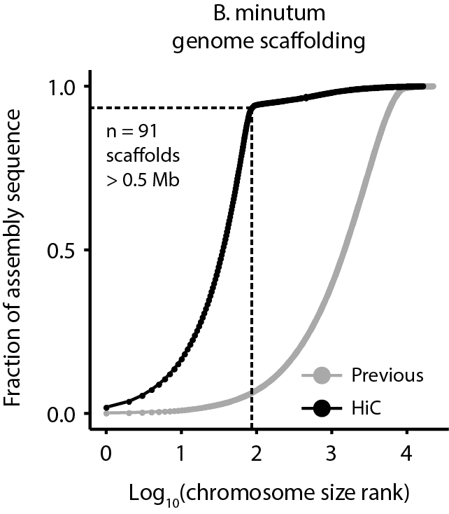
Supplementary Figure 1: Cumulative distribution of scaffolds and pseudochromosome sizes before and after Hi-C scaffolding of the draft Breviolum minutum assembly⁶. 3D DNA²⁵ scaffolding of the assembly results in 91 major pseudochromosomes ≥500kb encompassing ∼94% of the assembled sequence.
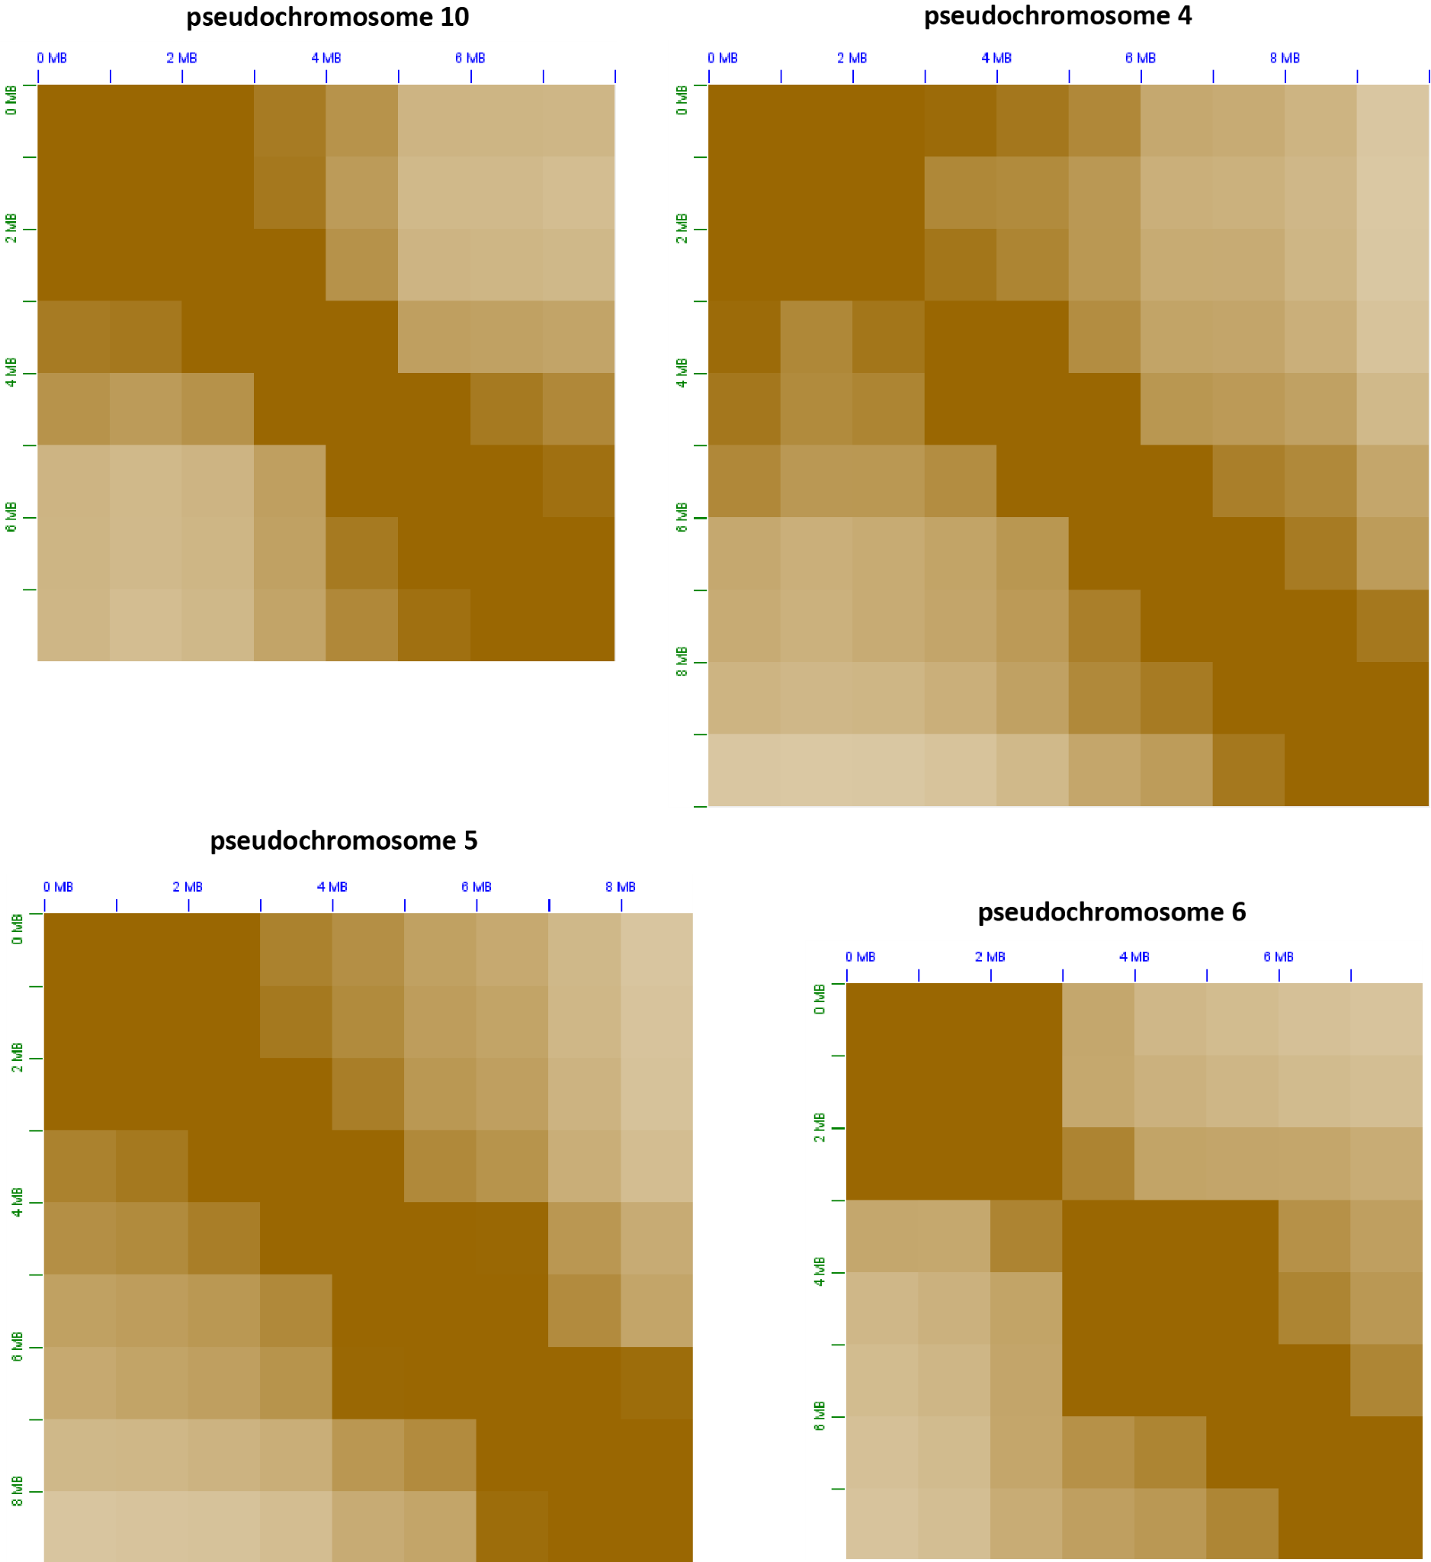
Supplementary Figure 2: Broad-level bipartite to tripartite topological structure of dinoflagellate chromosomes. Shown are 1Mbp-resolution KR-normalized³⁴ Hi-C matrices for four of the B. minutum pseudochromosomes.
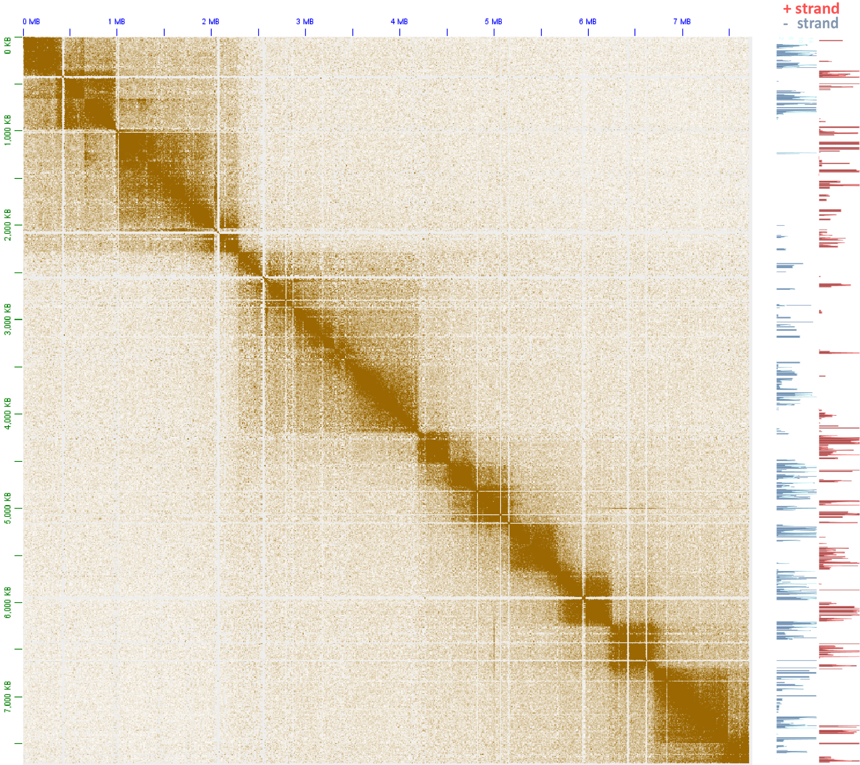
tan
Supplementary Figure 3: The topological domain organization of dinoflagellate chromosomes is related to dem gene array orientation. Shown is the 5kb-resolution KR-normalized Hi-C map together with strand-specific RNA expression levels for pseudochromosome 17.
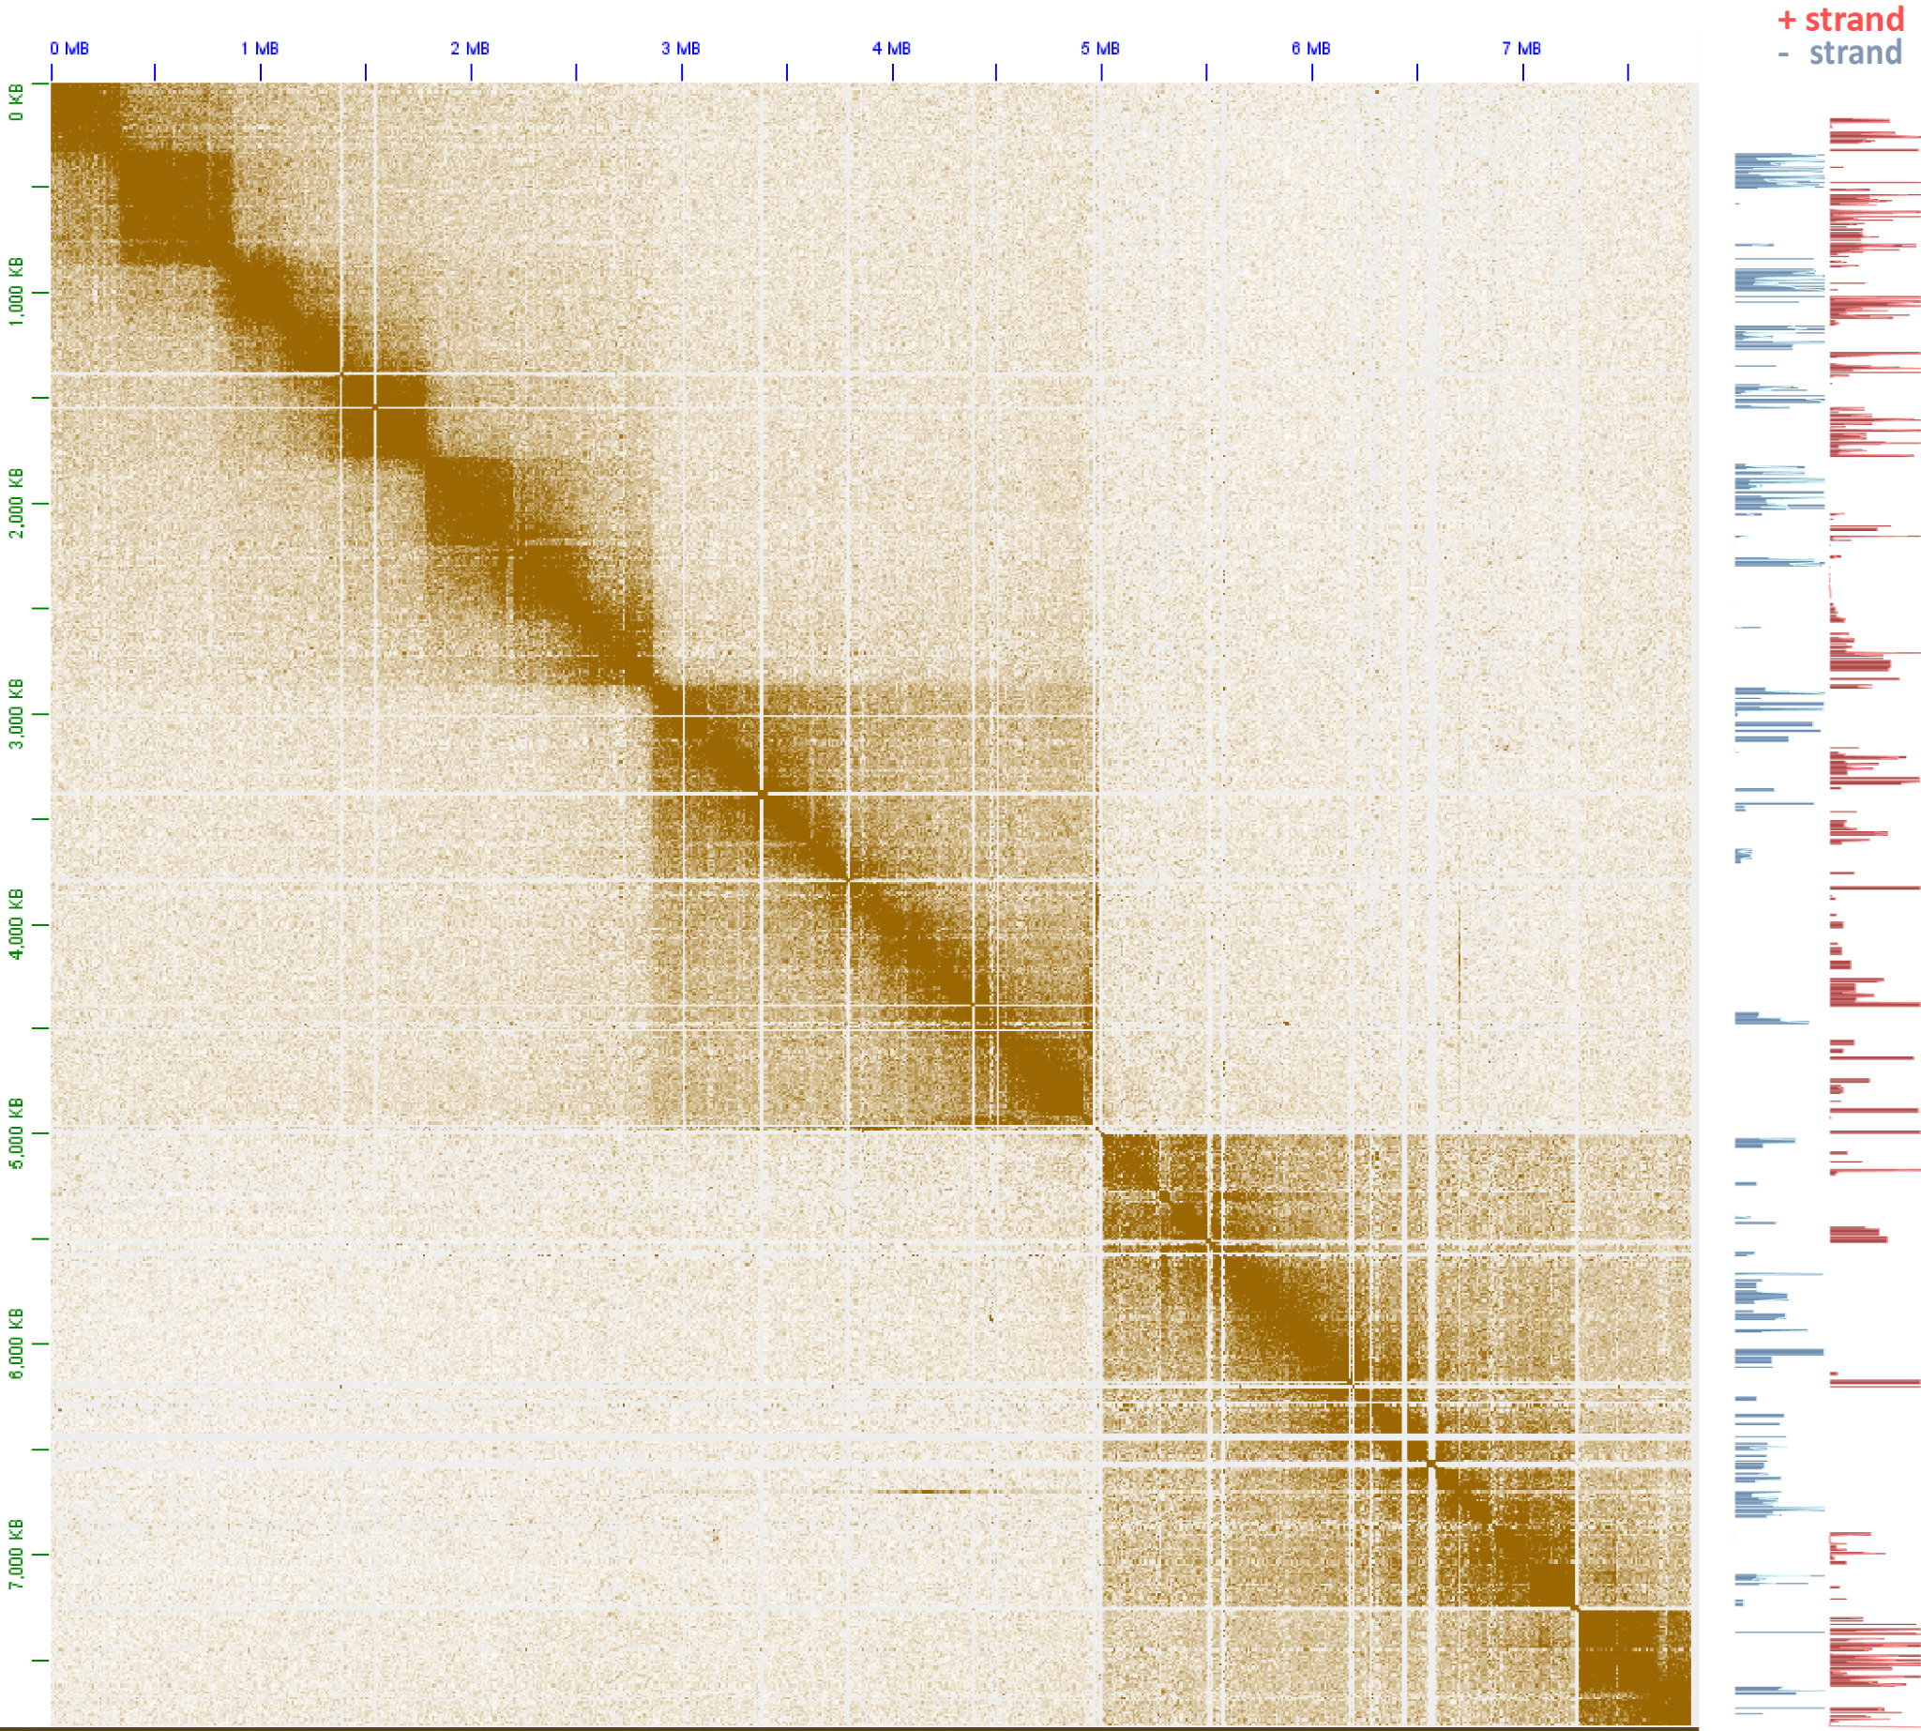
tan
Supplementary Figure 4: The topological domain organization of dinoflagellate chromosomes is related to dem gene array orientation. Shown is the 5kb-resolution KR-normalized Hi-C map together with strand-specific RNA expression levels for pseudochromosome 18.
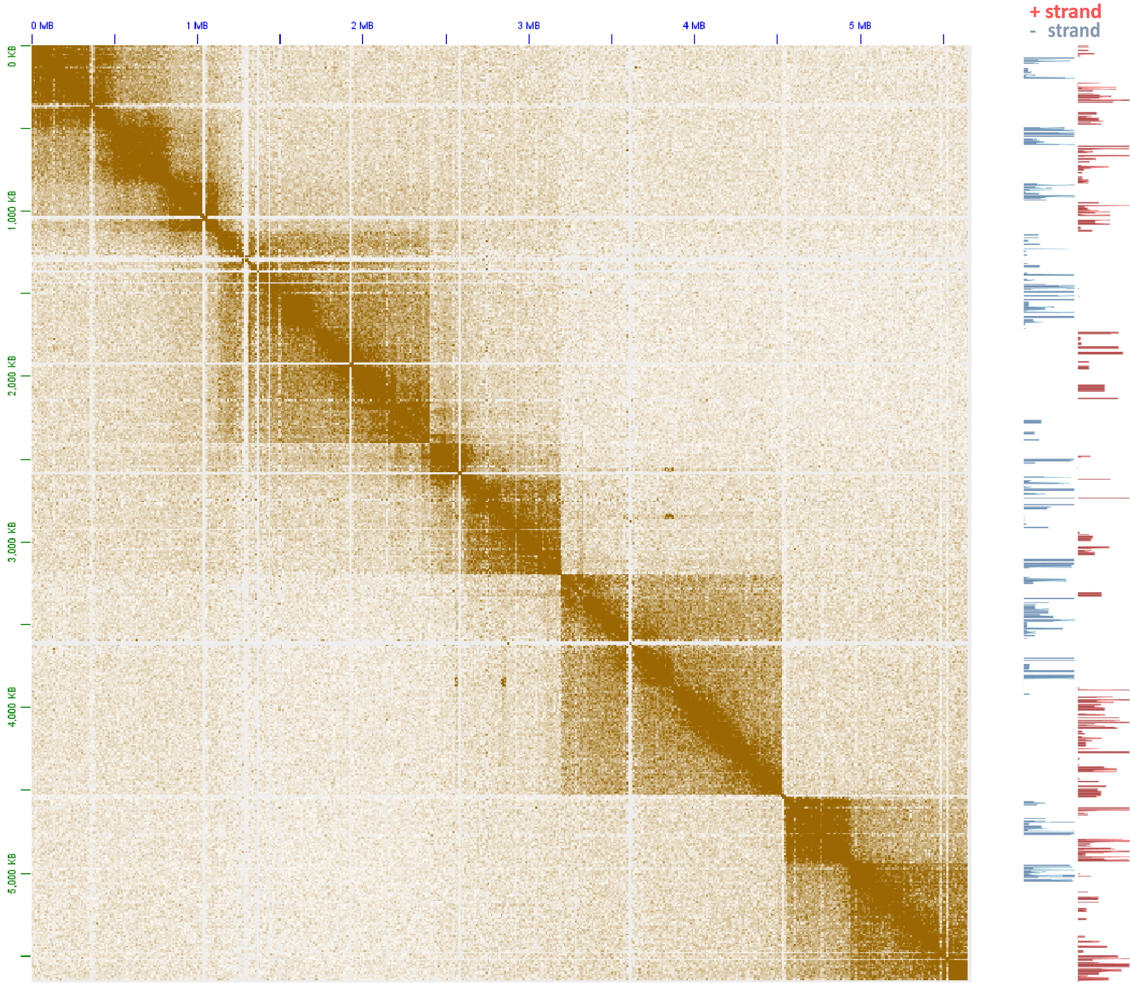
tan
Supplementary Figure 5: The topological domain organization of dinoflagellate chromosomes is related to dem gene array orientation. Shown is the 5kb-resolution KR-normalized Hi-C map together with strand-specific RNA expression levels for pseudochromosome 21.
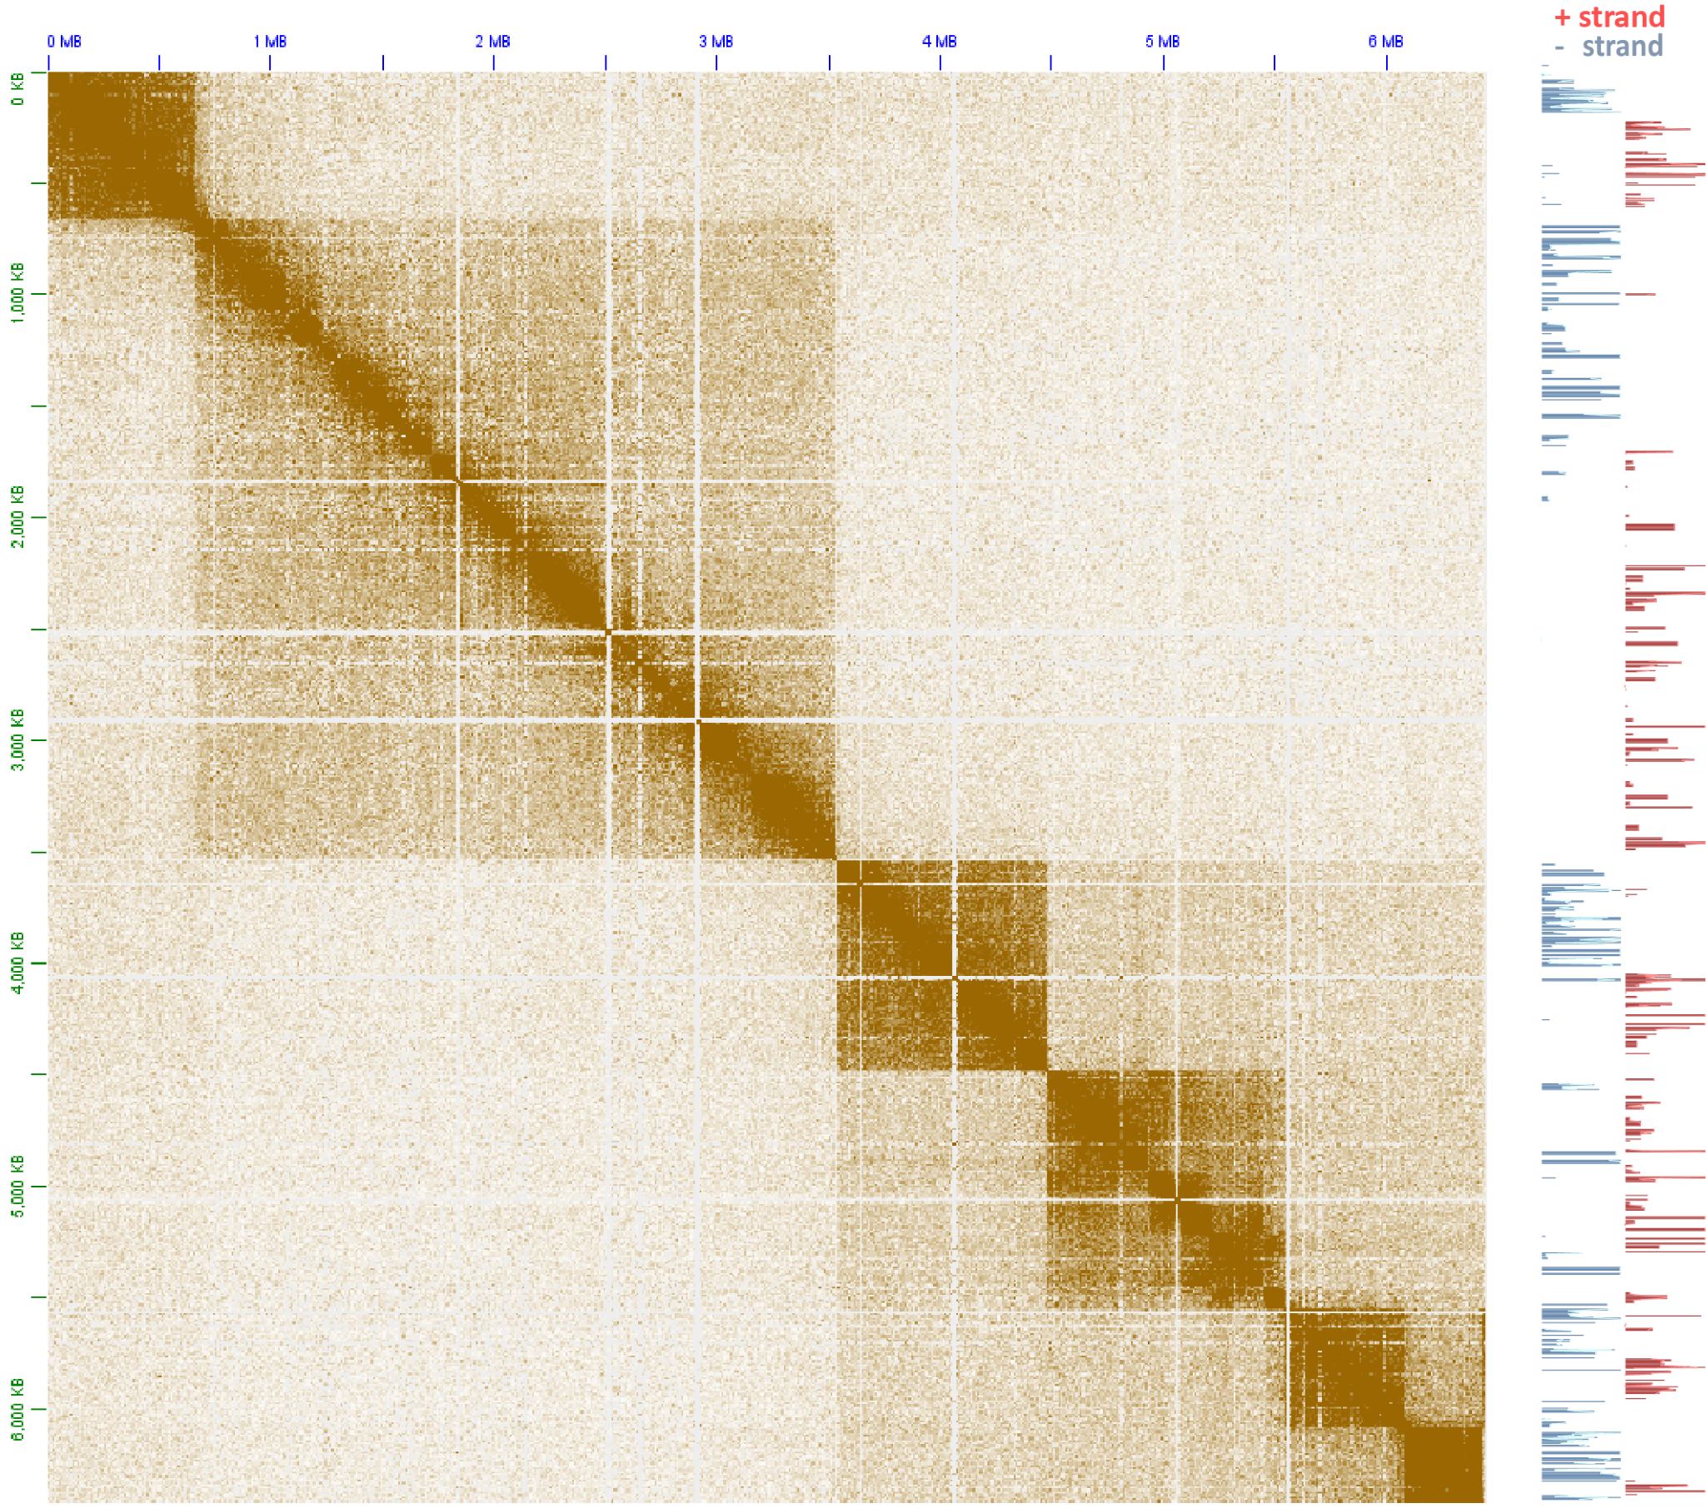
tan
Supplementary Figure 6: The topological domain organization of dinoflagellate chromosomes is related to dem gene array orientation. Shown is the 5kb-resolution KR-normalized Hi-C map together with strand-specific RNA expression levels for pseudochromosome 26.
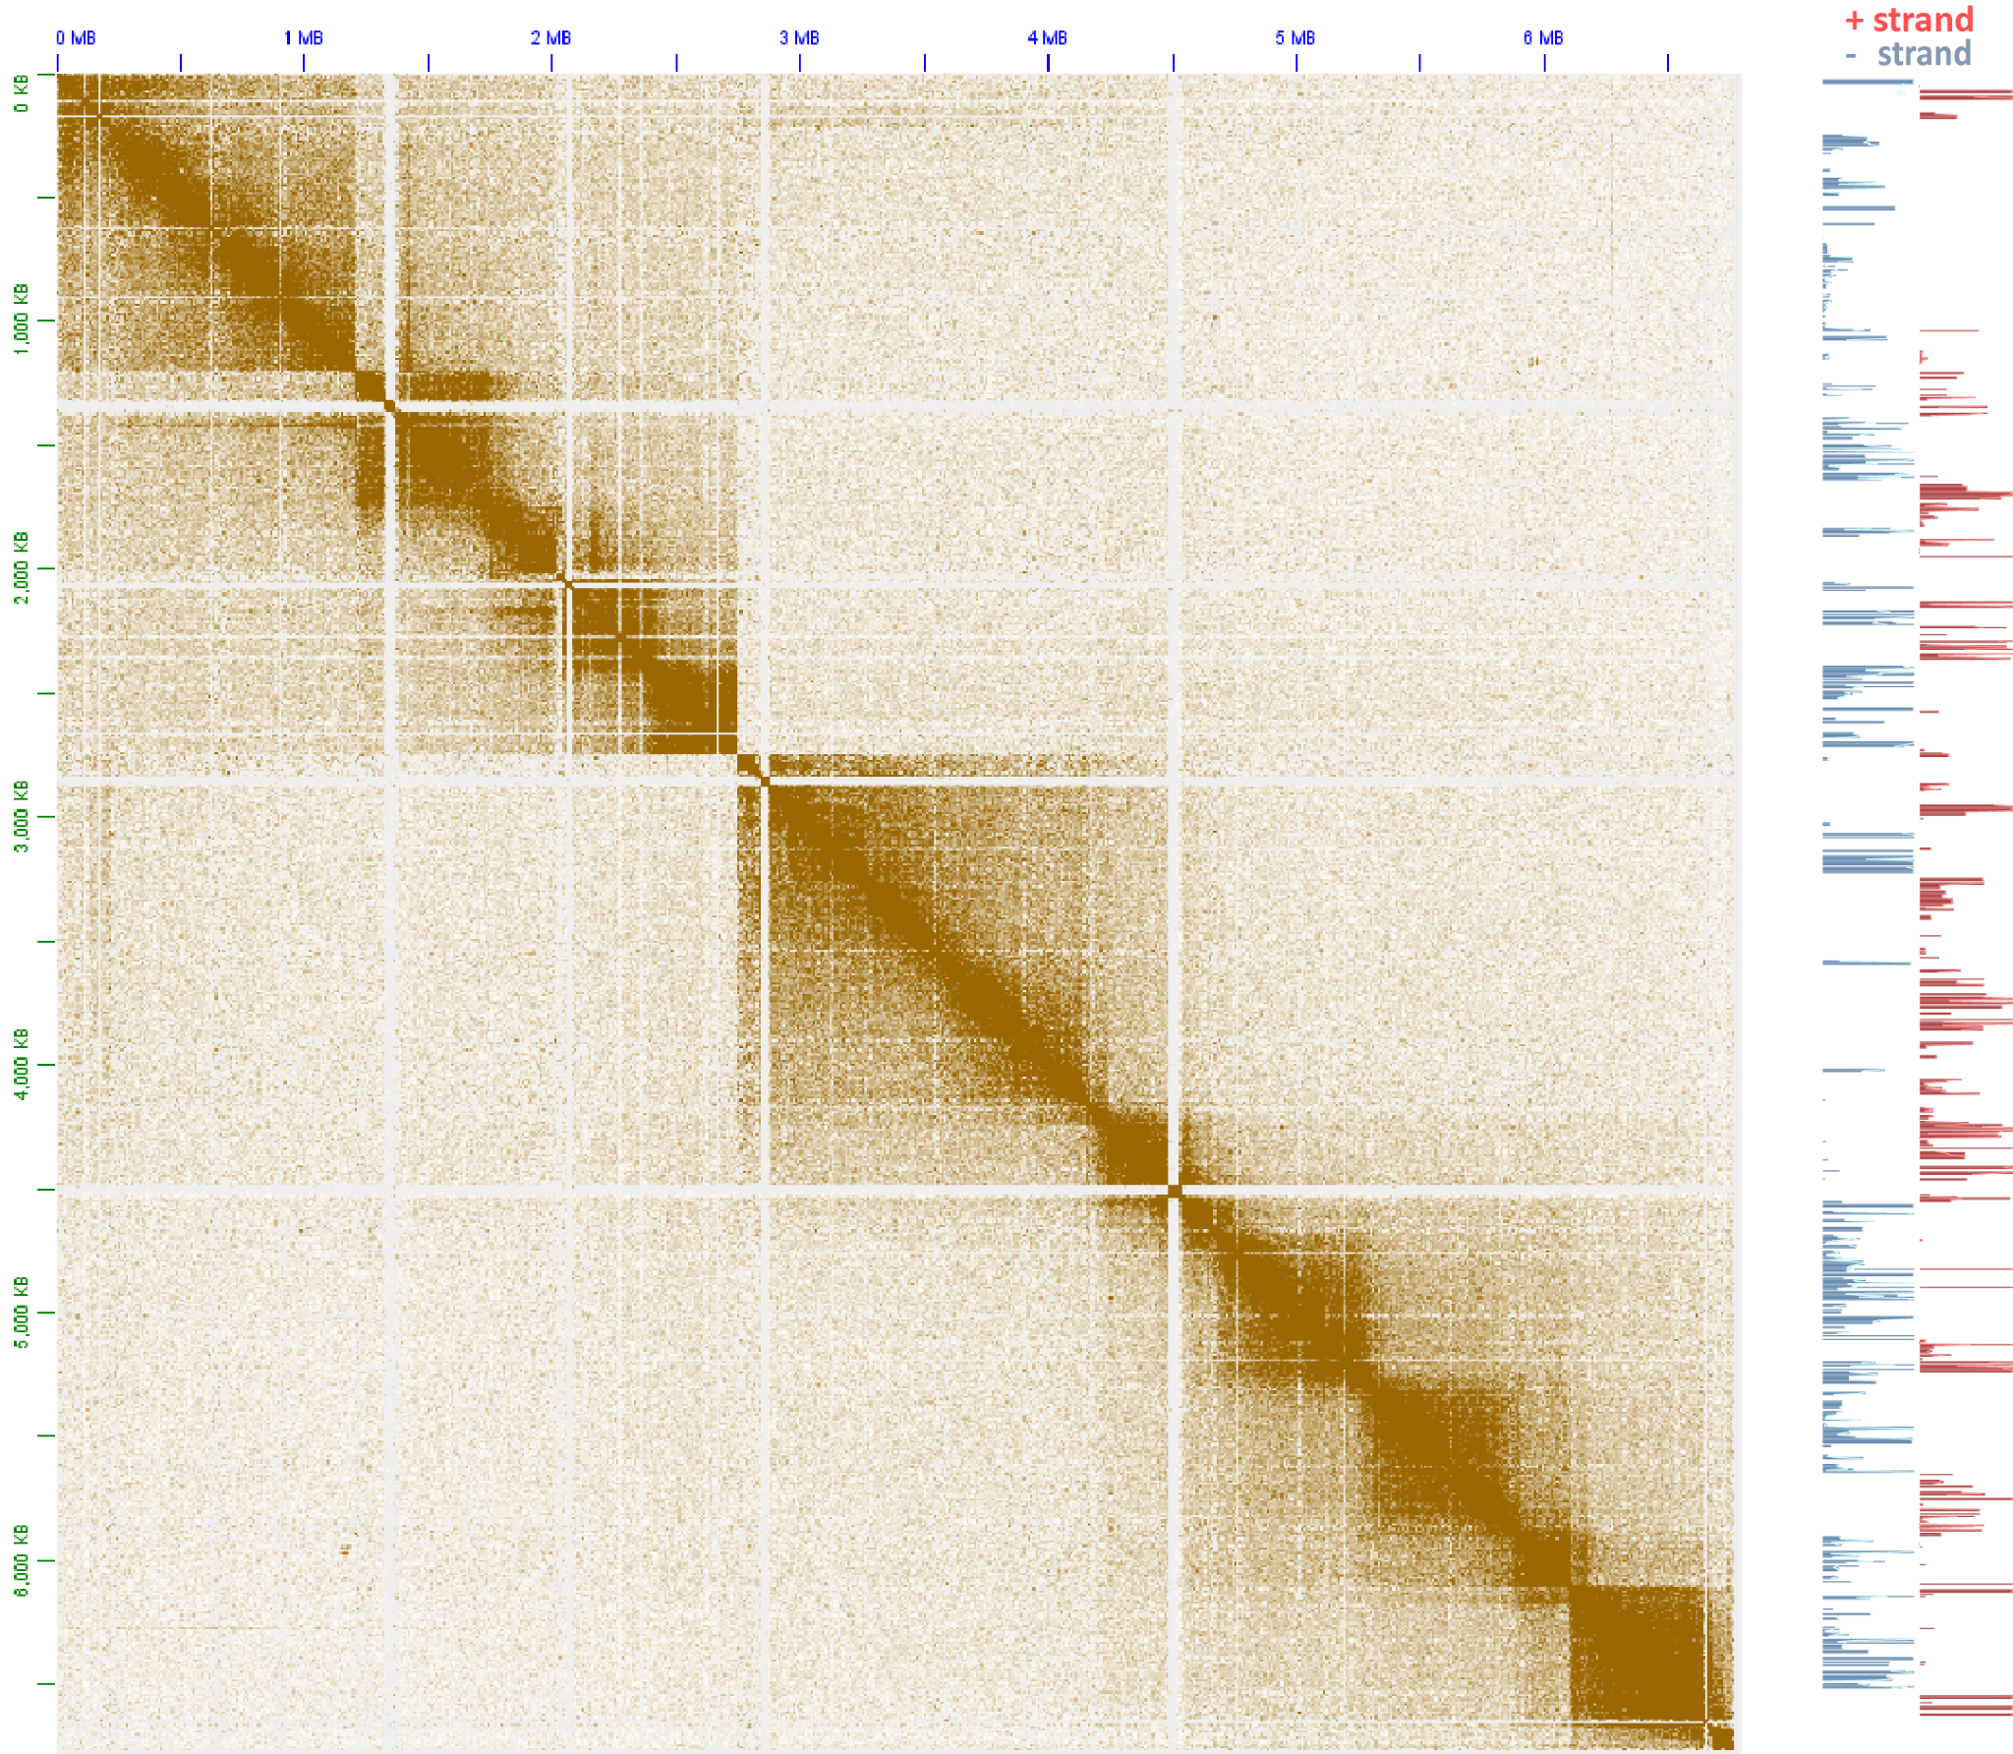
tan
Supplementary Figure 7: The topological domain organization of dinoflagellate chromosomes is related to dem gene array orientation. Shown is the 5kb-resolution KR-normalized Hi-C map together with strand-specific RNA expression levels for pseudochromosome 32.
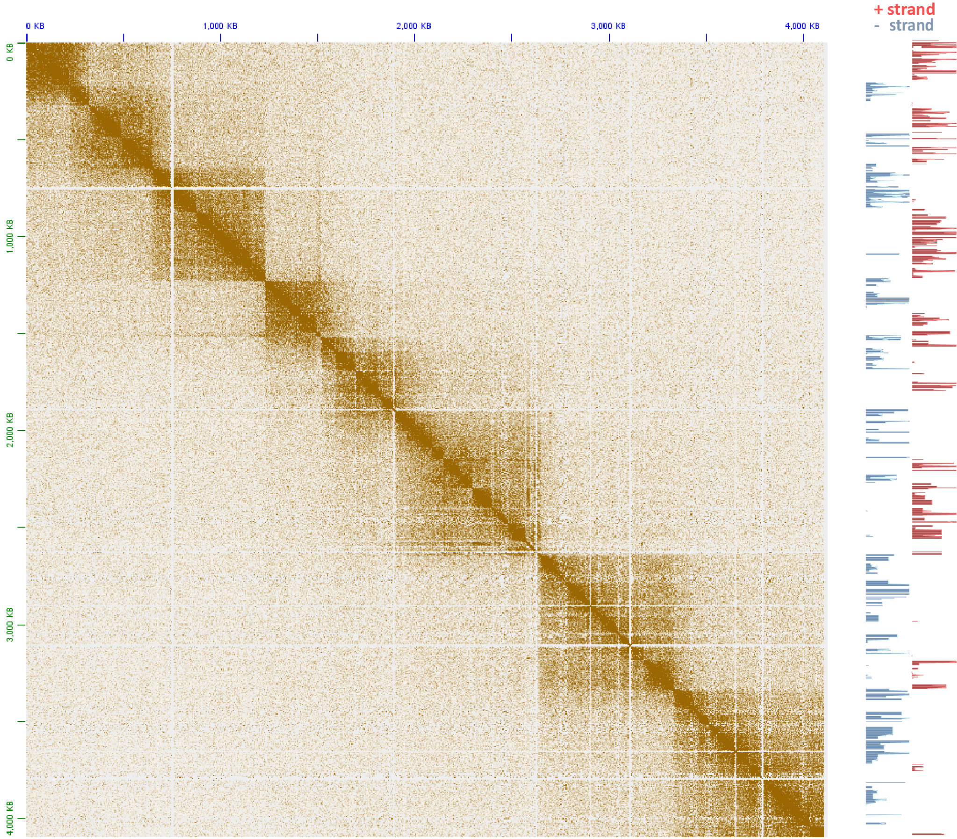
tan
Supplementary Figure 8: The topological domain organization of dinoflagellate chromosomes is related to dem gene array orientation. Shown is the 5kb-resolution KR-normalized Hi-C map together with strand-specific RNA expression levels for pseudochromosome 36.
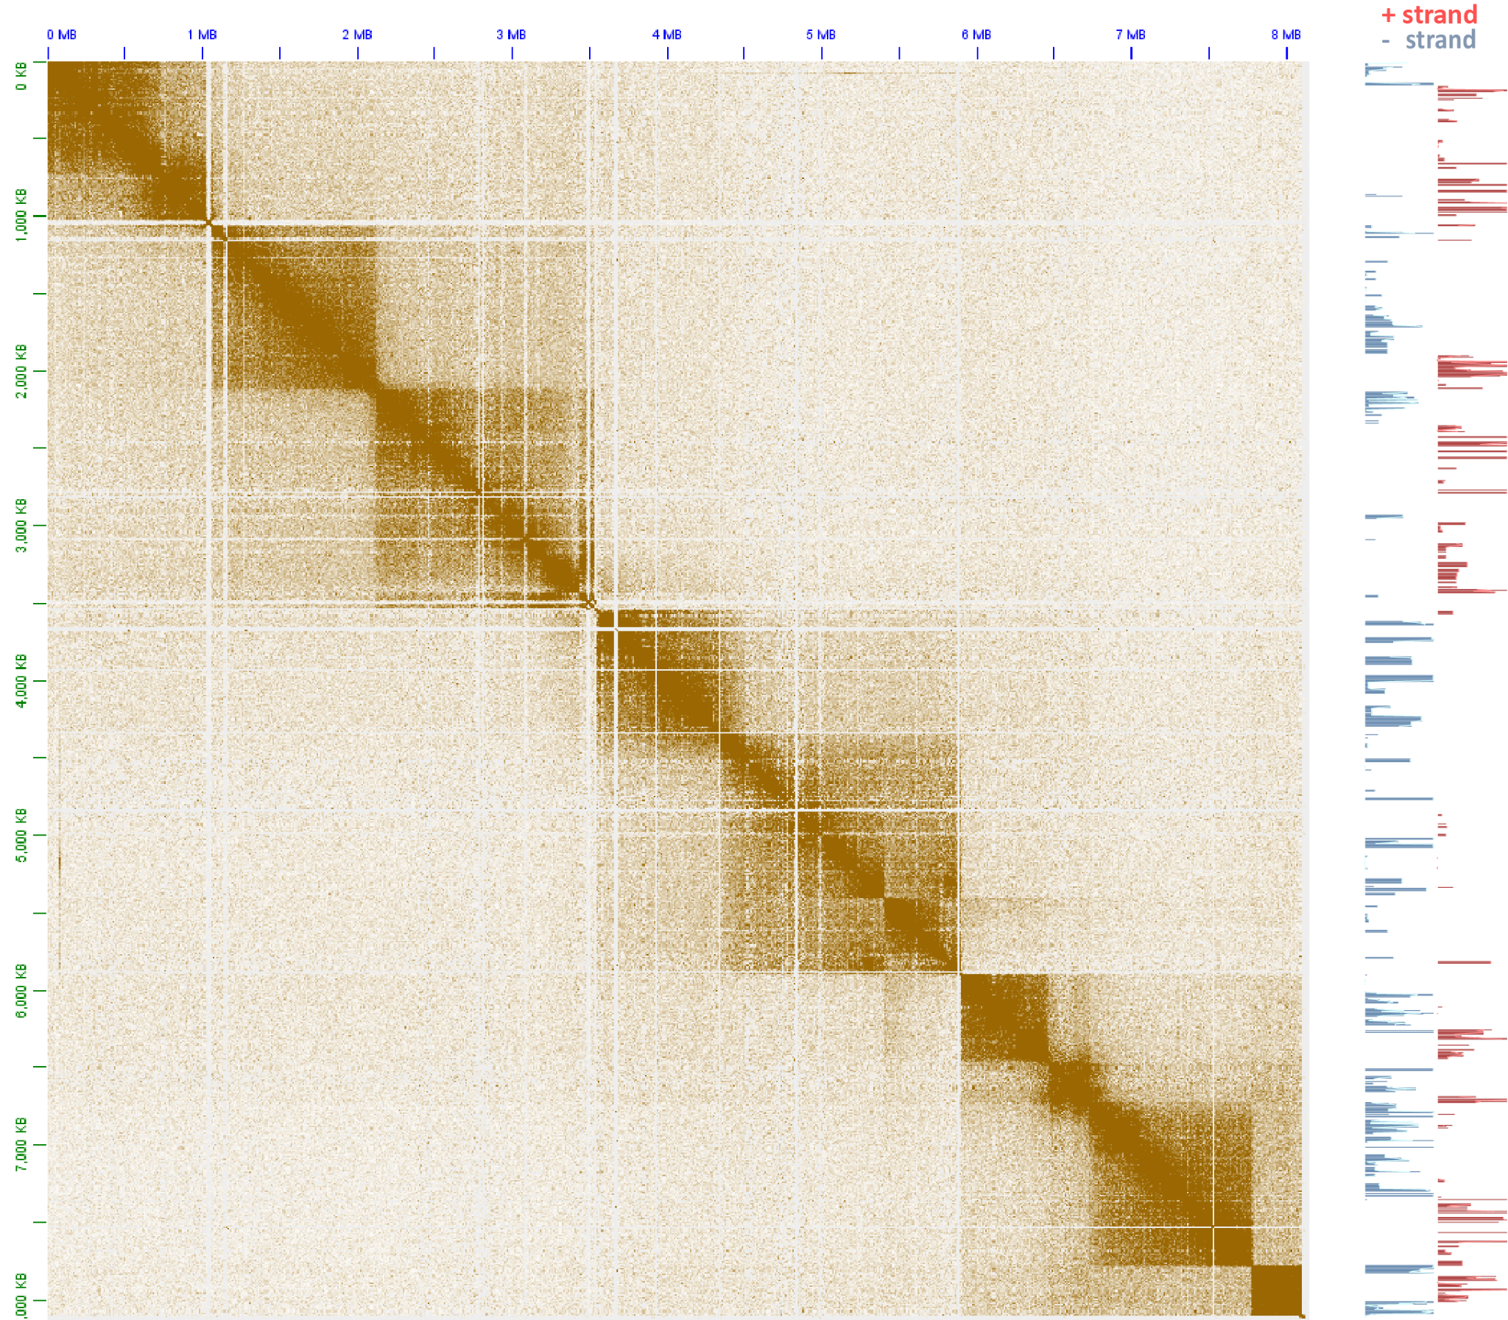
tan
Supplementary Figure 9: The topological domain organization of dinoflagellate chromosomes is related to dem gene array orientation. Shown is the 5kb-resolution KR-normalized Hi-C map together with strand-specific RNA expression levels for pseudochromosome 71.
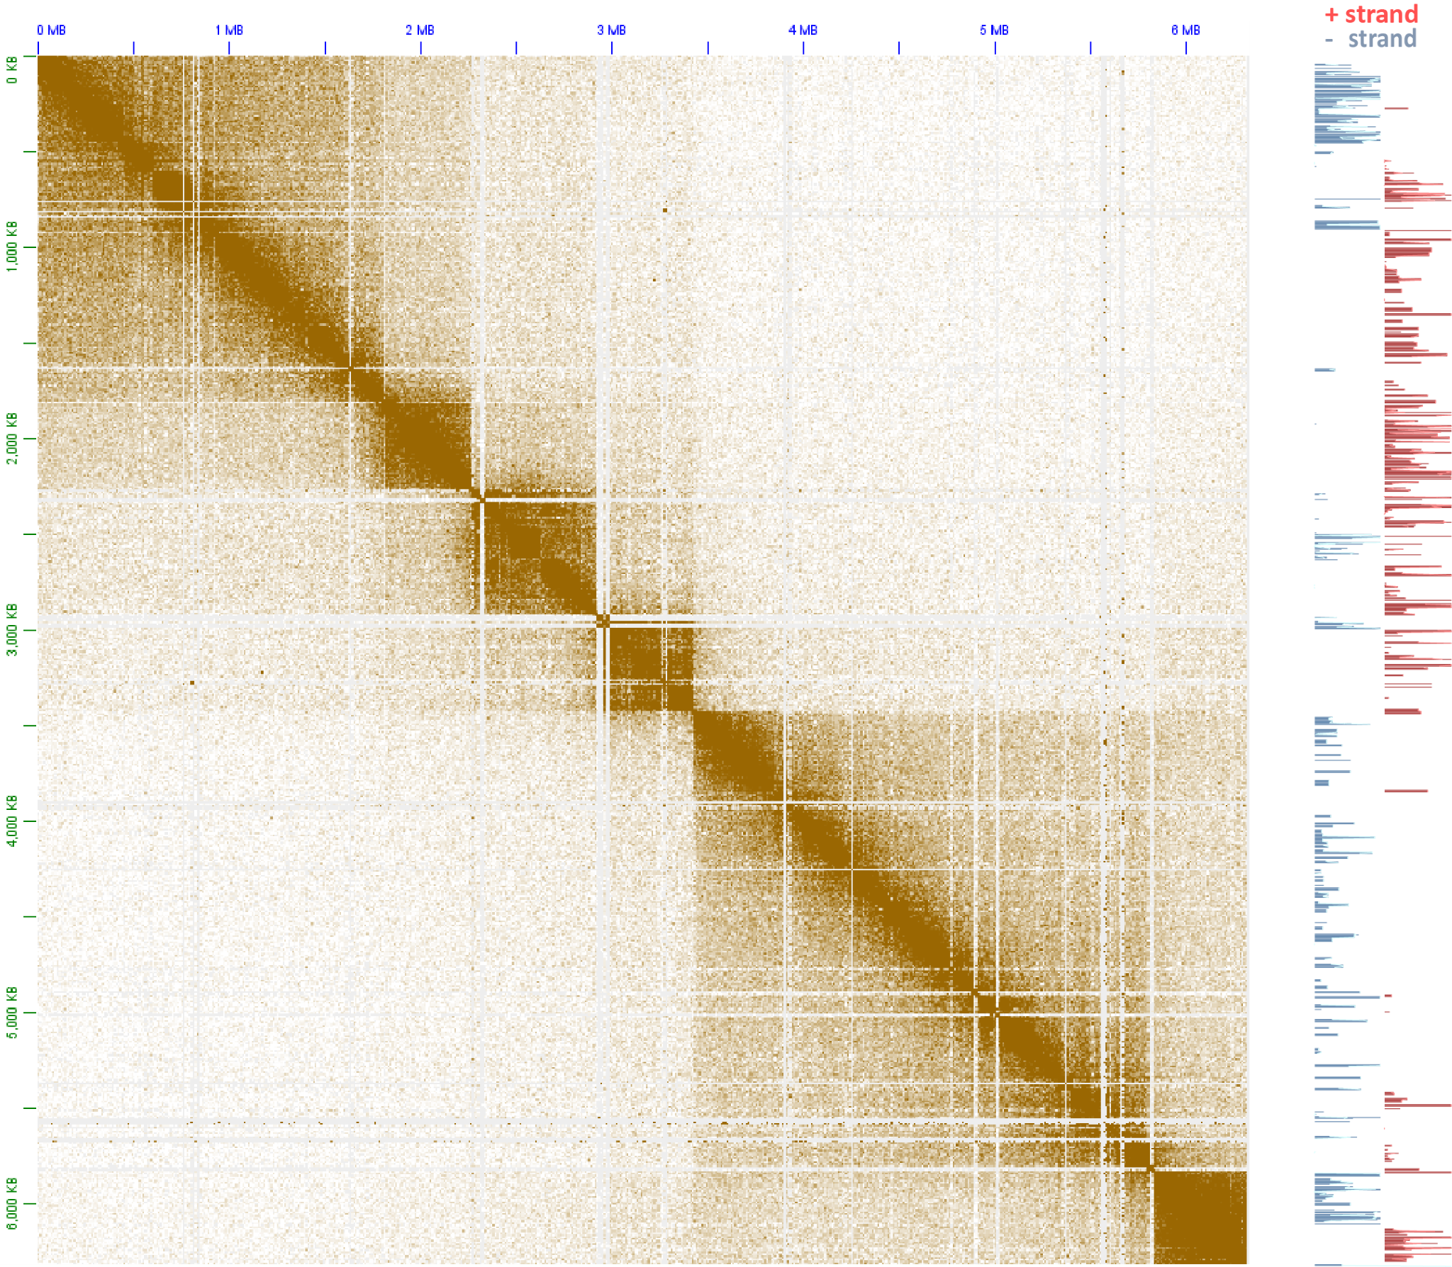
tan
Supplementary Figure 10: The topological domain organization of dinoflagellate chromosomes is related to dem gene array orientation. Shown is the 5kb-resolution KR-normalized Hi-C map together with strand-specific RNA expression levels for pseudochromosome 77.
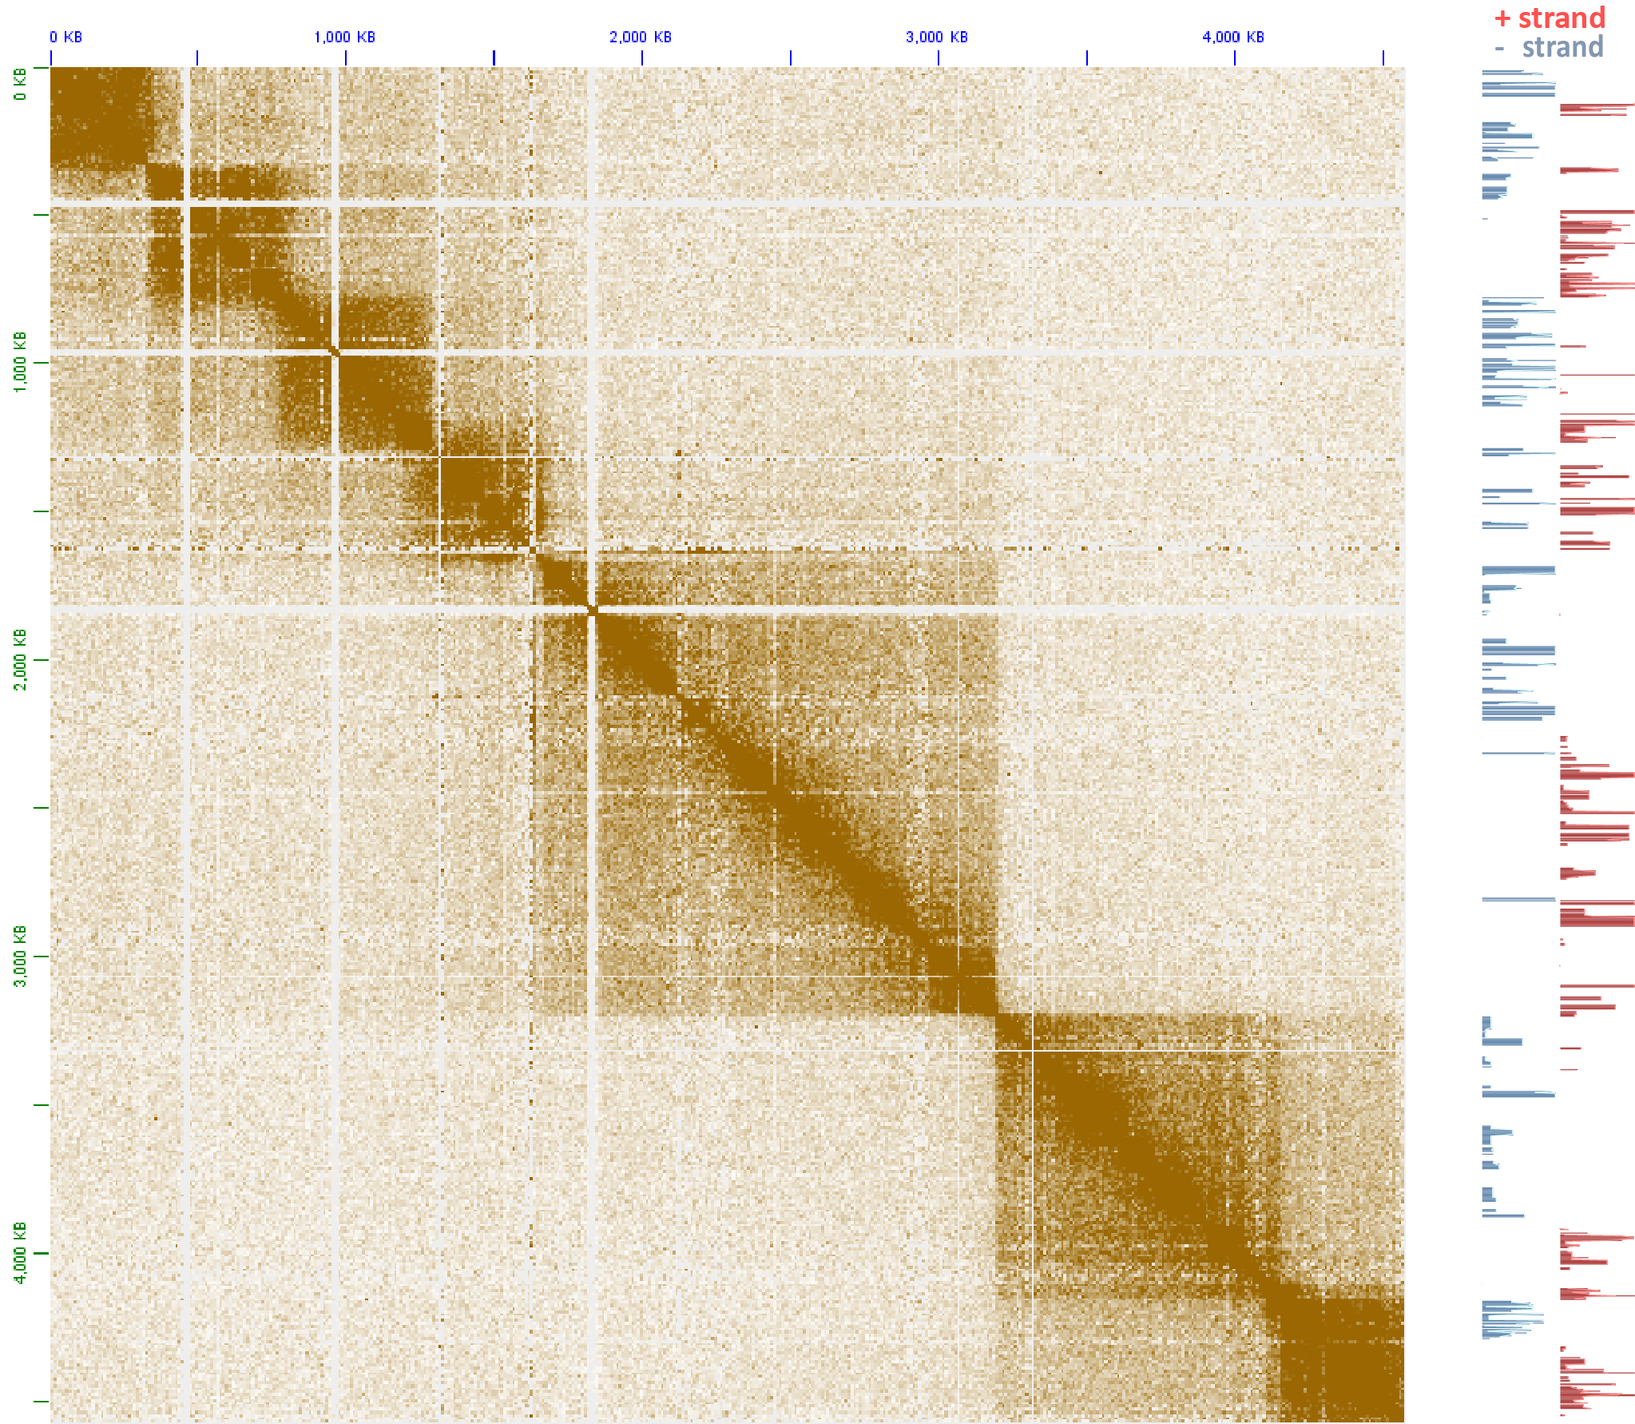
tan
Supplementary Figure 11: The topological domain organization of dinoflagellate chromosomes is related to dem gene array orientation. Shown is the 5kb-resolution KR-normalized Hi-C map together with strand-specific RNA expression levels for pseudochromosome 78.
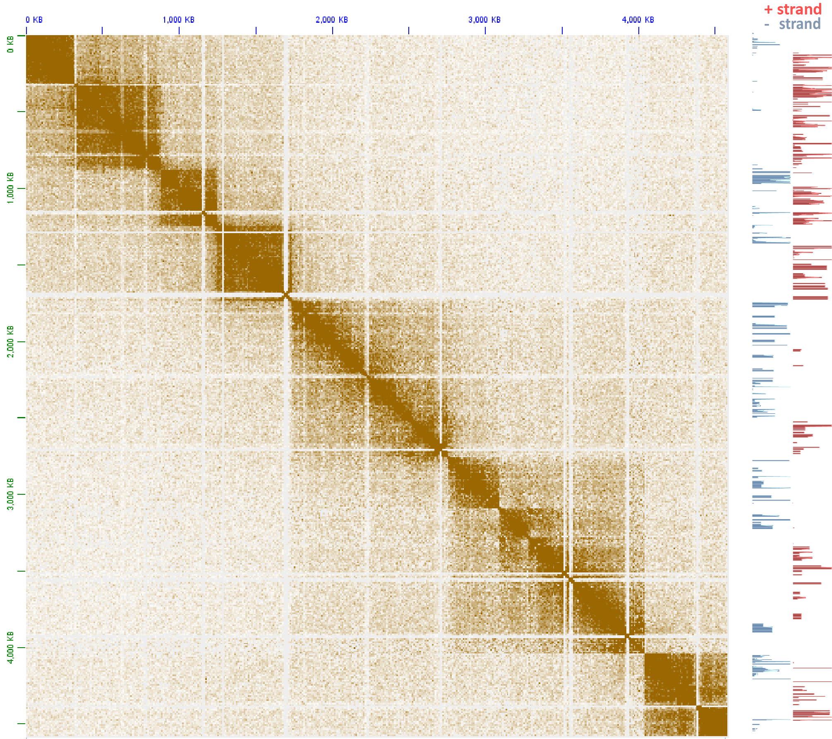
tan
Supplementary Figure 12: The topological domain organization of dinoflagellate chromosomes is related to dem gene array orientation. Shown is the 5kb-resolution KR-normalized Hi-C map together with strand-specific RNA expression levels for pseudochromosome 88.
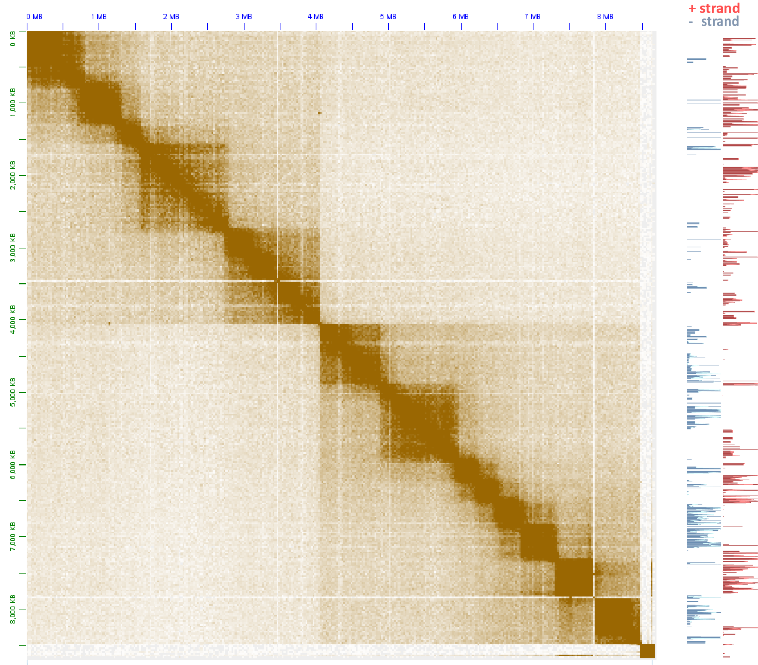
tan
Supplementary Figure 13: The topological domain organization of dinoflagellate chromosomes is related to dem gene array orientation. Shown is the 5kb-resolution KR-normalized Hi-C map together with strand-specific RNA expression levels for pseudochromosome 89.
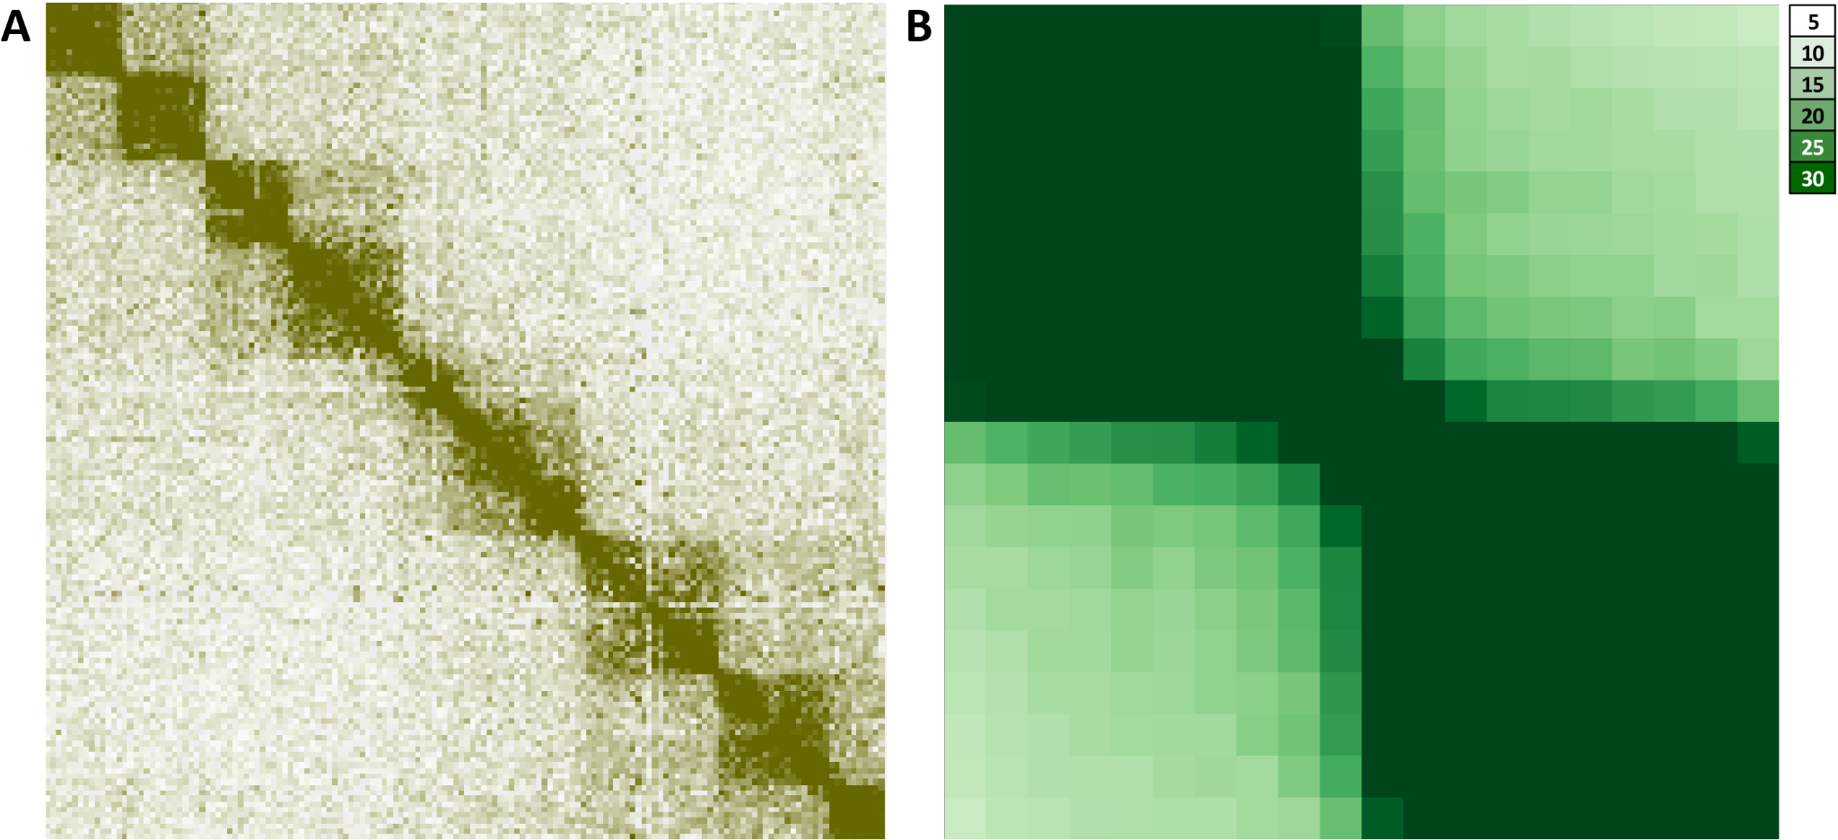
Supplementary Figure 14: DinoTADs become more strongly defined in Hi-C datasets generated by omituration step (sample “L1859” in Supplementary Table 1). (A) Snapshot of pseudochromo-
ting
the
SDS
de
nat
some 10 at 50-kbp resolution. (B) Metaplot across all dinoTAD boundaries at 50-kbp resolution (drawn to same scale as metaplots in main figures and elsewhere in the supplement)
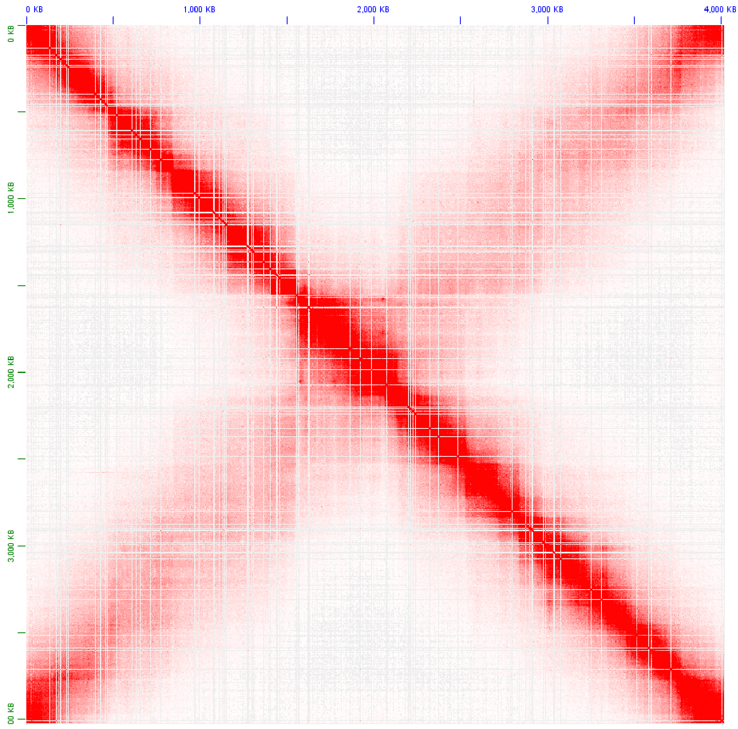
Supplementary Figure 15: Topological structure of the Caulobacter crescentus CB15 genome. Shown is the KR-normalized 5-kb resolution maps for the whole Caulobacter chromosome (GEO accession GSM1120448).
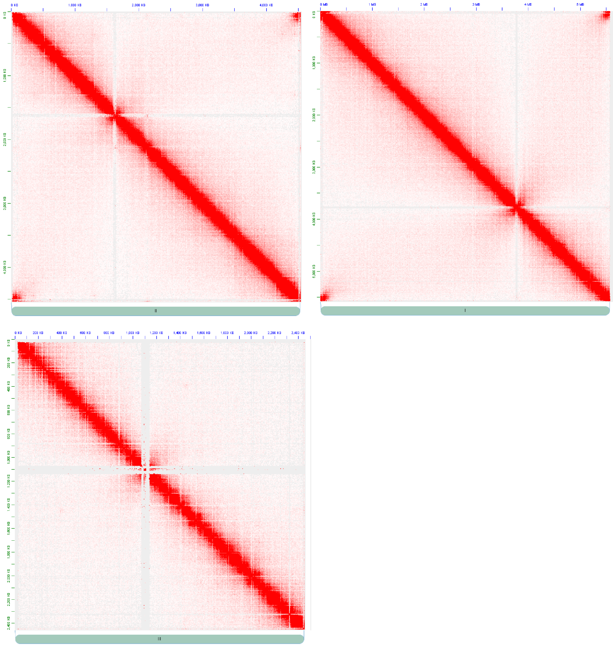
Supplementary Figure 16: Topological structure of the Schizosaccharomyces pombe genome. Shown are the KR-normalized 5-kb resolution maps for all three S. pombe chromosome (GEO accession GSM1379427).
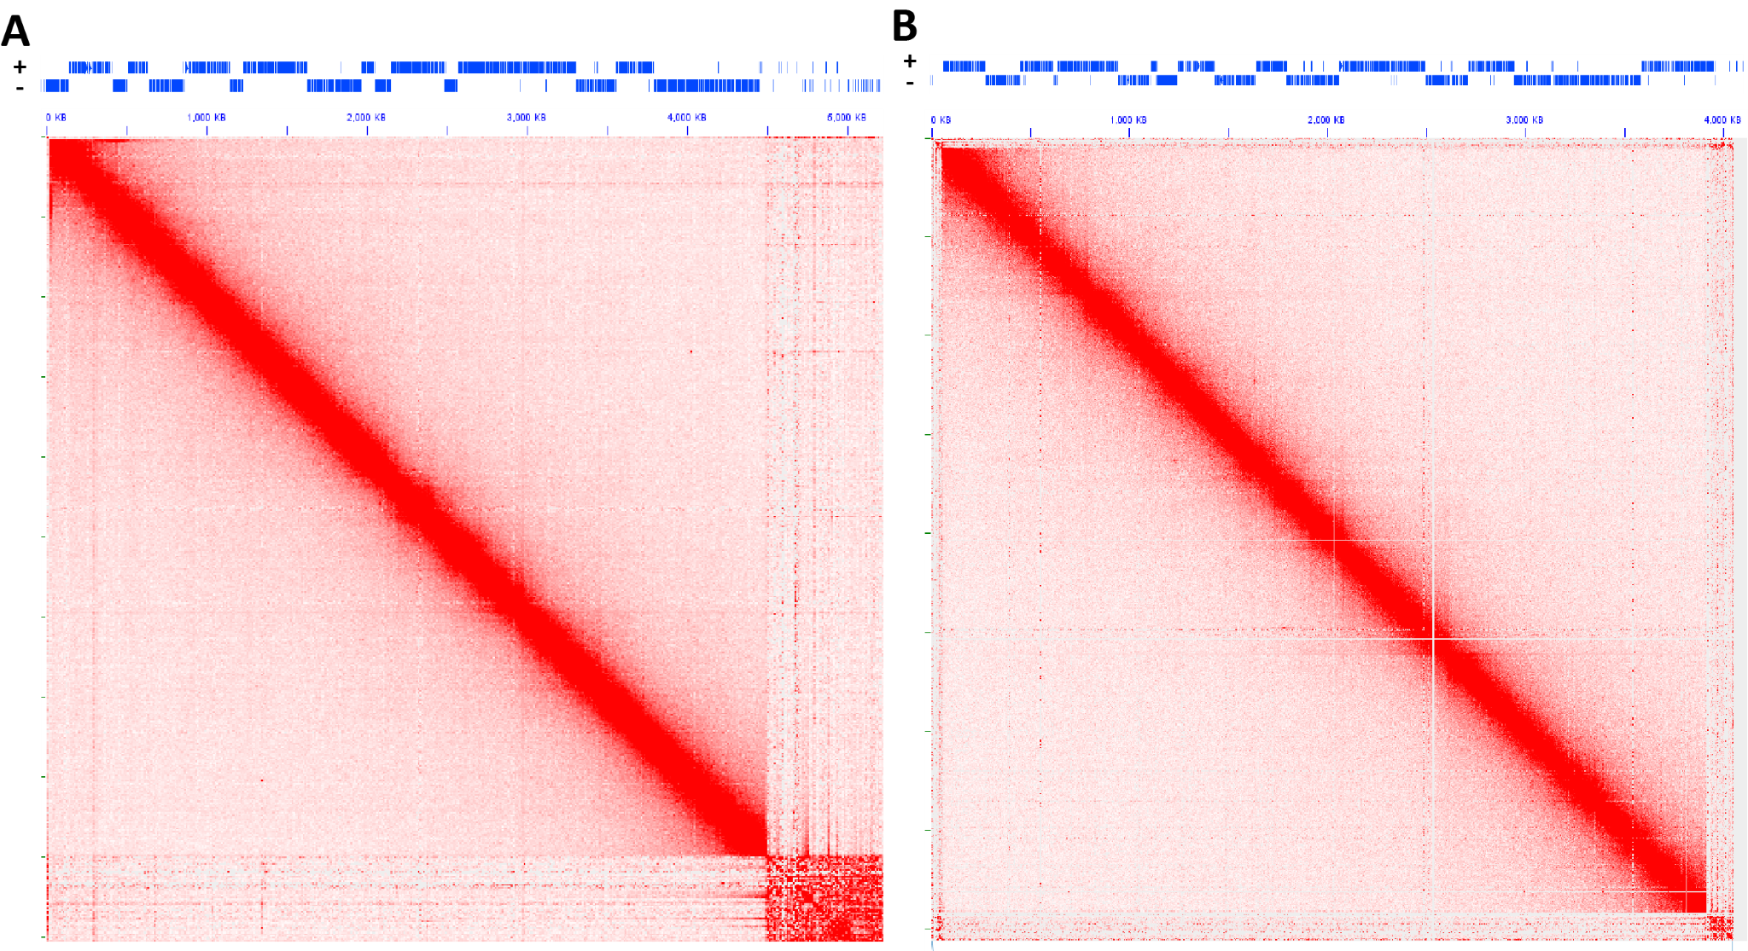
Supplementary Figure 17: No topological domains associated with gene arrays are observed in the kinetoplastid Trypanosoma brucei. Shown are KR-normalized 10-kb resolution maps for chr11 (A) and chr10 (B) for GEO accession GSM3346690.
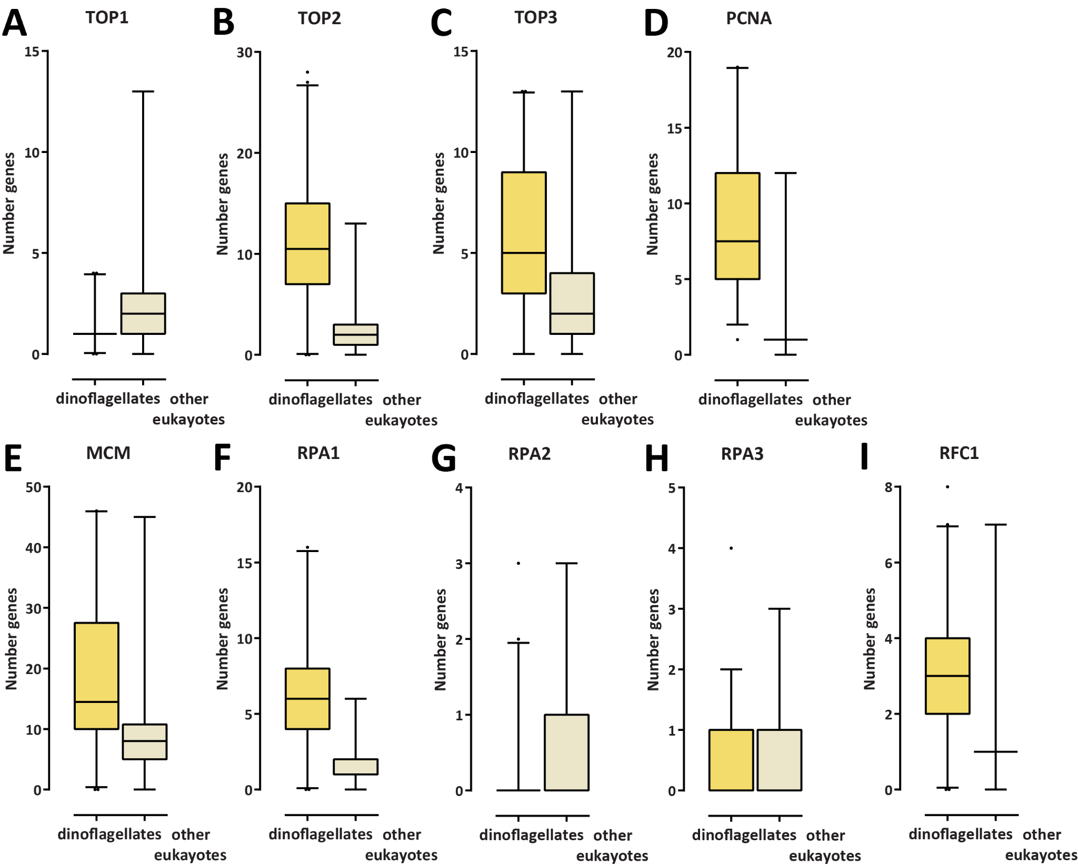
(see | Hou | et | al. | 35 | for | more | de
Supplementary Figure 18: Expansion of the Type II and II topoisomerase gene repertoire as well as of certain other replication-related tails) proteins in dinoflagellates. Shown are the number of genes annotated in MMETSP transcriptome assemblies of dinoflagellates and other eukaryotes. (A) Number of Type I topoisomerase genes; (B) Number of Type II topoisomerase genes; (C) Number of Type III topoisomerase genes; (D) Number of PCNA genes; (E) Number of MCM genes; (F) Number of RPA1 genes; (G) Number of RPA2 genes; (H) Number of RPA3 genes; (I) Number of RFC1 genes.
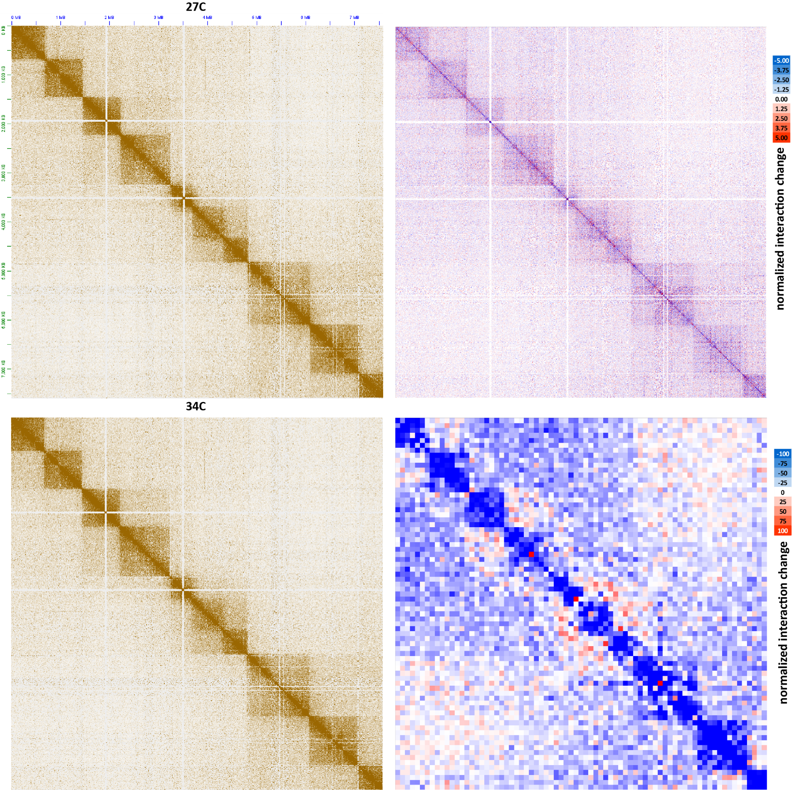
Supplementary Figure 19: Moderate decompaction of dinoTADs upon exposure to elevated temperatures. Shown is pseudochromosome 10 (KR-normalized) and the difference between the KR-normalized Hi-C maps generated from B. minutum grown at 34◦C and at 27◦C at 100-kb resolution (lower right) and 5-kb resolution (upper right).
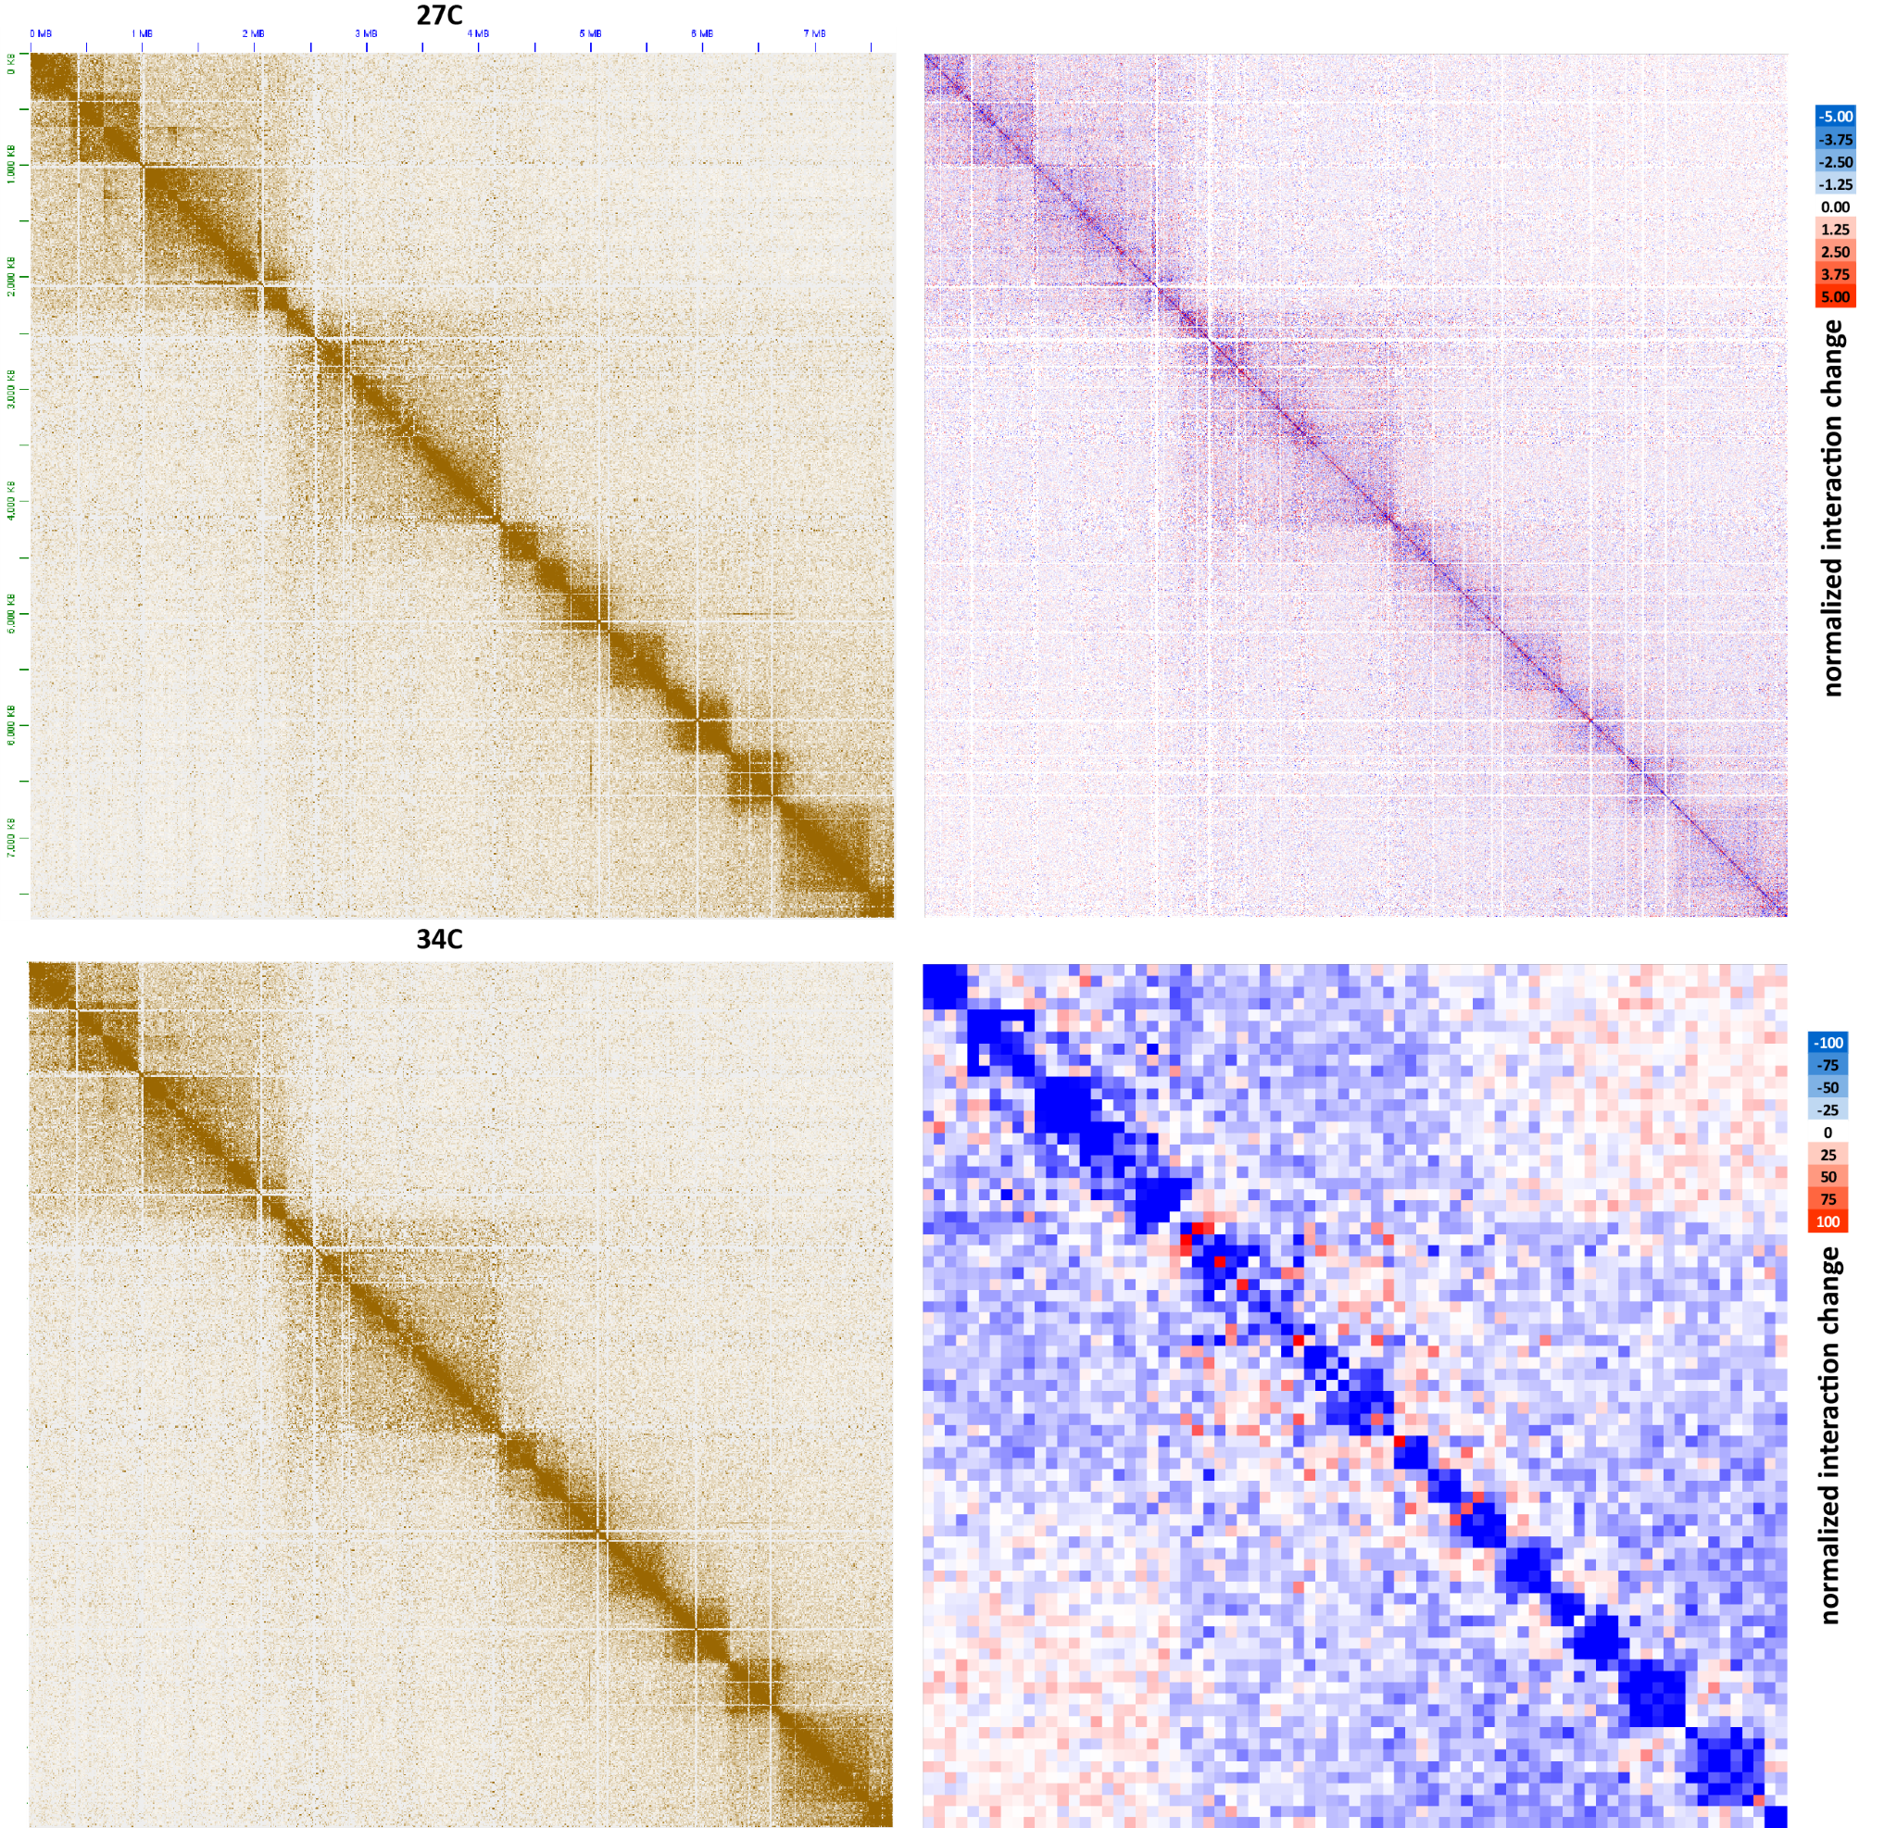
Supplementary Figure 20: Moderate decompaction of dinoTADs upon exposure to elevated temperatures. Shown is pseudochromosome 17 (KR-normalized) and the difference between the KR-normalized Hi-C maps generated from B. minutum grown at 34◦C and at 27◦C at 100-kb resolution (lower right) and 5-kb resolution (upper right).
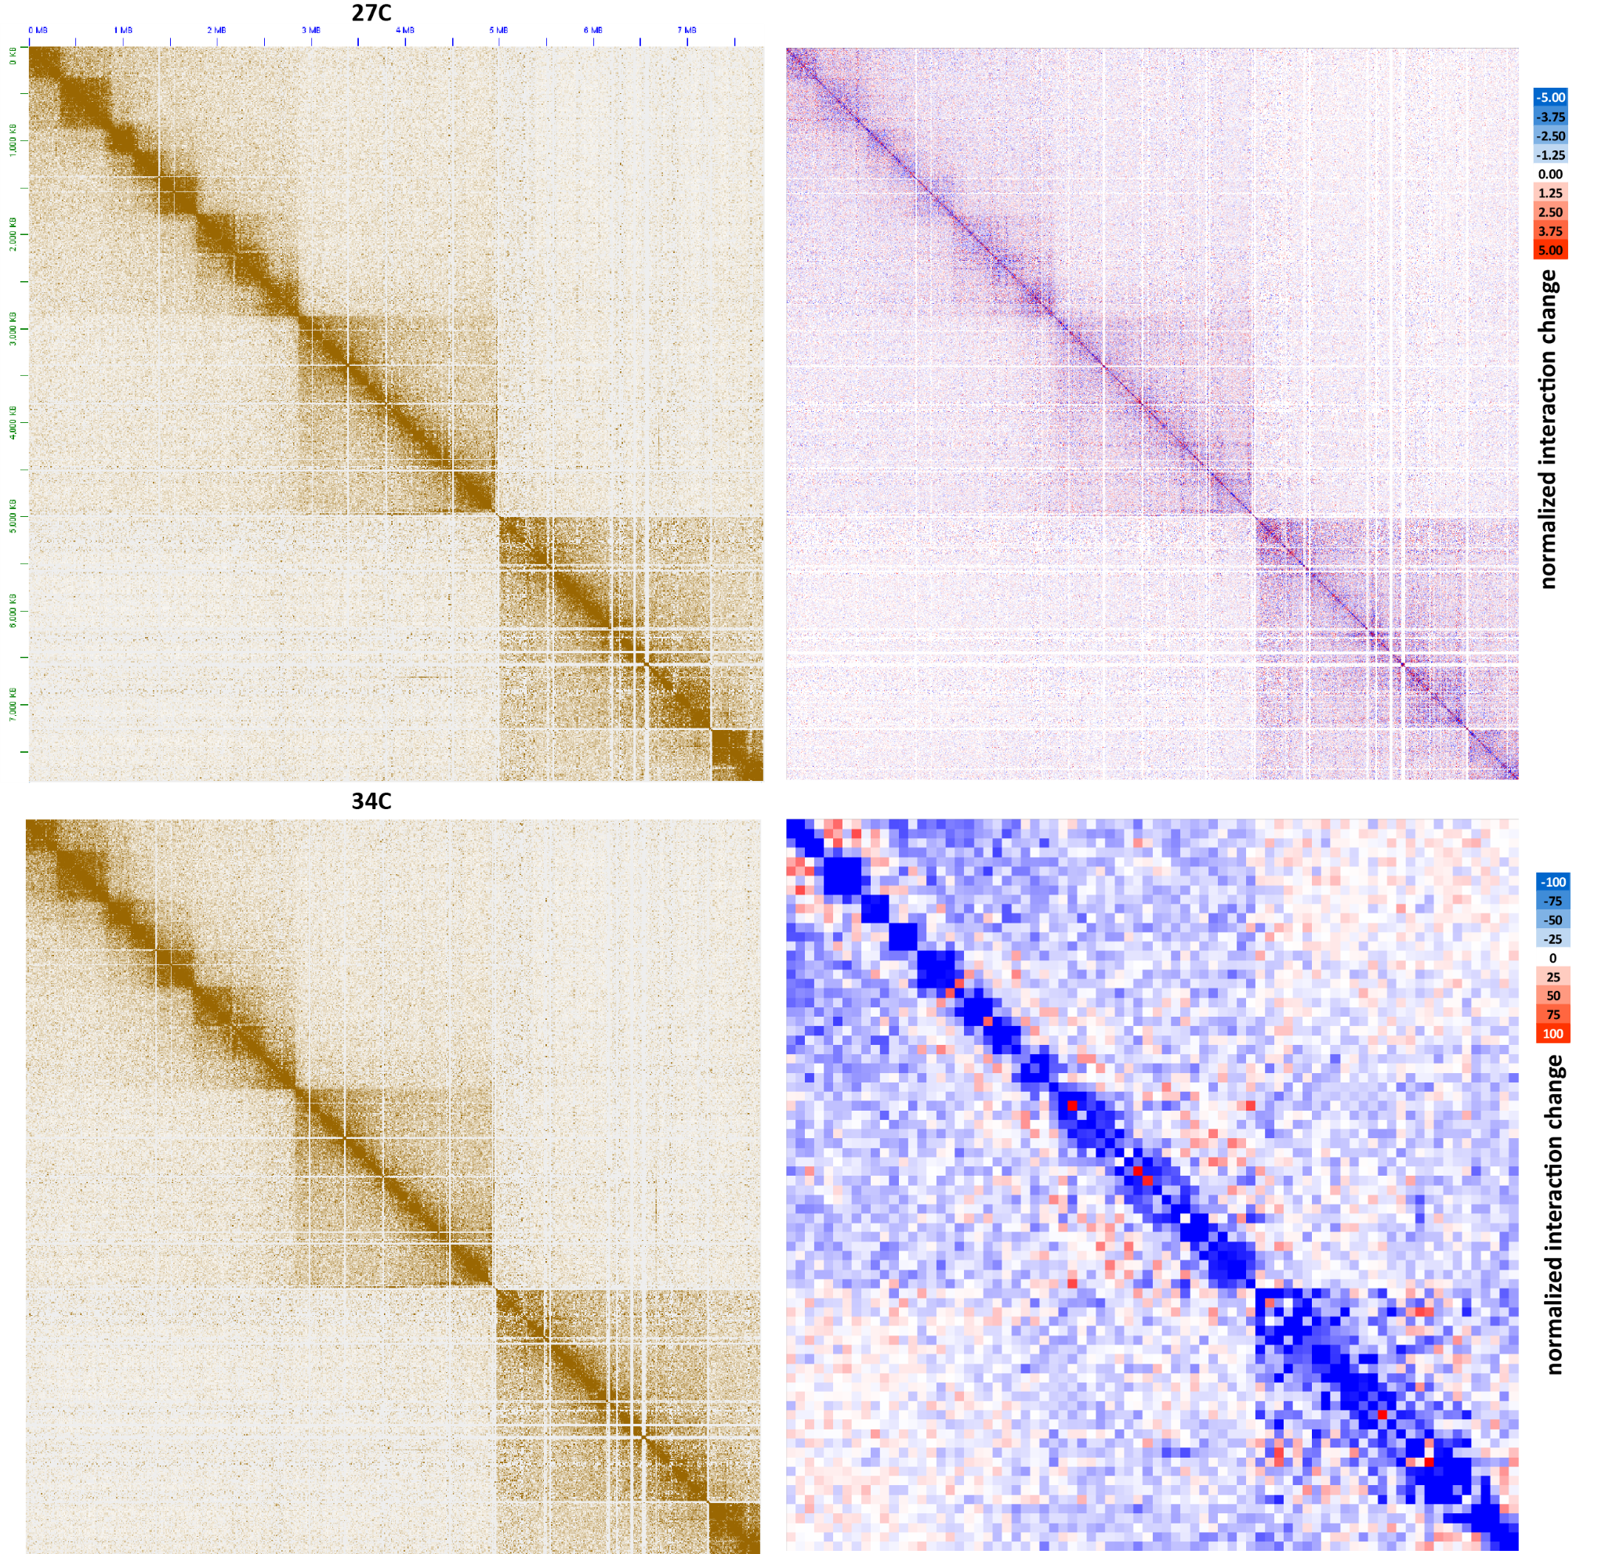
Supplementary Figure 21: Moderate decompaction of dinoTADs upon exposure to elevated temperatures. Shown is pseudochromosome 18 (KR-normalized) and the difference between the KR-normalized Hi-C maps generated from B. minutum grown at 34◦C and at 27◦C at 100-kb resolution (lower right) and 5-kb resolution (upper right).
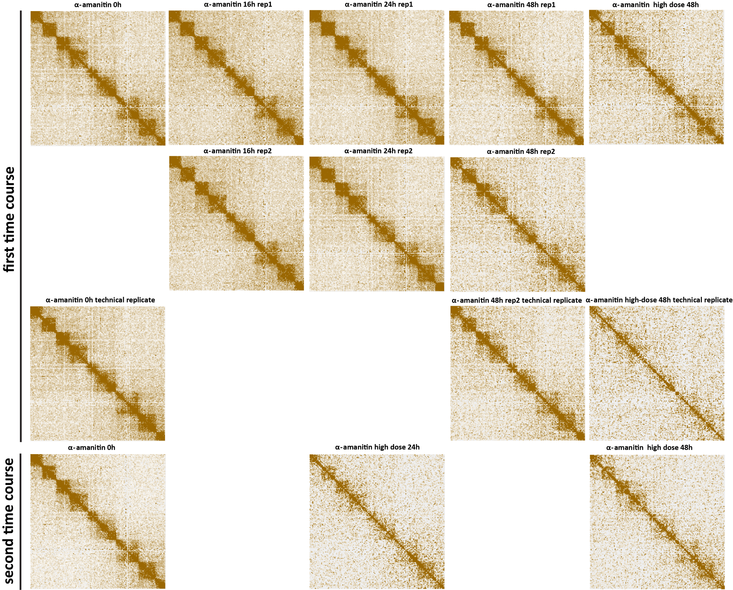
Supplementary Figure 22: Decompaction of dinoTADs upon transcriptional inhibition using α-amanitin. Shown is pseudochromosome 10. Two time courses were carried out following the outline presented in Figure 2B.
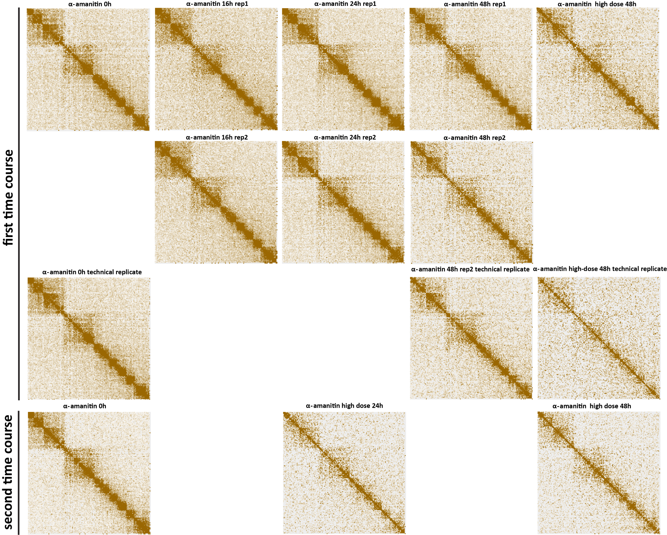
Supplementary Figure 23: Decompaction of dinoTADs upon transcriptional inhibition using α-amanitin. Shown is pseudochromosome 17. Two time courses were carried out following the outline presented in Figure 2B.
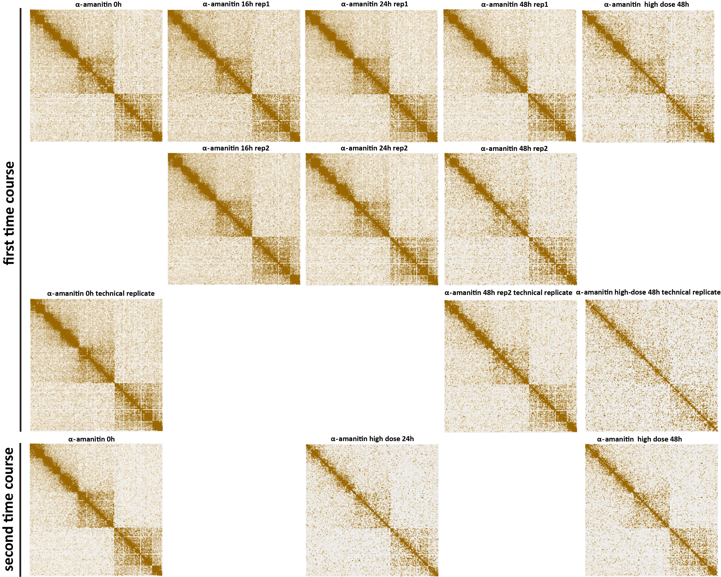
Supplementary Figure 24: Decompaction of dinoTADs upon transcriptional inhibition using α-amanitin. Shown is pseudochromosome 18. Two time courses were carried out following the outline presented in Figure 2B.
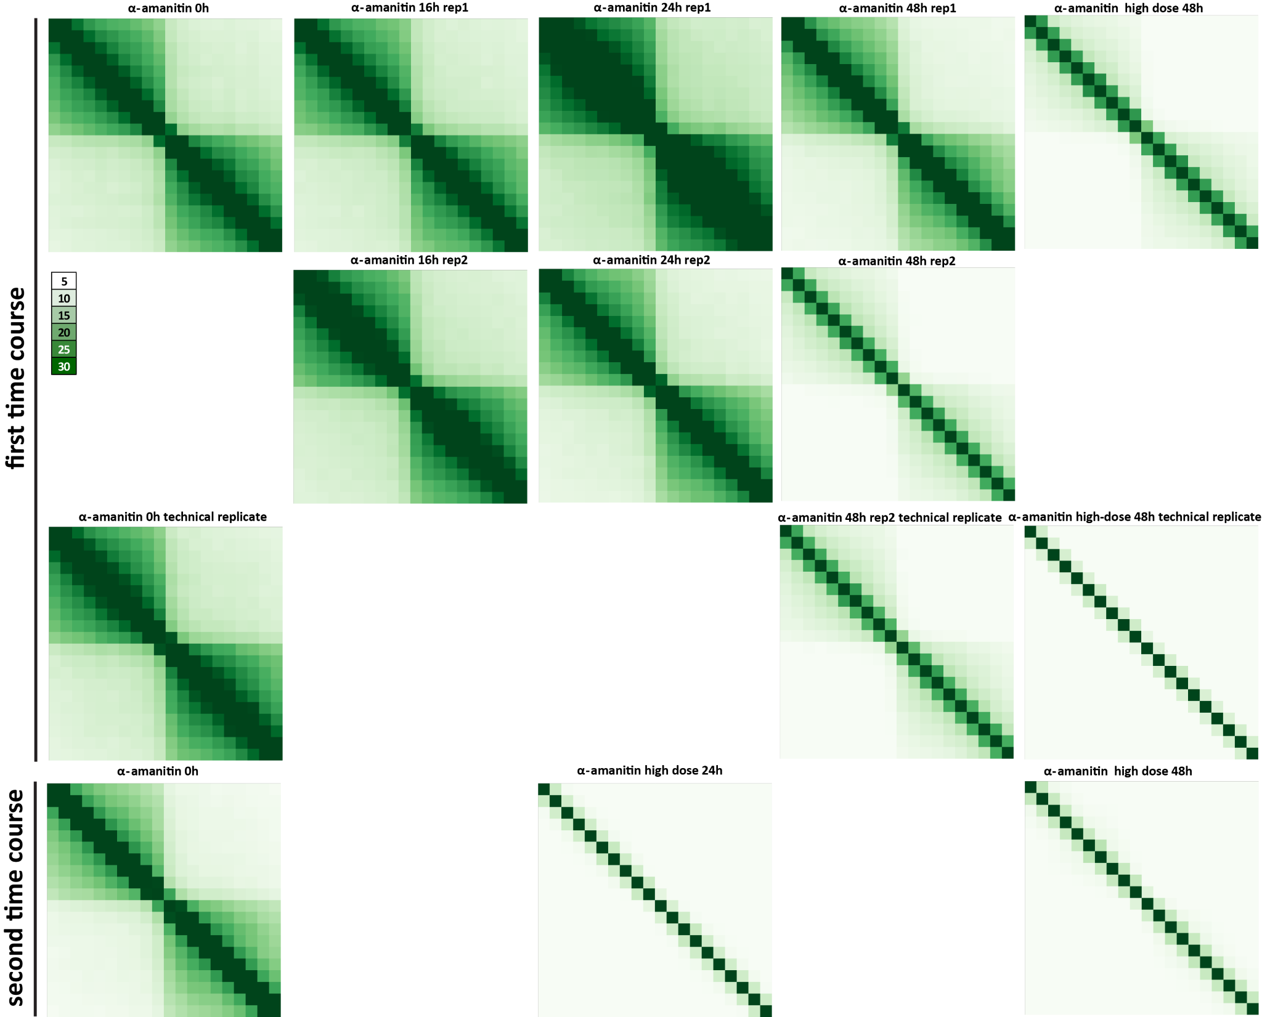
Supplementary Figure 25: Decompaction of dinoTADs upon transcriptional inhibition using α-amanitin. Shown are 50-kb resolution metaplots centered on dinoTAD domain boundaries. Two time courses were carried out following the outline presented in Figure 2B.
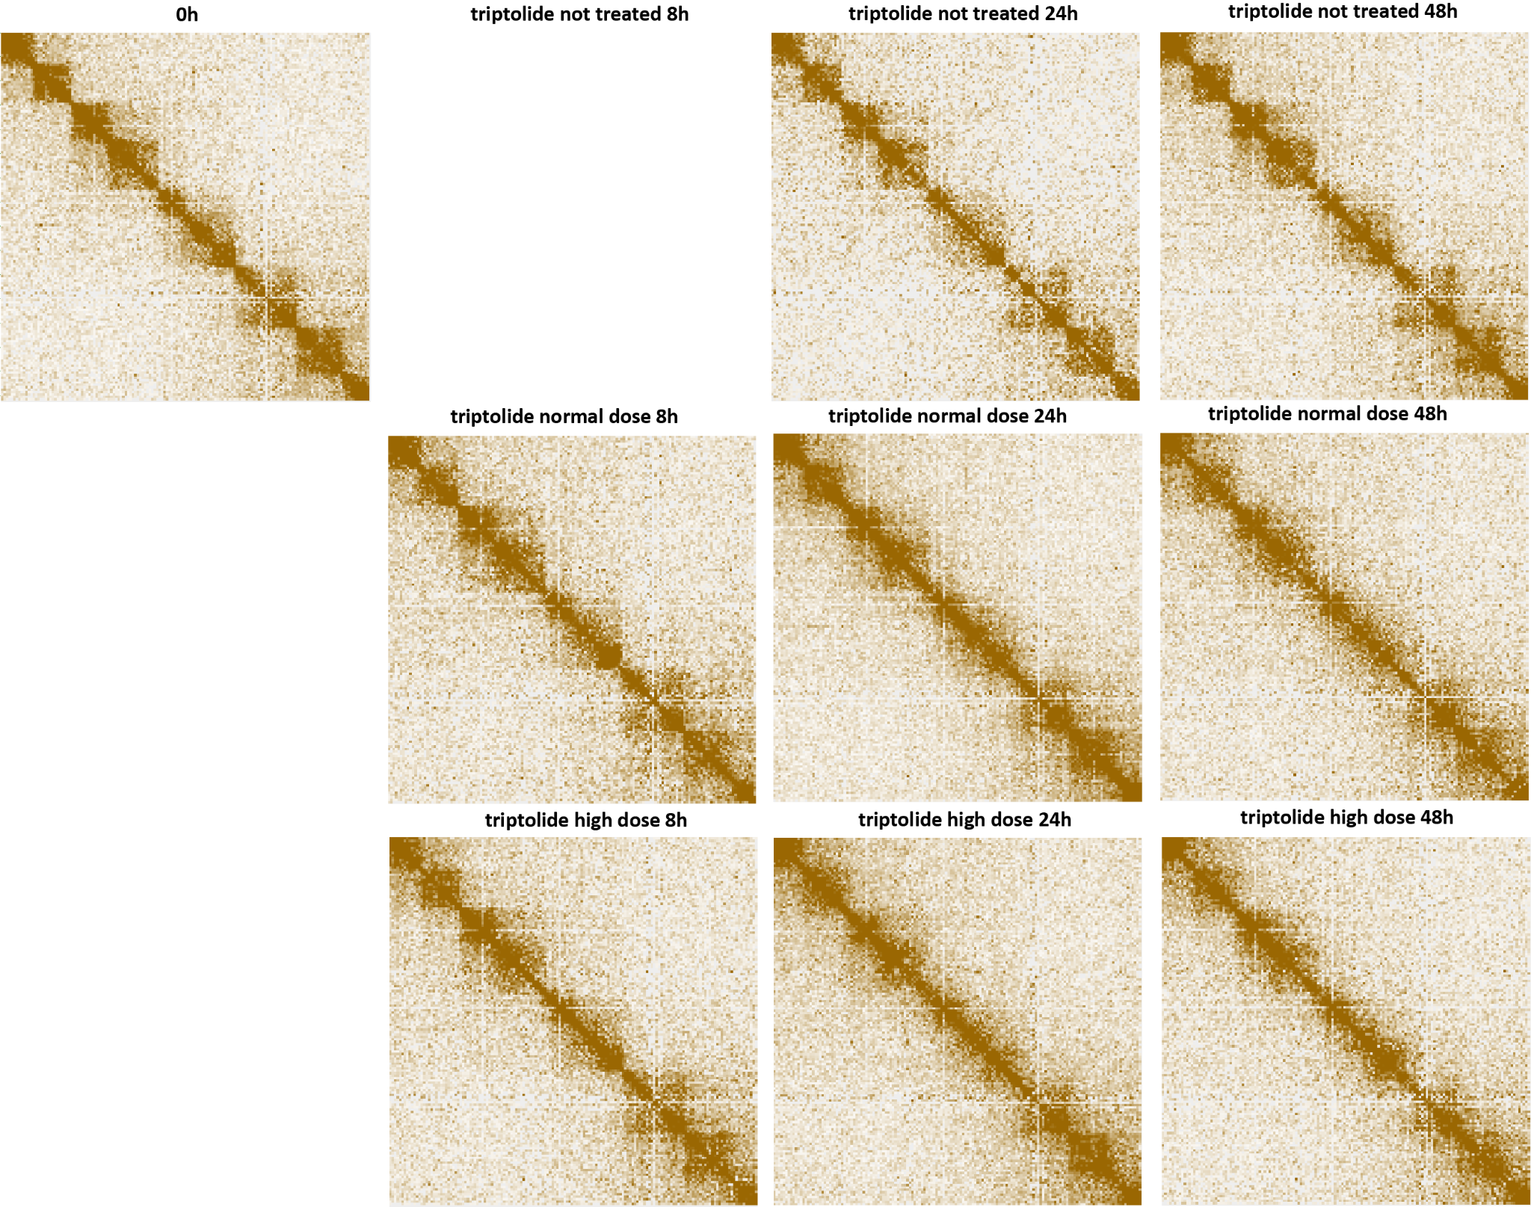
Supplementary Figure 26: Blurring of dinoTAD boundaries upon transcriptional inhibition using triptolide. Shown is pseudochromosome 10. The triptolide time course was carried out following the outline presented in Figure 2B.
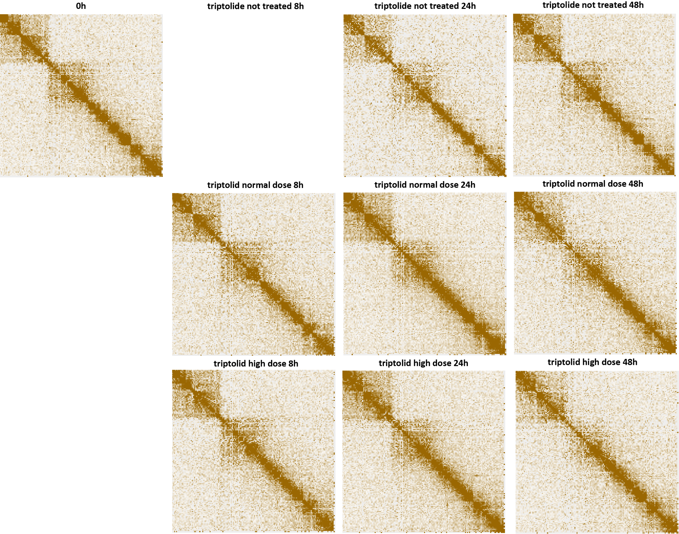
Supplementary Figure 27: Blurring of dinoTAD boundaries upon transcriptional inhibition using triptolide. Shown is pseudochromosome 17. The triptolide time course was carried out following the outline presented in Figure 2B.
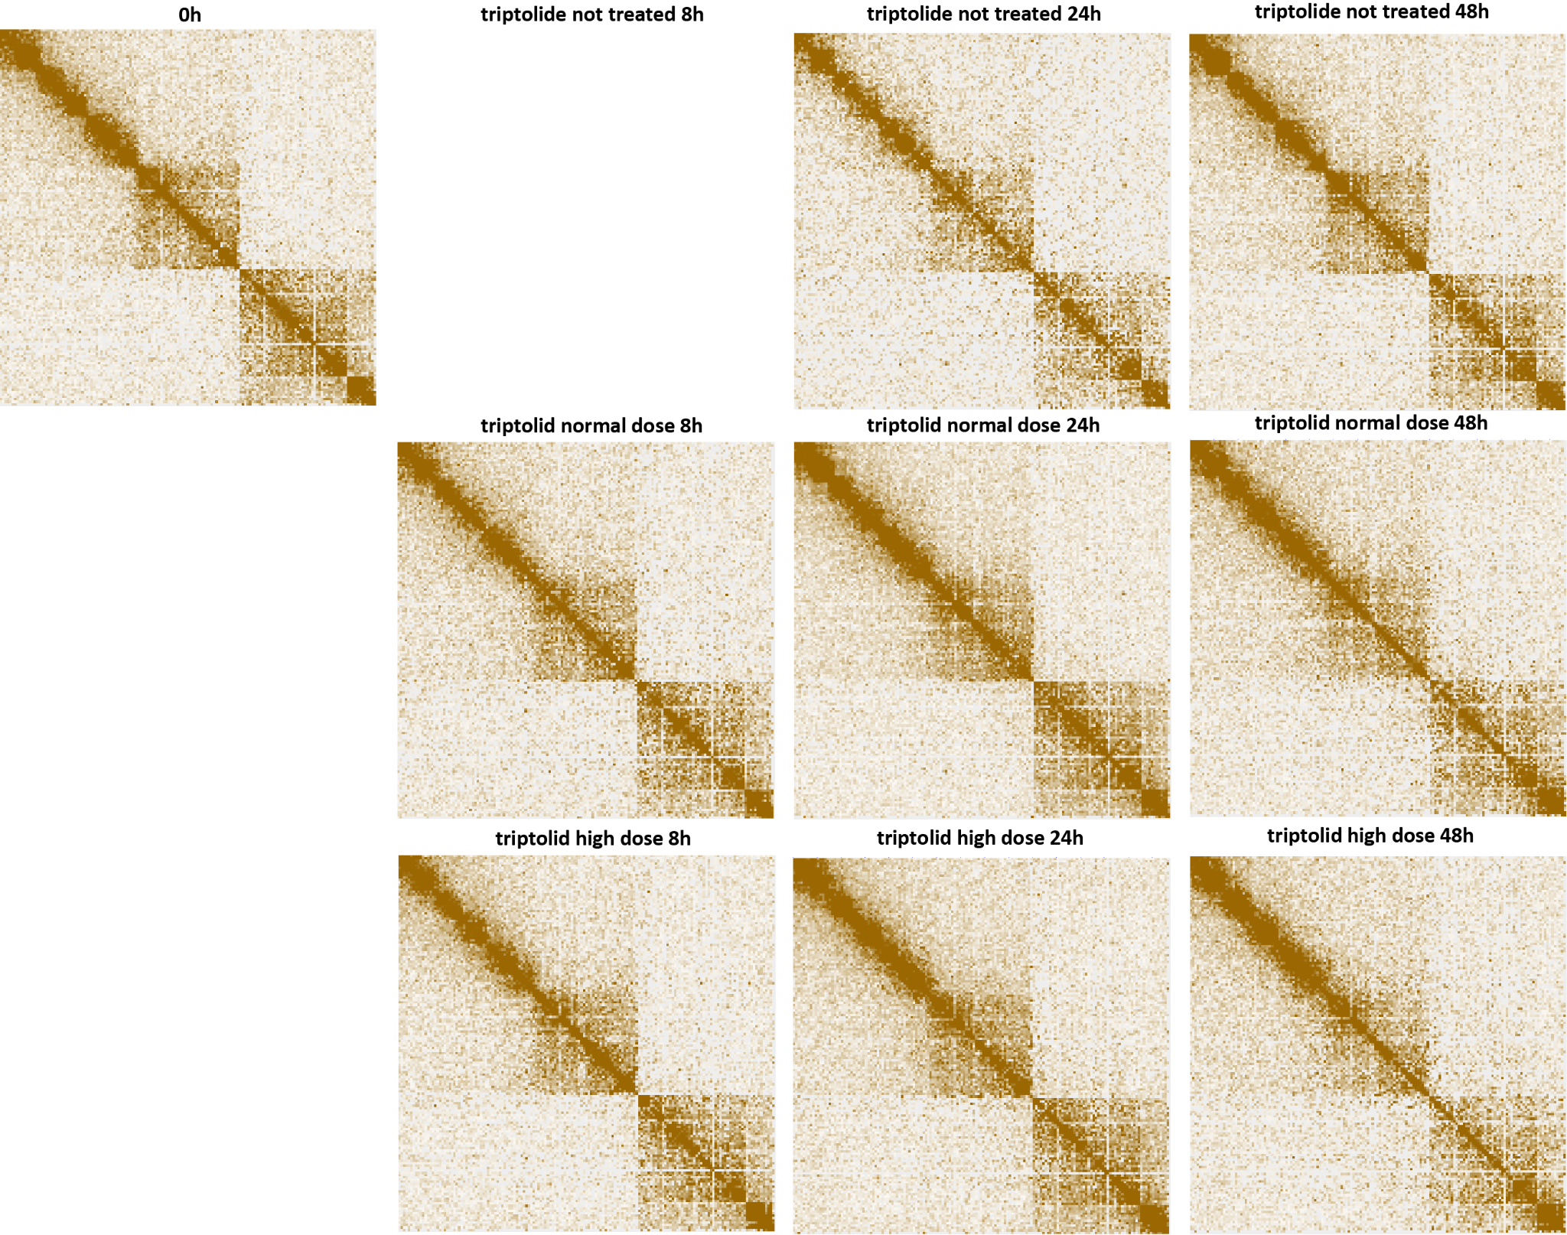
Supplementary Figure 28: Blurring of dinoTAD boundaries upon transcriptional inhibition using triptolide. Shown is pseudochromosome 18. The triptolide time course was carried out following the outline presented in Figure 2B.
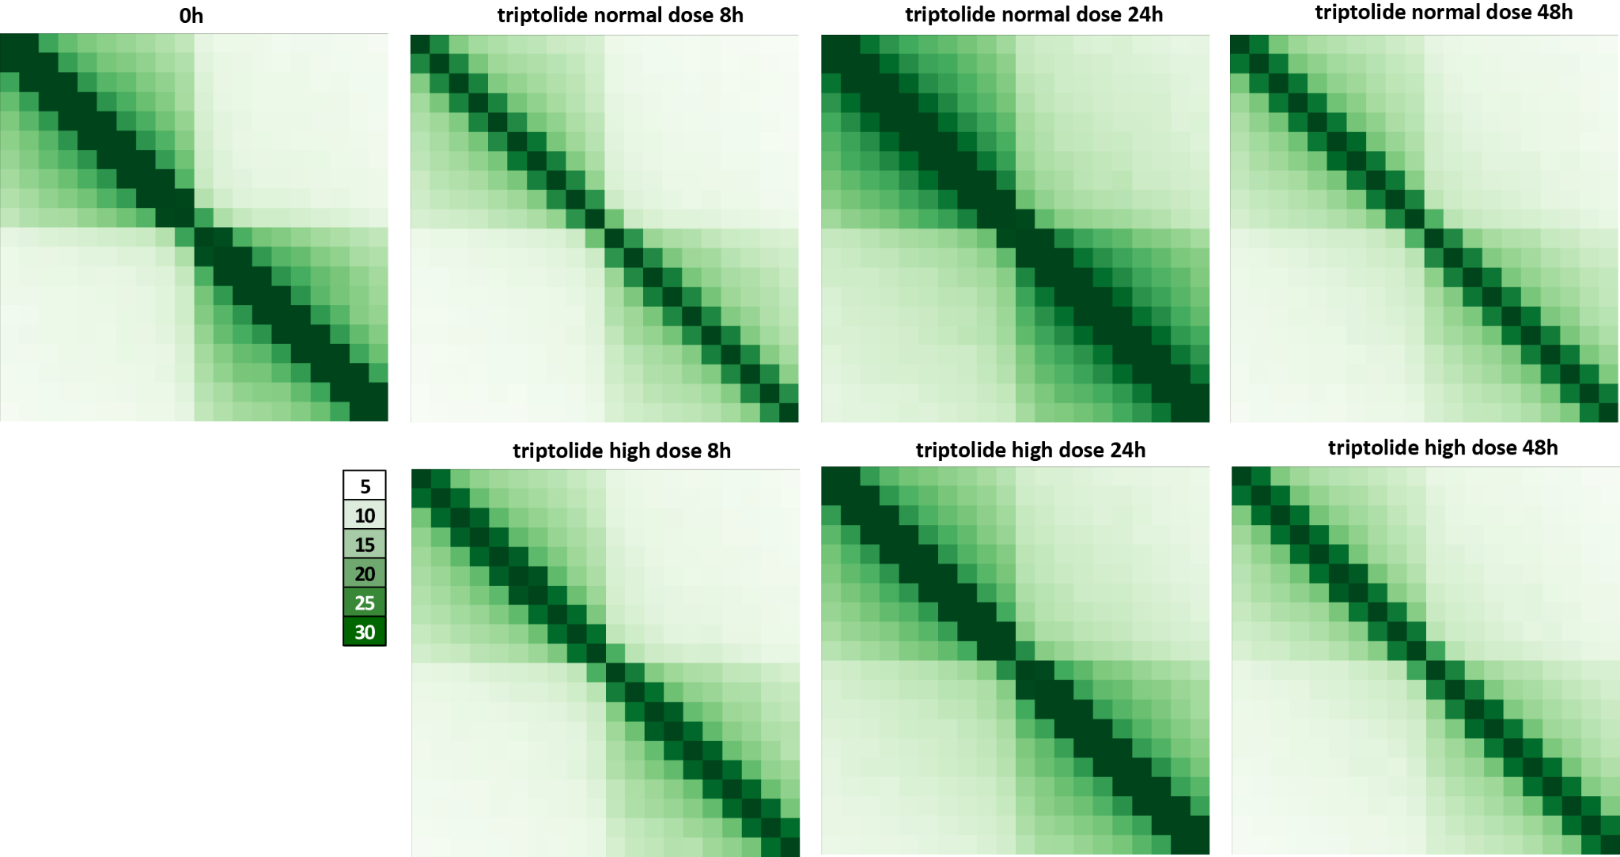
Supplementary Figure 29: Blurring of dinoTAD boundaries upon transcriptional inhibition using triptolide. Shown are 50-kb resolution metaplots centered on dinoTAD domain boundaries. The triptolide time course was carried out following the outline presented in Figure 2B.
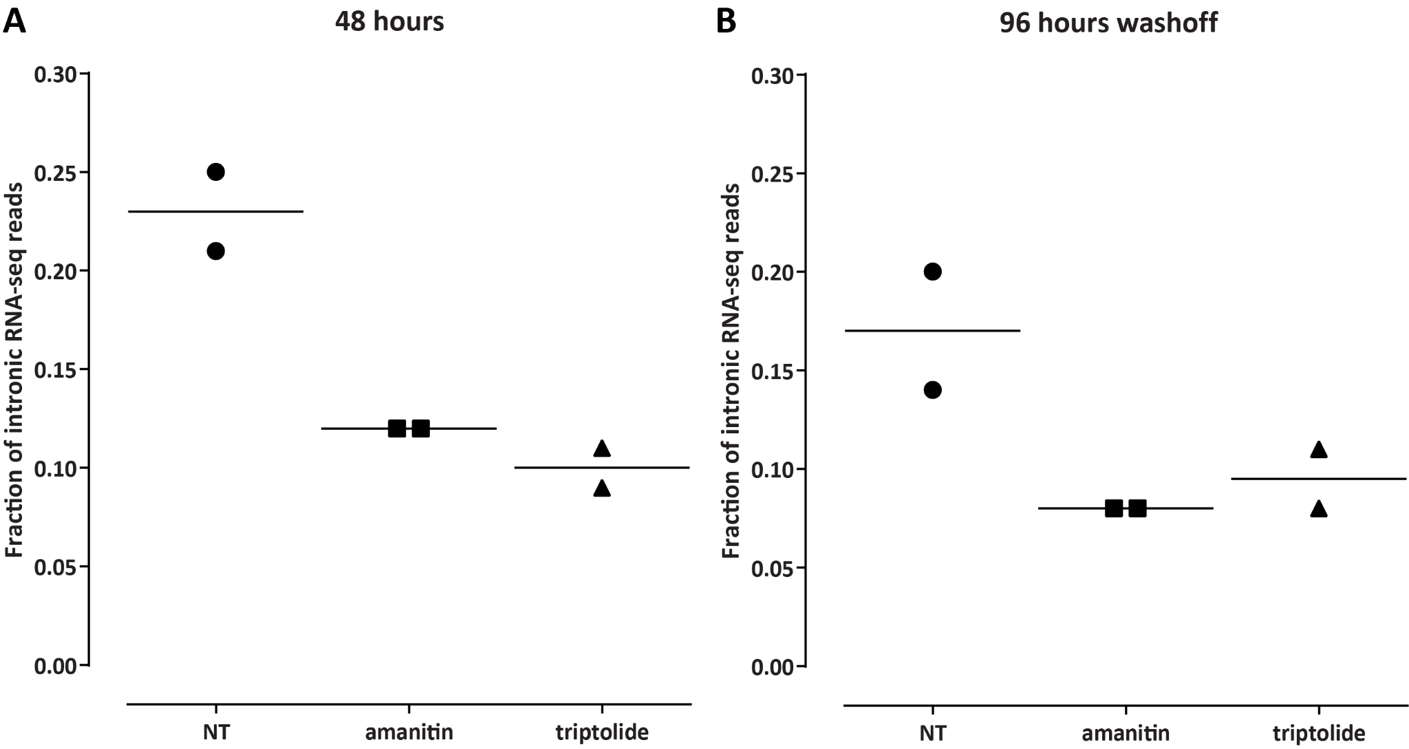
Supplementary Figure 30: Assessment of transcriptional activity upon α-amanitin and triptolide treatment and after withdrawal of the inhibitors. Shown is the fraction of intronic reads in PolyA+ RNA-seq datasets generated from cells treated with the “high” doses of the two drugs or no drug for 48 hours (A) , and at 48 hours later after withdrawing the inhibitor (B; “96 hours washoff”).
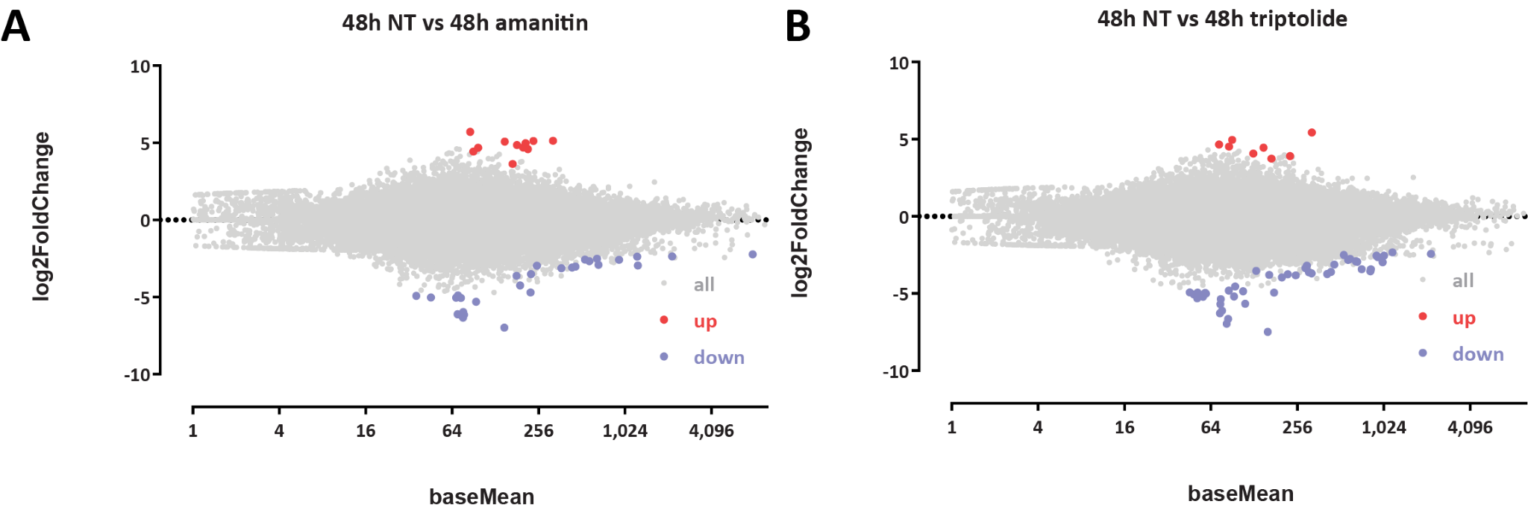
SupplementaryFigure31:
Lack
of
large
-
scale
tran
script
level
changes
upon
α
-
aman
itin
and
trip
tolide
treat | ment
. Differential expression was assessed using DESeq2 (see Methods). Number of differential genes: 12 genes up
in and 30 genes down in the α-amanitin-treateed relative to the untreated sample; 9 genes up in and 47 genes down in the triptolide-treated relative to the untreated sample.
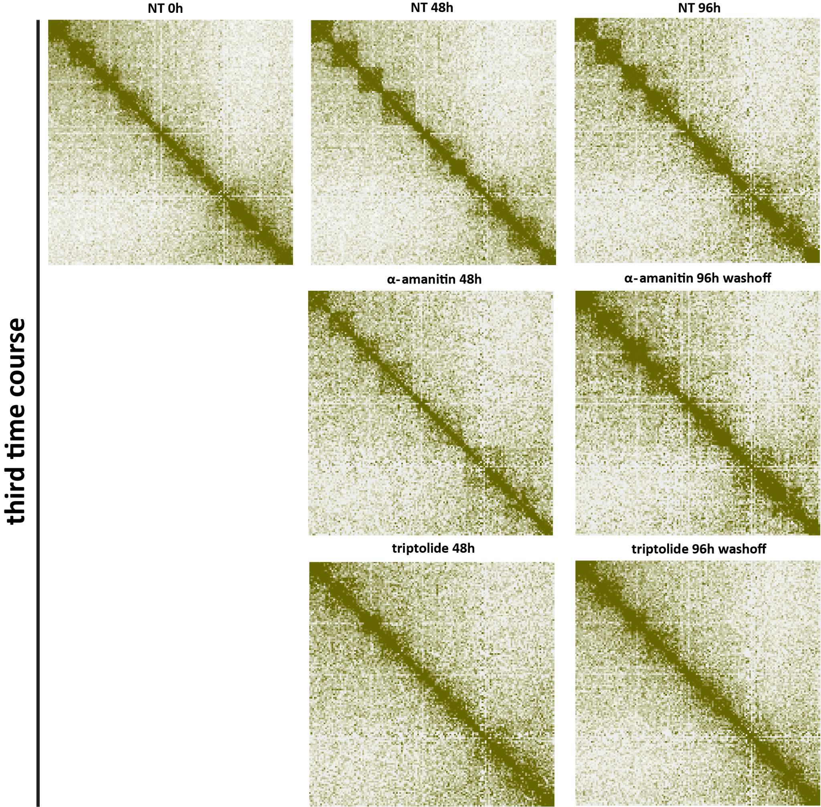
Par | tial | restora | tion | of | dino | TADs | within | 48 | hours | af | ter | re | moval | of | tran | scrip | tional
Supplementary Figure 32:
in | hibitors
. Cells were treated with α-amanitin or triptolide (“high” doses) for 48 hours, then the inhibitors was washed
away, and cells were harvested another 48 hours later (“96 hours washoff”). Shown is pseudochromosome 10.
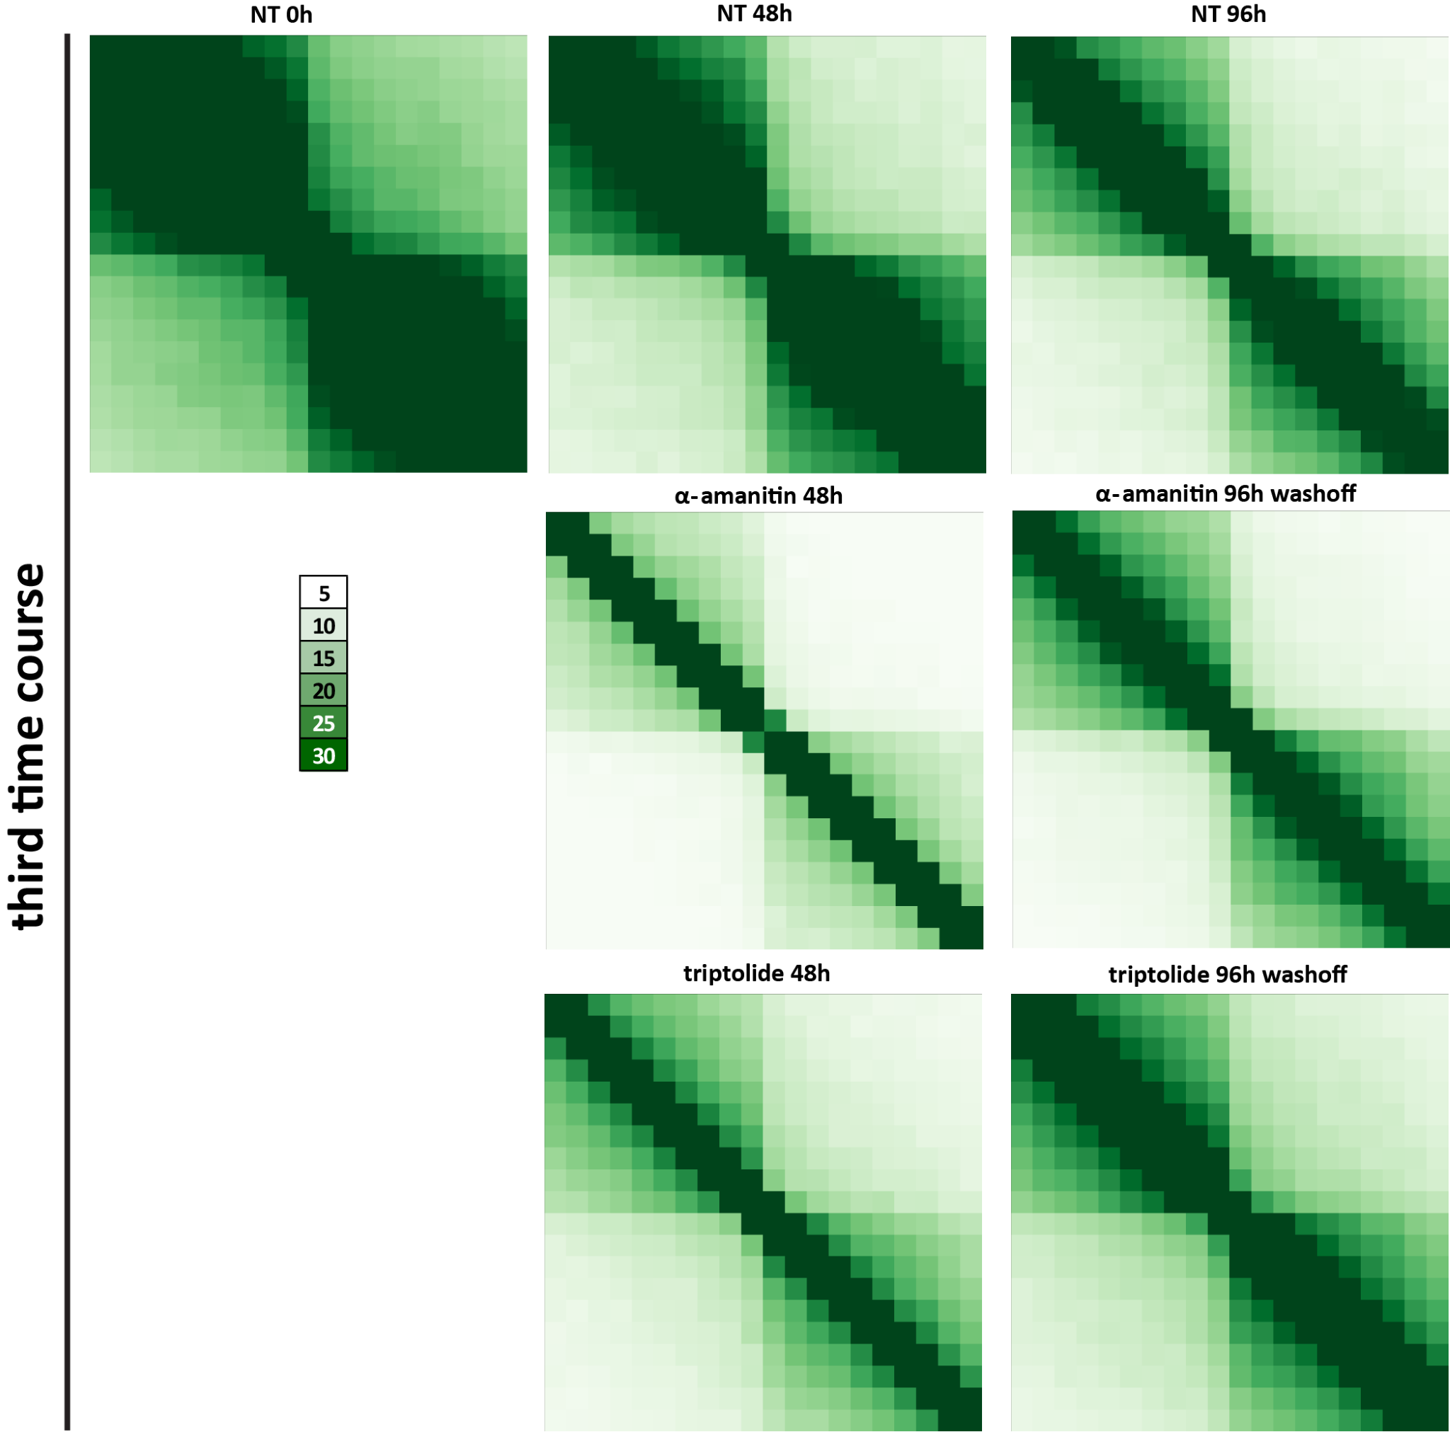
Par | tial | restora | tion | of | dino | TADs | within | 48 | hours | af | ter | re | moval | of | tran | scrip | tional
Supplementary Figure 33:
in | hibitors
. Cells were treated with α-amanitin or triptolide (“high” doses) for 48 hours, then the inhibitors was washed
away, and cells were harvested another 48 hours later (“96 hours washoff”). Shown is a metaplot across all dinoTAD boundaries.

